Mineral Titles Act 2010
NOTICE OF LAND CEASING TO BE A MINERAL TITLE AREA
Title Type and Number: | Extractive Mineral Permit 30028
Area ceased on: | 08 April 2022
Area: | 37.00 Hectare
Locality: | KOOLPINYAH
Name of Applicants(s)Holder(s): | 50% HILLIER Jennifer Mary, 50% HILLIER Anthony Michael
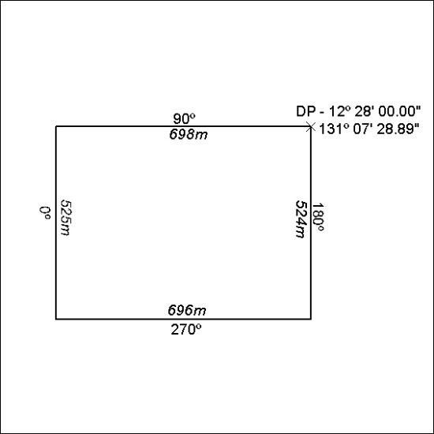

111/22

Mineral Titles Act 2010
NOTICE OF LAND CEASING TO BE A MINERAL TITLE AREA
Title Type and Number: | Extractive Mineral Permit 30031
Area ceased on: | 08 April 2022
Area: | 42.00 Hectare
Locality: | KOOLPINYAH
Name of Applicants(s)Holder(s): | 50% HILLIER Jennifer Mary, 50% HILLIER Anthony Michael
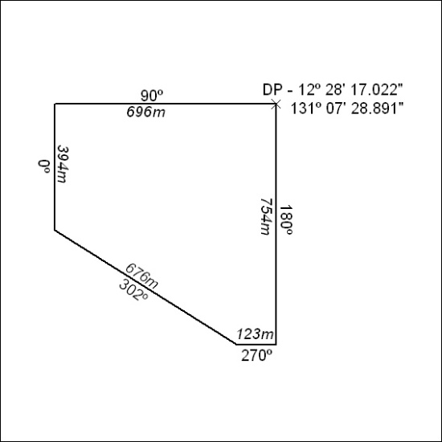

112/22

