Mineral Titles Act
NOTICE OF GRANT OF A MINERAL TITLE
Title Type and Number: | Exploration Licence 32834
Granted: | 05 April 2022, for a period of 6 Years
Area: | 191 Blocks, 609.29 km²
Locality: | HOME OF BULLION
Name of Holder/s: | 100% PEGMATITE ONE PTY LTD [ACN. 652 853 391]
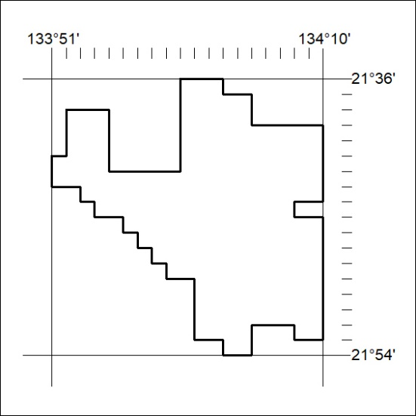
Area granted is indicated above. The titleholder is not permitted to exercise occupational rights on any land that is subject to a development title, or an application for a development title. Any land the subject of a Reserved Land gazettal under the Mineral Titles Act and all land vested in the Commonwealth of Australia is also excluded by description but not excised from the grant area.
89/22

Mineral Titles Act
NOTICE OF GRANT OF A MINERAL TITLE
Title Type and Number: | Exploration Licence 32835
Granted: | 05 April 2022, for a period of 6 Years
Area: | 122 Blocks, 389.09 km²
Locality: | HOME OF BULLION
Name of Holder/s: | 100% PEGMATITE ONE PTY LTD [ACN. 652 853 391]
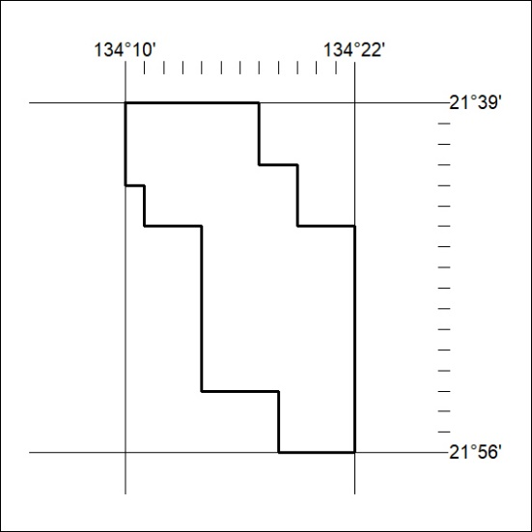
Area granted is indicated above. The titleholder is not permitted to exercise occupational rights on any land that is subject to a development title, or an application for a development title. Any land the subject of a Reserved Land gazettal under the Mineral Titles Act and all land vested in the Commonwealth of Australia is also excluded by description but not excised from the grant area.
90/22

Mineral Titles Act
NOTICE OF GRANT OF A MINERAL TITLE
Title Type and Number: | Exploration Licence 32839
Granted: | 06 April 2022, for a period of 6 Years
Area: | 10 Blocks, 32.58 km²
Locality: | HELEN
Name of Holder/s: | 100% SCRIVEN EXPLORATION PTY LTD [ACN. 006 264 615]
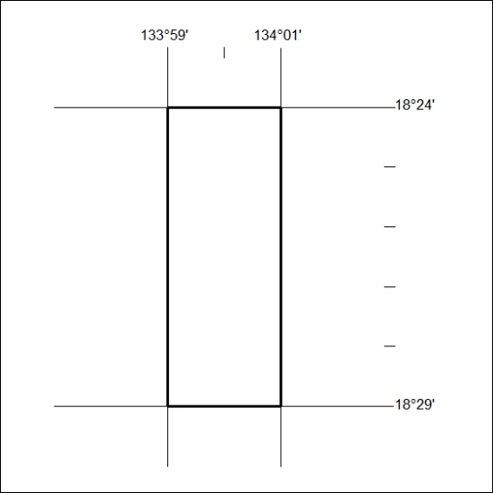
Area granted is indicated above. The titleholder is not permitted to exercise occupational rights on any land that is subject to a development title, or an application for a development title. Any land the subject of a Reserved Land gazettal under the Mineral Titles Act and all land vested in the Commonwealth of Australia is also excluded by description but not excised from the grant area.
91/22

Mineral Titles Act
NOTICE OF GRANT OF A MINERAL TITLE
Title Type and Number: | Exploration Licence 32840
Granted: | 05 April 2022, for a period of 6 Years
Area: | 33 Blocks, 105.47 km²
Locality: | CONICAL HILL
Name of Holder/s: | 100% PEGMATITE ONE PTY LTD [ACN. 652 853 391]
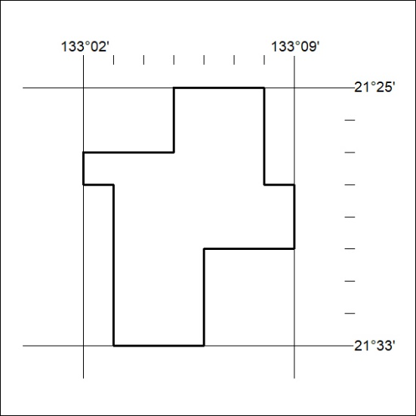
Area granted is indicated above. The titleholder is not permitted to exercise occupational rights on any land that is subject to a development title, or an application for a development title. Any land the subject of a Reserved Land gazettal under the Mineral Titles Act and all land vested in the Commonwealth of Australia is also excluded by description but not excised from the grant area.
92/22

Mineral Titles Act
NOTICE OF GRANT OF A MINERAL TITLE
Title Type and Number: | Exploration Licence 32844
Granted: | 05 April 2022, for a period of 6 Years
Area: | 226 Blocks, 716.38 km²
Locality: | REYNOLDS RANGE
Name of Holder/s: | 100% PEGMATITE ONE PTY LTD [ACN. 652 853 391]
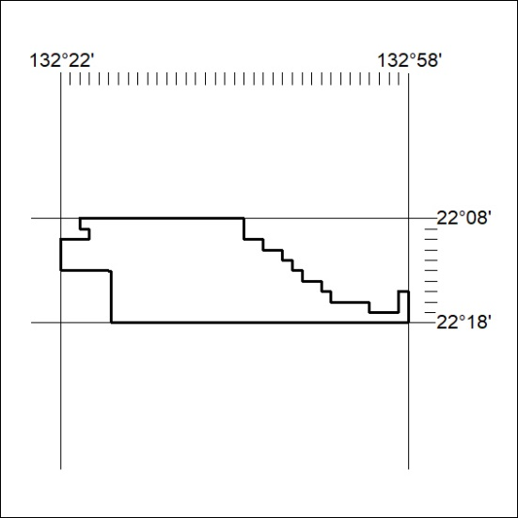
Area granted is indicated above. The titleholder is not permitted to exercise occupational rights on any land that is subject to a development title, or an application for a development title. Any land the subject of a Reserved Land gazettal under the Mineral Titles Act and all land vested in the Commonwealth of Australia is also excluded by description but not excised from the grant area.
93/22

Mineral Titles Act
NOTICE OF GRANT OF A MINERAL TITLE
Title Type and Number: | Exploration Licence 32845
Granted: | 05 April 2022, for a period of 6 Years
Area: | 250 Blocks, 789.39 km²
Locality: | REYNOLDS RANGE
Name of Holder/s: | 100% PEGMATITE ONE PTY LTD [ACN. 652 853 391]
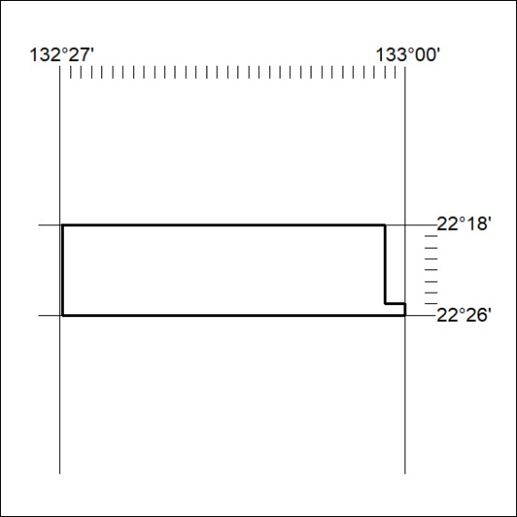
Area granted is indicated above. The titleholder is not permitted to exercise occupational rights on any land that is subject to a development title, or an application for a development title. Any land the subject of a Reserved Land gazettal under the Mineral Titles Act and all land vested in the Commonwealth of Australia is also excluded by description but not excised from the grant area.
94/22

Mineral Titles Act
NOTICE OF GRANT OF A MINERAL TITLE
Title Type and Number: | Exploration Licence 32846
Granted: | 05 April 2022, for a period of 6 Years
Area: | 146 Blocks, 462.92 km²
Locality: | REYNOLDS RANGE
Name of Holder/s: | 100% PEGMATITE ONE PTY LTD [ACN. 652 853 391]
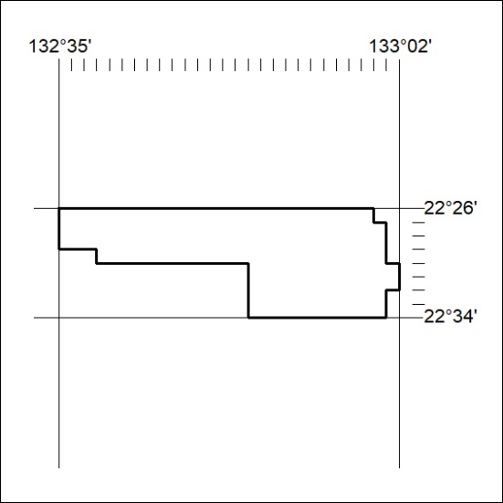
Area granted is indicated above. The titleholder is not permitted to exercise occupational rights on any land that is subject to a development title, or an application for a development title. Any land the subject of a Reserved Land gazettal under the Mineral Titles Act and all land vested in the Commonwealth of Australia is also excluded by description but not excised from the grant area.
95/22

Mineral Titles Act
NOTICE OF GRANT OF A MINERAL TITLE
Title Type and Number: | Exploration Licence 32847
Granted: | 05 April 2022, for a period of 6 Years
Area: | 22 Blocks, 70.38 km²
Locality: | TAYLOR
Name of Holder/s: | 100% PEGMATITE ONE PTY LTD [ACN. 652 853 391]
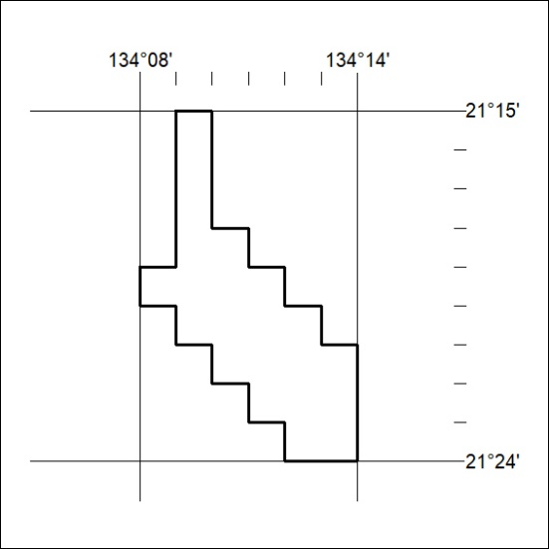
Area granted is indicated above. The titleholder is not permitted to exercise occupational rights on any land that is subject to a development title, or an application for a development title. Any land the subject of a Reserved Land gazettal under the Mineral Titles Act and all land vested in the Commonwealth of Australia is also excluded by description but not excised from the grant area.
96/22

Mineral Titles Act
NOTICE OF GRANT OF A MINERAL TITLE
Title Type and Number: | Exploration Licence 32848
Granted: | 05 April 2022, for a period of 6 Years
Area: | 25 Blocks, 79.95 km²
Locality: | CRAWFORD
Name of Holder/s: | 100% PEGMATITE ONE PTY LTD [ACN. 652 853 391]
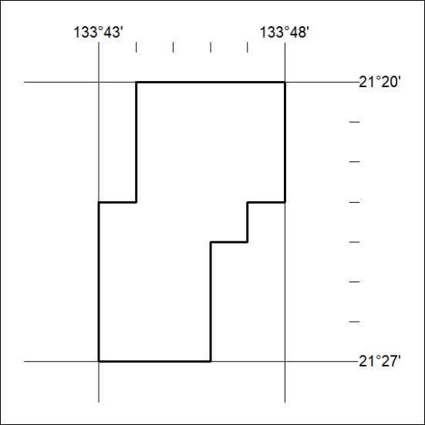
Area granted is indicated above. The titleholder is not permitted to exercise occupational rights on any land that is subject to a development title, or an application for a development title. Any land the subject of a Reserved Land gazettal under the Mineral Titles Act and all land vested in the Commonwealth of Australia is also excluded by description but not excised from the grant area.
97/22

Mineral Titles Act
NOTICE OF GRANT OF A MINERAL TITLE
Title Type and Number: | Exploration Licence 32851
Granted: | 05 April 2022, for a period of 6 Years
Area: | 68 Blocks, 216.37 km²
Locality: | DENISON
Name of Holder/s: | 100% PEGMATITE ONE PTY LTD [ACN. 652 853 391]
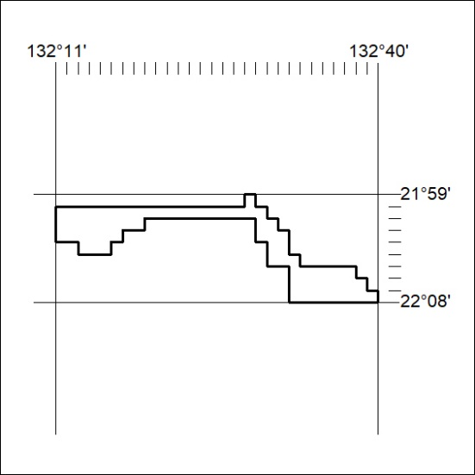
Area granted is indicated above. The titleholder is not permitted to exercise occupational rights on any land that is subject to a development title, or an application for a development title. Any land the subject of a Reserved Land gazettal under the Mineral Titles Act and all land vested in the Commonwealth of Australia is also excluded by description but not excised from the grant area.
98/22

Mineral Titles Act
NOTICE OF GRANT OF A MINERAL TITLE
Title Type and Number: | Exploration Licence 32852
Granted: | 05 April 2022, for a period of 6 Years
Area: | 18 Blocks, 57.25 km²
Locality: | DENISON
Name of Holder/s: | 100% PEGMATITE ONE PTY LTD [ACN. 652 853 391]
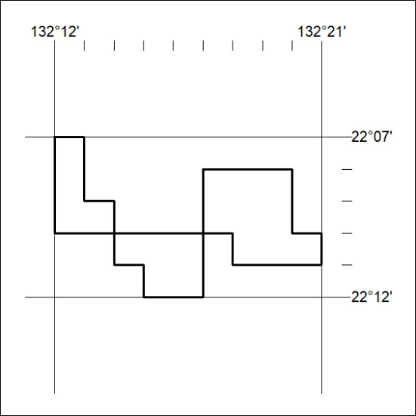
Area granted is indicated above. The titleholder is not permitted to exercise occupational rights on any land that is subject to a development title, or an application for a development title. Any land the subject of a Reserved Land gazettal under the Mineral Titles Act and all land vested in the Commonwealth of Australia is also excluded by description but not excised from the grant area.
99/22

Mineral Titles Act
NOTICE OF GRANT OF A MINERAL TITLE
Title Type and Number: | Exploration Licence 32853
Granted: | 05 April 2022, for a period of 6 Years
Area: | 8 Blocks, 25.45 km²
Locality: | DENISON
Name of Holder/s: | 100% PEGMATITE ONE PTY LTD [ACN. 652 853 391]
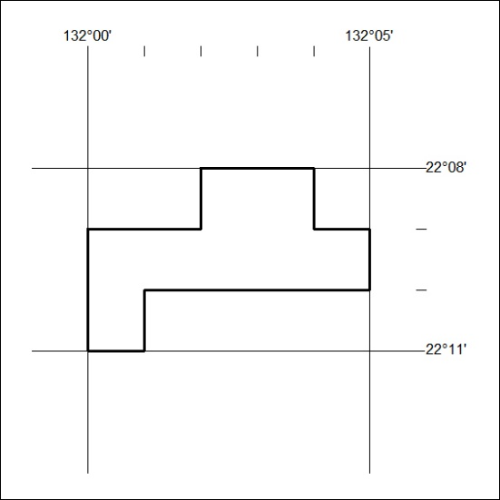
Area granted is indicated above. The titleholder is not permitted to exercise occupational rights on any land that is subject to a development title, or an application for a development title. Any land the subject of a Reserved Land gazettal under the Mineral Titles Act and all land vested in the Commonwealth of Australia is also excluded by description but not excised from the grant area.
100/22

Mineral Titles Act
NOTICE OF GRANT OF A MINERAL TITLE
Title Type and Number: | Exploration Licence 32854
Granted: | 05 April 2022, for a period of 6 Years
Area: | 206 Blocks, 635.97 km²
Locality: | LAUGHLEN
Name of Holder/s: | 100% PEGMATITE ONE PTY LTD [ACN. 652 853 391]
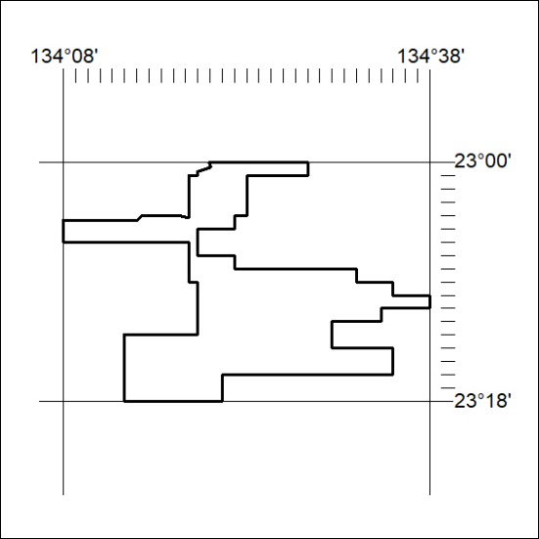
Area granted is indicated above. The titleholder is not permitted to exercise occupational rights on any land that is subject to a development title, or an application for a development title. Any land the subject of a Reserved Land gazettal under the Mineral Titles Act and all land vested in the Commonwealth of Australia is also excluded by description but not excised from the grant area.
101/22

Mineral Titles Act
NOTICE OF GRANT OF A MINERAL TITLE
Title Type and Number: | Exploration Licence 32855
Granted: | 05 April 2022, for a period of 6 Years
Area: | 86 Blocks, 271.32 km²
Locality: | RIDDOCH
Name of Holder/s: | 100% PEGMATITE ONE PTY LTD [ACN. 652 853 391]
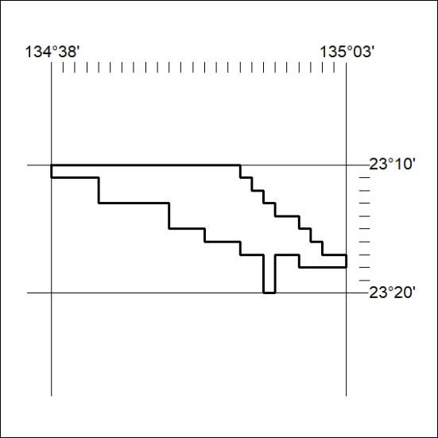
Area granted is indicated above. The titleholder is not permitted to exercise occupational rights on any land that is subject to a development title, or an application for a development title. Any land the subject of a Reserved Land gazettal under the Mineral Titles Act and all land vested in the Commonwealth of Australia is also excluded by description but not excised from the grant area.
102/22

Mineral Titles Act
NOTICE OF GRANT OF A MINERAL TITLE
Title Type and Number: | Exploration Licence 32861
Granted: | 05 April 2022, for a period of 6 Years
Area: | 208 Blocks, 660.71 km²
Locality: | TEA TREE
Name of Holder/s: | 100% PEGMATITE ONE PTY LTD [ACN. 652 853 391]
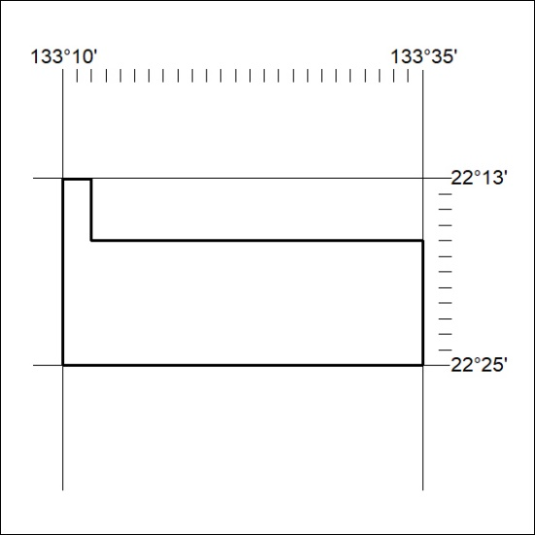
Area granted is indicated above. The titleholder is not permitted to exercise occupational rights on any land that is subject to a development title, or an application for a development title. Any land the subject of a Reserved Land gazettal under the Mineral Titles Act and all land vested in the Commonwealth of Australia is also excluded by description but not excised from the grant area.
103/22

Mineral Titles Act
NOTICE OF GRANT OF A MINERAL TITLE
Title Type and Number: | Exploration Licence 32862
Granted: | 05 April 2022, for a period of 6 Years
Area: | 74 Blocks, 234.82 km²
Locality: | TEA TREE
Name of Holder/s: | 100% PEGMATITE ONE PTY LTD [ACN. 652 853 391]
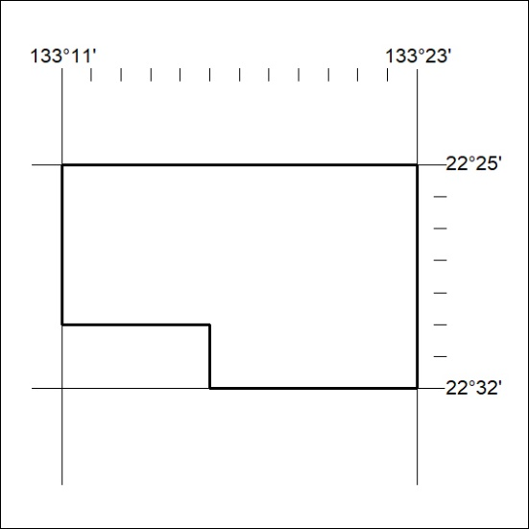
Area granted is indicated above. The titleholder is not permitted to exercise occupational rights on any land that is subject to a development title, or an application for a development title. Any land the subject of a Reserved Land gazettal under the Mineral Titles Act and all land vested in the Commonwealth of Australia is also excluded by description but not excised from the grant area.
104/22

Mineral Titles Act
NOTICE OF GRANT OF A MINERAL TITLE
Title Type and Number: | Exploration Licence 32863
Granted: | 05 April 2022, for a period of 6 Years
Area: | 40 Blocks, 127.78 km²
Locality: | ANNINGIE
Name of Holder/s: | 100% PEGMATITE ONE PTY LTD [ACN. 652 853 391]
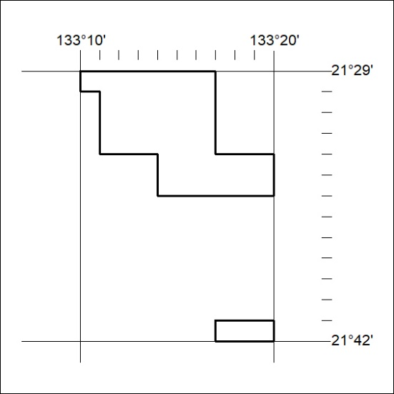
Area granted is indicated above. The titleholder is not permitted to exercise occupational rights on any land that is subject to a development title, or an application for a development title. Any land the subject of a Reserved Land gazettal under the Mineral Titles Act and all land vested in the Commonwealth of Australia is also excluded by description but not excised from the grant area.
105/22

Mineral Titles Act
NOTICE OF GRANT OF A MINERAL TITLE
Title Type and Number: | Exploration Licence 32866
Granted: | 05 April 2022, for a period of 6 Years
Area: | 163 Blocks, 515.22 km²
Locality: | BUSHY PARK
Name of Holder/s: | 100% PEGMATITE ONE PTY LTD [ACN. 652 853 391]
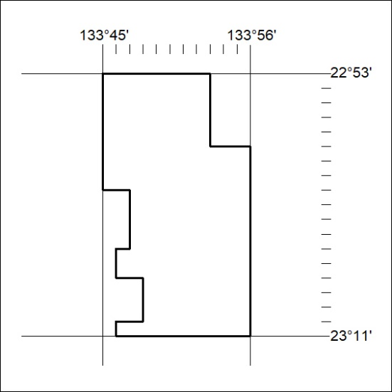
Area granted is indicated above. The titleholder is not permitted to exercise occupational rights on any land that is subject to a development title, or an application for a development title. Any land the subject of a Reserved Land gazettal under the Mineral Titles Act and all land vested in the Commonwealth of Australia is also excluded by description but not excised from the grant area.
106/22

Mineral Titles Act
NOTICE OF GRANT OF A MINERAL TITLE
Title Type and Number: | Exploration Licence 32868
Granted: | 05 April 2022, for a period of 6 Years
Area: | 32 Blocks, 102.25 km²
Locality: | HOME OF BULLION
Name of Holder/s: | 100% PEGMATITE ONE PTY LTD [ACN. 652 853 391]
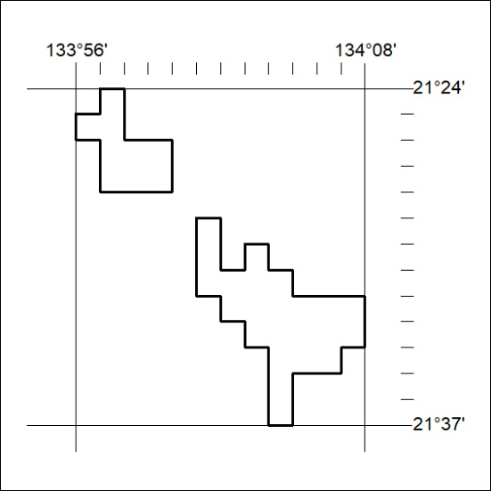
Area granted is indicated above. The titleholder is not permitted to exercise occupational rights on any land that is subject to a development title, or an application for a development title. Any land the subject of a Reserved Land gazettal under the Mineral Titles Act and all land vested in the Commonwealth of Australia is also excluded by description but not excised from the grant area.
107/22

Mineral Titles Act
NOTICE OF GRANT OF A MINERAL TITLE
Title Type and Number: | Exploration Licence 32869
Granted: | 05 April 2022, for a period of 6 Years
Area: | 48 Blocks, 151.72 km²
Locality: | AILERON
Name of Holder/s: | 100% PEGMATITE ONE PTY LTD [ACN. 652 853 391]
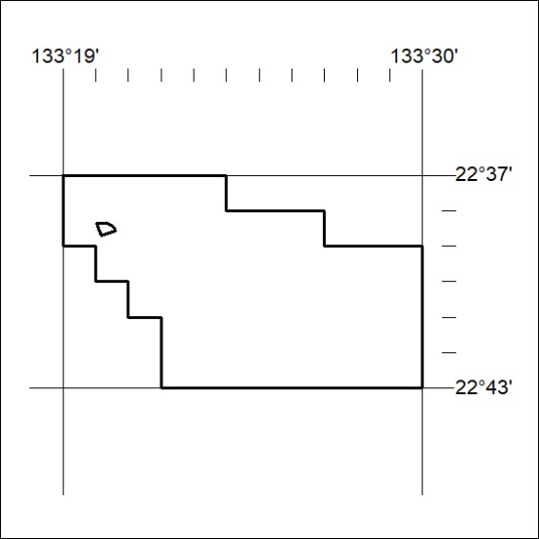
Area granted is indicated above. The titleholder is not permitted to exercise occupational rights on any land that is subject to a development title, or an application for a development title. Any land the subject of a Reserved Land gazettal under the Mineral Titles Act and all land vested in the Commonwealth of Australia is also excluded by description but not excised from the grant area.
108/22

Mineral Titles Act
NOTICE OF GRANT OF A MINERAL TITLE
Title Type and Number: | Exploration Licence 32871
Granted: | 05 April 2022, for a period of 6 Years
Area: | 119 Blocks, 377.59 km²
Locality: | WOODGREEN
Name of Holder/s: | 100% PEGMATITE ONE PTY LTD [ACN. 652 853 391]
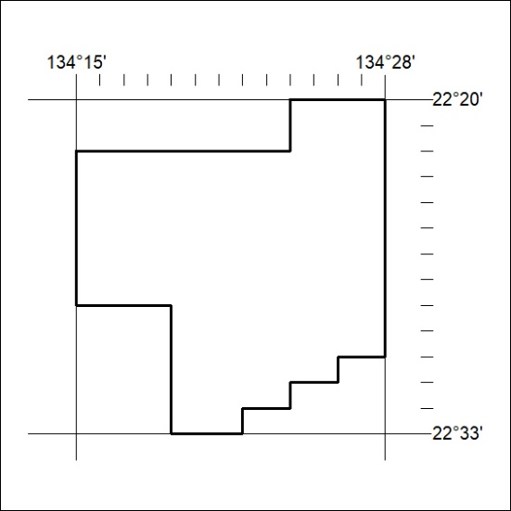
Area granted is indicated above. The titleholder is not permitted to exercise occupational rights on any land that is subject to a development title, or an application for a development title. Any land the subject of a Reserved Land gazettal under the Mineral Titles Act and all land vested in the Commonwealth of Australia is also excluded by description but not excised from the grant area.
109/22

Mineral Titles Act
NOTICE OF GRANT OF A MINERAL TITLE
Title Type and Number: | Exploration Licence 32872
Granted: | 05 April 2022, for a period of 6 Years
Area: | 244 Blocks, 762.15 km²
Locality: | MACDONALD DOWNS
Name of Holder/s: | 100% PEGMATITE ONE PTY LTD [ACN. 652 853 391]
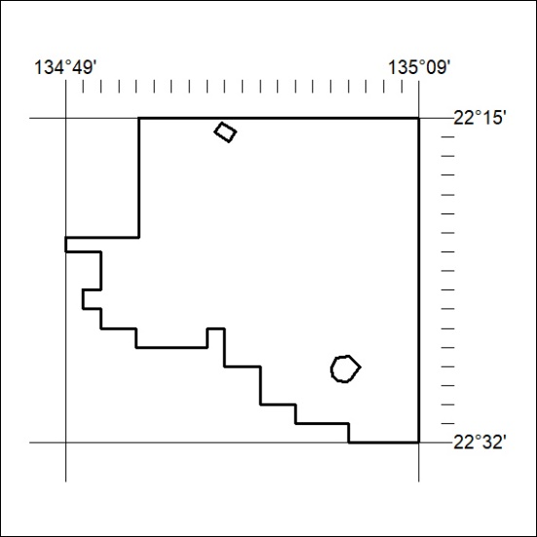
Area granted is indicated above. The titleholder is not permitted to exercise occupational rights on any land that is subject to a development title, or an application for a development title. Any land the subject of a Reserved Land gazettal under the Mineral Titles Act and all land vested in the Commonwealth of Australia is also excluded by description but not excised from the grant area.
110/22

