Mineral Titles Act
NOTICE OF GRANT OF A MINERAL TITLE
Title Type and Number: | Exploration Licence 32737
Granted: | 16 February 2022, for a period of 6 Years
Area: | 250 Blocks, 780.85 km²
Locality: | MOUNT PEAKE
Name of Holder/s: | 100% URE METALS PTY LTD [ACN. 633 442 181]
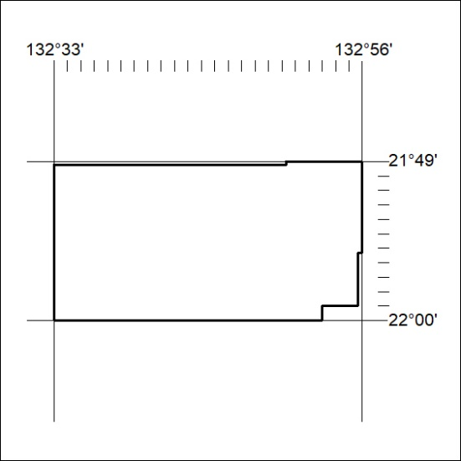
Area granted is indicated above. The titleholder is not permitted to exercise occupational rights on any land that is subject to a development title, or an application for a development title. Any land the subject of a Reserved Land gazettal under the Mineral Titles Act and all land vested in the Commonwealth of Australia is also excluded by description but not excised from the grant area.
43/22

Mineral Titles Act
NOTICE OF GRANT OF A MINERAL TITLE
Title Type and Number: | Exploration Licence 32738
Granted: | 16 February 2022, for a period of 6 Years
Area: | 100 Blocks, 312.17 km²
Locality: | REYNOLDS RANGE
Name of Holder/s: | 100% URE METALS PTY LTD [ACN. 633 442 181]
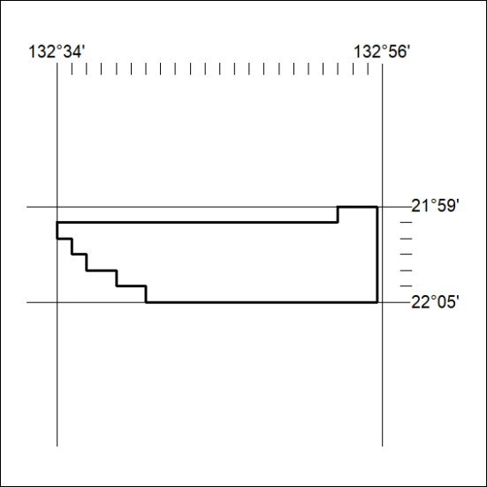
Area granted is indicated above. The titleholder is not permitted to exercise occupational rights on any land that is subject to a development title, or an application for a development title. Any land the subject of a Reserved Land gazettal under the Mineral Titles Act and all land vested in the Commonwealth of Australia is also excluded by description but not excised from the grant area.
44/22

Mineral Titles Act
NOTICE OF GRANT OF A MINERAL TITLE
Title Type and Number: | Exploration Licence 32755
Granted: | 16 February 2022, for a period of 6 Years
Area: | 155 Blocks, 481.90 km²
Locality: | GILES
Name of Holder/s: | 100% URE METALS PTY LTD [ACN. 633 442 181]
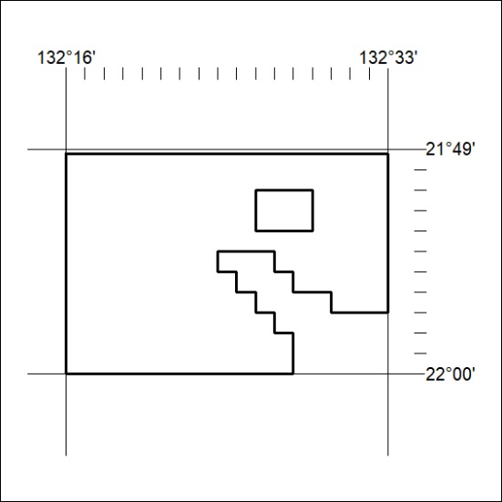
Area granted is indicated above. The titleholder is not permitted to exercise occupational rights on any land that is subject to a development title, or an application for a development title. Any land the subject of a Reserved Land gazettal under the Mineral Titles Act and all land vested in the Commonwealth of Australia is also excluded by description but not excised from the grant area.
45/22

