Mineral Titles Act 2010
NOTICE OF LAND CEASING TO BE A MINERAL TITLE AREA
Title Type and Number: | Exploration Licence 32196
Area Ceased on: | 23 January 2022
Area: | 120 Blocks, 371.10 km²
Locality: | HALE
Name of Applicant(s)/Holder(s): | 100% GEMPART (NT) PTY LTD* [ACN. 081 859 896]
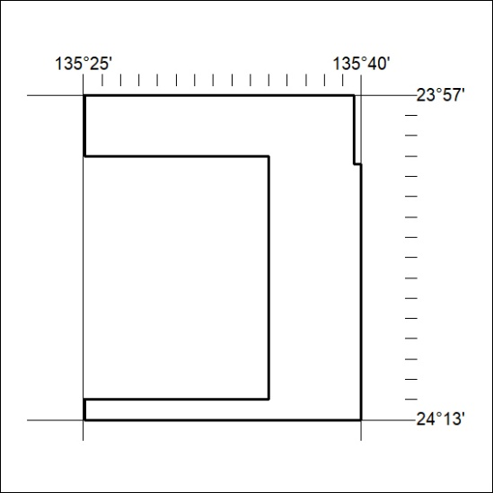

017/22

Mineral Titles Act 2010
NOTICE OF LAND CEASING TO BE A MINERAL TITLE AREA
Title Type and Number: | Extractive Mineral Exploration Licence 32129
Area Ceased on: | 22 January 2022
Area: | 4 Blocks, 13.23 km²
Locality: | LARRIMAH
Name of Applicant(s)/Holder(s): | 100% TERRITORY SANDS PTY LTD [ACN. 632 797 972]
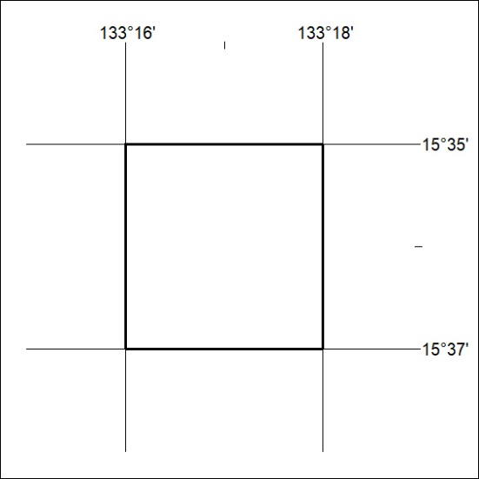

018/22
Mineral Titles Act 2010
NOTICE OF LAND CEASING TO BE A MINERAL TITLE AREA
Title Type and Number: | Extractive Mineral Exploration Licence 32130
Area Ceased on: | 22 January 2022
Area: | 4 Blocks, 13.23 km²
Locality: | LARRIMAH
Name of Applicant(s)/Holder(s): | 100% TERRITORY SANDS PTY LTD [ACN. 632 797 972]
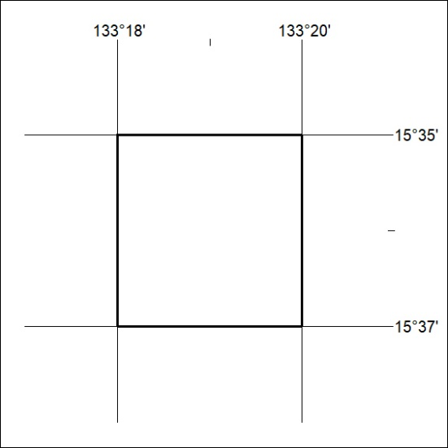

019/22

Mineral Titles Act 2010
NOTICE OF LAND CEASING TO BE A MINERAL TITLE AREA
Title Type and Number: | Extractive Mineral Exploration Licence 32131
Area Ceased on: | 22 January 2022
Area: | 4 Blocks, 13.22 km²
Locality: | LARRIMAH
Name of Applicant(s)/Holder(s): | 100% TERRITORY SANDS PTY LTD [ACN. 632 797 972]
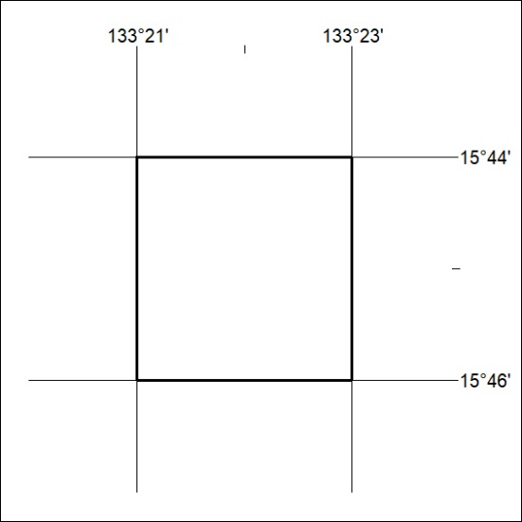

020/22
Mineral Titles Act 2010
NOTICE OF LAND CEASING TO BE A MINERAL TITLE AREA
Title Type and Number: | Extractive Mineral Exploration Licence 32132
Area Ceased on: | 22 January 2022
Area: | 4 Blocks, 13.21 km²
Locality: | LARRIMAH
Name of Applicant(s)/Holder(s): | 100% TERRITORY SANDS PTY LTD [ACN. 632 797 972]
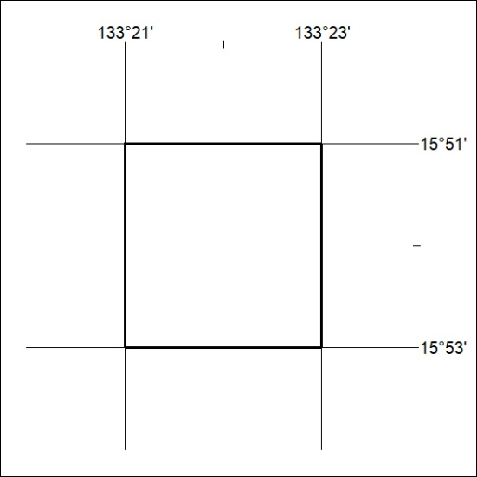

021/22

Mineral Titles Act 2010
NOTICE OF LAND CEASING TO BE A MINERAL TITLE AREA
Title Type and Number: | Extractive Mineral Lease 31512
Area ceased on: | 18 January 2022
Area: | 13.00 Hectare
Locality: | KATHERINE
Name of Applicants(s)Holder(s): | 100% NT LAND DEVELOPMENT CORPORATION PTY LTD [ACN. 078 816 814]
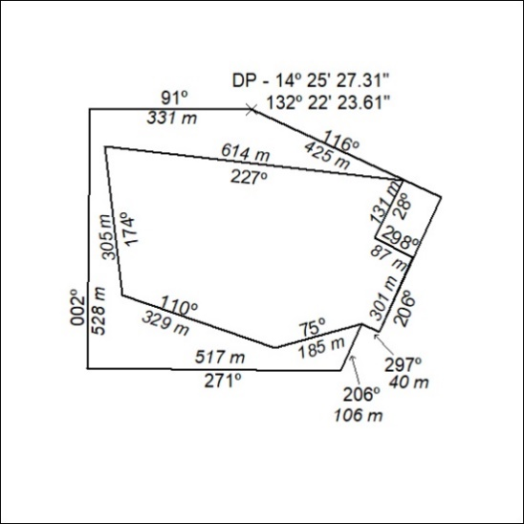

022/22

