Mineral Titles Act 2010
NOTICE OF LAND CEASING TO BE A MINERAL TITLE APPLICATION AREA
Title Type and Number: | Exploration Licence 32838
Area Ceased on: | 25 November 2021
Area: | 150 Blocks, 479.67 km²
Locality: | CRAWFORD
Name of Applicant(s)/Holder(s): | 100% PEGMATITE ONE PTY LTD [ACN. 652 853 391]
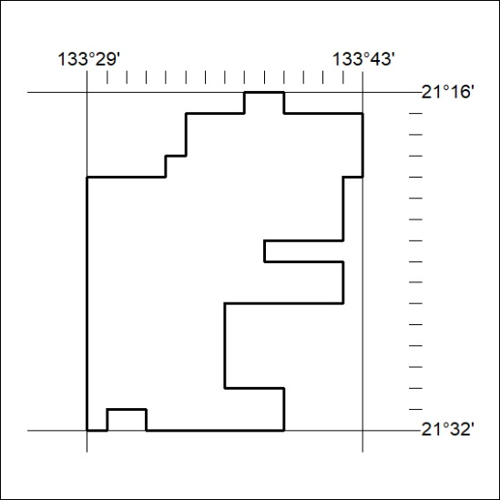

438/21

Mineral Titles Act 2010
NOTICE OF LAND CEASING TO BE A MINERAL TITLE APPLICATION AREA
Title Type and Number: | Exploration Licence 32842
Area Ceased on: | 25 November 2021
Area: | 153 Blocks, 489.67 km²
Locality: | TAYLOR
Name of Applicant(s)/Holder(s): | 100% PEGMATITE ONE PTY LTD [ACN. 652 853 391]
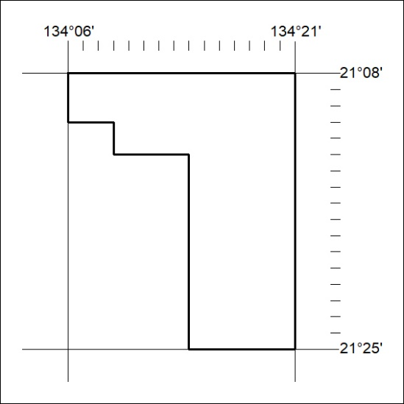

439/21
Mineral Titles Act 2010
NOTICE OF LAND CEASING TO BE A MINERAL TITLE APPLICATION AREA
Title Type and Number: | Exploration Licence 32843
Area Ceased on: | 25 November 2021
Area: | 185 Blocks, 591.57 km²
Locality: | TAYLOR
Name of Applicant(s)/Holder(s): | 100% PEGMATITE ONE PTY LTD [ACN. 652 853 391]
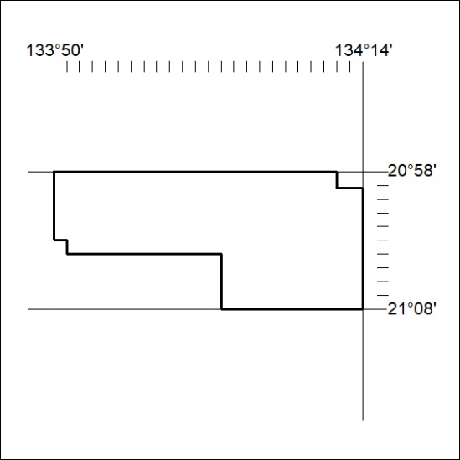

440/21

Mineral Titles Act 2010
NOTICE OF LAND CEASING TO BE A MINERAL TITLE APPLICATION AREA
Title Type and Number: | Exploration Licence 32867
Area Ceased on: | 25 November 2021
Area: | 250 Blocks, 788.10 km²
Locality: | BUSHY PARK
Name of Applicant(s)/Holder(s): | 100% PEGMATITE ONE PTY LTD [ACN. 652 853 391]
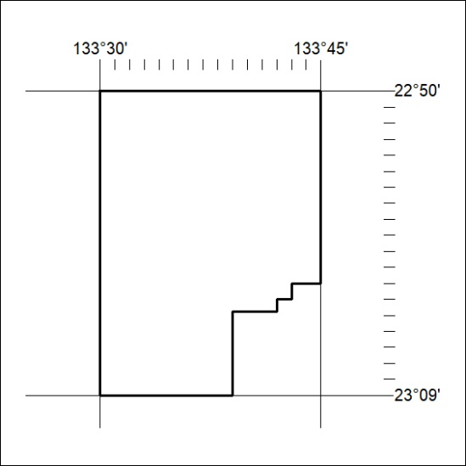

441/21
Mineral Titles Act 2010
NOTICE OF LAND CEASING TO BE A MINERAL TITLE APPLICATION AREA
Title Type and Number: | Exploration Licence 32870
Area Ceased on: | 25 November 2021
Area: | 67 Blocks, 198.10 km²
Locality: | WOODGREEN
Name of Applicant(s)/Holder(s): | 100% PEGMATITE ONE PTY LTD [ACN. 652 853 391]
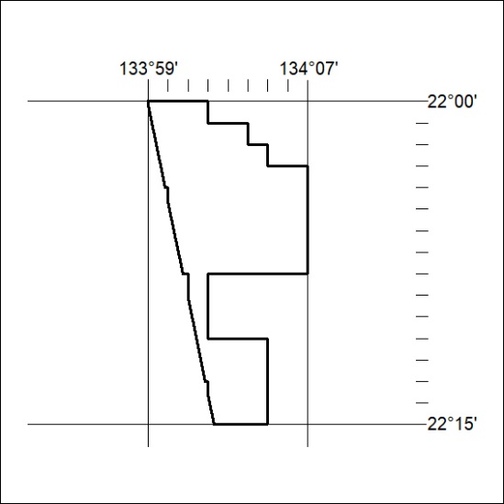

442/21

