Mineral Titles Act 2010
NOTICE OF LAND CEASING TO BE A MINERAL TITLE APPLICATION AREA
Title Type and Number: | Exploration Licence 32773
Area Ceased on: | 04 November 2021
Area: | 28 Blocks, 68.52 km²
Locality: | ALCOOTA
Name of Applicant(s)/Holder(s): | 100% IGO NEWSEARCH PTY LTD [ACN. 142 192 701]
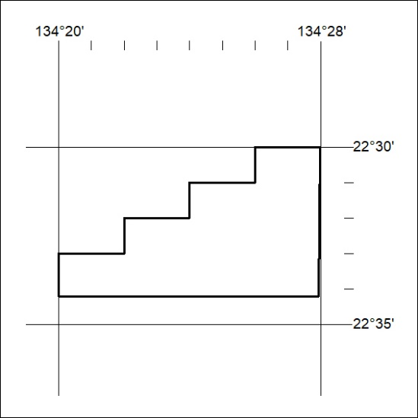

418/21

Mineral Titles Act 2010
NOTICE OF LAND CEASING TO BE A MINERAL TITLE APPLICATION AREA
Title Type and Number: | Exploration Licence 32774
Area Ceased on: | 04 November 2021
Area: | 248 Blocks, 721.84 km²
Locality: | ALCOOTA
Name of Applicant(s)/Holder(s): | 100% IGO NEWSEARCH PTY LTD [ACN. 142 192 701]
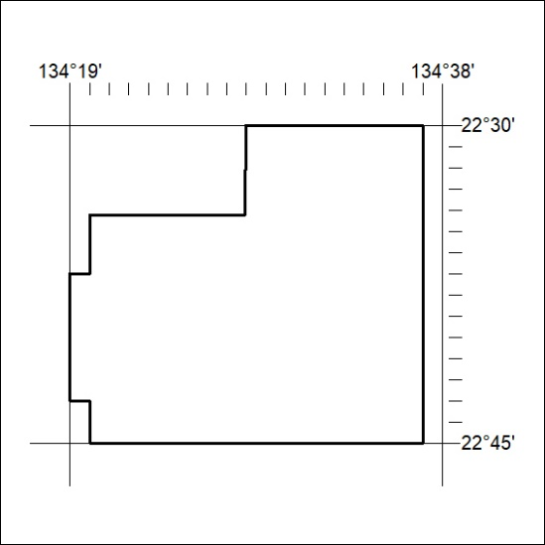

419/21

