Mineral Titles Act 2010
NOTICE OF LAND CEASING TO BE A MINERAL TITLE AREA
Title Type and Number: | Exploration Licence 25146
Area Ceased on: | 15 October 2021
Area: | 22 Blocks, 69.56 km²
Locality: | EGERTON
Name of Applicant(s)/Holder(s): | 100% PRODIGY GOLD NL* [ACN. 009 127 020]
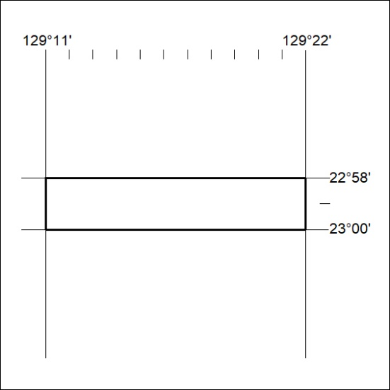

386/21

Mineral Titles Act
NOTICE OF GRANT OF A MINERAL TITLE
Title Type and Number: | Exploration Licence 32688
Granted: | 14 October 2021, for a period of 6 Years
Area: | 250 Blocks, 808.78 km²
Locality: | RANKEN
Name of Holder/s: | 90% INCA MINERALS LIMITED [ACN. 128 512 907], 10% MRG RESOURCES PTY LTD [ACN. 614 946 164]
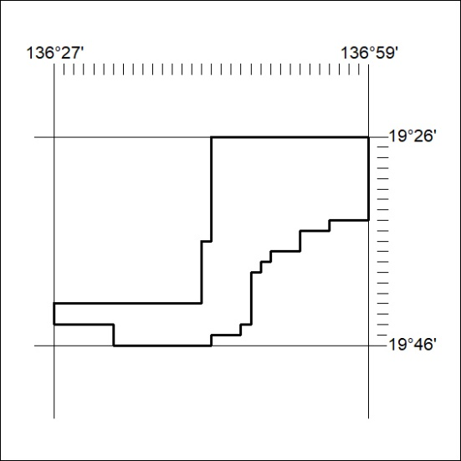
Area granted is indicated above. The titleholder is not permitted to exercise occupational rights on any land that is subject to a development title, or an application for a development title. Any land the subject of a Reserved Land gazettal under the Mineral Titles Act and all land vested in the Commonwealth of Australia is also excluded by description but not excised from the grant area.

387/21

Mineral Titles Act
NOTICE OF GRANT OF A MINERAL TITLE
Title Type and Number: | Exploration Licence 32689
Granted: | 14 October 2021, for a period of 6 Years
Area: | 250 Blocks, 807.65 km²
Locality: | RANKEN
Name of Holder/s: | 90% INCA MINERALS LIMITED [ACN. 128 512 907], 10% MRG RESOURCES PTY LTD [ACN. 614 946 164]
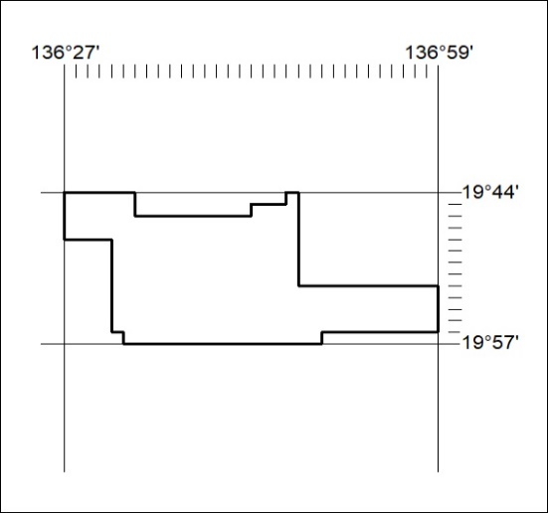
Area granted is indicated above. The titleholder is not permitted to exercise occupational rights on any land that is subject to a development title, or an application for a development title. Any land the subject of a Reserved Land gazettal under the Mineral Titles Act and all land vested in the Commonwealth of Australia is also excluded by description but not excised from the grant area.
388/21

Mineral Titles Act
NOTICE OF GRANT OF A MINERAL TITLE
Title Type and Number: | Exploration Licence 32690
Granted: | 14 October 2021, for a period of 6 Years
Area: | 250 Blocks, 806.77 km²
Locality: | BARRY CAVES
Name of Holder/s: | 90% INCA MINERALS LIMITED [ACN. 128 512 907], 10% MRG RESOURCES PTY LTD [ACN. 614 946 164]
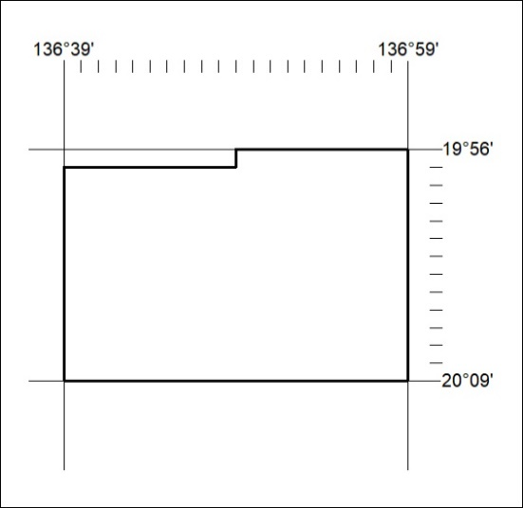
Area granted is indicated above. The titleholder is not permitted to exercise occupational rights on any land that is subject to a development title, or an application for a development title. Any land the subject of a Reserved Land gazettal under the Mineral Titles Act and all land vested in the Commonwealth of Australia is also excluded by description but not excised from the grant area.
389/21

