Mineral Titles Act 2010
NOTICE OF LAND CEASING TO BE A MINERAL TITLE APPLICATION AREA
Title Type and Number: | Exploration Licence 26868
Area Ceased on: | 13 August 2021
Area: | 211 Blocks, 454.25 km²
Locality: | ANSON
Name of Applicant(s)/Holder(s): | 100% TERRITORY MINERALS LTD* [ACN. 121 200 299]
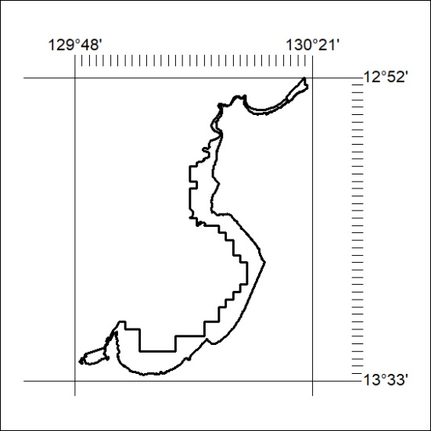

297/21

Mineral Titles Act 2010
NOTICE OF LAND CEASING TO BE A MINERAL TITLE APPLICATION AREA
Title Type and Number: | Exploration Licence 26869
Area Ceased on: | 13 August 2021
Area: | 82 Blocks, 128.96 km²
Locality: | DOMBEY
Name of Applicant(s)/Holder(s): | 100% TERRITORY MINERALS LTD* [ACN. 121 200 299]
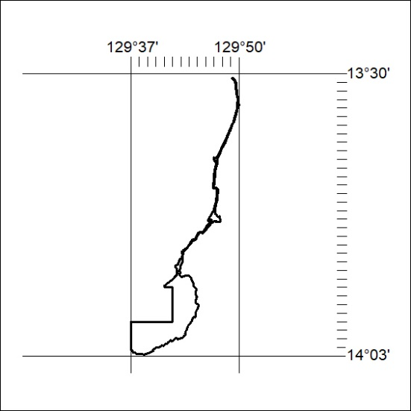

298/21
Mineral Titles Act 2010
NOTICE OF LAND CEASING TO BE A MINERAL TITLE APPLICATION AREA
Title Type and Number: | Exploration Licence 28085
Area Ceased on: | 13 August 2021
Area: | 485 Blocks, 1349.96 km²
Locality: | BLANE
Name of Applicant(s)/Holder(s): | 100% WINCHELSEA MINING PTY LTD [ACN. 626 747 037]
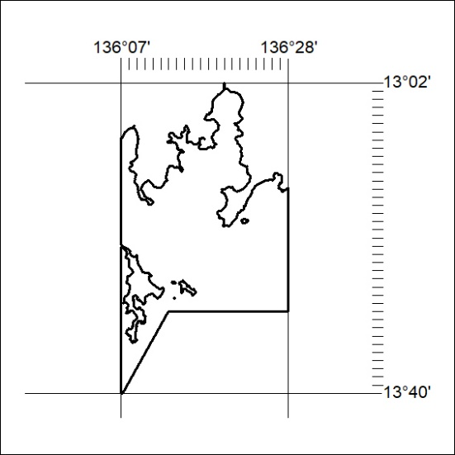

299/21

Mineral Titles Act 2010
NOTICE OF LAND CEASING TO BE A MINERAL TITLE APPLICATION AREA
Title Type and Number: | Exploration Licence 28086
Area Ceased on: | 13 August 2021
Area: | 473 Blocks, 1337.84 km²
Locality: | BLANE
Name of Applicant(s)/Holder(s): | 100% WINCHELSEA MINING PTY LTD [ACN. 626 747 037]
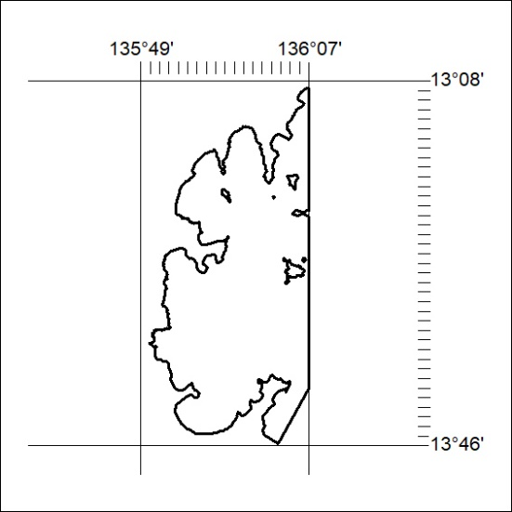

300/21
Mineral Titles Act 2010
NOTICE OF LAND CEASING TO BE A MINERAL TITLE APPLICATION AREA
Title Type and Number: | Exploration Licence 28087
Area Ceased on: | 13 August 2021
Area: | 403 Blocks, 1152.23 km²
Locality: | GREY
Name of Applicant(s)/Holder(s): | 100% WINCHELSEA MINING PTY LTD [ACN. 626 747 037]
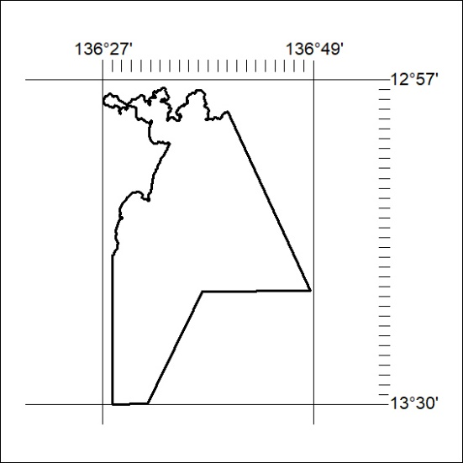

301/21

Mineral Titles Act 2010
NOTICE OF LAND CEASING TO BE A MINERAL TITLE APPLICATION AREA
Title Type and Number: | Exploration Licence 28882
Area Ceased on: | 13 August 2021
Area: | 198 Blocks, 451.83 km²
Locality: | ELCHO
Name of Applicant(s)/Holder(s): | 100% OCRE ROUGE RESOURCES PTY LTD [ACN. 151 217 079]
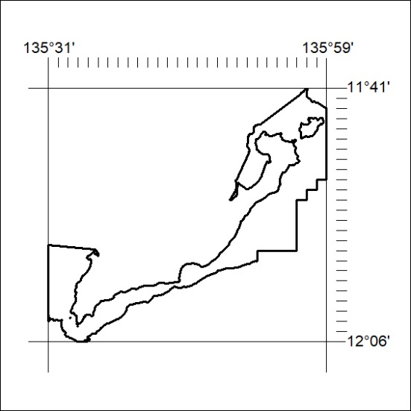

302/21
Mineral Titles Act 2010
NOTICE OF LAND CEASING TO BE A MINERAL TITLE APPLICATION AREA
Title Type and Number: | Exploration Licence 28883
Area Ceased on: | 13 August 2021
Area: | 298 Blocks, 835.33 km²
Locality: | HOWARD
Name of Applicant(s)/Holder(s): | 100% OCRE ROUGE RESOURCES PTY LTD [ACN. 151 217 079]
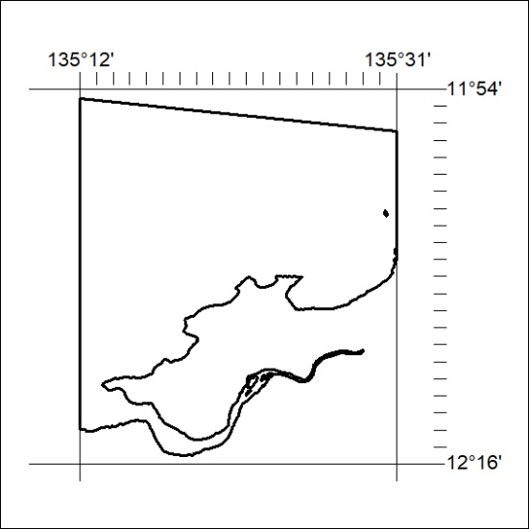

303/21

Mineral Titles Act 2010
NOTICE OF LAND CEASING TO BE A MINERAL TITLE APPLICATION AREA
Title Type and Number: | Exploration Licence 31481
Area Ceased on: | 13 August 2021
Area: | 42 Blocks, 99.19 km²
Locality: | ADAM
Name of Applicant(s)/Holder(s): | 100% AUSTRALIAN GAS STORAGE VENTURES PTY LTD [ACN. 610 582 253]
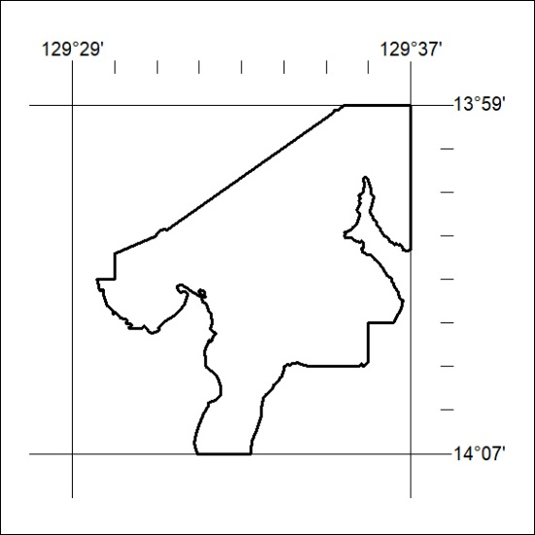

304/21
Mineral Titles Act 2010
NOTICE OF LAND CEASING TO BE A MINERAL TITLE APPLICATION AREA
Title Type and Number: | Mineral Authority 28131
Area Ceased on: | 13 August 2021
Area: | Blocks, 196.65 km²
Locality: | ROSE RIVER
Name of Applicant(s)/Holder(s): | 100% WINCHELSEA MINING PTY LTD [ACN. 626 747 037]
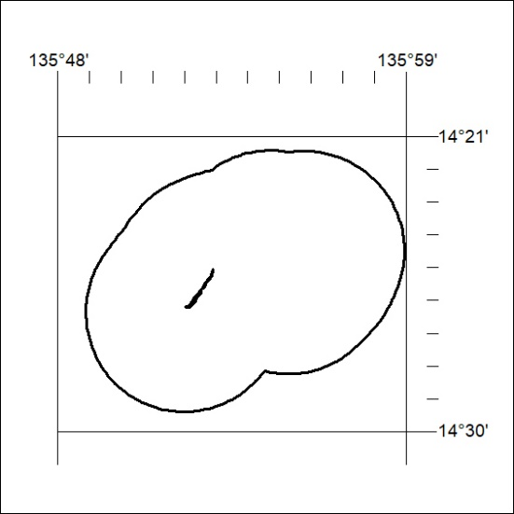

305/21

Mineral Titles Act 2010
NOTICE OF LAND CEASING TO BE A MINERAL TITLE APPLICATION AREA
Title Type and Number: | Mineral Authority 28132
Area Ceased on: | 13 August 2021
Area: | Blocks, 114.95 km²
Locality: | LIMMEN
Name of Applicant(s)/Holder(s): | 100% WINCHELSEA MINING PTY LTD [ACN. 626 747 037]
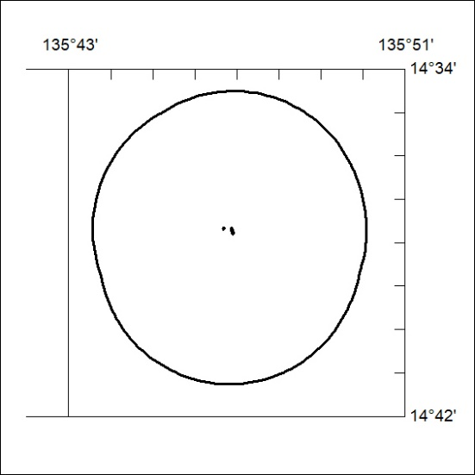

306/21
Mineral Titles Act 2010
NOTICE OF LAND CEASING TO BE A MINERAL TITLE APPLICATION AREA
Title Type and Number: | Mineral Authority 28133
Area Ceased on: | 13 August 2021
Area: | Blocks, 278.48 km²
Locality: | LIMMEN
Name of Applicant(s)/Holder(s): | 100% WINCHELSEA MINING PTY LTD [ACN. 626 747 037]
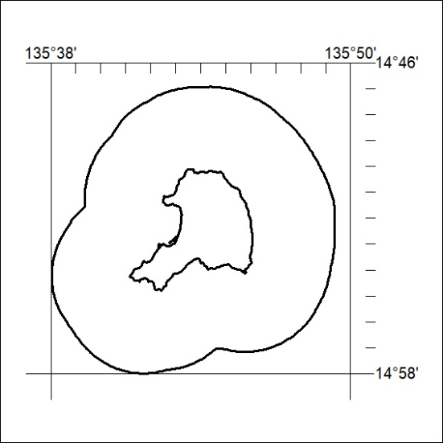

307/21

Mineral Titles Act 2010
NOTICE OF LAND CEASING TO BE A MINERAL TITLE APPLICATION AREA
Title Type and Number: | Mineral Authority 28134
Area Ceased on: | 13 August 2021
Area: | Blocks, 772.91 km²
Locality: | MT YOUNG
Name of Applicant(s)/Holder(s): | 100% WINCHELSEA MINING PTY LTD [ACN. 626 747 037]
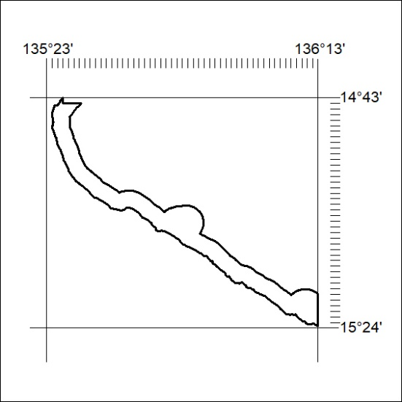

308/21
Mineral Titles Act 2010
NOTICE OF LAND CEASING TO BE A MINERAL TITLE APPLICATION AREA
Title Type and Number: | Mineral Authority 28135
Area Ceased on: | 13 August 2021
Area: | Blocks, 387.88 km²
Locality: | ROSIE CREEK
Name of Applicant(s)/Holder(s): | 100% WINCHELSEA MINING PTY LTD [ACN. 626 747 037]
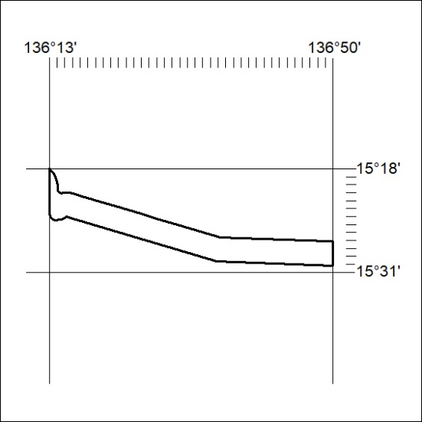

309/21

Mineral Titles Act 2010
NOTICE OF LAND CEASING TO BE A MINERAL TITLE APPLICATION AREA
Title Type and Number: | Mineral Authority 28881
Area Ceased on: | 13 August 2021
Area: | Blocks, 536.90 km²
Locality: | ELCHO
Name of Applicant(s)/Holder(s): | 100% OCRE ROUGE RESOURCES PTY LTD [ACN. 151 217 079]
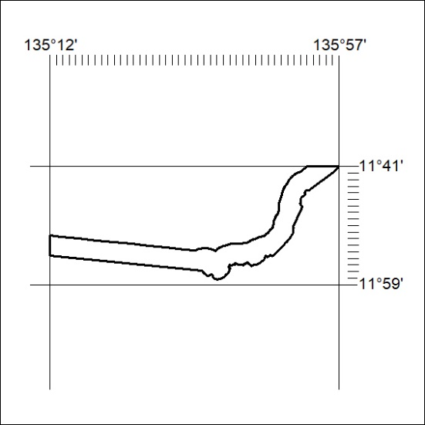

310/21

