Mineral Titles Act
NOTICE OF GRANT OF A MINERAL TITLE
Title Type and Number: | Exploration Licence 27252
Granted: | 20 April 2021, for a period of 6 Years
Area: | 4 Blocks, 6.75 km²
Locality: | GOOMADEER
Name of Holder/s: | 100% NORTHERN PROSPECTOR PTY LTD [ACN. 122 557 073]
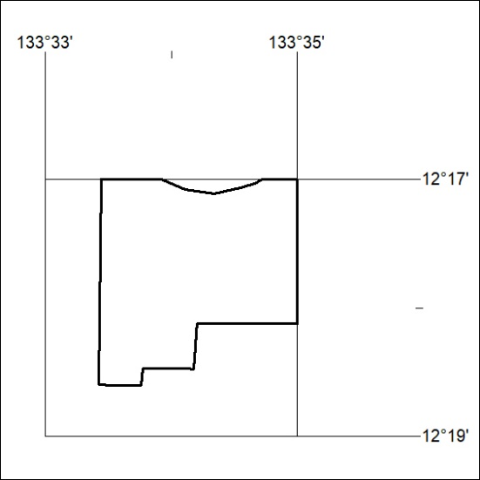
Area granted is indicated above. The titleholder is not permitted to exercise occupational rights on any land that is subject to a development title, or an application for a development title. Any land the subject of a Reserved Land gazettal under the Mineral Titles Act and all land vested in the Commonwealth of Australia is also excluded by description but not excised from the grant area.
99/21

Mineral Titles Act
NOTICE OF GRANT OF A MINERAL TITLE
Title Type and Number: | Exploration Licence 27253
Granted: | 20 April 2021, for a period of 6 Years
Area: | 2 Blocks, 5.61 km²
Locality: | GOOMADEER
Name of Holder/s: | 100% NORTHERN PROSPECTOR PTY LTD [ACN. 122 557 073]
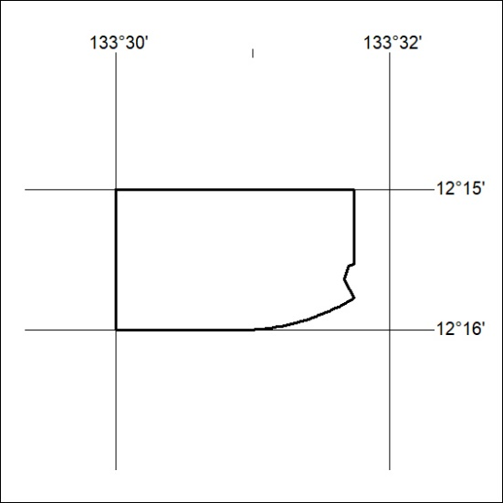
Area granted is indicated above. The titleholder is not permitted to exercise occupational rights on any land that is subject to a development title, or an application for a development title. Any land the subject of a Reserved Land gazettal under the Mineral Titles Act and all land vested in the Commonwealth of Australia is also excluded by description but not excised from the grant area.
100/21

Mineral Titles Act
NOTICE OF GRANT OF A MINERAL TITLE
Title Type and Number: | Exploration Licence 28389
Granted: | 20 April 2021, for a period of 6 Years
Area: | 33 Blocks, 110.83 km²
Locality: | OENPELLI
Name of Holder/s: | 100% NORTHERN PROSPECTOR PTY LTD [ACN. 122 557 073]
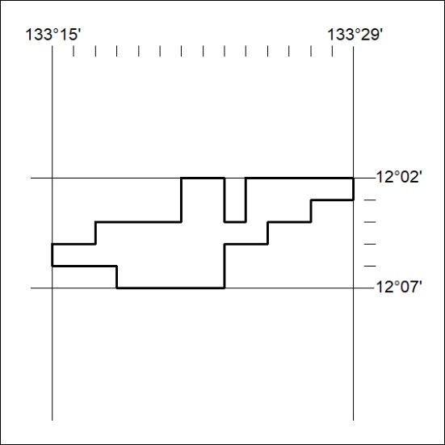
Area granted is indicated above. The titleholder is not permitted to exercise occupational rights on any land that is subject to a development title, or an application for a development title. Any land the subject of a Reserved Land gazettal under the Mineral Titles Act and all land vested in the Commonwealth of Australia is also excluded by description but not excised from the grant area.
101/21

Mineral Titles Act
NOTICE OF GRANT OF A MINERAL TITLE
Title Type and Number: | Exploration Licence 28390
Granted: | 20 April 2021, for a period of 6 Years
Area: | 10 Blocks, 33.58 km²
Locality: | OENPELLI
Name of Holder/s: | 100% NORTHERN PROSPECTOR PTY LTD [ACN. 122 557 073]
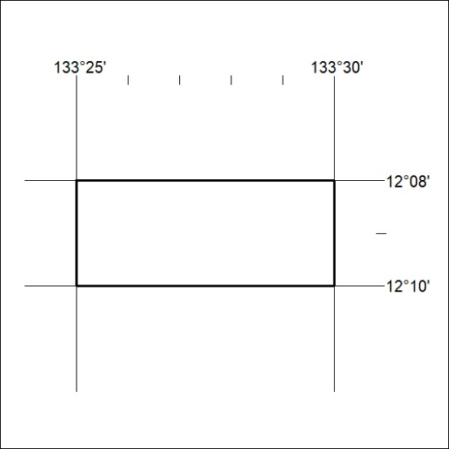
Area granted is indicated above. The titleholder is not permitted to exercise occupational rights on any land that is subject to a development title, or an application for a development title. Any land the subject of a Reserved Land gazettal under the Mineral Titles Act and all land vested in the Commonwealth of Australia is also excluded by description but not excised from the grant area.
102/21

Mineral Titles Act
NOTICE OF GRANT OF A MINERAL TITLE
Title Type and Number: | Exploration Licence 29991
Granted: | 20 April 2021, for a period of 6 Years
Area: | 8 Blocks, 26.87 km²
Locality: | OENPELLI
Name of Holder/s: | 100% NORTHERN PROSPECTOR PTY LTD [ACN. 122 557 073]
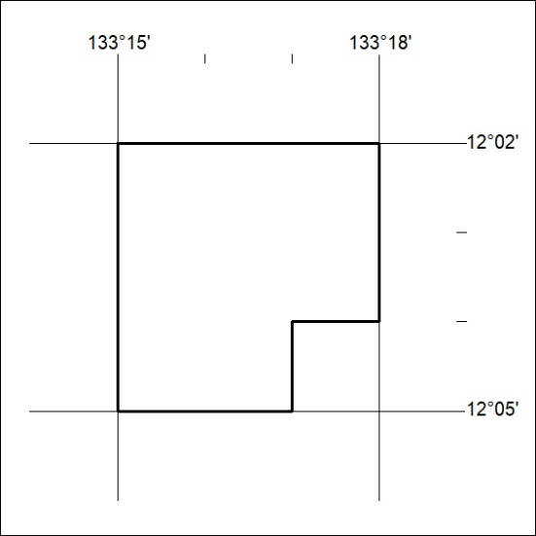
Area granted is indicated above. The titleholder is not permitted to exercise occupational rights on any land that is subject to a development title, or an application for a development title. Any land the subject of a Reserved Land gazettal under the Mineral Titles Act and all land vested in the Commonwealth of Australia is also excluded by description but not excised from the grant area.
103/21

Mineral Titles Act
NOTICE OF GRANT OF A MINERAL TITLE
Title Type and Number: | Exploration Licence 29992
Granted: | 20 April 2021, for a period of 6 Years
Area: | 19 Blocks, 63.81 km²
Locality: | OENPELLI
Name of Holder/s: | 100% NORTHERN PROSPECTOR PTY LTD [ACN. 122 557 073]
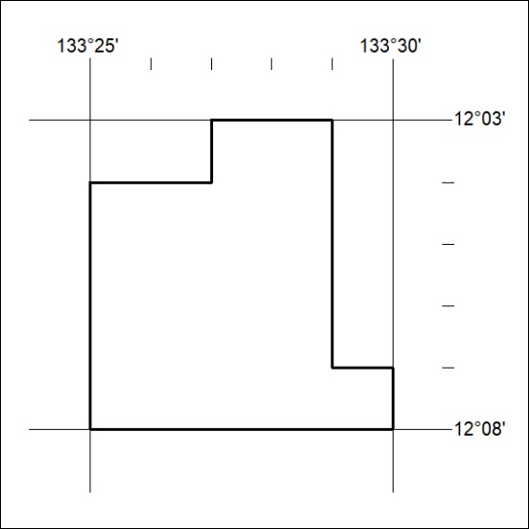
Area granted is indicated above. The titleholder is not permitted to exercise occupational rights on any land that is subject to a development title, or an application for a development title. Any land the subject of a Reserved Land gazettal under the Mineral Titles Act and all land vested in the Commonwealth of Australia is also excluded by description but not excised from the grant area.
104/21

Mineral Titles Act
NOTICE OF GRANT OF A MINERAL TITLE
Title Type and Number: | Exploration Licence 29993
Granted: | 20 April 2021, for a period of 6 Years
Area: | 17 Blocks, 57.06 km²
Locality: | OENPELLI
Name of Holder/s: | 100% NORTHERN PROSPECTOR PTY LTD [ACN. 122 557 073]
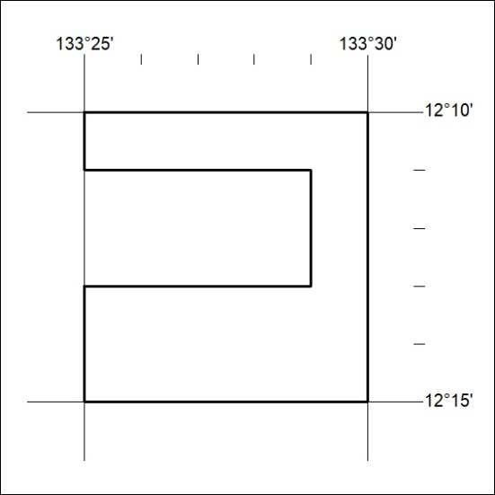
Area granted is indicated above. The titleholder is not permitted to exercise occupational rights on any land that is subject to a development title, or an application for a development title. Any land the subject of a Reserved Land gazettal under the Mineral Titles Act and all land vested in the Commonwealth of Australia is also excluded by description but not excised from the grant area.
105/21

Mineral Titles Act
NOTICE OF GRANT OF A MINERAL TITLE
Title Type and Number: | Exploration Licence 31480
Granted: | 20 April 2021, for a period of 6 Years
Area: | 71 Blocks, 188.44 km²
Locality: | OENPELLI
Name of Holder/s: | 100% NORTHERN PROSPECTOR PTY LTD [ACN. 122 557 073]
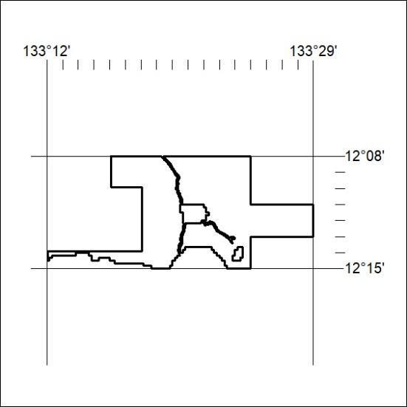
Area granted is indicated above. The titleholder is not permitted to exercise occupational rights on any land that is subject to a development title, or an application for a development title. Any land the subject of a Reserved Land gazettal under the Mineral Titles Act and all land vested in the Commonwealth of Australia is also excluded by description but not excised from the grant area.
106/21

Mineral Titles Act
NOTICE OF GRANT OF A MINERAL TITLE
Title Type and Number: | Exploration Licence 32243
Granted: | 20 April 2021, for a period of 6 Years
Area: | 12 Blocks, 25.73 km²
Locality: | TENNANT CREEK
Name of Holder/s: | 100% TENNANT RESOURCES PTY LTD [ACN. 108 494 168]
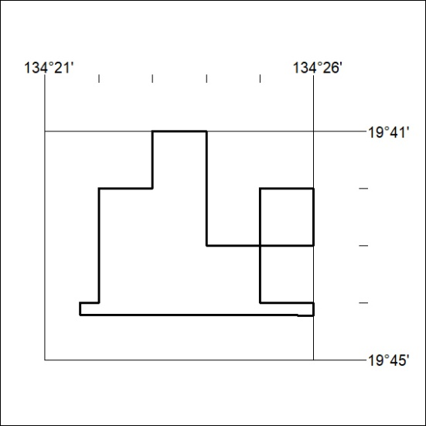
Area granted is indicated above. The titleholder is not permitted to exercise occupational rights on any land that is subject to a development title, or an application for a development title. Any land the subject of a Reserved Land gazettal under the Mineral Titles Act and all land vested in the Commonwealth of Australia is also excluded by description but not excised from the grant area.
107/21

