Mineral Titles Act 2010
NOTICE OF LAND CEASING TO BE A MINERAL TITLE AREA
Title Type and Number: | Exploration Licence 28904
Area Ceased on: | 29 March 2021
Area: | 70 Blocks, 205.90 km²
Locality: | SHORT RANGE
Name of Applicant(s)/Holder(s): | 100% MANTO MINING PTY LTD [ACN. 152 392 562]
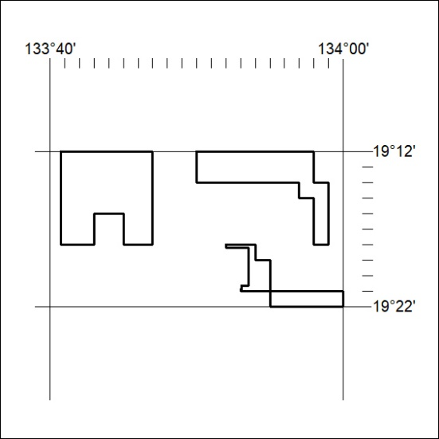

56/21

Mineral Titles Act 2010
NOTICE OF LAND CEASING TO BE A MINERAL TITLE AREA
Title Type and Number: | Exploration Licence 28907
Area Ceased on: | 29 March 2021
Area: | 34 Blocks, 110.20 km²
Locality: | FLYNN
Name of Applicant(s)/Holder(s): | 100% MANTO MINING PTY LTD [ACN. 152 392 562]
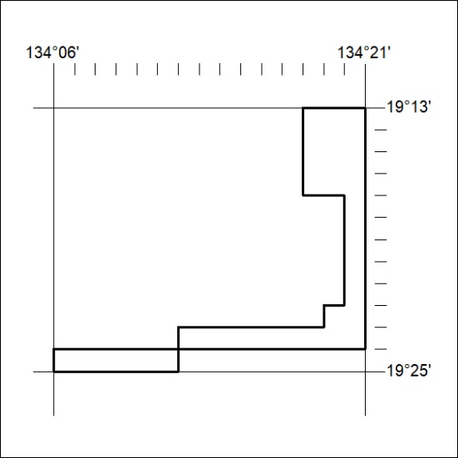

57/21

Mineral Titles Act
NOTICE OF GRANT OF A MINERAL TITLE
Title Type and Number: | Exploration Licence 32419
Granted: | 26 March 2021, for a period of 6 Years
Area: | 40 Blocks, 127.08 km²
Locality: | ARAPUNGA
Name of Holder/s: | 100% TERRITORY LITHIUM PTY LTD [ACN. 610 691 033]
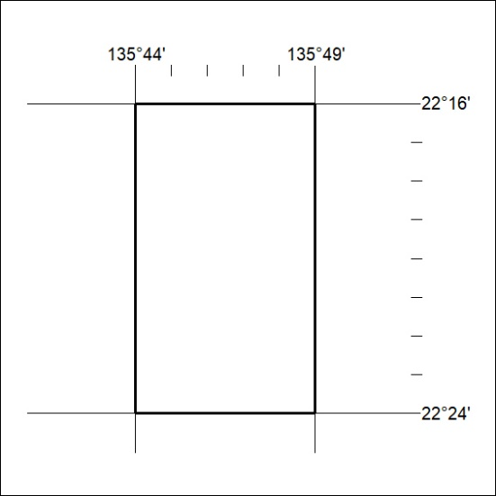
Area granted is indicated above. The titleholder is not permitted to exercise occupational rights on any land that is subject to a development title, or an application for a development title. Any land the subject of a Reserved Land gazettal under the Mineral Titles Act and all land vested in the Commonwealth of Australia is also excluded by description but not excised from the grant area.
58/21

Mineral Titles Act
NOTICE OF GRANT OF A MINERAL TITLE
Title Type and Number: | Exploration Licence 32420
Granted: | 26 March 2021, for a period of 6 Years
Area: | 24 Blocks, 75.87 km²
Locality: | LAUGHLEN
Name of Holder/s: | 100% TERRITORY LITHIUM PTY LTD [ACN. 610 691 033]
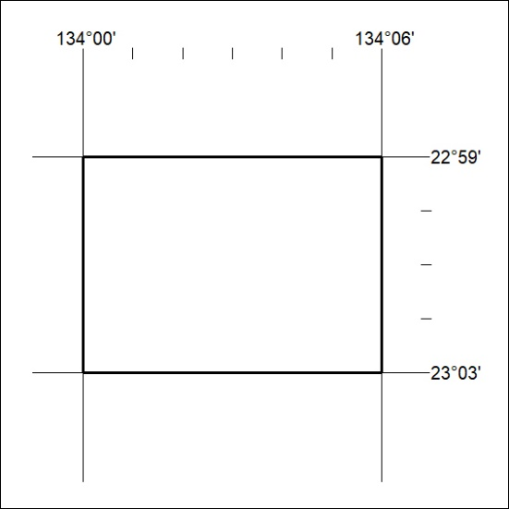
Area granted is indicated above. The titleholder is not permitted to exercise occupational rights on any land that is subject to a development title, or an application for a development title. Any land the subject of a Reserved Land gazettal under the Mineral Titles Act and all land vested in the Commonwealth of Australia is also excluded by description but not excised from the grant area.
59/21

