Mineral Titles Act 2010
NOTICE OF LAND CEASING TO BE A MINERAL TITLE AREA
Title Type and Number: | Exploration Licence 31292
Area Ceased on: | 11 February 2021
Area: | 21 Blocks, 66.88 km²
Locality: | WOODGREEN
Name of Applicant(s)/Holder(s): | 100% BOWGAN MINERALS LTD [ACN. 137 527 336]
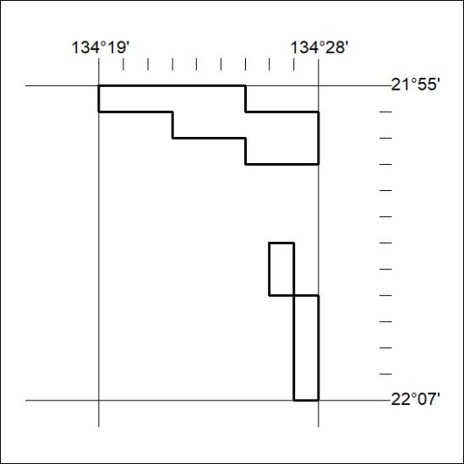

34/21

