Mineral Titles Act 2010
NOTICE OF LAND CEASING TO BE A MINERAL TITLE AREA
Title Type and Number: | Exploration Licence 24329
Area Ceased on: | 24 January 2021
Area: | 10 Blocks, 33.64 km²
Locality: | BATHURST ISLAND
Name of Applicant(s)/Holder(s): | 100% TIWI RESOURCES PTY LTD [ACN. 054 667 051]
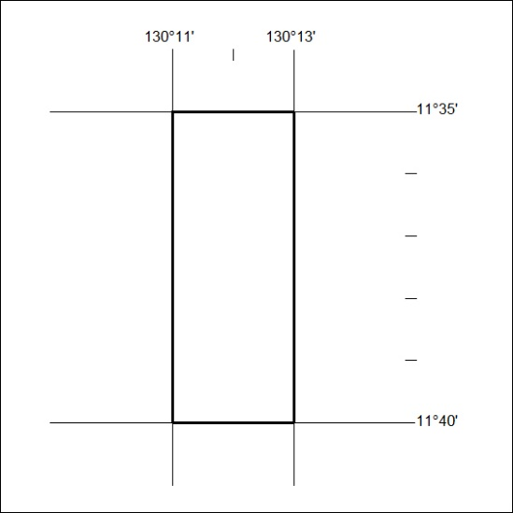

13/21

Mineral Titles Act 2010
NOTICE OF LAND CEASING TO BE A MINERAL TITLE AREA
Title Type and Number: | Extractive Mineral Permit 30029
Area ceased on: | 21 January 2021
Area: | 43.00 Hectare
Locality: | KOOLPINYAH
Name of Applicants(s)Holder(s): | 100% TOMAZOS GROUP PTY LTD [ACN. 009 618 704]
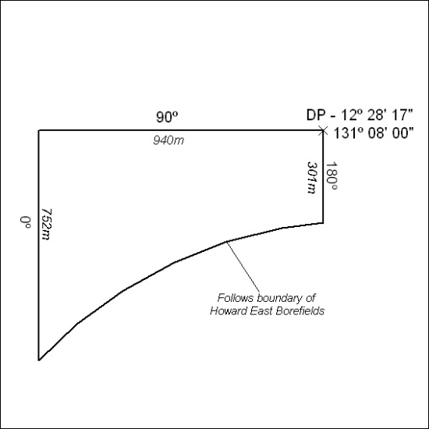

14/21

Mineral Titles Act 2010
NOTICE OF LAND CEASING TO BE A MINERAL TITLE AREA
Title Type and Number: | Extractive Mineral Permit 30030
Area ceased on: | 21 January 2021
Area: | 49.00 Hectare
Locality: | KOOLPINYAH
Name of Applicants(s)Holder(s): | 100% TOMAZOS GROUP PTY LTD [ACN. 009 618 704]
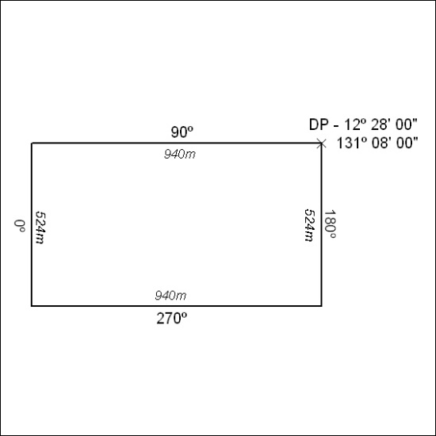

15/21

