Mineral Titles Act 2010
NOTICE OF LAND CEASING TO BE A MINERAL TITLE AREA
Title Type and Number: | Exploration Licence 31251
Area Ceased on: | 23 November 2020
Area: | 58 Blocks, 175.60 km²
Locality: | ILLOGWA
Name of Applicant(s)/Holder(s): | 100% GEMPART (NT) PTY LTD* [ACN. 081 859 896]
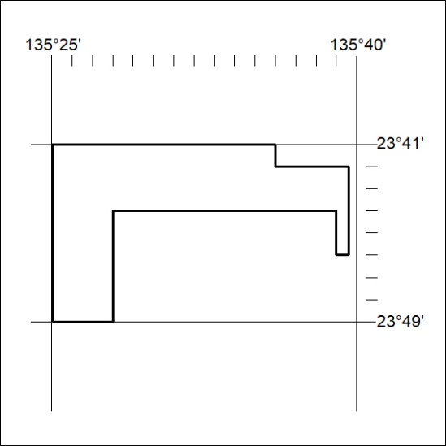

382/20

Mineral Titles Act
NOTICE OF GRANT OF A MINERAL TITLE
Title Type and Number: | Exploration Licence 32151
Granted: | 20 November 2020, for a period of 6 Years
Area: | 13 Blocks, 43.42 km²
Locality: | McKINLAY RIVER
Name of Holder/s: | 100% WOODLEIGH NOMINEES PTY LIMITED [ACN. 050 120 057]
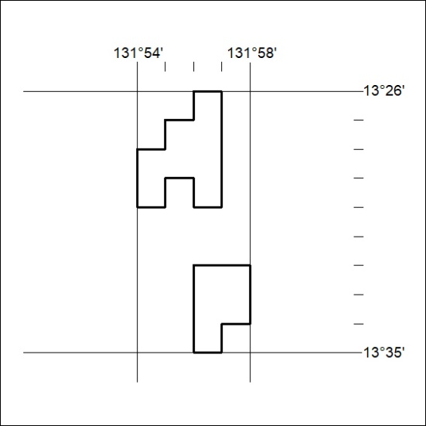
Area granted is indicated above. The titleholder is not permitted to exercise occupational rights on any land that is subject to a development title, or an application for a development title. Any land the subject of a Reserved Land gazettal under the Mineral Titles Act and all land vested in the Commonwealth of Australia is also excluded by description but not excised from the grant area.

383/20
Corrigendum
Notice Number 367/20 appearing in MN114/20 on 18 November 2020 is hereby cancelled and replaced by the following:

Mineral Titles Act 2010
NOTICE OF LAND CEASING TO BE A MINERAL TITLE AREA
Title Type and Number: | Exploration Licence in Retention 46
Area ceased on: | 16 November 2020
Area: | 121.00 Hectares
Locality: | VAUGHAN
Name of Applicants(s)Holder(s): | 100% ENERGY METALS LTD [ACN. 111 306 533]
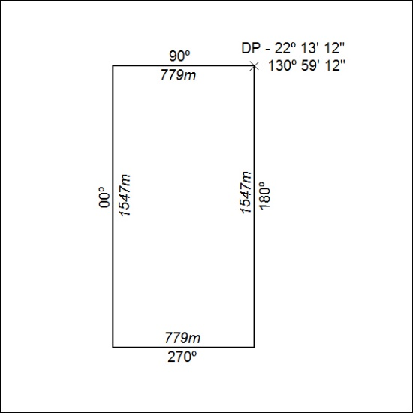
(Area now amalgamated into Exploration Licence in Retention 32552 under s102)

384/20

Corrigendum
Notice Number 368/20 appearing in MN114/20 on 18 November 2020 is hereby cancelled and replaced by the following:

Mineral Titles Act 2010
NOTICE OF LAND CEASING TO BE A MINERAL TITLE AREA
Title Type and Number: | Exploration Licence in Retention 47
Area ceased on: | 16 November 2020
Area: | 197.00 Hectares
Locality: | VAUGHAN
Name of Applicants(s)Holder(s): | 100% ENERGY METALS LTD [ACN. 111 306 533]
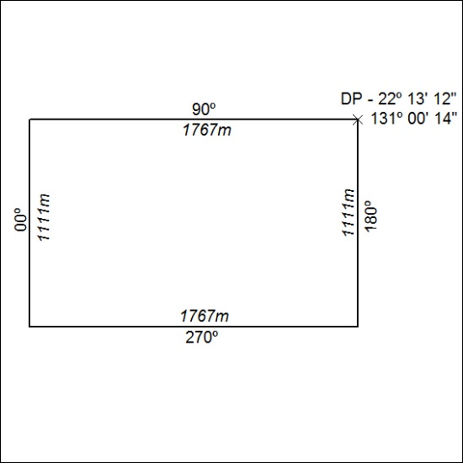
(Area now amalgamated into Exploration Licence in Retention 32552 under s102)

385/20

Corrigendum
Notice Number 369/20 appearing in MN114/20 on 18 November 2020 is hereby cancelled and replaced by the following:

Mineral Titles Act 2010
NOTICE OF LAND CEASING TO BE A MINERAL TITLE AREA
Title Type and Number: | Exploration Licence in Retention 48
Area ceased on: | 16 November 2020
Area: | 99.00 Hectare
Locality: | VAUGHAN
Name of Applicants(s)Holder(s): | 100% ENERGY METALS LTD [ACN. 111 306 533]
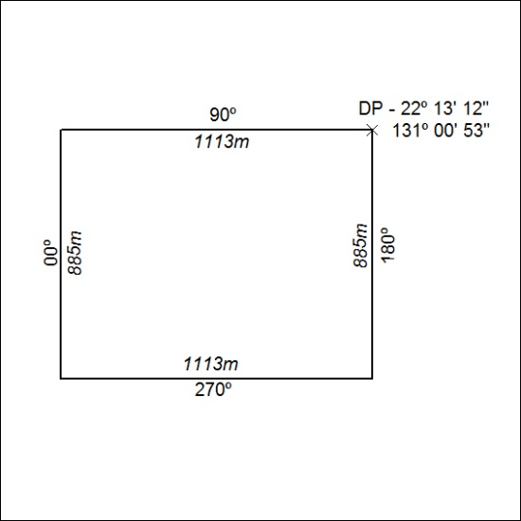
(Area now amalgamated into Exploration Licence in Retention 32552 under s102)

386/20

Notice Number 370/20 appearing in MN114/20 on 18 November 2020 is hereby cancelled and replaced by the following:

Mineral Titles Act 2010
NOTICE OF LAND CEASING TO BE A MINERAL TITLE AREA
Title Type and Number: | Exploration Licence in Retention 49
Area ceased on: | 16 November 2020
Area: | 112.00 Hectares
Locality: | DOREEN
Name of Applicants(s)Holder(s): | 100% ENERGY METALS LTD [ACN. 111 306 533]
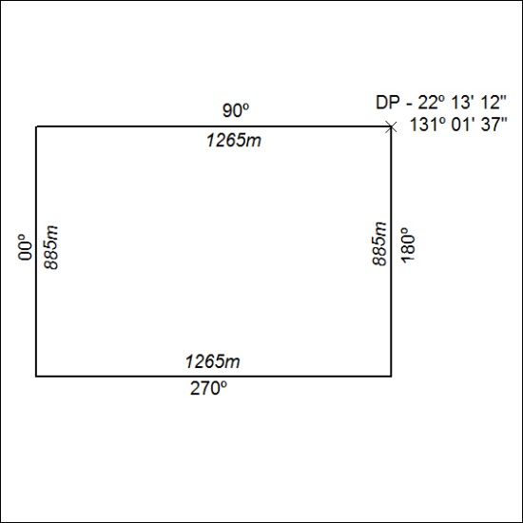
(Area now amalgamated into Exploration Licence in Retention 32552 under s102)

387/20

Notice Number 371/20 appearing in MN114/20 on 18 November 2020 is hereby cancelled and replaced by the following:

Mineral Titles Act 2010
NOTICE OF LAND CEASING TO BE A MINERAL TITLE AREA
Title Type and Number: | Exploration Licence in Retention 50
Area ceased on: | 16 November 2020
Area: | 114.00 Hectares
Locality: | DOREEN
Name of Applicants(s)Holder(s): | 100% ENERGY METALS LTD [ACN. 111 306 533]
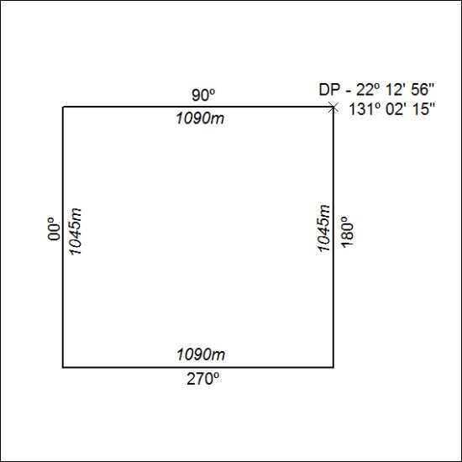
(Area now amalgamated into Exploration Licence in Retention 32552 under s102)

388/20

Notice Number 372/20 appearing in MN114/20 on 18 November 2020 is hereby cancelled and replaced by the following:

Mineral Titles Act 2010
NOTICE OF LAND CEASING TO BE A MINERAL TITLE AREA
Title Type and Number: | Exploration Licence in Retention 51
Area ceased on: | 16 November 2020
Area: | 69.00 Hectare
Locality: | DOREEN
Name of Applicants(s)Holder(s): | 100% ENERGY METALS LTD [ACN. 111 306 533]
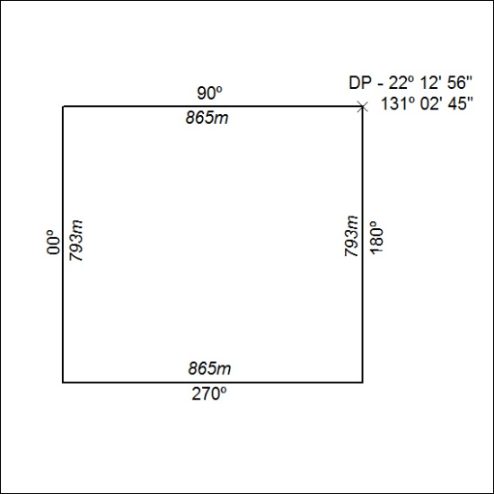
(Area now amalgamated into Exploration Licence in Retention 32552 under s102)

389/20

Notice Number 373/20 appearing in MN114/20 on 18 November 2020 is hereby cancelled and replaced by the following:

Mineral Titles Act 2010
NOTICE OF LAND CEASING TO BE A MINERAL TITLE AREA
Title Type and Number: | Exploration Licence in Retention 52
Area ceased on: | 16 November 2020
Area: | 132.00 Hectares
Locality: | DOREEN
Name of Applicants(s)Holder(s): | 100% ENERGY METALS LTD [ACN. 111 306 533]
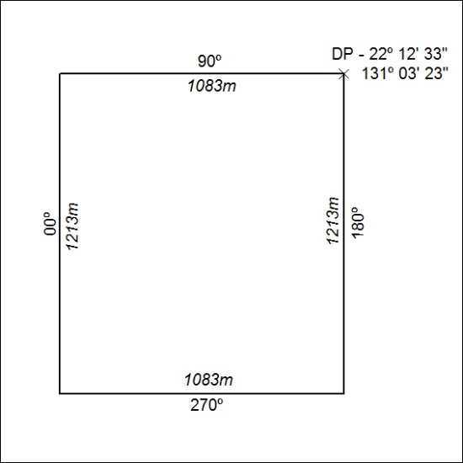
(Area now amalgamated into Exploration Licence in Retention 32552 under s102)

390/20

Notice Number 374/20 appearing in MN114/20 on 18 November 2020 is hereby cancelled and replaced by the following:

Mineral Titles Act 2010
NOTICE OF LAND CEASING TO BE A MINERAL TITLE AREA
Title Type and Number: | Exploration Licence in Retention 53
Area ceased on: | 16 November 2020
Area: | 85.00 Hectare
Locality: | DOREEN
Name of Applicants(s)Holder(s): | 100% ENERGY METALS LTD [ACN. 111 306 533]
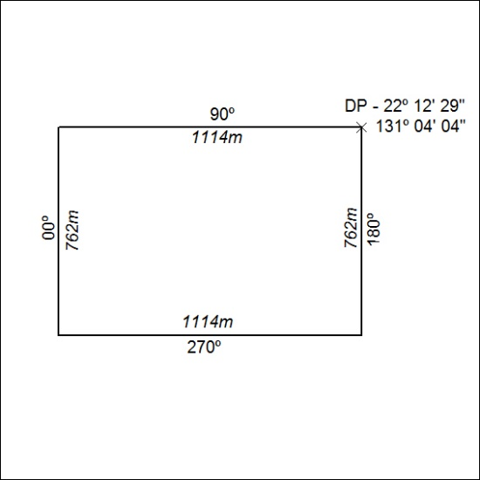
(Area now amalgamated into Exploration Licence in Retention 32552 under s102)

391/20

Notice Number 375/20 appearing in MN114/20 on 18 November 2020 is hereby cancelled and replaced by the following:

Mineral Titles Act 2010
NOTICE OF LAND CEASING TO BE A MINERAL TITLE AREA
Title Type and Number: | Exploration Licence in Retention 54
Area ceased on: | 16 November 2020
Area: | 84.00 Hectare
Locality: | DOREEN
Name of Applicants(s)Holder(s): | 100% ENERGY METALS LTD [ACN. 111 306 533]
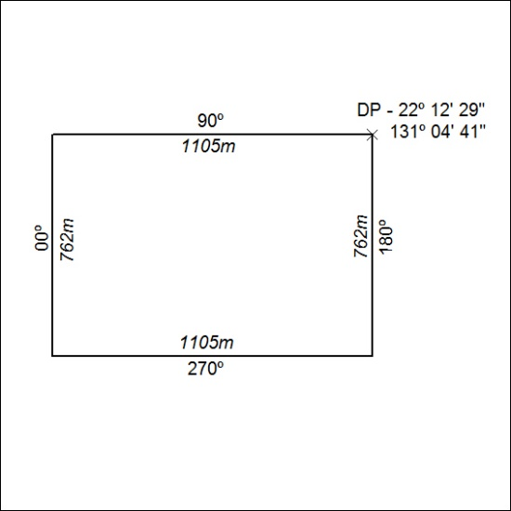
(Area now amalgamated into Exploration Licence in Retention 32552 under s102)

392/20

Notice Number 376/20 appearing in MN114/20 on 18 November 2020 is hereby cancelled and replaced by the following:

Mineral Titles Act 2010
NOTICE OF LAND CEASING TO BE A MINERAL TITLE AREA
Title Type and Number: | Exploration Licence in Retention 55
Area ceased on: | 16 November 2020
Area: | 204.00 Hectares
Locality: | DOREEN
Name of Applicants(s)Holder(s): | 100% ENERGY METALS LTD [ACN. 111 306 533]
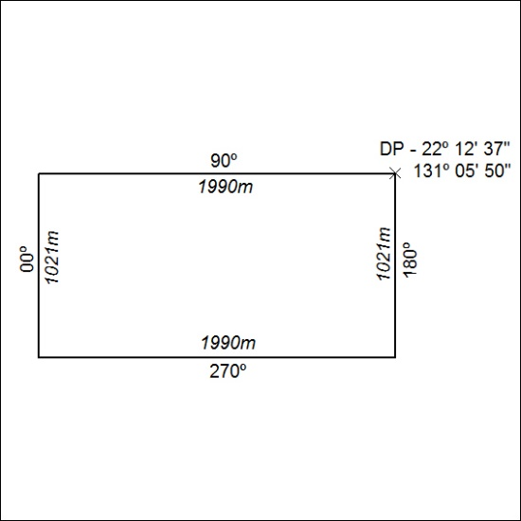
(Area now amalgamated into Exploration Licence in Retention 32552 under s102)

393/20

