Mineral Titles Act 2010
NOTICE OF LAND CEASING TO BE A MINERAL TITLE AREA
Title Type and Number: | Exploration Licence 31013
Area Ceased on: | 17 August 2020
Area: | 10 Blocks, 32.81 km²
Locality: | LANCEWOOD
Name of Applicant(s)/Holder(s): | 100% SCRIVEN EXPLORATION PTY LTD [ACN. 006 264 615]
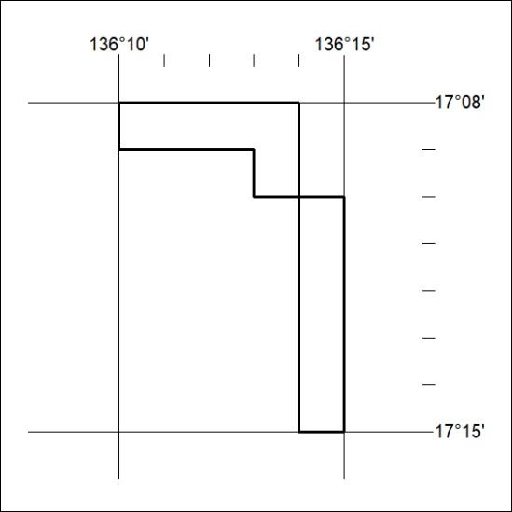

277/20

