Mineral Titles Act 2010
NOTICE OF LAND CEASING TO BE A MINERAL TITLE AREA
Title Type and Number: | Extractive Mineral Lease (Northern) 29
Area ceased on: | 19 June 2020
Area: | 11.00 Hectare
Locality: | NOONAMAH
Name of Applicants(s)Holder(s): | 100% HY-TEC INDUSTRIES (NORTHERN TERRITORY) PTY LTD [ACN. 096 310 824]
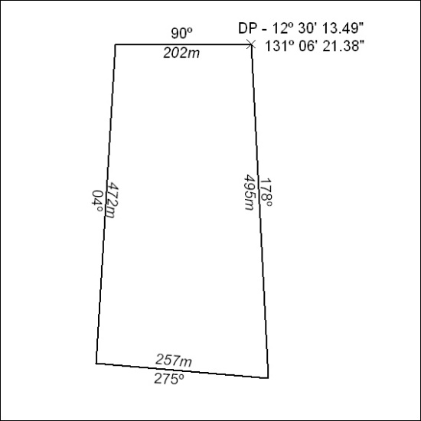

207/20

Mineral Titles Act 2010
NOTICE OF LAND CEASING TO BE A MINERAL TITLE AREA
Title Type and Number: | Extractive Mineral Permit 27176
Area ceased on: | 19 June 2020
Area: | 33.00 Hectare
Locality: | NOONAMAH
Name of Applicants(s)Holder(s): | 100% CECCON Suzanne Yoko
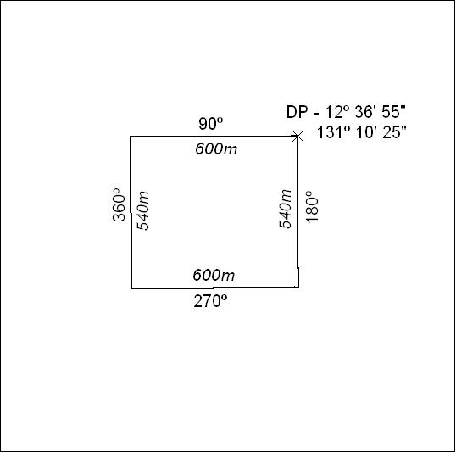

208/20

Mineral Titles Act 2010
NOTICE OF LAND CEASING TO BE A MINERAL TITLE AREA
Title Type and Number: | Extractive Mineral Permit 27177
Area ceased on: | 19 June 2020
Area: | 32.00 Hectare
Locality: | NOONAMAH
Name of Applicants(s)Holder(s): | 100% CECCON Suzanne Yoko
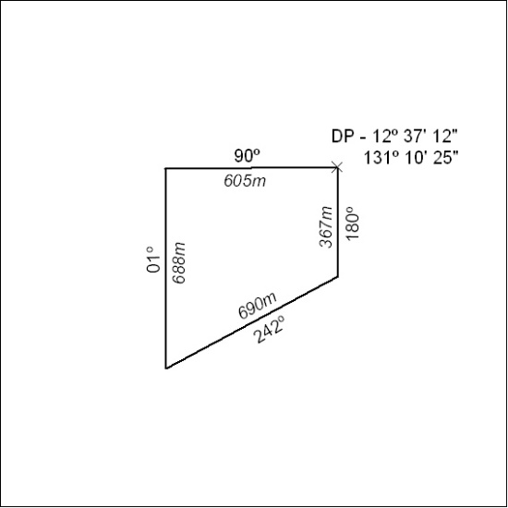

209/20

Mineral Titles Act 2010
NOTICE OF LAND CEASING TO BE A MINERAL TITLE AREA
Title Type and Number: | Extractive Mineral Permit 28209
Area ceased on: | 19 June 2020
Area: | 13.00 Hectare
Locality: | NOONAMAH
Name of Applicants(s)Holder(s): | 100% CECCON Suzanne Yoko
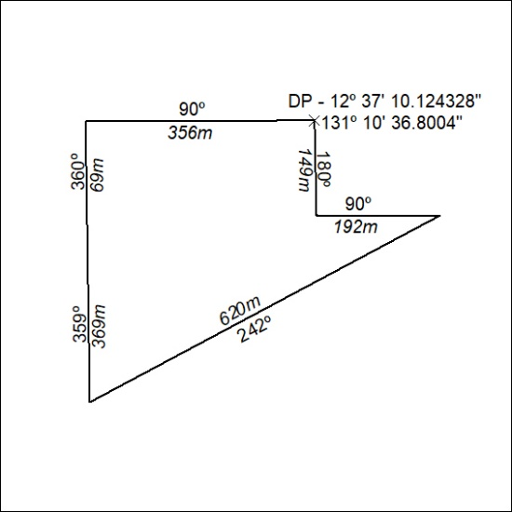

210/20

