Mineral Titles Act 2010
NOTICE OF LAND CEASING TO BE A MINERAL TITLE AREA
Title Type and Number: | Extractive Mineral Exploration Licence 31727
Area Ceased on: | 31 May 2020
Area: | 2 Blocks, 6.53 km²
Locality: | NOONAMAH
Name of Applicant(s)/Holder(s): | 100% GOSSAN RESOURCES PTY LTD [ACN. 161 395 964]
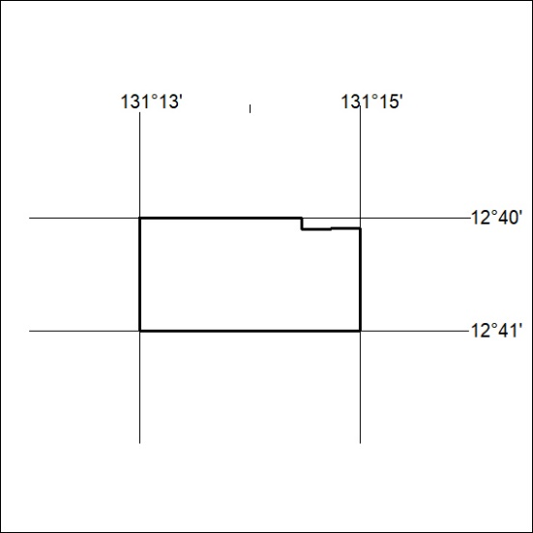

202/20

