Mineral Titles Act 2010
NOTICE OF LAND CEASING TO BE A MINERAL TITLE AREA
Title Type and Number: | Exploration Licence 29841
Area Ceased on: | 26 May 2020
Area: | 14 Blocks, 40.53 km²
Locality: | WONARAH
Name of Applicant(s)/Holder(s): | 100% MINEMAKERS AUSTRALIA PTY LTD* [ACN. 081 911 917]
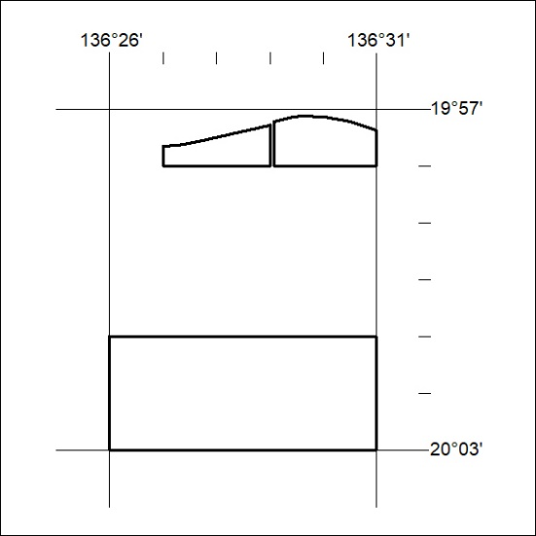
(Area now amalgamated into Exploration Licence 32359 under s102 – EL moratorium period does not apply)
187/20

Mineral Titles Act 2010
NOTICE OF LAND CEASING TO BE A MINERAL TITLE AREA
Title Type and Number: | Exploration Licence 31477
Area Ceased on: | 26 May 2020
Area: | 18 Blocks, 58.10 km²
Locality: | WONARAH
Name of Applicant(s)/Holder(s): | 100% MINEMAKERS AUSTRALIA PTY LTD* [ACN. 081 911 917]
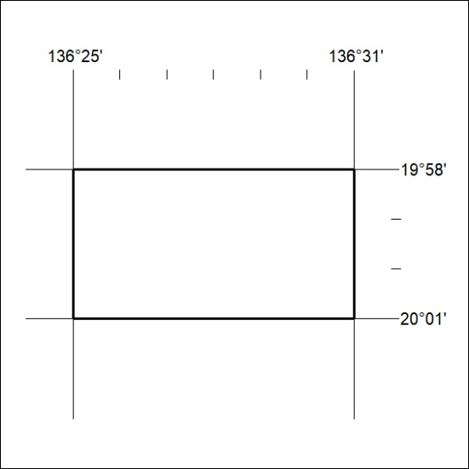
(Area now amalgamated into Exploration Licence 32359 under s102 – EL moratorium period does not apply)
188/20
Mineral Titles Act 2010
NOTICE OF LAND CEASING TO BE A MINERAL TITLE AREA
Title Type and Number: | Exploration Licence 31926
Area Ceased on: | 28 May 2020
Area: | 35 Blocks, 109.92 km²
Locality: | LIMBLA
Name of Applicant(s)/Holder(s): | 100% MAY DOWNS RESOURCES PTY LTD [ACN. 624 302 530]
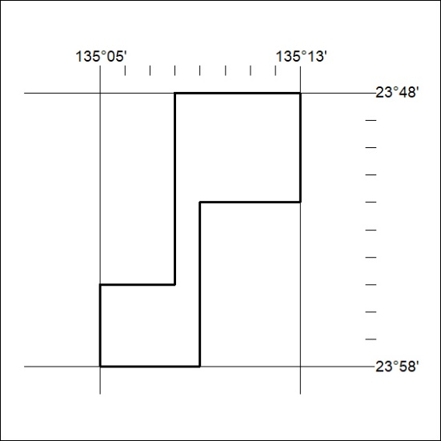
189/20

Mineral Titles Act 2010
NOTICE OF LAND CEASING TO BE A MINERAL TITLE AREA
Title Type and Number: | Exploration Licence 32227
Area Ceased on: | 26 May 2020
Area: | 1 Block, .18 km²
Locality: | WONARAH
Name of Applicant(s)/Holder(s): | 100% MINEMAKERS AUSTRALIA PTY LTD* [ACN. 081 911 917]
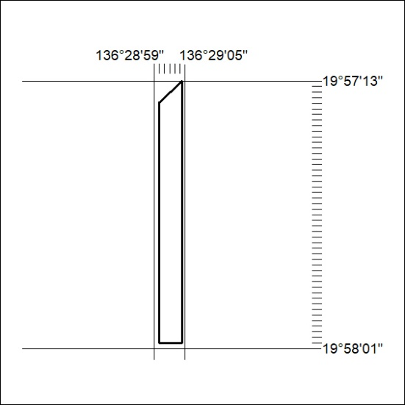
(Area now amalgamated into Exploration Licence 32359 under s102 – EL moratorium period does not apply)
190/20

Mineral Titles Act 2010
NOTICE OF LAND CEASING TO BE A MINERAL TITLE AREA
Title Type and Number: | Extractive Mineral Permit 26343
Area ceased on: | 27 May 2020
Area: | 22.00 Hectare
Locality: | NOONAMAH
Name of Applicants(s)Holder(s): | 100% OSTOJIC GROUP PTY LTD* [ACN. 009 629 805]
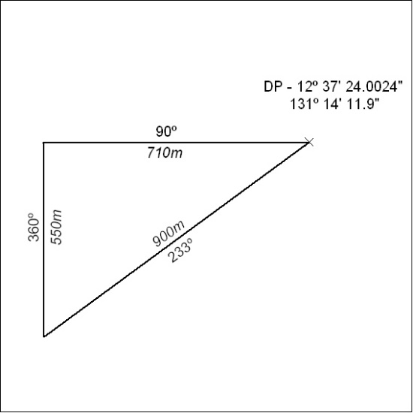
191/20

Mineral Titles Act 2010
NOTICE OF LAND CEASING TO BE A MINERAL TITLE AREA
Title Type and Number: | Extractive Mineral Permit 27935
Area ceased on: | 27 May 2020
Area: | 39.00 Hectare
Locality: | NOONAMAH
Name of Applicants(s)Holder(s): | 100% OSTOJIC GROUP PTY LTD* [ACN. 009 629 805]
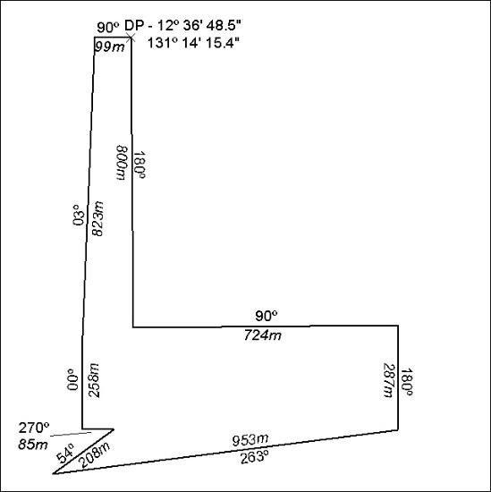
192/20

