Mineral Titles Act 2010
NOTICE OF LAND CEASING TO BE A MINERAL TITLE AREA
Title Type and Number: | Mineral Lease (Southern) 155
Area ceased on: | 20 February 2020
Area: | 79.00 Hectare
Locality: | RIDDOCH
Name of Applicants(s)Holder(s): | 100% IN MINERALS PTY LTD [ACN. 092 036 603]
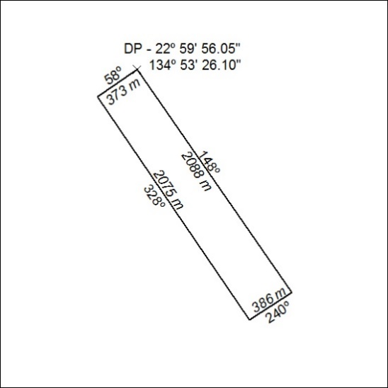

101/20

Mineral Titles Act 2010
NOTICE OF LAND CEASING TO BE A MINERAL TITLE AREA
Title Type and Number: | Mineral Lease (Southern) 156
Area ceased on: | 20 February 2020
Area: | 38.00 Hectare
Locality: | RIDDOCH
Name of Applicants(s)Holder(s): | 100% IN MINERALS PTY LTD [ACN. 092 036 603]
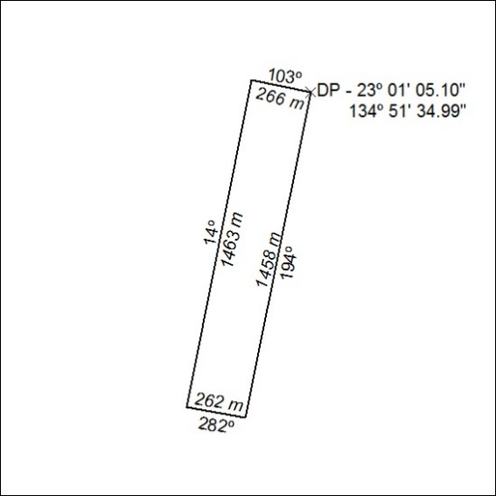

102/20

Mineral Titles Act 2010
NOTICE OF LAND CEASING TO BE A MINERAL TITLE AREA
Title Type and Number: | Mineral Lease (Southern) 157
Area ceased on: | 20 February 2020
Area: | 79.00 Hectare
Locality: | RIDDOCH
Name of Applicants(s)Holder(s): | 100% IN MINERALS PTY LTD [ACN. 092 036 603]
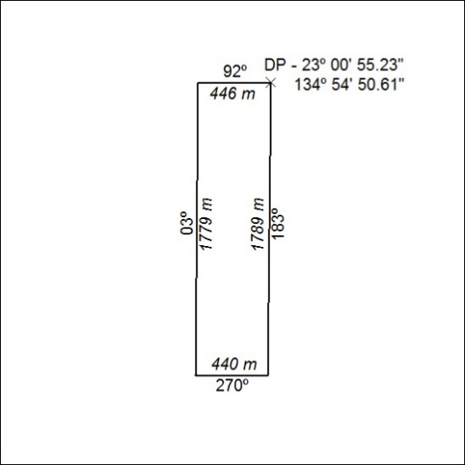

103/20

Mineral Titles Act 2010
NOTICE OF LAND CEASING TO BE A MINERAL TITLE AREA
Title Type and Number: | Mineral Lease (Southern) 158
Area ceased on: | 20 February 2020
Area: | 74.00 Hectare
Locality: | RIDDOCH
Name of Applicants(s)Holder(s): | 100% IN MINERALS PTY LTD [ACN. 092 036 603]
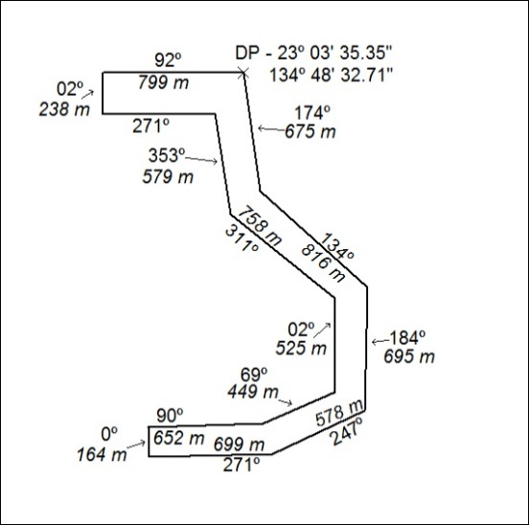

104/20

Mineral Titles Act 2010
NOTICE OF LAND CEASING TO BE A MINERAL TITLE AREA
Title Type and Number: | Mineral Lease (Southern) 159
Area ceased on: | 20 February 2020
Area: | 52.00 Hectare
Locality: | RIDDOCH
Name of Applicants(s)Holder(s): | 100% IN MINERALS PTY LTD [ACN. 092 036 603]
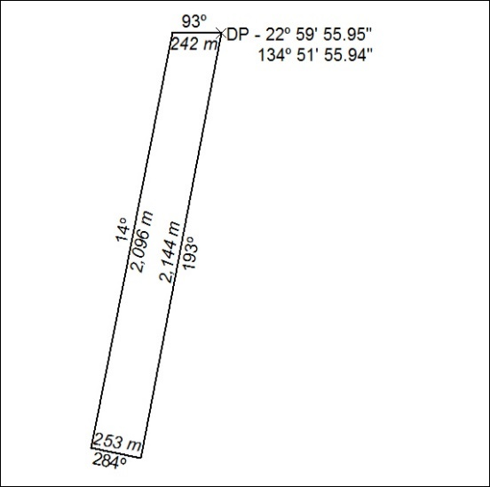

105/20

Mineral Titles Act 2010
NOTICE OF LAND CEASING TO BE A MINERAL TITLE AREA
Title Type and Number: | Mineral Lease (Southern) 160
Area ceased on: | 20 February 2020
Area: | 93.00 Hectare
Locality: | RIDDOCH
Name of Applicants(s)Holder(s): | 100% IN MINERALS PTY LTD [ACN. 092 036 603]
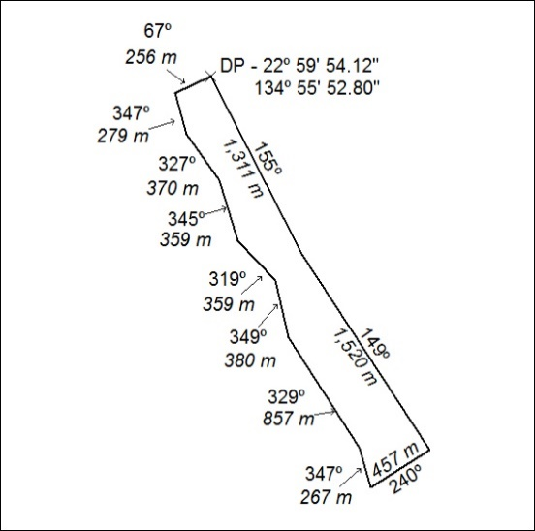

106/20

Mineral Titles Act 2010
NOTICE OF LAND CEASING TO BE A MINERAL TITLE AREA
Title Type and Number: | Mineral Lease (Southern) 161
Area ceased on: | 20 February 2020
Area: | 125.00 Hectares
Locality: | RIDDOCH
Name of Applicants(s)Holder(s): | 100% IN MINERALS PTY LTD [ACN. 092 036 603]
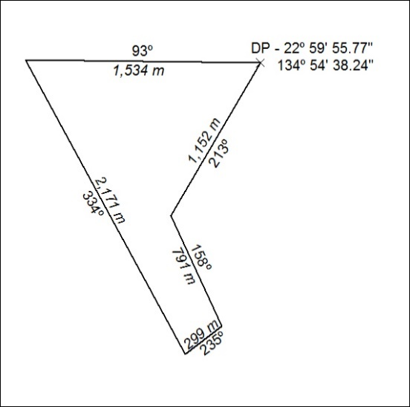

107/20

Mineral Titles Act 2010
NOTICE OF LAND CEASING TO BE A MINERAL TITLE AREA
Title Type and Number: | Mineral Lease (Southern) 162
Area ceased on: | 20 February 2020
Area: | 24.00 Hectare
Locality: | RIDDOCH
Name of Applicants(s)Holder(s): | 100% IN MINERALS PTY LTD [ACN. 092 036 603]
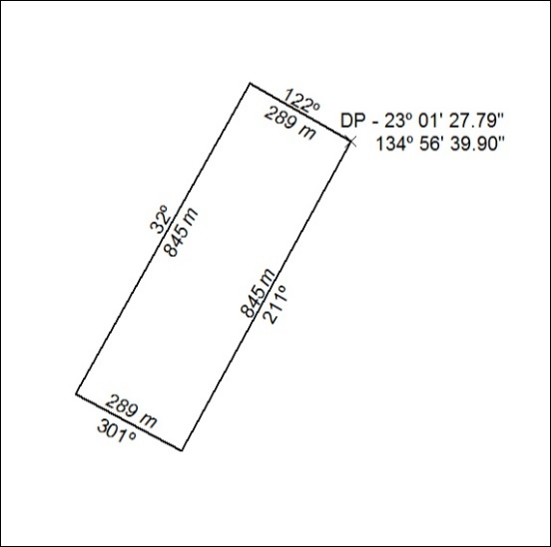

108/20
Mineral Titles Act 2010
NOTICE OF LAND CEASING TO BE A MINERAL TITLE AREA
Title Type and Number: | Exploration Licence 4170
Area Ceased on: | 20 February 2020
Area: | 16 Blocks, 38.81 km²
Locality: | GOVE
Name of Applicant(s)/Holder(s): | 100% RIO TINTO EXPLORATION PTY LIMITED [ACN. 000 057 125]
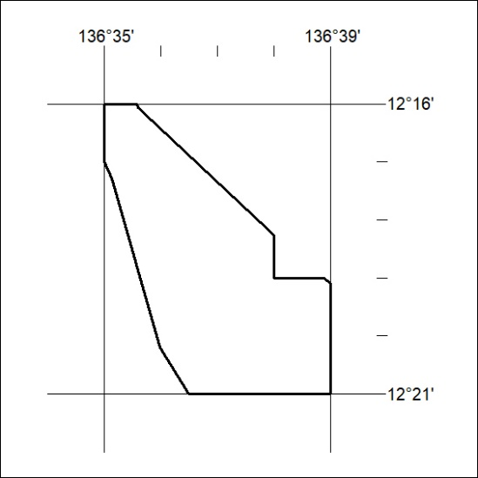

109/20

Mineral Titles Act 2010
NOTICE OF LAND CEASING TO BE A MINERAL TITLE AREA
Title Type and Number: | Exploration Licence 4171
Area Ceased on: | 20 February 2020
Area: | 14 Blocks, 46.96 km²
Locality: | ARNHEM
Name of Applicant(s)/Holder(s): | 100% RIO TINTO EXPLORATION PTY LIMITED [ACN. 000 057 125]
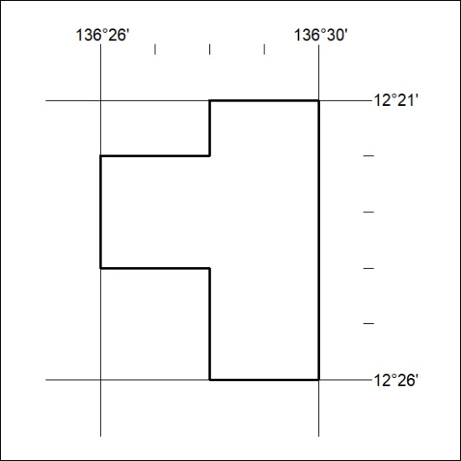

110/20
Mineral Titles Act 2010
NOTICE OF LAND CEASING TO BE A MINERAL TITLE AREA
Title Type and Number: | Exploration Licence 24389
Area Ceased on: | 20 February 2020
Area: | 92 Blocks, 191.39 km²
Locality: | GOVE
Name of Applicant(s)/Holder(s): | 100% RIO TINTO EXPLORATION PTY LIMITED [ACN. 000 057 125]
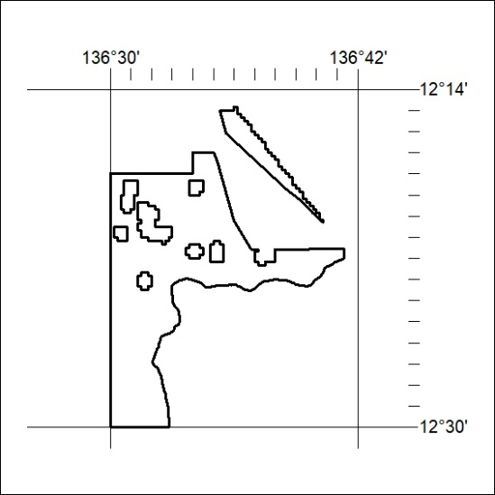

111/20

