Mineral Titles Act 2010
NOTICE OF LAND CEASING TO BE A MINERAL TITLE APPLICATION AREA
Title Type and Number: | Exploration Licence 32127
Area Ceased on: | 10 January 2020
Area: | 203 Blocks, 641.02 km²
Locality: | DENISON
Name of Applicant(s)/Holder(s): | 100% YACIMIENTO PTY LTD [ACN. 633 215 782]
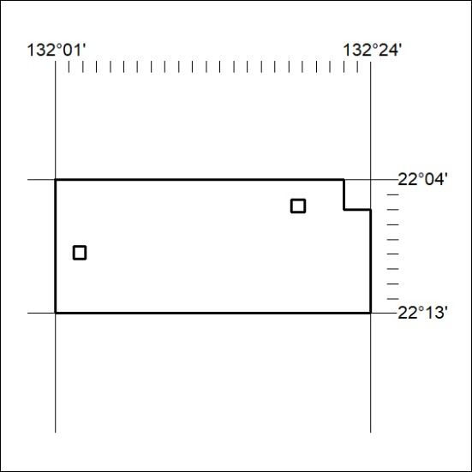

15/20

