Mineral Titles Act 2010
NOTICE OF LAND CEASING TO BE A MINERAL TITLE AREA
Title Type and Number: | Mineral Lease (Southern) 177
Area ceased on: | 21 October 2019
Area: | 205.00 Hectares
Locality: | DELNY
Name of Applicants(s)Holder(s): | 100% IN MINERALS PTY LTD [ACN. 092 036 603]
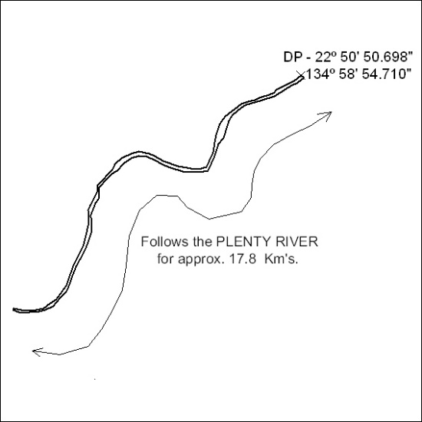

442/19

Mineral Titles Act 2010
NOTICE OF LAND CEASING TO BE A MINERAL TITLE AREA
Title Type and Number: | Mineral Lease (Southern) 178
Area ceased on: | 21 October 2019
Area: | 751.00 Hectares
Locality: | DNEIPER
Name of Applicants(s)Holder(s): | 100% IN MINERALS PTY LTD [ACN. 092 036 603]
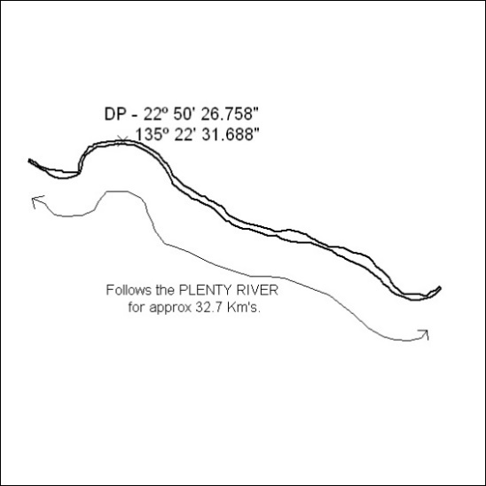

443/19

Mineral Titles Act 2010
NOTICE OF LAND CEASING TO BE A MINERAL TITLE AREA
Title Type and Number: | Mineral Lease (Southern) 179
Area ceased on: | 21 October 2019
Area: | 843.00 Hectares
Locality: | JINKA
Name of Applicants(s)Holder(s): | 100% IN MINERALS PTY LTD [ACN. 092 036 603]
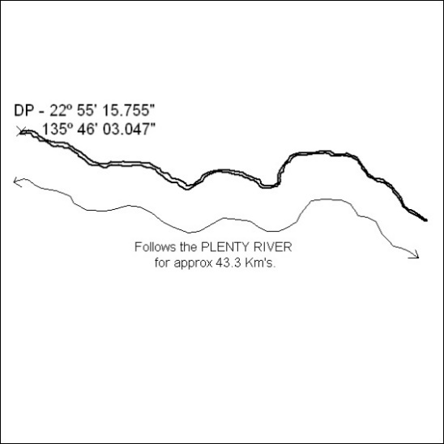

444/19

Mineral Titles Act 2010
NOTICE OF LAND CEASING TO BE A MINERAL TITLE AREA
Title Type and Number: | Mineral Lease (Southern) 182
Area ceased on: | 21 October 2019
Area: | 421.00 Hectares
Locality: | DNEIPER
Name of Applicants(s)Holder(s): | 100% IN MINERALS PTY LTD [ACN. 092 036 603]
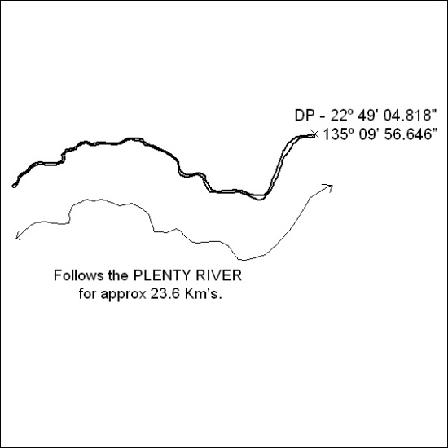

445/19

Mineral Titles Act 2010
NOTICE OF LAND CEASING TO BE A MINERAL TITLE AREA
Title Type and Number: | Mineral Lease (Southern) 183
Area ceased on: | 21 October 2019
Area: | 226.00 Hectares
Locality: | QUARTZ
Name of Applicants(s)Holder(s): | 100% IN MINERALS PTY LTD [ACN. 092 036 603]
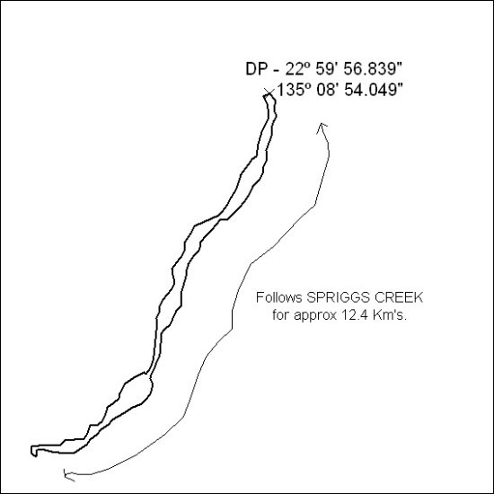

446/19

Mineral Titles Act 2010
NOTICE OF LAND CEASING TO BE A MINERAL TITLE AREA
Title Type and Number: | Mineral Lease (Southern) 184
Area ceased on: | 21 October 2019
Area: | 202.00 Hectares
Locality: | DNEIPER
Name of Applicants(s)Holder(s): | 100% IN MINERALS PTY LTD [ACN. 092 036 603]
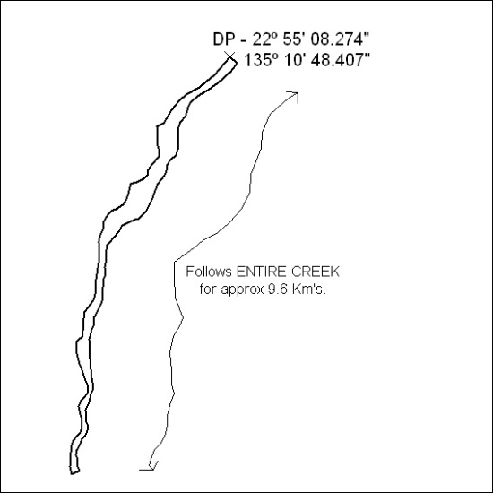

447/19

Mineral Titles Act 2010
NOTICE OF LAND CEASING TO BE A MINERAL TITLE AREA
Title Type and Number: | Mineral Lease (Southern) 185
Area ceased on: | 21 October 2019
Area: | 433.00 Hectares
Locality: | DNEIPER
Name of Applicants(s)Holder(s): | 100% IN MINERALS PTY LTD [ACN. 092 036 603]
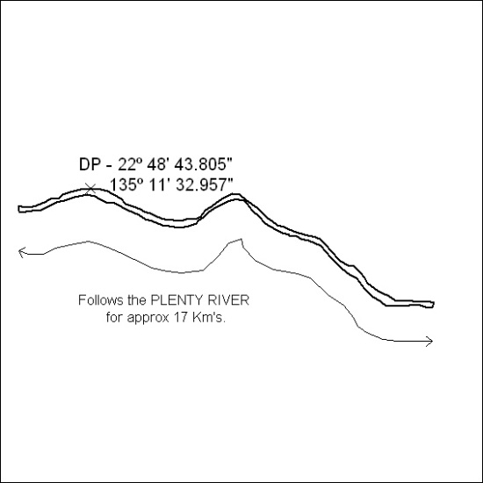

448/19

