Mineral Titles Act 2010
NOTICE OF LAND CEASING TO BE A MINERAL TITLE AREA
Title Type and Number: | Exploration Licence 25467
Area Ceased on: | 10 October 2019
Area: | 100 Blocks, 330.31 km²
Locality: | TAWALLAH RANGE
Name of Applicant(s)/Holder(s): | 100% MARINDI METALS LIMITED* [ACN. 118 522 124]
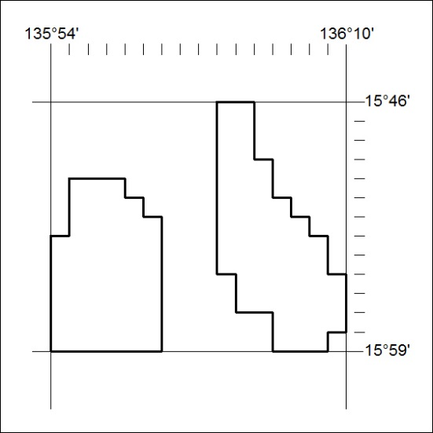
422/19

Mineral Titles Act 2010
NOTICE OF LAND CEASING TO BE A MINERAL TITLE AREA
Title Type and Number: | Exploration Licence 26530
Area Ceased on: | 10 October 2019
Area: | 125 Blocks, 390.18 km²
Locality: | BLOODS RANGE
Name of Applicant(s)/Holder(s): | 100% GEMPART (NT) PTY LTD* [ACN. 081 859 896]
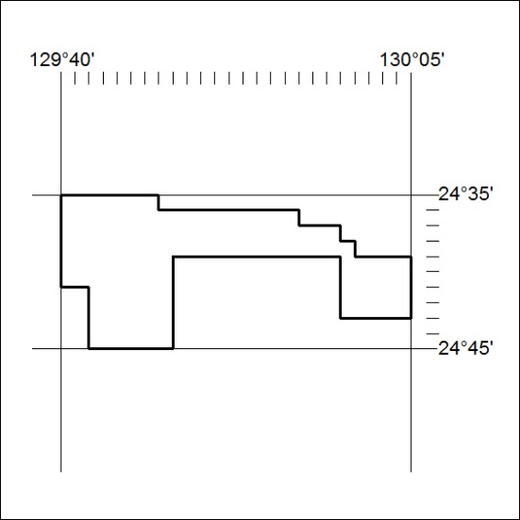
423/19

Mineral Titles Act 2010
NOTICE OF LAND CEASING TO BE A MINERAL TITLE AREA
Title Type and Number: | Exploration Licence 26819
Area Ceased on: | 10 October 2019
Area: | 50 Blocks, 155.21 km²
Locality: | POTTOYU
Name of Applicant(s)/Holder(s): | 100% GEMPART (NT) PTY LTD* [ACN. 081 859 896]
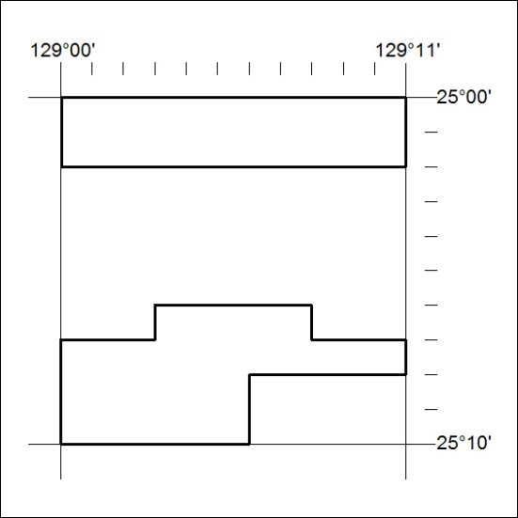
424/19

Mineral Titles Act 2010
NOTICE OF LAND CEASING TO BE A MINERAL TITLE AREA
Title Type and Number: | Exploration Licence 29021
Area Ceased on: | 10 October 2019
Area: | 46 Blocks, 151.98 km²
Locality: | BING BONG
Name of Applicant(s)/Holder(s): | 100% MARINDI METALS LIMITED* [ACN. 118 522 124]
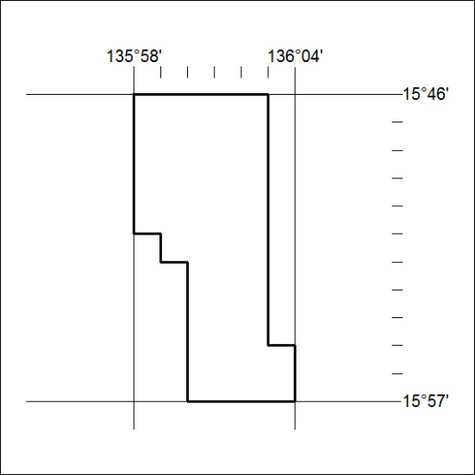
425/19

Mineral Titles Act 2010
NOTICE OF LAND CEASING TO BE A MINERAL TITLE APPLICATION AREA
Title Type and Number: | Exploration Licence 31978
Area Ceased on: | 07 October 2019
Area: | 165 Blocks, 511.38 km²
Locality: | POTTOYU
Name of Applicant(s)/Holder(s): | 100% GEMPART (NT) PTY LTD* [ACN. 081 859 896]
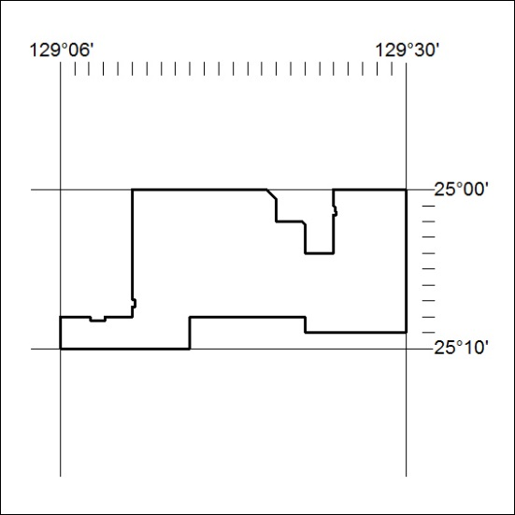
426/19

Mineral Titles Act
NOTICE OF GRANT OF A MINERAL TITLE
Title Type and Number: | Exploration Licence 32121
Granted: | 10 October 2019, for a period of 6 Years
Area: | 4 Blocks, 10.06 km²
Locality: | NOONAMAH
Name of Holder/s: | 100% PANTHER METALS PTY LTD [ACN. 614 676 578]
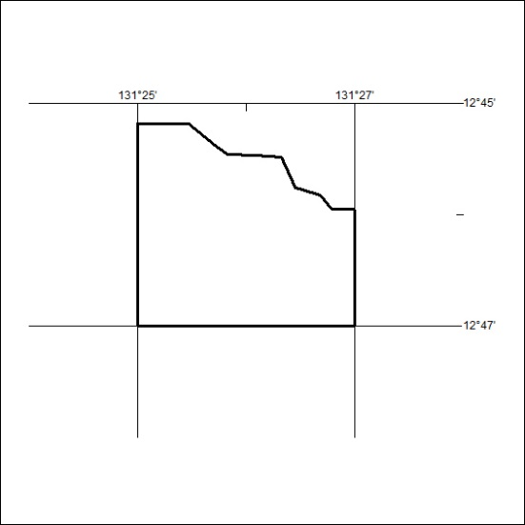
Area granted is indicated above. The titleholder is not permitted to exercise occupational rights on any land that is subject to a development title, or an application for a development title. Any land the subject of a Reserved Land gazettal under the Mineral Titles Act and all land vested in the Commonwealth of Australia is also excluded by description but not excised from the grant area.
427/19

