Mineral Titles Act 2010
NOTICE OF LAND CEASING TO BE A MINERAL TITLE AREA
Title Type and Number: | Exploration Licence 28434
Area Ceased on: | 28 July 2019
Area: | 43 Blocks, 135.29 km²
Locality: | MACDONNELL RANGES
Name of Applicant(s)/Holder(s): | 56.28% CROSSLAND NICKEL PTY LTD* [ACN. 099 477 915], 43.72% ESSENTIAL MINING RESOURCES PTY LTD [ACN. 601 655 725]
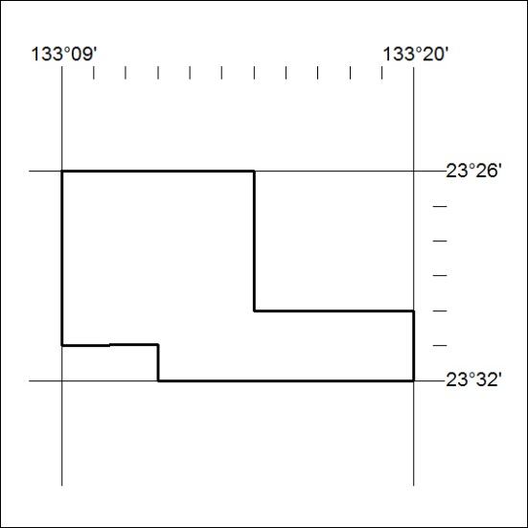

323/19

Mineral Titles Act 2010
NOTICE OF LAND CEASING TO BE A MINERAL TITLE AREA
Title Type and Number: | Exploration Licence 30846
Area Ceased on: | 29 July 2019
Area: | 3 Blocks, 9.34 km²
Locality: | KILGOUR
Name of Applicant(s)/Holder(s): | 100% MMG EXPLORATION PTY LTD* [ACN. 119 136 659]
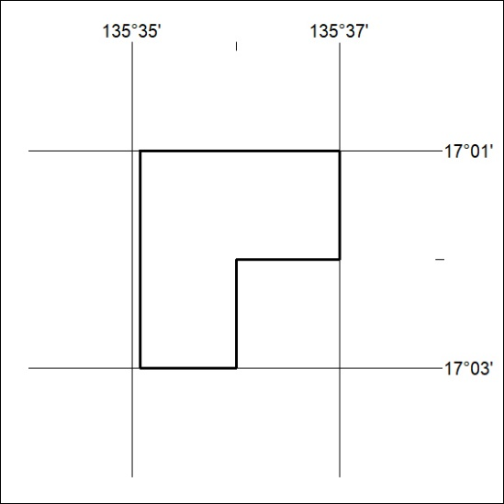

324/19

