Live Exports via Darwin Port – APRIL 2019

Please note: figures are for stock exported through the Port of Darwin only; some NT stock are exported through interstate ports.

Please note: the NT Cattle figures here have been rounded respectively and may not tally to totals.

The figures listed below are correct as at April 30 2019 and are subject to change as further data becomes available.

Table of live exports via Darwin Port in April 2019.  

\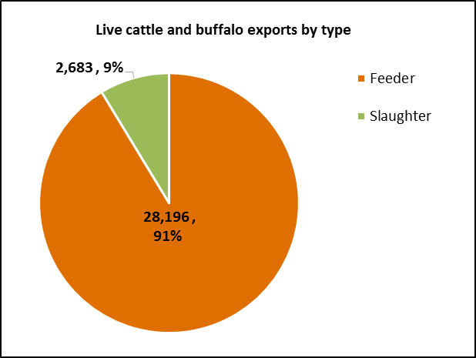

**OTHER LIVESTOCK 2019**

Other livestock in 2019 including Buffalo, Goat and Camel

**LIVESTOCK MOVEMENT STATISTICS**

Reports for livestock movements from NT to Interstate, within NT and Interstate to NT are updated biannually - see [www.dpir.nt.gov.au/primary-industry/primary-industry-strategies-projects-and-research/livestock-movement-statistics](http://www.dpir.nt.gov.au/primary-industry/primary-industry-strategies-projects-and-research/livestock-movement-statistics)