Mineral Titles Act 2010
NOTICE OF LAND CEASING TO BE A MINERAL TITLE APPLICATION AREA
Title Type and Number: | Mineral Lease 24828
Area ceased on: | 20 March 2019
Area: | 930.00 Hectares
Locality: | MARY RIVER
Name of Applicants(s)Holder(s): | 100% PRIMARY MINERALS PTY LTD* [ACN. 153 582 962]
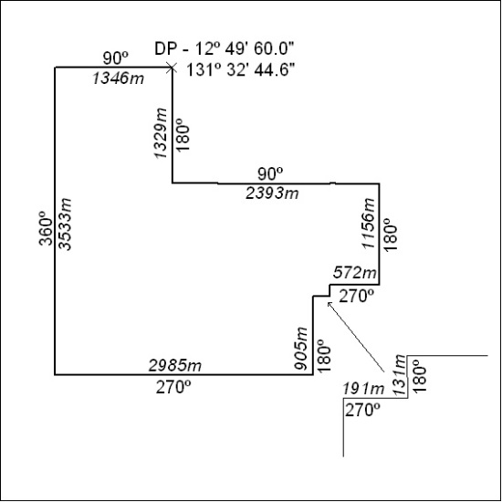

105/19

