Mineral Titles Act
NOTICE OF LAND CEASING TO BE A MINERAL TITLE AREA
Title Type and Number: | Exploration Licence 29883
Area Ceased on: | 28 November 2018
Area: | 8 Blocks, 25.88 km²
Locality: | KELLY
Name of Applicant(s)/Holder(s): | 100% RESOURCE HOLDINGS (WA) PTY LTD [ACN. 079 106 684]
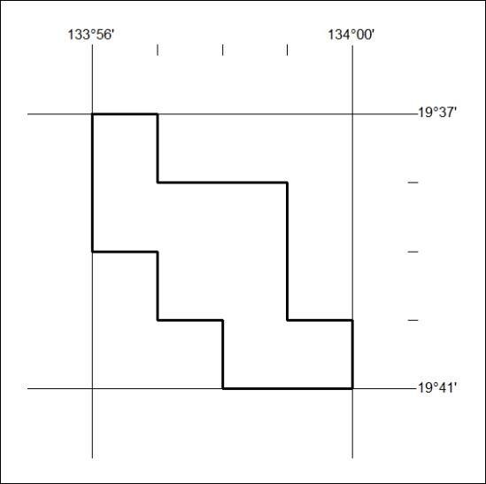

549/18

Mineral Titles Act
NOTICE OF GRANT OF A MINERAL TITLE
Title Type and Number: | Mineral Lease 31403
Granted: | 26 November 2018, for a period of 8 Years
Area: | 19.53 Hectares
Locality: | CHAPMAN
Name of Holder/s: | 100% AUSTRALIAN ILMENITE RESOURCES PTY LIMITED* [ACN. 093 419 311]
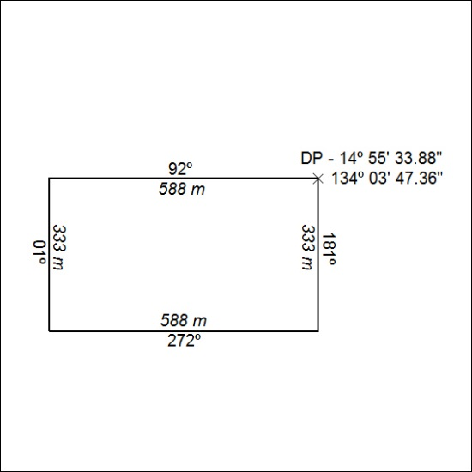

550/18

Mineral Titles Act
NOTICE OF GRANT OF A MINERAL TITLE
Title Type and Number: | Mineral Lease 31954
Granted: | 28 November 2018, for a period of 8 Years
Area: | 370.18 Hectares
Locality: | CHAPMAN
Name of Holder/s: | 100% AUSTRALIAN ILMENITE RESOURCES PTY LIMITED* [ACN. 093 419 311]
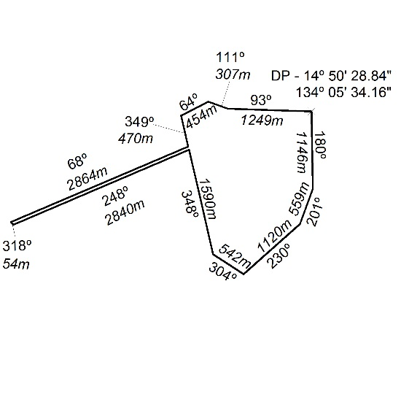

551/18

