Mineral Titles Act
NOTICE OF LAND CEASING TO BE A MINERAL TITLE AREA
Title Type and Number: | Exploration Licence 26555
Area Ceased on: | 11 September 2018
Area: | 88 Blocks, 287.55 km²
Locality: | ROPER
Name of Applicant(s)/Holder(s): | 100% SANDFIRE RESOURCES NL [ACN. 105 154 185]
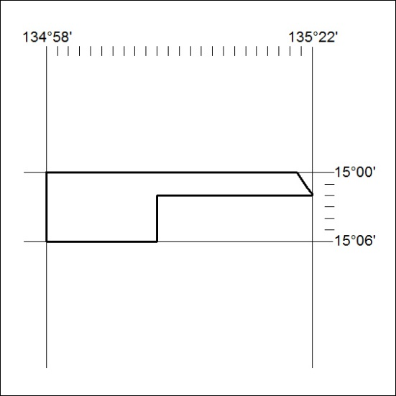

390/18

Mineral Titles Act
NOTICE OF LAND CEASING TO BE A MINERAL TITLE AREA
Title Type and Number: | Exploration Licence 28534
Area Ceased on: | 11 September 2018
Area: | 4 Blocks, 13.19 km²
Locality: | BATTEN
Name of Applicant(s)/Holder(s): | 100% SANDFIRE RESOURCES NL [ACN. 105 154 185]
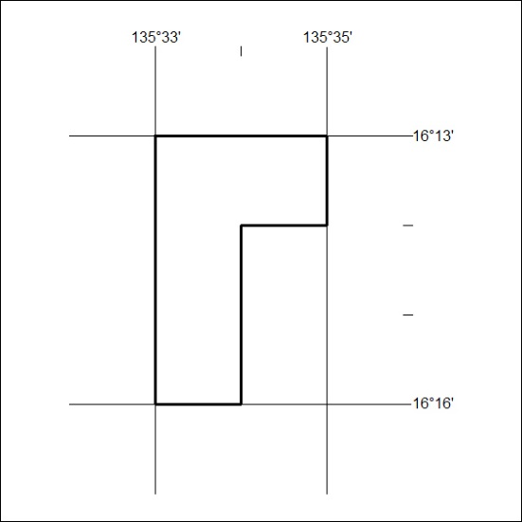

391/18

Mineral Titles Act
NOTICE OF LAND CEASING TO BE A MINERAL TITLE AREA
Title Type and Number: | Exploration Licence 28540
Area Ceased on: | 11 September 2018
Area: | 4 Blocks, 13.20 km²
Locality: | BATTEN
Name of Applicant(s)/Holder(s): | 100% SANDFIRE RESOURCES NL [ACN. 105 154 185]
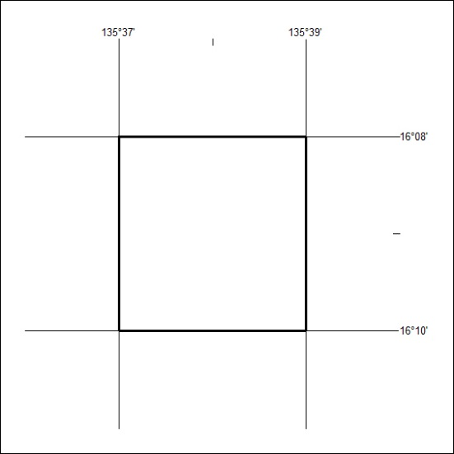

392/18

Mineral Titles Act
NOTICE OF LAND CEASING TO BE A MINERAL TITLE AREA
Title Type and Number: | Exploration Licence 28541
Area Ceased on: | 11 September 2018
Area: | 3 Blocks, 9.90 km²
Locality: | BATTEN
Name of Applicant(s)/Holder(s): | 100% SANDFIRE RESOURCES NL [ACN. 105 154 185]
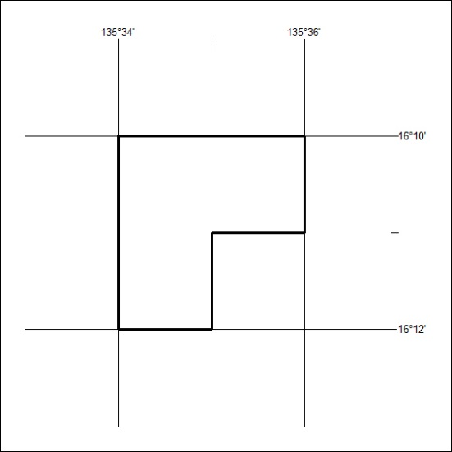

393/18

Mineral Titles Act
NOTICE OF GRANT OF A MINERAL TITLE
Title Type and Number: | Exploration Licence 31684
Granted: | 11 September 2018, for a period of 6 Years
Area: | 7 Blocks, 22.97 km²
Locality: | LANCEWOOD
Name of Holder/s: | 100% SCRIVEN EXPLORATION PTY LTD [ACN. 006 264 615]
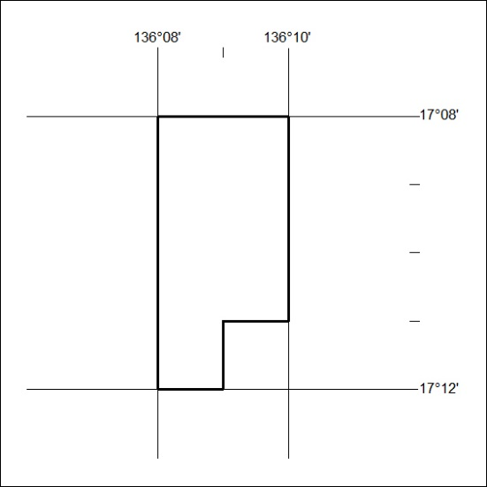
Area granted is indicated above. The titleholder is not permitted to exercise occupational rights on any land that is subject to a development title, or an application for a development title. Any land the subject of a Reserved Land gazettal under the Mineral Titles Act and all land vested in the Commonwealth of Australia is also excluded by description but not excised from the grant area.
394/18

Mineral Titles Act
NOTICE OF GRANT OF A MINERAL TITLE
Title Type and Number: | Exploration Licence 31685
Granted: | 11 September 2018, for a period of 6 Years
Area: | 35 Blocks, 114.87 km²
Locality: | LANCEWOOD
Name of Holder/s: | 100% SCRIVEN EXPLORATION PTY LTD [ACN. 006 264 615]
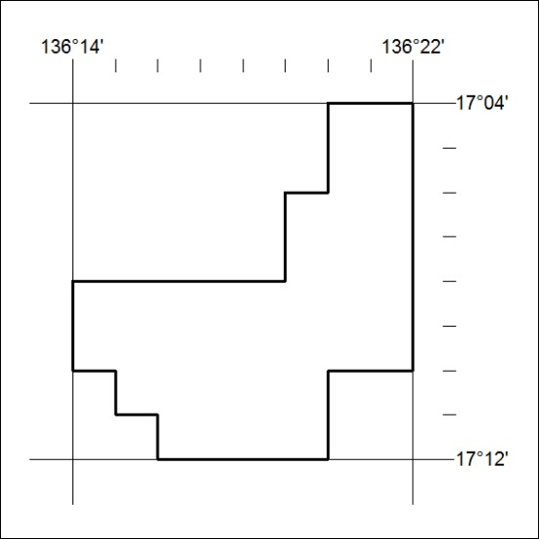
Area granted is indicated above. The titleholder is not permitted to exercise occupational rights on any land that is subject to a development title, or an application for a development title. Any land the subject of a Reserved Land gazettal under the Mineral Titles Act and all land vested in the Commonwealth of Australia is also excluded by description but not excised from the grant area.
395/18

Mineral Titles Act
NOTICE OF GRANT OF A MINERAL TITLE
Title Type and Number: | Exploration Licence 31782
Granted: | 11 September 2018, for a period of 6 Years
Area: | 245 Blocks, 773.44 km²
Locality: | GLEN HELEN
Name of Holder/s: | 100% SCRIVEN EXPLORATION PTY LTD [ACN. 006 264 615]
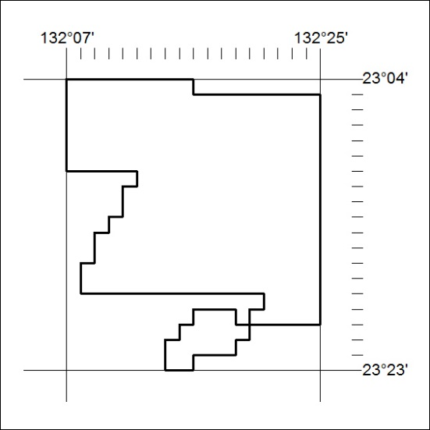
Area granted is indicated above. The titleholder is not permitted to exercise occupational rights on any land that is subject to a development title, or an application for a development title. Any land the subject of a Reserved Land gazettal under the Mineral Titles Act and all land vested in the Commonwealth of Australia is also excluded by description but not excised from the grant area.
396/18

Mineral Titles Act
NOTICE OF GRANT OF A MINERAL TITLE
Title Type and Number: | Exploration Licence 31783
Granted: | 11 September 2018, for a period of 6 Years
Area: | 239 Blocks, 754.31 km²
Locality: | NARWIETOOMA
Name of Holder/s: | 100% SCRIVEN EXPLORATION PTY LTD [ACN. 006 264 615]
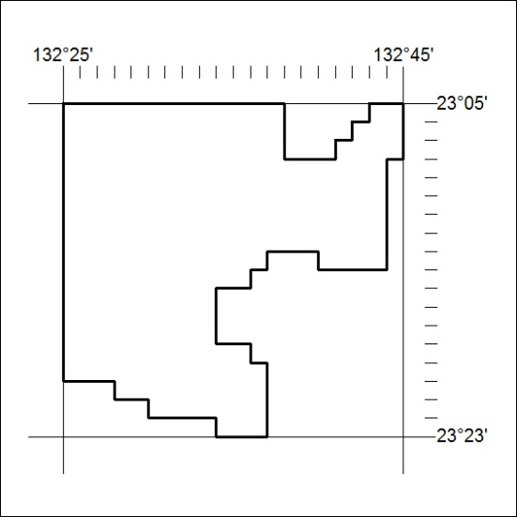
Area granted is indicated above. The titleholder is not permitted to exercise occupational rights on any land that is subject to a development title, or an application for a development title. Any land the subject of a Reserved Land gazettal under the Mineral Titles Act and all land vested in the Commonwealth of Australia is also excluded by description but not excised from the grant area.
397/18

