Mineral Titles Act
NOTICE OF LAND CEASING TO BE A MINERAL TITLE AREA
Title Type and Number: | Exploration Licence 30099
Area Ceased on: | 14 June 2018
Area: | 2 Blocks, 2.99 km²
Locality: | WELLINGTON RANGE
Name of Applicant(s)/Holder(s): | 100% RIO TINTO EXPLORATION PTY LIMITED [ACN. 000 057 125]
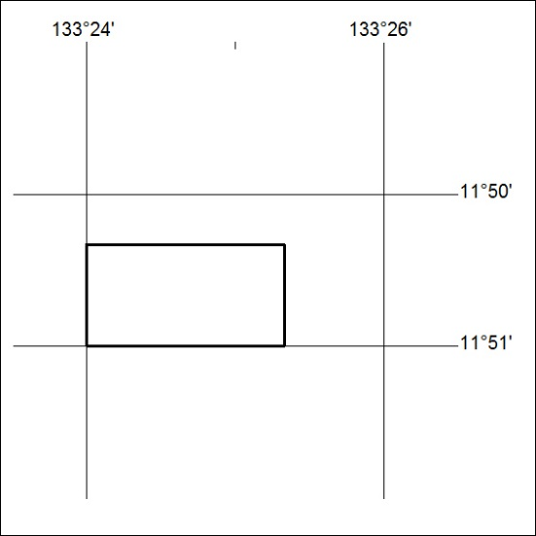

262/18

Mineral Titles Act
NOTICE OF GRANT OF A MINERAL TITLE
Title Type and Number: | Exploration Licence 31300
Granted: | 06 June 2018, for a period of 6 Years
Area: | 247 Blocks, 813.88 km²
Locality: | REYNOLDS RIVER
Name of Holder/s: | 100% LITCHFIELD MINERALS PTY LTD [ACN. 612 660 429]
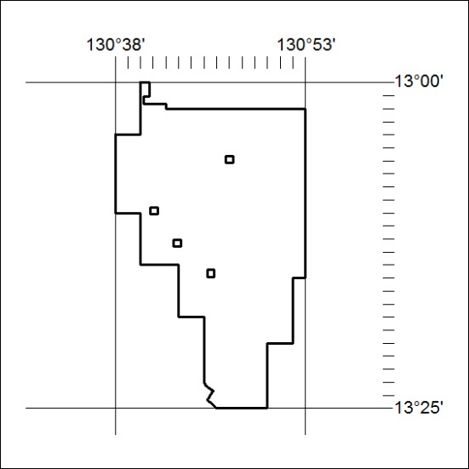
Area granted is indicated above. The titleholder is not permitted to exercise occupational rights on any land that is subject to a development title, or an application for a development title. Any land the subject of a Reserved Land gazettal under the Mineral Titles Act and all land vested in the Commonwealth of Australia is also excluded by description but not excised from the grant area.

263/18

Mineral Titles Act
NOTICE OF GRANT OF A MINERAL TITLE
Title Type and Number: | Exploration Licence 31305
Granted: | 06 June 2018, for a period of 6 Years
Area: | 244 Blocks, 776.20 km²
Locality: | DOREEN
Name of Holder/s: | 100% LITCHFIELD MINERALS PTY LTD [ACN. 612 660 429]
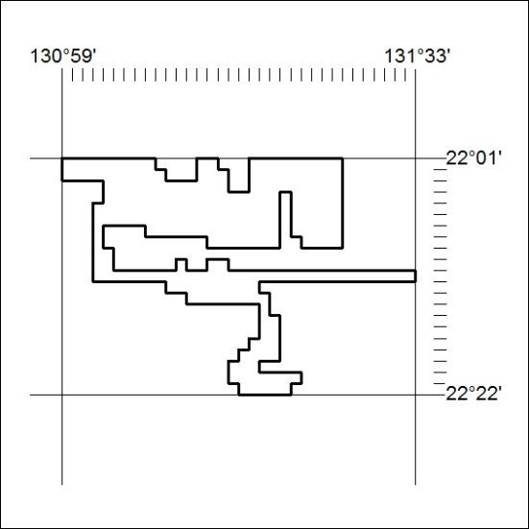
Area granted is indicated above. The titleholder is not permitted to exercise occupational rights on any land that is subject to a development title, or an application for a development title. Any land the subject of a Reserved Land gazettal under the Mineral Titles Act and all land vested in the Commonwealth of Australia is also excluded by description but not excised from the grant area.

264/18

