Mineral Titles Act
NOTICE OF LAND CEASING TO BE A MINERAL TITLE
Title Type and Number: | Mineral Lease (Central) 52
Area ceased on: | 05 June 2018
Area: | 14.00 Hectare
Locality: | TENNANT CREEK
Name of Applicants(s)Holder(s): | 100% SANTEXCO PTY LTD [ACN. 002 910 296]
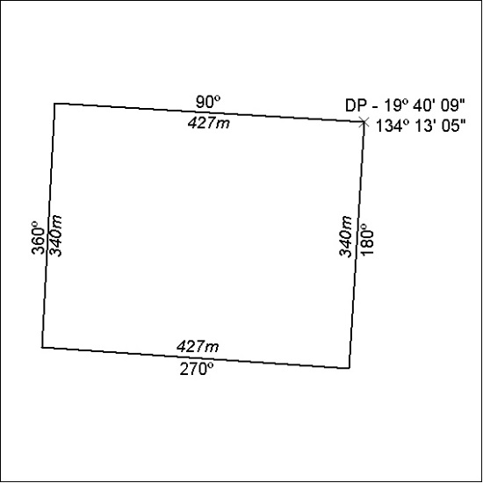

244/18

Mineral Titles Act
NOTICE OF LAND CEASING TO BE A MINERAL TITLE
Title Type and Number: | Mineral Lease 30712
Area ceased on: | 05 June 2018
Area: | 36.00 Hectare
Locality: | TENNANT CREEK
Name of Applicants(s)Holder(s): | 100% SANTEXCO PTY LTD [ACN. 002 910 296]
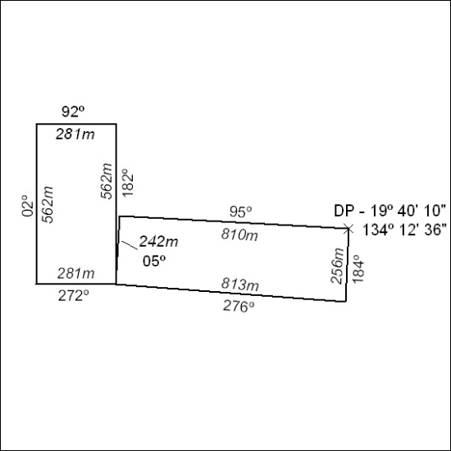

245/18

Mineral Titles Act
NOTICE OF LAND CEASING TO BE A MINERAL TITLE
Title Type and Number: | Mineral Lease 30713
Area ceased on: | 05 June 2018
Area: | 15.00 Hectare
Locality: | TENNANT CREEK
Name of Applicants(s)Holder(s): | 100% GIANTS REEF EXPLORATION PTY LTD* [ACN. 009 200 346]
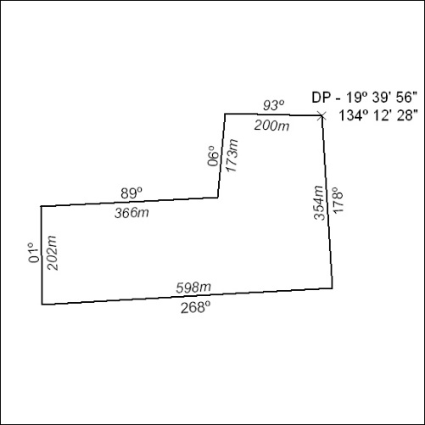

246/18

Mineral Titles Act
NOTICE OF GRANT OF A MINERAL TITLE
Title Type and Number: | Mineral Lease 31705
Granted: | 06 June 2018, for a period of 10 Years
Area: | 38.00 Hectares
Locality: | RANFORD HILL
Name of Holder/s: | 50% WOOD Sandra Maureen, 50% WOOD Gregory Lance
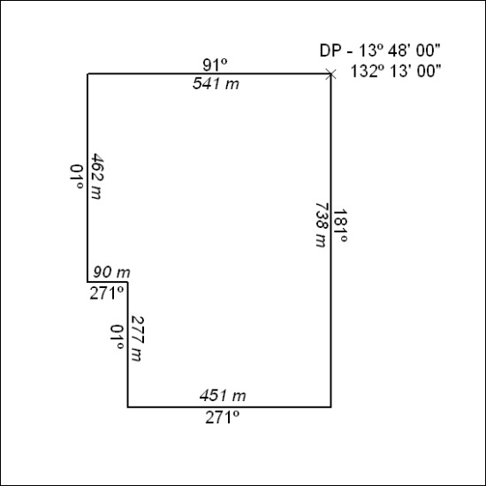

247/18

