Mineral Titles Act
NOTICE OF LAND CEASING TO BE A MINERAL TITLE
Title Type and Number: | Mineral Lease 30308
Area ceased on: | 14 May 2018
Area: | 15.00 Hectare
Locality: | LAUGHLEN
Name of Applicants(s)Holder(s): | 33.33% MASON Jennifer, 33.33% PEARSON Trevor Lance, 33.33% VAN HYFTE Joseph
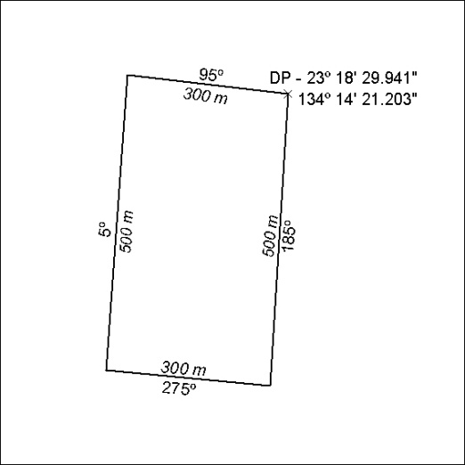

180/18

Mineral Titles Act
NOTICE OF GRANT OF A MINERAL TITLE
Title Type and Number: | Exploration Licence 31354
Granted: | 14 May 2018, for a period of 6 Years
Area: | 37 Blocks, 122.22 km²
Locality: | TAWALLAH RANGE
Name of Holder/s: | 100% WEST ROCK RESOURCES PTY LTD [ACN. 150 296 923]
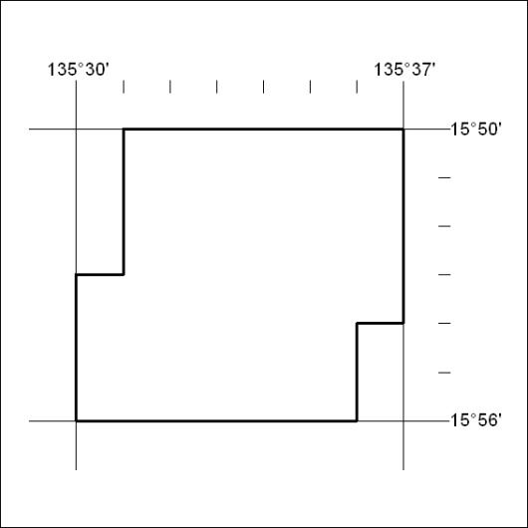
Area granted is indicated above. The titleholder is not permitted to exercise occupational rights on any land that is subject to a development title, or an application for a development title. Any land the subject of a Reserved Land gazettal under the Mineral Titles Act and all land vested in the Commonwealth of Australia is also excluded by description but not excised from the grant area.

181/18

