Published by the Department of Trade, Business and Innovation

© Northern Territory Government 2016
You may download, display, print and copy any material in this report, in unaltered form only, for your personal use or for non-commercial use within your organisation.
Except as permitted above you must not copy, adapt, publish, distribute or commercialise any material contained in this report without prior written permission from the Northern Territory Government through the Department of Trade, Business and Inovation.
Enquiries should be made to:
Department of Trade, Business and Innovation
GPO Box 3200
DARWIN NT 0801
Telephone: (08) 8999 5511
Email: businessinfo@nt.gov.au
Web: https://business.nt.gov.au/about
ISSN 1837-4239 (Print) ISSN 1837-4247 (Online)

Purpose of the report
This annual report highlights Department of Business achievements for the 2015-16 financial year.
This report has been prepared to meet the requirements of section 28 of the Public Sector Employment and Management Act, and section 11 of the Financial Management Act.
It provides the Minister, the Northern Territory Legislative Assembly and other interested parties with:
- the primary functions and responsibilities of the department’s significant activities undertaken during the year
- the department’s financial management and performance
- a summary of the department’s progress in achieving its planned outcomes as outlined in
2015-16 Budget Paper No.3 and the department’s Strategic Directions 2015-2020
- an overview of the department’s future direction.

The Hon Michael Gunner MLA  Minister for Trade, Business and Innovation  Parliament House  Darwin NT 0800 | Office of the Chief Executive  Level 5, Charles Darwin Centre  19 Smith Street, The Mall  DARWIN NT 0800  Postal Address  GPO Box 3200  DARWIN NT 0800  T 08 8999 5204  F 08 8999 5333  E michael.tennant@nt.gov.au
Dear Minister
In accordance with the provisions of section 28 of the Public Sector Employment and Management Act, I am pleased to present you with the Department of Business 2015-16 Annual Report on activities and achievements.
Pursuant to the Public Sector Employment and Management Act, the Financial Management Act and the Information Act, I advise that to the best of my knowledge and belief:
- Proper records of all transactions affecting the department are kept and the employees under my control observe the provisions of the Financial Management Act, the Financial Management Regulations and the Treasurer’s Directions.
- Procedures within the department afford proper internal control, in accordance with the Treasurer’s Direction G2.2, and include controls identified in the department’s Strategic Risk Management register.
- There is no indication of fraud, malpractice, major breach of legislation or delegation, major error in, or omission from, the accounts and records.
- The internal audit capacity available to the department is adequate and the results of internal audits have been reported to me.
- The financial statements in the annual report have been prepared from proper accounts and records and is in accordance with the Treasurer’s Directions.
- All Employment Instructions issued by the Commissioner for Public Employment have been satisfied.
- The department is working in compliance with the Information Act.
Yours sincerely

Michael Tennant
Chief Executive Officer
14 September 2016

Contents
Purpose of the report 3
Message from the Chief Executive Officer 6
About the Department of Business 9
What we do 9
Our values 9
Strategic Directions 2015-2020 9
Report against strategic issues for 2015-16 as identified in Budget Paper No 3 10
Organisational structure at 30 June 2016 19
Executive 20
Income and expenditure at a glance 22
Corporate governance framework 23
Governance bodies 26
Business Advisory Council 31
Performance reporting 32
Supporting business to start, run and grow 32
Developing industry and attracting investment 41
Simplifying doing business and working 46
Building and growing our capability 52
Reporting against Employment Instructions 62
Performance reporting against output groups – Key Deliverables 66
Appendix A 69
Statutory responsibilities / legislation administered 69
Appendix B 71
Department of Business statutory authorities and boards 71
Appendix C 75
Business grants and funding 75
Appendix D 82
Insurance Arrangements 82
Appendix E 84
Financial Statements Overview 84
Appendix F 88
Financial Statements 88
Comprehensive Operating Statement 89
Statement of Financial Position 90
Statement of Changes in Equity 91
Index of Notes to the Financial Statements 93
Appendix G 133
Department contact details 133
Appendix H 134
Feedback 134

Message from the Chief Executive Officer
The 2015-16 financial year has been both exciting and challenging. The Department of Business has continued to work closely with industry and business, playing a leadership role in identifying and pursuing growth opportunities for the Northern Territory.
Delivering on our Strategic Directions 2015-2020 has been a core focus, together with an ongoing commitment to continuous improvement and taking a client centred approach to our services.
The Northern Territory is in a period of transition as the economy diversifies off the back of an unparalleled growth period. Strategies and initiatives implemented by our department have, and will continue to, support Territory businesses, employers and workers respond to this change.
The business sector is a key contributor not only to our economy, but also to our community. Our department is focused on ensuring the Northern Territory is the best place to work and do business by driving the right environment for business, industry and workers.
The Buy Local Plan, announced in December 2015, delivered comprehensive changes to the government’s procurement framework, embedding local benefit as a critical element of value-for-money. The Buy Local Plan ensures every dollar spent by the Northern Territory Government delivers the greatest possible benefit to our economy and community. Two rounds of reforms were undertaken to implement that Plan. In February 2016, the mandatory minimum weighting for local content increased from 20% to 25%, and a mandatory requirement to include a Territory Enterprise in all quotations estimated to be worth up to $100 000 was introduced. In April 2016 the Local Benefit Advisory Panel was established and local benefit commitments in contracts with an estimated value of $100 000 or greater was introduced.
The department was pivotal in the design and delivery of the $20 million Home Improvement Scheme launched in June 2016, as an economic stimulus initiative to increase small-scale home improvement and maintenance activity and keep work flowing for construction-related small businesses.
We are continuing to deliver on our commitment to Territory businesses and workers and in 2015-16 provided a range of grants, advice, workshops, information sessions, licence approvals, training support and workforce growth support.
We have an additional five Business Development Officers (BDOs) in our Territory-wide network, bringing the total number to 24. BDOs are active in all regions of the Territory from bases in Darwin, Alice Springs, Tennant Creek, Katherine and Nhulunbuy and have seen over 339 businesses engage in programs with NT Government investment of over $3 million this year.
Our regional commitment has been further strengthened by opening pop-up Territory Business Centres in the Tiwi Islands, Borroloola and Maningrida, to provide a range of business-focused services and also delivered ‘Boosting Business in the Bush’ workshops across 15 Champion Communities.
In 2015, we held a record-breaking October Business Month, coordinating 183 business events across the Northern Territory, which attracted more than 9 300 people.
The inaugural Open Territory program of events was held from March to May 2016, showcasing business capability and highlighting trade and investment opportunities through a series of domestic and international events. This program coordinated 154 events across the Territory, attracting a total of 115 475 attendees.
We have continued the reform agenda to identify and eliminate unnecessary red tape, through internal, administrative and regulatory reform.

The Red Tape Reduction Strategy was launched in July 2015, and has been reducing paperwork and compliance costs by extending licence terms, moving transactions online and removing unnecessary red tape. Three sector reviews were completed for the construction and development industry, tourism and hospitality industry and non-government organisation sector. In April this year the Red Tape Reduction (Miscellaneous Amendments) Bill 2016 passed through Parliament. In 2015-16 approximately 250 red tape reduction issues were raised with the Red Tape Reduction Squad. By the end of June 2016 270 initiatives have been completed or are underway across government since August 2012.
Territory Business Centres are our 'one stop shop' for business, industry and workers. During the 2015-16 financial year there have been over 161 000 client contacts with the TBCs, an increase of 25 000 from the previous year. This key service will continue to improve and enhance during 2016-17 with further efficiencies to the way various licences and permits are processed and approved.
The value of Community Benefit Fund grants increased to $8 million in 2015-16, as a result of contributions by Northern Territory casinos. This saw the number of major grant rounds increase from one to four and the number of small grant rounds from two to four with a new quick grant category established.
In November 2015 a 20 year licence was granted to UBET NT Pty Ltd to exclusively operate totalisator wagering in the NT. This new agreement will mean more job opportunities for Territorians, a better outcome for the thoroughbred and greyhound racing sectors and a lower overall call on taxpayer funds.
We continue to deliver a balanced policy and regulatory framework that supports industry, business and community needs.
This year NT WorkSafe continued to strengthen its risk based compliance approach with NT employers. It introduced the Small Business Safety Program and delivered a regional visitation program to improve engagement and work health and safety outcomes in regional and remote areas. A Remote Engagement Strategy is scheduled for implementation in 2016-17.
The Asian Engagement, Trade and Investment Strategic Plan was launched in July 2015 to leverage the Northern Territory’s position, exploit future trade and investment activities and broaden engagement with the Asian region. We are implementing this plan, actively promoting the Northern Territory as a preferred location for investment by:
- introducing a new model for international representation, with representatives in Indonesia and Singapore to support and promote the Northern Territory’s political, economic, and cultural relationships in the region
- completing 80 inbound and 14 outbound delegations
- leading the Northern Territory’s involvement in the development of a trilateral economic cooperation framework between Australia, Indonesia and Timor-Leste
- re-connecting the NT with the Brunei Darussalam, Indonesia, Malaysia, Philippines - East ASEAN Growth Area (BIMP-EAGA) including hosting delegations in Darwin during November 2015 and April 2016
- hosting the NT and Timor-Leste Bilateral Ministerial Forum in Darwin during April 2016, the first such meeting since 2011
- co-ordinating and assisting ministerial missions to China, Taiwan, Hong Kong, Japan, Malaysia, Singapore and Timor-Leste
- facilitating the Australian Government’s Northern Australia Investment Forum in November 2015.

The Territory labour market remains tight, characterised by high participation and low unemployment. One of the key roles of our department continues to be developing a capable labour market through increased participation, appropriate training and educational opportunities.
This year, 3 802 apprentices and trainees were in training across the NT, with 47.3% of these in traditional trade occupations; 32.4% are women and 26.2% are Aboriginal.
I am proud of the initiatives our department has delivered to increase Aboriginal participation in the labour force. In 2015-16, 332 Aboriginal people were placed in jobs assisting 106 businesses and organisations to grow their workforce, and a further 99 Aboriginal employees assisted to progress in their careers. The Indigenous Workforce Participation Program also funded five new initiatives to support employers access a ready and available workforce in remote parts of the NT.
We completed a review of our remote and regional training centres in October 2015 and government subsequently transferred the centres to the departments of Education and Local Government and Community Services, to support a wider range of government and community activities.
The continued development of a new funding model for Vocational Education and Training to provide greater transparency of investment is progressing. It is on track to be finalised for a staged multi-year introduction commencing in the 2017 academic year.
Where a local skilled workforce does not exist, Migration NT works to support NT businesses to attract and engage interstate workers. The team plays a key role in promoting the Territory as the best place to work.
I am proud of the outcomes and achievements we have realised this year and appreciate our team’s commitment and hard work. Our team has focussed on the delivery of our strategic plan to ensure we deliver on our shared goals and ensure we deliver results for the community we serve. The talent and dedication across our department continues to shape the NT as the best place to do business and work.
I look forward to further strengthening our collaborative efforts with business, industry and community partners to ensure the department leads the government’s investment in creating a robust and innovative economy that supports jobs and opportunities.

Michael Tennant
Chief Executive Officer
14 September 2016

About the Department of Business

What we do
With a vision to make the Territory the best place to work and do business, the Department of Business is creating the right environment for business, industry and workers by:
- supporting business to start, run and grow
- developing industry and attracting investment
- simplifying doing business and working
- building and growing our capability.
The department delivers a wide range of programs and services to business, industry and workers across divisions including:
- Office of Asian Engagement, Trade and Investment
- Business NT
- Training NT
- NT WorkSafe
- Licensing NT
- Procurement NT
- Red Tape Abolition Squad
- Strategic Services.

Our values
- Commitment to service
- Ethical practice
- Respect
- Accountability
- Impartiality
- Diversity

Strategic Directions 2015-2020

Report against strategic issues for 2015-16 as identified in Budget Paper No 3
Strategic issue | Outcome
Delivering services to support business and industry. | Business NT provided over $3 million in funding and supported 339 businesses to improve their profitability, sustainability and capability through the following services:  - Business Growth Program  - Indigenous Business Development Program  - Smarter Business Solutions  - Community Based Childcare Centre Support Program  - October Business Month  - Business Upskills  - Open Territory  - Introduction to Business Workshops  - Indigenous Workforce Participation Initiatives Program - including Business in the Bush.  Full details of these programs can be found on pages 32-36.  The Office of Asian Engagement, Trade and Investment (OAETI) administered over $600 000 via the following programs to support business and industry to develop new export markets and products through innovation, productivity, efficiencies and improving competitiveness :  - Trade Support Scheme  - Business Innovation Support Initiatives.  Full details of these programs are outlined on pages 35 and 40.  Business grants and funding provided by the department are itemised in Appendix C.
Identifying economic opportunities for business growth and expanding the Territory’s industry base. | Within OAETI, the Industry Development and Innovation Unit worked with targeted industry sectors to identify and promote opportunities to grow the economic base of the Territory. The Unit:  - produced strategic plans, analysis and reports for priority industry sectors, providing valuable information to encourage new supply chain models and investment to support economic growth  - supported the delivery of major projects through coordination of whole-of-government servicing  - managed major project Industry Participation Plans, to maximise contract opportunities for local business, including Indigenous enterprises, and local employment in major projects  - developed and implemented the Northern Territory Crocodile Farming Industry Strategic Plan  2016-2021  - commenced development of the Northern Territory Oil and Gas Supply and Service Strategy 2015-2020  - developed the Onshore Oil and Gas Supply and Service Industry analysis  Pages 41-45 of this report provides further details on OAETI’s accomplishments in developing industry and attracting investment within the NT.  Licensing NT granted a 20 year licence to UBET NT Pty Ltd in November 2015 providing them with exclusivity to operate totalisator wagering in the NT. This agreement will provide more job opportunities for Territorians, a better outcome for the thoroughbred and greyhound racing sectors and a lower overall call on taxpayer funds.
Reducing regulatory and administrative red tape, including reviewing the Work Health and Safety Act to reduce unnecessary red tape for workers and employers. | The Red Tape Abolition Squad (RTAS) released the Red Tape Reduction Strategy in July 2015. The Strategy aims to ensure regulation and administrative requirements:  - maximise productivity  - provide incentive for investment and innovations  - are proportionate to the risk being managed  - are customer focused  - minimise costs to individuals, businesses and non-government organisations.  Key elements of the Red Tape Reduction Strategy implemented this financial year are outlined on page 46.  In April 2016, Parliament passed the Red Tape Reduction (Miscellaneous Amendments) Act 2016. Effective 1 July 2016, the Act reduces regulatory and administrative red tape relating to licensing compliance across various industries.  After extensive local consultation in 2015, three key changes to the Work Health and Safety (National Uniform Legislation) Regulations commenced on 4 April 2016. These amendments are outlined on page 48.  Pages 46-51 provide further information on how the department has simplified doing business by reducing red tape and modernising legislation.
Implementing procurement reforms to improve efficiency. | Procurement NT led a review of the NT Government’s Local Development and Value Adding policy. The review lead to the policy being replaced by the Buy Local Plan, announced in December 2015. The Buy Local Plan is a critical element of the government’s value-for-money Procurement Framework, helping to ensure that the largest possible proportion of every dollar spent by the NT Government remain in the Northern Territory and delivers benefits for the Northern Territory economy and community.  The Buy Local Plan was implemented in January 2016 supported by the delivery of 16 information sessions across the NT during March and April 2016. The sessions attracted over 400 participants from government and private sectors.  A component of the Buy Local Plan is the Local Benefit Advisory Panel (LBAP) introduced in April 2016. The LBAP comprises long-standing Territorians who provide advice on the local content and local benefit commitments of tenders with an estimated value of $5 million or greater. Membership includes 20 representatives from across industries and geographical locations in the NT.  Procurement NT has also implemented reforms to the Procurement Review Board and commenced a review process aimed at further contemporising the existing procurement framework.  Other improvement activities supported by Procurement NT have included:  - conducting the Better Procurement Survey in September 2015, attracting 479 responses from industry, as well as general consultation with industry/stakeholder groups, individual businesses, NT Government departments and other jurisdictions  - introducing procurement practices in support of the Remote Contracting Policy  - completing a review of the Procurement Complaints process  - developing a whole-of-government procurement capability strategy  - implementing ongoing enhancements to whole-of-government procurement systems.  Further detail is provided on page 50.
Growing Indigenous business and employment opportunities for Indigenous Territorians. | The following programs and initiatives were provided by the department to grow Indigenous business and employment opportunities for Indigenous Territorians:  - 15 Introduction to Business workshops were delivered across 15 Champion Communities. There were 123 people that participated and over 25 business ideas identified.  - Two Business in the Bush bootcamps were held to further support 20 participants that were identified in the Introduction to Business workshops as business ready.  - The Indigenous Business Development Program invested over $1 million dollars in new and significant growth ventures across the Territory.  - The Indigenous Responsive Program delivered 162 training programs across 39 communities with  2 000 students participating in the training.  - Indigenous workforce participation programs have collectively assisted 106 businesses move 332 people into employment and assisted 99 Indigenous Territorians to progress in their jobs and careers.  - The Industry Participation Policy helped increase Indigenous businesses and employment outcomes from major projects. Projects included the Northern Gas Pipeline and Ichthys which are detailed on page 43.  Page 36 provides further detail on programs and services that support Indigenous business and job creation.
Modernising the Territory’s vocational education and training system. | In January 2016, the NT Government agreed to establish a new independent incorporated association to provide industry based advice to government as well as vocational education and training (VET) assistance and advice to industry. The Industry Skills Advisory Council Northern Territory Inc. was operational by 30 June 2016.  Parliament passed the Training and Skills Development Bill on 27 June 2016 replacing the Northern Territory Employment and Training Act as of 5 July 2016.  The Act will ensure the Northern Territory has contemporary legislation to govern and manage the Northern Territory VET sector, including apprenticeships and traineeships, and provides a platform to achieve maximum return on investment.  The department continued to implement the 5-year National Partnership Agreement on Skills Reform (2012-2017). All State and Territory Governments in partnership with the Australian Government reached an agreement on a new Skills Action Plan.
Implementing the Return to Work Act. | The Return to Work Act commenced on 1 July 2015 and additional amendments commenced on 1 October 2015.  The new legislation reduces insurance costs for businesses and maintains the long-term viability of the scheme, while providing reasonable financial support for injured workers.  Page 48 provides the full list of changes.
Supporting employers and workers to have safe workplaces. | With the National Work Health and Safety Strategy increasing the focus on education, NT WorkSafe increased education and information sessions from 157 in 2014-15 to 271 in 2015-16. The increase was supported by broadening the definition of information and training to recognise Inspector attendance at toolbox meetings.  Sessions also included:  - safety seminars  - Small Business Safety Program engagements  - remote visits.
Modernising and streamlining licensing for liquor, racing, gaming, occupations and other licences. | The Racing and Betting Act was amended to allow betting exchange licences to be issued and to bring the NT in line with other jurisdictions. The amendments allow NT racing and sporting control bodies to levy a product fee for the use of their information by wagering operators.  The Red Tape Reduction (Miscellaneous Amendments) Act 2016 streamlined licences for property agents, commercial and private agents, auctioneers, tobacco retailers and liquor wholesalers by extending licence terms.  A review of occupational building licensing is currently in progress and is due to be finalised in 2017.
Implementing the International Trade and Investment Strategy to increase trade and investment. | The NT Government launched its Asian Engagement, Trade and Investment Strategic Plan 2015-2020 on  16 September 2015.  The Plan aims to leverage the Territory’s position, capitalise on future trade and investment activities, and broaden engagement with the Asian region.  Further details of the Plan are reported on page 41.
Strengthening relationships with international partners. | OAETI delivered a coordinated program of inbound and outbound international trade and investment missions for NT business.  They conducted 14 outbound trade and investment missions to eight different countries and hosted 80 inbound missions from 15 different countries.  A new overseas representation model was implemented by placing locally recruited trade and investment practitioners with Austrade in Jakarta and Singapore.  Major events were secured for the NT such as the Australia-Taiwan Business Council Joint Conference and the Australian Government’s Northern Australian Investment Forum.  Key diplomatic activities included:  - Brunei Darussalam, Indonesia, Malaysia, Philippines – East ASEAN Growth Area (BIMP-EAGA)  - Senior Officials Meeting, Darwin November 2015  - Ministerial Forum, Kota Kintabalu December 2015  - NT Dialogue, Darwin April 2016  - Timor-Leste  - Bilateral Ministerial Forum, Darwin April 2016  - Indonesia/Timor-Leste/Australia  - Tri-lateral Economic Coordination Group, Darwin November 2015  - Senior Officials Sub-working group, May 2016.  - Association of Southeast Asian Nations (ASEAN)  - Heads of mission visit, Darwin April 2016
Facilitating community-led solutions to reduce alcohol harm | The Minister approved Alcohol Management Plans (AMPs) for Tennant Creek and Alice Springs and reviewed membership of the Alcohol Reference Groups in each location. The Alcohol Reference Group will implement the AMPs over a two-year period.  In May 2016 a new National Partnership Agreement was signed, which will see $13.044 million over seven years allocated for Alcohol Action Initiatives (AAI) to reduce alcohol harm.  41 initiatives across the Northern Territory have been endorsed for implementation in the 2016 AAI Program of Works.  These initiatives are outlined on page 51.
Developing defence-related industries and business opportunities. | On 1 July 2015 a new Administrative Arrangements Order transferred responsibility for the development of defence-related industries to the Department of the Chief Minister.
Supporting the defence and veterans communities. | On 1 July 2015 a new Administrative Arrangements Order transferred responsibility for defence community liaison and veterans support to the Department of the Chief Minister.

Organisational structure at 30 June 2016

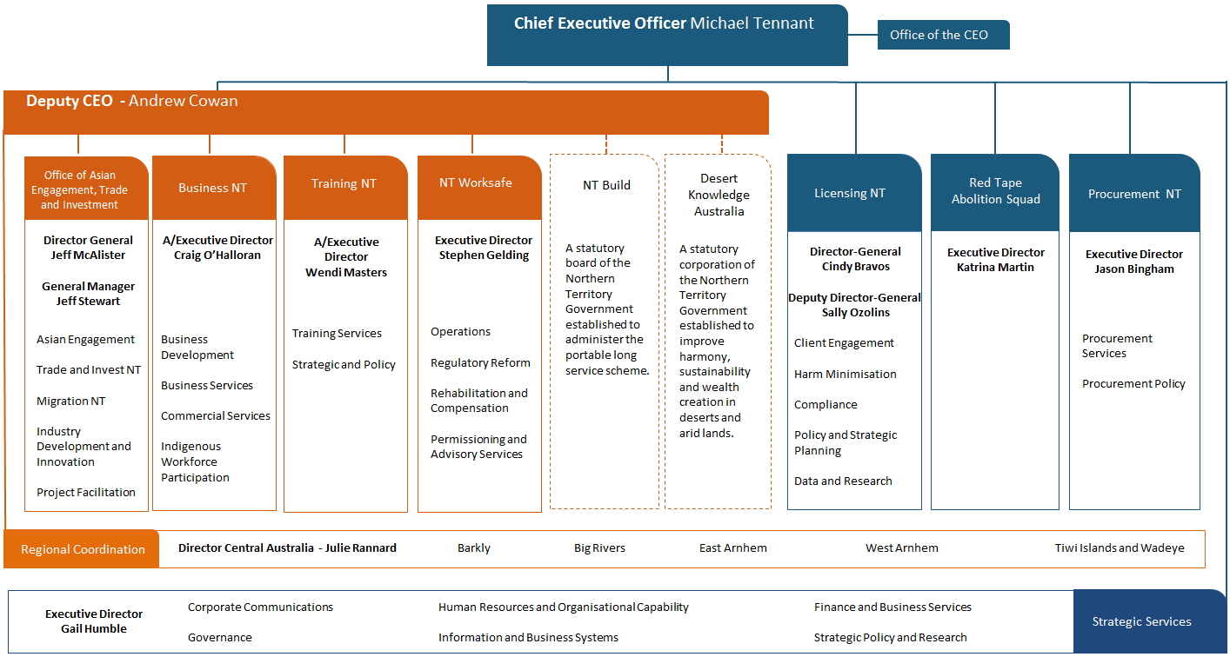

Executive

Income and expenditure at a glance
For further detail refer to Appendices E and F.

Revenue by source $'000
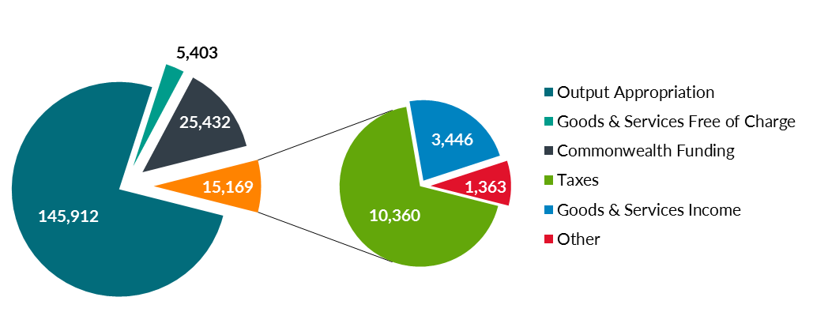

Expenditure by category $'000
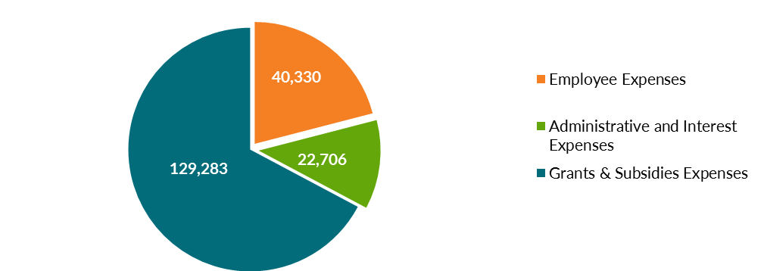

Expenditure by function $'000
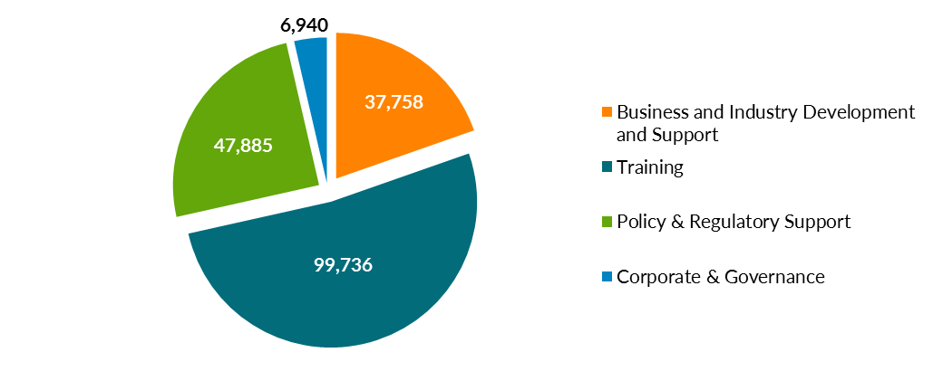

Corporate governance framework

Framework
The department’s governance structures aim to ensure outcomes are achieved in a way that enhances confidence in the department, its decisions and actions.
The department’s corporate governance is guided by the following principles:
- Performance: ensuring our governance arrangements positively contribute to overall performance and the delivery of our services and programs.
- Conformance: using our governance arrangements to meet legislative requirements, comply with necessary regulations and standards and satisfy expectations of probity, accountability and transparency.
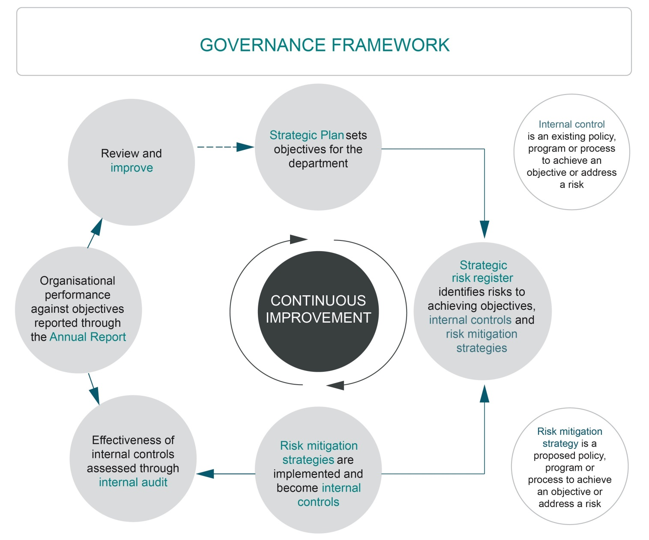
The department operates under a whole of enterprise approach to risk management. Strategies are set under corporate planning processes. Risks to achieving strategies are managed and performance against strategic objectives are measured and reported.

Structure
The following diagram describes the department’s governance, advice and decision-making structures.
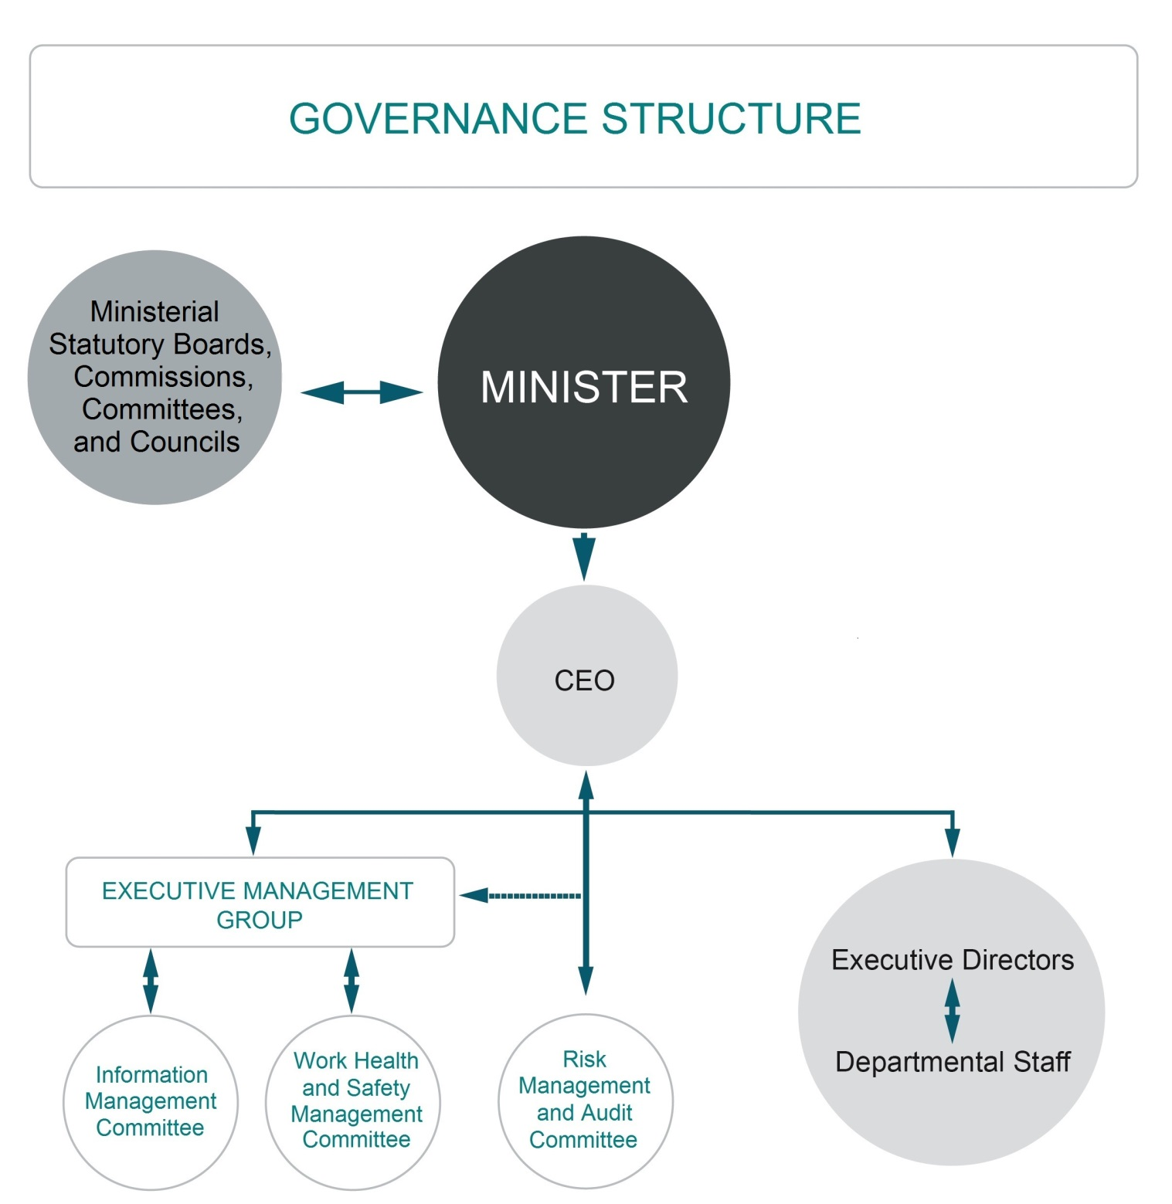

Strategic Directions 2015-2020 overview
The Department of Business Strategic Directions 2015-2020, sets out the department’s vision and purpose providing a platform for all departmental resourcing and planning activities. It sets out key priorities that support the department’s efforts to drive the right environment for business, industry and workers.
Strategic Directions 2015-2020 is a road map that enables the department to build on its growing role in the Northern Territory’s economic landscape.
The department’s operational structure and outputs are designed to underpin its strategic role and contribute to the vision of the Northern Territory being the best place to do business and work. This annual report is based on the output framework set out in Strategic Directions 2015-2020.

Corporate Communications
The Corporate Communications team manages the department’s marketing, public relations, media liaison and online presence including social media.
Corporate Communications partners with divisions across the department to deliver a proactive communications and marketing program through the year to:
- promote services, programs, events and initiatives that support Territory businesses and employees (local audience)
- showcase local business and employment successes to promote business confidence (local audience)
- position the Northern Territory as a preferred destination to live, work, invest and trade (national and international audience).

Access to information
The Director Information and Business Systems is the decision maker in relation to all Freedom of Information (FOI) applications.
In 2015-16, 28 FOI requests were received and actioned:
- 14 related to NT WorkSafe
- two were for Strategic Services
- one was for Licensing NT
- one was withdrawn
- two were transferred to another department
- one was transferred from another department
- one where the department was consulted as a third party
- two were internal reviews
- four enquiry advices were received and responded to.

Legislative framework
Under the Administrative Arrangements Orders, the department is responsible for the principal areas of government and administering the legislation detailed in Appendix A.

Governance bodies

Executive Management Group
The Executive Management Group (EMG) oversees high-level operations of the department from a governance point of view as well as setting the department’s goals and strategic direction. The Group acts as the responsible body for governance within the department. This includes:
- leadership and direction
- strategy and policy formulation
- organisation performance monitoring
- decision making
- probity and effective governance.
Its membership comprises the Chief Executive Officer, Deputy Chief Executive Officer, Chief Financial Officer and each of the Executive Directors.
The EMG met monthly during 2015-16 including two strategic planning days in February 2016 and June 2016. Three committees assist the Group in its operations:
- Risk Management and Audit Committee
- Information Management Committee
- Work Health and Safety Management Committee.

Risk Management and Audit Committee
The Risk Management and Audit Committee provides independent assurance and assistance to the Chief Executive Officer in the areas of statutory reporting, internal control systems, risk management systems, and audit.
Members are appointed by the Chief Executive Officer, and comprise:
- at least one external member who is the independent chairperson
- at least two Executive Directors (other than the Executive Director Strategic Services)
- at least one other department employee to provide a skill set relevant to the Committee’s role and a diverse view of the department’s operations.
The Committee met five times during 2015-16.

Summary of work performed during 2015-16
- Revised committee membership to ensure suitability and align with Terms of Reference.
- Monitored the Strategic Risk Register identifying key risks to the department achieving its objectives.
- Reviewed the Internal Audit Plan linked to the Risk Management Plan.
- Provided oversight of four internal audits in accordance with the Internal Audit Plan.
- Provided oversight of three internal audits as directed by the NT Government.
- Monitored the Register of Audit Findings.
- Provided an executive summary report to the Chief Executive Officer after each meeting.

Internal audits conducted for the period 2015-16
- Business NT, Commercial Services Audit
The objective of this audit was to review the effectiveness of management of grant programs in the Commercial Services Unit of Business NT.
- Strategic Services, Accountable Forms Audit
The objective of this audit was to review the management and use of accountable forms across the department.

- NT WorkSafe, Training Audit
The objective of this audit was to review the effectiveness of employee training programs in the NT WorkSafe division.
- Department of Business Compliance with Northern Territory Government Air Travel Policy Audit x 2
The objective of this audit was to review the compliance of the department with the NT Government Air Travel Policy.
- Payments to Mabunji Aboriginal Resource Corporation
The objective of this audit was to ensure that payments to Mabunji Aboriginal Resource Corporation were made in accordance with funding agreements and the requirements of the funding agreement had been met by the corporation.
- Latitude Travel Audit
The objective of this audit was to review the transactions with Latitude Travel and its affiliated entities for compliance with best value policies.

External audits conducted during 2015-16
- Australian Vocational Education and Training Management Information Statistical Standard (AVETMISS) Financial Data Audit undertaken by the Auditor General.
The department is responsible for the preparation and fair presentation of the Summary Australian Vocational Education and Training Management Information Statistical Standard (AVETMISS) Financial Data for the Northern Territory in accordance with the requirements of AVETMISS, The Standard for VET Financial Data.
The objective of this audit was to express an opinion on the certified AVETMISS financial data acquittal statement.
- Compliance Audit – Information Technology
The objective of this audit was to test the general computing controls associated with information systems (FAMS, Receipting and Tracking).
- Agency Compliance Audit
The objective of the audit was to access the Agency compliance with Treasurer’s Directions and the Financial Management Act.
- End of Year Review
The objective of this review was to access the adequacy of selected aspects of end of financial year controls over reporting, accounting and material transactions and balances, with the primary purpose of providing support to the audit or the Treasurer’s Annual Financial Statements.

Priorities for 2016-17
- Oversee the implementation of outstanding audit recommendations and any other audit findings that may arise during 2016-17.
- Monitor the review of the strategic risk register aligned with the Strategic Directions for the department and subsequent reviews throughout the year.
- Oversee the review of the operational risk register to align with business plans for 2016-17 and subsequent reviews.
- Monitor the review and implementation of the Internal Audit Plan.
- Continue to have oversight of the schedule of external non-financial audits.

Membership comprises:
Role | Position | Name
Independent Chairperson | Governance consultant and past Auditor-General for the Northern Territory (1995-2002) | Iain Summers
Secretariat | Manager Governance | Anna Collins
Member | A/Executive Director Training NT | Wendi Masters
Member | General Manager OAETI ¹ | Jeff Stewart
Member | Senior Director Alcohol Policy ¹ | Jane Alley
Member | Deputy Chief Executive Officer | Andy Cowan
Member | Director Central Australia | Julie Rannard
Member | Executive Director Procurement NT ² | Jason Bingham
Member | Director-General OAETI ² | Jeff McAlister
- Left the Committee during 2015-16.
- Joined the Committee during 2015-16.

Information Management Committee
The Information Management Committee (IMC) implements and monitors the department’s Information Communication and Technology (ICT) policies, strategies and performance.
The Committee ensures integration and alignment of ICT architecture and business objectives across the department and NT Government, ensuring oversight of department ICT projects and compliance with the NT Government ICT Governance Framework and Treasurer’s Directions.
The ongoing review and reporting of ICT activities ensures consistency with NT Government policy and the strategic objectives of the department, creating cost efficiencies and consistency in decision-making.
The IMC met three times during the 2015-16 year.

Summary of work performed during 2015-16
- Reviewed and updated the Committee Terms of Reference.
- Revised committee membership to ensure suitability and align with Terms of Reference.
- Developed and implemented the ICT Project Approval Framework.

Priorities for 2016-17
- Ensure alignment of key improvement initiatives with the long term strategic vision of the ICT Strategic Plan.
- Oversee the implementation of the department’s Customer Relationship Management System and Licensing and Compliance System.
- Continue to improve accountability in line with the Treasurer’s Directions through policy development and project approval/oversight.
- Oversee the ICT Systems Audit.
- Oversee the development of an ICT Systems Architecture.

Membership comprises:
Role | Position | Name
Chair | Deputy Chief Executive Officer | Andy Cowan
Secretariat | ICT Manager, Information and Business Systems | William Chin
Member | Director Corporate Communications | Wendy Pritchard
Member | Director Industry and Innovation (OAETI) | Chris Howard
Member | Director Information and Business Systems | Helen Perry
Member | A/Executive Director Business NT | Craig O’Halloran
Ex Officio Member | Director ICT Service Delivery and Contract Management (DCIS) | Ken Conway

Work Health and Safety Management Committee
The Work Health and Safety Management Committee assists the Chief Executive Officer to meet the department’s obligations under the Work Health and Safety Act.
The Committee ensures the department is engaging employees to identify and manage workplace risks through the support of workplace committees.
The composition of the Committee was adjusted during 2015-16 to align with the reviewed terms of reference. The previous Committee structure included representation from all workplace committees, with an Executive Director as Chair, and met twice during the 2015-16 financial year.
The new Committee includes representation from senior management and key department stakeholders who review and monitor compliance with work health and safety legislation. Workers are included in the department’s management of work health and safety through a representative from the workplace committees attending meetings on a rotating basis. The revised Committee met twice during 2015-16.
The Committee reports to the Executive Management Group on the cost and impact of workplace incidents including workers compensation claims and other workplace incidents reported through the online incident reporting system.

Summary of work performed during 2015-16
- Updated and issued the Work Health and Safety Policy.
- Updated and issued the Work Health and Safety Framework.
- Developed and issued Work Health and Safety Workplace Committee guidelines.
- Updated and issued Work Health and Safety Management Committee Terms of Reference.
- Revised Work Health and Safety Management Committee membership to align with Terms of Reference.
- Monitored and reported on the number and cost of new and existing Workers Compensation claims.
- Monitored and reported on the number of workplace incidents recorded in the online incident reporting system.
- Commenced a review of employee induction processes to incorporate self-guided Work Health and Safety awareness.

Priorities for 2016-17
- Continue to develop and implement a comprehensive employee Work Health and Safety induction process.
- Continue to ensure the department complies with its requirements under the Act.
- Continue to increase employee awareness of Work Health and Safety requirements through active workplace committees.
- Develop and implement health and wellbeing strategy including mental health awareness plan.
Membership comprises:
Role | Position | Member
Chair | Executive Director Strategic Services | Gail Humble
Secretariat | Executive Assistant | Caitlin Hatzivalsamis
Member | Director Human Resources | Shirley Wilkshire
Member | Director Central Australia | Julie Rannard
Member | Director Policy and Strategic Planning (Licensing NT) | Anna McGill
Member | Director Asian Engagement (OAETI) | Kate Walker
Member | Director Regulatory Reform  (NT WorkSafe) | Chris Wicks
Member | Manager Governance  (Strategic Services) | Anna Collins

Business Advisory Council
The Business Advisory Council is non-statutory and was created by the Minister to provide strategic advice on business issues and emerging trends. It has significant influence on the development of policy within the department and is included in this report for transparency.
The council provides advice on the services and functions of the department and promotes the expectations of the business community to the department and across government.
Members are business people representing a diverse range of industries and business types. Current membership includes representation from across the Territory.
The council met six times during the 2015-16 financial year.
As well as establishing frameworks and priorities for the conduct of the council, key achievements in 2015-16 included providing oversight and input to:
- business confidence
- procurement reform
- the development of the department’s Strategic Plan
- the economic growth of the Northern Territory
- major projects in the Northern Territory.
Membership comprises:
Role | Name
Chair | Rachel Beaumont-Smith
Member | Jared Baldwin
Member | Steve Brouwer
Member | Darren Clark
Member | Jason Elsegood
Member | Bruce Fadelli
Member | Karen Green
Member | Paul Graham
Member | Arthur Hamilton
Member | Michael Milatos
Member | Julie Newton
Member | Denys Stedman
Member | John Tourish
Member | Giovanna Webb

Performance reporting
Strategic Directions 2015-2020 focuses the department’s efforts to achieve the vision of the Northern Territory as the best place to do business and work. This report describes how the department has implemented the Strategic Directions to achieve results in:
- supporting business to start, run and grow
- developing industry and attracting investment
- simplifying doing business and working
- building and growing our capability.

Supporting business to start, run and grow
Deliver services and programs to support business and not-for-profit sustainability
Introduce an NT wide network of Business Development Officers. | Business NT introduced a network of 24 Business Development Officers (BDOs) servicing all regions of the Northern Territory from:  - Darwin (12)  - Alice Springs (6)  - Katherine (3)  - Nhulunbuy (2)  - Tennant Creek (1).  The BDO network is working with local businesses to help them start, run and grow by providing information and access to initiatives, services and support programs.  The BDOs also visit 15 remote communities to support the advancement of Indigenous business and wealth creation opportunities.
Deliver the October Business Month’s 21st Anniversary. | October Business Month (OBM) 2015 provided small to medium business owners with opportunities for professional development and networking.  9 332 people attended OBM events across the Northern Territory, which was an increase of 327 attendees compared to 2014.  There were 183 partner events held during OBM, which was an increase of 30 events from 2014. The public sector held 76 events and the remaining 107 events were held by private enterprises.
Deliver new NT business events. | The Open Territory program ran for the first time from 3 March to 31 May 2016. The program included a series of domestic and international events to profile business capacity in the NT, and highlight trade and investment opportunities alongside sport, arts and cultural events.  154 events were held that attracted 115 475 attendees across the Territory.  Attendees accessed a range of activities, networks and professional education sessions that provided both immediate and long-term benefits for participants.  The program provided opportunities for businesses to host partner events around five key themes:  - Arts and Culture  - Business through Sport  - Business through Technology and Communication  - Food and Agribusiness  - Trade and Investment.  The department designed the program, scheduling and marketing of events to increase the volume of international and inter-state visitation with a secondary focus on increasing the length of visits during the shoulder period to the peak tourism period.  Events included:  - Northern Australia Food Futures Conference  - Territory Taste Festival  - Business Technology Conference  - Chamber of Commerce Territory Expo  - Central Australian Mining Expo.  The following Open Territory events showcased the Territory to the International market:  - Red Carpet Investor Forum  - Regional Australia-Asia Chambers Forum  - Filipino Masterchef Challenge  - BIMP-EAGA NT Dialogue  - Timor-Leste Ministerial Forum  - Association of Southeast Asian Nations (ASEAN) heads of mission visit to Darwin  - The NT Expo  - Timor Sea Cup.
Deliver a suite of tailored programs to assist business and not-for-profits to start.run.grow. | The Industry Buildskills program provided funding to deliver industry specific training for existing workers. The program targeted employees who:  - required a qualification or recognised skills to continue working in their job  - desired a higher level qualification to increase their employer’s productivity.  Over $1 million was allocated to fund 13 projects in agriculture, automotive, aviation, building and construction, environmental management and hospitality.  The Business Upskills program provided practical, hands-on and informative workshops facilitated by industry experts to help 352 business owners develop and strengthen their businesses.  NT WorkSafe delivered the Small Business Safety Pilot Program. The program was a new initiative to assist small businesses to understand, comply with and manage their work, health and safety obligations. The program provides businesses with access to Small Business Safety Advisors who provide free workplace consultations.  The Business Growth Program provided $1.34 million in funding and services to run and grow 219 businesses, Indigenous enterprises and not-for-profit organisations.  The Indigenous Workforce Participation Initiatives Program supported businesses and employers, including those in the not-for-profit sector, to grow, develop and retain their local Indigenous workforce to help meet current and future demand. In 2015-16 the department invested over $1 million across 106 businesses, employing 332 people and enhancing the careers of 99 others.  Boosting Business in the Bush introduced business workshops to 123 participants across 15 remote communities. From these workshops, 10 individuals were identified as business ready and attended a Boosting Business in the Bush bootcamp in March 2016. A further 10 entrepreneurs were identified in the Tiwi Islands and attended a second bootcamp in early 2016. The bootcamps assisted remote Indigenous entrepreneurs to realise their business aspirations.  The Indigenous Business Development Program has invested over $1 million to support 59 Indigenous Territorians and Indigenous businesses to start or expand their enterprises.  The Smarter Business Solutions program provided over $610 000 in grants and provided assistance for 50 enterprises to adopt efficient, innovative technologies and best practices to reduce their energy, water, waste and material costs.  The Community Based Childcare support program provided $130 511 in grants to 19 childcare centres and engaged with 24 community based management committees to provide assistance to centres.
The Trade Support Scheme (TSS) and Business Innovation Support Initiatives (BISI) supported business and industry to develop new export markets and become innovative, productive, efficient and competitive.
- TSS approved $402 000 in funding across 68 successful applications.
- BISI funded $204 920 across 9 successful applications.
The department provided over $300 000 in funding for pre-employment training programs to support unskilled and semi-skilled people gain skills that help them take up and successfully complete a traineeship or apprenticeship, or to gain employment. Priority was given to programs that lead to employment in occupations with skills shortages and difficult-to-fill occupations.
Training NT supported six programs that covered electrotechnology, building/construction/mining, hospitality, trade entry and soft skills for migrants.
In May 2016 the NT government announced the Home Improvement Scheme as part of the 2016-17 budget. This scheme was a $20 million economic stimulus package to support small local businesses and tradies. As of 30 June 2016, 1 006 businesses had applied to participate with 807 homeowner applications received.

Deliver programs and services to support Aboriginal business and job creation
Contribute to the delivery of the Aboriginal Affairs Strategy. | Procurement reforms including the Remote Contracting Policy have supported Indigenous businesses to compete for contract work.  Procurement NT has helped improve the local content element of procurements to better identify remote and Indigenous opportunities in the planning stage, improve the consideration of these local content components during evaluation and monitor compliance with each successful tenderer.  The Indigenous Workforce Participation Program funded five new initiatives to support employers access a ready and available workforce in remote parts of the NT. These projects have put contracts in place to achieve job targets and have provided funding support for labour coordination projects that link employers to available workers and will be able to demonstrate results in 2016-17.  BDOs supported the advancement of Indigenous businesses through:  - monthly visits to remote communities  - delivery of Introduction to Business workshops  - facilitating access to the Business Growth, Smarter Business Solutions and Indigenous Business Development programs.  The Business Growth Program exceeded its target of supporting 15 Indigenous businesses, with 44 Indigenous enterprises accessing the program.  The department supported the economic development of remote communities through the Community Champions program, via its programs aimed at supporting and growing business in the bush. The department’s CEO is a community champion for Numbulwar and Ngukurr communities and made a total of 5 visits to these communities in 2015-16.  NT WorkSafe developed and commenced implementing a plan to consult with remote Aboriginal organisations to improve safety in the workplace and have NT WorkSafe representation embedded in the community.  NT WorkSafe’s remote visitation plan has resulted in 14 visits to the East Arnhem and Tiwi Island regions, with further visits planned for West Daly and Roper Gulf regions in the 2016-17 financial year.  Approximately 420 Indigenous people were employed through the JKC Industry Participation Plan.  The department has helped build the NT Aboriginal workforce to meet the needs of business and employers across the Territory for a skilled and available workforce through its grants programs and by working with individual employers through the Indigenous Responsive Program as per page 14.

Equip Territorians with vocational skills to get jobs and build careers
Deliver the 60th Anniversary NT Training Awards. | The NT Training Awards is an annual event that recognises achievements in training excellence by Territory businesses, training organisations, trainers, apprentices, trainees, students and employers.  Finalists are recognised as part of an elite group of ambassadors who represent the Territory’s best in vocational education and training.  The awards consisted of two categories, individual and organisational, with 11 awards in total.  Key highlights of the 60th Anniversary NT Training Awards include:  - Over 500 guests attended the Awards at the Darwin Convention Centre on 29 August 2015.  - Two Territorians were winners at the 2015 Australian Training Awards in Hobart in November 2015 in the Vocational Student of the Year and Aboriginal and Torres Strait Islander Student of the Year categories. A Territorian was also runner-up in the Australian Apprentice of the Year category.  The success of the NT Training Awards is supported by the work of Training NT.  Training NT provides funding to registered training organisation to deliver a broad range of vocational education and training programs in urban and remote settings, building the skills of Territorians to gain and maintain employment. For the 2016 calendar year, funding has been allocated as follows:  - $30.8 million to six training organisations for general skills development programs  - $22.48 million to 64 training organisations to deliver training to apprentices and trainees  - $397 000 to four organisation to deliver training and employment programs to equity groups.

Modernise and manage the Northern Territory vocational education and training (VET) system
Modernise Training NT’s business and funding models and legislation. | Training NT appointed consultants to develop a new funding and business model for VET in the Northern Territory. The new model will maximise the return on public investment and increase contestability in the training market. The consultants have started engaging with stakeholders and completed economic and labour market profiling. A new funding model will commence in 2017.  The ‘Industry Skills Advisory Council Northern Territory Inc.’ was established to provide industry based advice to government as well as VET advice and assistance to industry.  The Training and Skills Development Act commenced on 5 July 2016 replacing the Northern Territory Employment and Training Act. The new Act provides modernised legislation with a central focus on industry, training and skills needs.

Support workforce participation of Territorians
Launch ‘Training for the Future – Employer Support Scheme’. | This scheme commenced on 1 July 2015, and is available to all Northern Territory private sector businesses that employ apprentices and trainees at the Certificate III and IV level.  The Scheme comprises of three grants:  - A commencement grant of $1 000 paid when an apprenticeship/traineeship contract is recorded within the department’s apprenticeship database.  - A completion grant of $2 000 paid when the apprentice or trainee’s training record has been classified as completed in the database.  - A re-commencement grant of $500 paid to an employer who employs an apprentice or trainee at some other point during their training, for example an apprentice who leaves the employment of a previous employer.  Grants have been made to employers of apprentices/trainees as follows:  - 1 412 commencement grants.  - 589 completion grants.  - 221 re-commencement grants.

Increase the skilled workforce through interstate and international migration
Deliver the pilot worker participation project in partnership with business, CDU and the Kalymnos Council. | The department has worked closely with members of the NT Greek community to identify ways Greek skilled workers can fill local skills shortages.  At the request of the NT Greek community leaders, Migration NT has refocused its efforts to assisting Greek workers already in the Territory on temporary skilled work visas and their employers. Migration NT is exploring options for workers to remain in the Territory through either permanent residence or finding work beyond their first visa.  Migration NT and the Vice Consul of Greece held an information evening on 17 November 2015. The session was attended by 42 people who received information on work visa options and pathways to permanent residence.  Meetings have since been arranged with 22 individual Greek workers and employers to tailor information to their specific needs.
Implement the Designated Area Migration Agreement and workforce attraction programs. | The Designated Area Migration Agreement (DAMA) addresses workforce shortages specific to the Territory and came into effect on  9 August 2015.  Twenty-four NT businesses have lodged applications to access the NT DAMA this financial year. The department has endorsed 13 of those applications to the Department of Immigration and Border Protection. Three applications have been withdrawn, and Migration NT is working with the remaining eight employers to progress their applications.  Migration NT have continued to advocate to the Australian Government on behalf of local businesses and industry to ensure migration arrangements applied to regional Australia are fair, equitable and support business growth.  The NT Workforce Attraction Program participated in the following events:  - IDP Education Student Exhibition and Charles Darwin University agent briefings in Singapore, Vietnam and the Philippines  - in partnership with Charles Darwin University, the department conducted briefings for current international students on their work and migration options in India, Sri Lanka and Vietnam  - Business Skilled Migration and Trade and Investment Seminars in Malaysia, Vietnam, Brunei Darussalam and China  - dedicated NT Job Information Seminars in New Zealand, New South Wales, Tasmania and South Australia  - ‘Backpack the Outback’ event in Melbourne  - various information seminars for NT employers across the Territory.

Strengthen services to regional and remote areas
Finalise and implement the review of regional and remote training centres. | In October 2015, the NT Government approved the transfer of training centres to other departments and associations. The transfer of the centres had commenced by 30 June 2016 and will support a wider range of government and community initiatives and priorities.  Jabiru, Nhulunbuy, Angururu, Yirrkala, Milingimbi, Galiwin’ku, Borroloola, Papunya and Yuendumu Centres transferred to the Department of Local Government and Community Services.  The Katherine and Tennant Creek Centres were transferred to the Department of Education.  The department gifted the Kintore and Milikapiti centres to the McDonnell Regional Council and Jilmara Arts Association respectively as these organisations hold the lease on the land.

Help business to export
Build export and investment readiness. | Over 150 individual businesses participated in three export training workshops that aimed to broaden the NT’s base of potential new businesses to export.  The Winning International Business for the NT forums were delivered to over 250 business representatives during October Business Month.  The department supported the Chief Minister’s Northern Territory Export and Industry Awards coordinated by the Chamber of Commerce. The awards recognise and acknowledge the success of NT exporters.  The Trade Support Scheme (TSS) provided assistance to 68 business and industry associations towards the costs of international marketing activities. Recipients were from the tourism, primary industry, manufacturing, mining, education, services and Indigenous arts industries.  Recipients of the TSS have successfully marketed their products and services to:  - help their business establish new export markets of consumer products into China and clothing into the United States of America  - enable their tourism business to better understand the needs and requirements of Asian visitors and therefore attract a greater number of tourists from Asia to the NT  - increase specialty food and beverage exports into north Asia and into new markets.  Events such as the Northern Australia Investment Forum and the Red Carpet Investor Forum assisted NT businesses to develop and enhance their investment capability and profile.  NT companies’ capabilities were promoted to overseas companies at:  - NT Resources Week, August 2015  - Australian Oil and Gas Exhibition and Conference (AOG), February 2016  - 18th International Conference and Exhibition on Liquefied Natural Gas (LNG18), April 2016  - Food Futures Conference, April 2016  - Australian Petroleum Production and Exploration Association Exhibition and Conference (APPEA), June 2016.

Developing industry and attracting investment
Identify and facilitate opportunities to grow key industry sectors
Develop and contribute to industry development plans and actions for priority industry sectors. | OAETI worked on the following industry development plans and actions this year:  - The Northern Territory Crocodile Farming Industry Strategic Plan 2016-2021 was completed.  - The Onshore Oil and Gas Supply and Service Industry analysis was developed. Further research is ongoing.  - Development commenced on the NT Science and Innovation Policy and Strategy.  These publications provide valuable information to encourage new supply chain models and ongoing investment opportunities to support economic growth.

Identify national and international investment and export opportunities
Implement the Asian Engagement, Trade and Investment Strategy. | The department has developed the Asian Engagement, Trade and Investment Strategic Plan.  The Plan sets out the NT Government’s strategic goals and critical enablers to:  - increase exports  - increase foreign investment  - provide capacity building assistance  - ensure Northern Australia becomes the pre-eminent supply and service hub for the region by 2020.  The following key activities supported the Plan:  - The Australian Government’s Northern Australia Investment Forum showcased the diversity and scale of the exciting opportunities available in Asia and Northern Australia.  - The Red Carpet Investor Forum was held as a part of Open Territory 2016 to facilitate discussions between businesses and investors about opportunities in the Northern Territory.  - Delivered a coordinated program of inbound and outbound international trade and investment missions for NT business as outlined on page 44.  - The InvestNT website was renewed and updated and a new suite of marketing collateral produced.  - Re-engagement with BIMP-EAGA region to drive new trade, investment and business opportunities.  - OAETI participated in six international diplomatic forums to strengthen regional ties.

Develop, promote and facilitate investment in the Northern Territory
Build a pipeline of investment projects. | The investment pipeline currently includes 13 projects listed nationally with Austrade with a combined value of over $2.5 billion.  OAETI continuously worked with business and industry during the last 12 months to develop, strengthen and refine the pipeline of projects.  The department directly facilitated the NT Beverages investment of over $12.5 million into a new water bottling facility at East Arm, generating up to 20 new jobs and opening up new export markets in China and Indonesia.
Deliver a trade and investment readiness program for NT business. | OAETI coordinated and supported trade readiness activities with a range of government and industry associations, including Austrade, Export Finance and Insurance Corporation, the NT Branch of the Australia China Business Council, and the NT Farmers Association.  The following programs were delivered during 2015-16:  - Women in Global Business international business seminars were held in Alice Springs and Darwin during OBM.  - Winning International Business for the NT forums were also held during OBM. They highlighted the benefits of investment and services provided by the NT Government for attracting investment.  - Export readiness workshops were delivered in Darwin and Alice Springs in conjunction with the Chamber of Commerce NT as part of Open Territory 2016.  - Understanding Chinese Investors seminar was held in April 2016.

Play a key role to facilitate and deliver significant projects
Coordinate whole-of-government delivery of the Ichthys LNG Project. | OAETI coordinated the whole-of-government support for delivery of the Ichthys LNG Project. This involved:  - Developing and maintaining strong working relationships with INPEX and government agencies.  - Providing a secretariat function to the NT Government/INPEX Executive Coordination Committee and ensuring information was timely and accurate.  - Identifying and resolving issues to reduce impediments that may negatively impact on the project and/or social impacts to the NT.  - Reporting on the project’s progress to government.  - administering the Project Development Agreement.  - Managing whole-of-government media communications relating to the project.  - Overseeing the implementation of the Ichthys Project Industry Participation Plan to maximise local business and employment opportunities for the project. Over $8.7 billion will be expended through local business during the construction phase of the project and over 3 500 people have been employed locally (of which 10% are Indigenous).
Play a key role to facilitate and deliver significant projects
Maximise NT business outcomes from major projects. | The department continued to negotiate, implement and manage detailed Industry Participation Plans (IPPs) for major projects or government tenders worth $5 million or more.  Combined with the work of the Industry Capability Network NT (ICN NT), IPPs provided support to maximise opportunities for local business, including Indigenous owned enterprises, from the following projects:  - Ichthys LNG  - Northern Gas Pipeline.  As of 30 June 2016, cumulative spend commitments made within the Northern Territory economy by the Ichthys LNG project are in excess of $9 billion. NT local industry involvement in the project to date is supported through:  - JKC first tier sub-contractors have awarded 2 100 scopes of work to 860 NT based businesses  - additionally JKC has awarded 2 000 direct purchase orders and subcontracts to more than 390 NT based businesses  - 49 NT Aboriginal and Torres Strait Islander majority owned and controlled businesses have been awarded more than 340 scopes of work valued at in excess of $121 million  - direct locally-based employment through JKC and its subcontractors for the second quarter of 2016 was approximately 3 900 hired in the NT, of which approximately 11% were Indigenous personnel.  The department continues to monitor and work with other major project proponents to successfully conclude IPP agreements. The list of projects currently under development include:  - Mt Peake (Vanadium) Project  - Nolans Rare Earth Project  - Mt Todd Gold Mine  - Wonarah Phosphate Mine  - Ord Stage 3  - Darwin Ship Lift  - Marine Industry Precinct.

Strengthen the Northern Territory’s national and international engagement with priority partners
Deliver a coordinated program of inbound and outbound international trade and investment missions for NT business. | A coordinated program of international trade and investment missions provided NT businesses and industry bodies opportunities to engage with international companies and organisations.  There were 80 inbound missions from 15 countries and 14 outbound missions to eight countries to profile the Northern Territory’s strong economy and new trade and investment opportunities.  The Minister visited China, Taiwan, Hong Kong, Japan, Malaysia, Singapore and Timor-Leste and the department sent missions to Indonesia, China, Singapore and Malaysia.  Key events that received international delegations in the Northern Territory included:  - Association of South East Asian Nations (ASEAN) Heads of Mission NT Engagement visit  - Red Carpet Investor Forum  - the NT BIMP-EAGA Dialogue held in Darwin in April 2016  - an inbound business and government mission by Rizhao City (home of Landbridge Group).
Implement a new overseas representation model. | The department implemented a new overseas representation model to place locally recruited trade and investment practitioners overseas.  Service level agreements were signed with Austrade approving the placement of NT state specialists at the Australian High Commission in Singapore and the Australian Embassy in Jakarta.  The Indonesian representative was appointed in September 2015 and the Singapore representative was appointed in early May 2016.
Secure major events for the NT such as the Australia-Taiwan Business Council Joint Conference and the Northern Australian Investment Forum. | The major events hosted and facilitated by the department in  2015-16 were:  - the inaugural ASEAN Heads of Mission NT Engagement visit  - the Australia Taiwan Business Council conference, hosted in Darwin in September 2015  - the Australian Government’s Northern Australia Investment Forum, hosted in Darwin  - the Red Carpet Investor Forum, which exposed numerous domestic and international companies to NT opportunities  - BIMP-EAGA Ministerial Meeting and NT-Dialogue  - Timor-Leste Bilateral Northern Territory Ministerial Forum  - sponsorship and attendance at the Regional Australasian Chamber Forum  - the Territory Expo, hosted in Darwin in April 2016 as part of Open Territory.

Facilitate innovation and research partnerships
Develop a Science, Technology, Engineering and Mathematics plan. | The department commenced development of a Northern Territory Science and Innovation Strategy with an audit to identify supply and demand gaps of science, technology, engineering and mathematics (STEM) skills in the Territory.  The audit focuses on drivers of innovation and the development of initiatives to support the growth of existing industries and the development of new industries.  The NT Government approved the establishment of the Office of the Chief Scientist to provide high-level independent advice on matters relating to science and innovation. This Office has been created to maintain oversight of the results of the audit and development of a STEM policy and plan.

Simplifying doing business and working
Reduce regulatory and administrative red tape
Implement the Red Tape Reduction Strategy. | The Red Tape Abolition Squad (RTAS) released the Red Tape Reduction Strategy in July 2015. The following key elements have been implemented:  - A strong and rigorous Regulatory Impact Statement process was maintained.  - Draft department specific Red Tape Reduction Action Plans were developed. These action plans identify opportunities to reduce red tape across regulatory activities within the government.  - Three sector reviews, overseen by industry-based Advisory Councils, were completed by working with stakeholders to identify regulatory impacts and develop solutions to improve the regulatory framework. Reviews were completed for construction and development (with an approved Implementation Plan), tourism and hospitality, and non-government organisations.  - The Building Certifiers Panel was established by the department as part of implementing the recommendations of the Construction and Development Advisory Council sector review. The panel is investigating opportunities to streamline the building certification process.  - The Red Tape Reduction (Miscellaneous Amendments) Act 2016 was delivered. The Act saves time for approximately 1 000 individuals and businesses on licensing compliance through the introduction of longer licence terms for property agents, commercial and private agents, auctioneers, liquor wholesalers, and tobacco retailers.  - The department implemented common commencement dates for legislative changes.

Support employers and workers to understand and meet their workplace safety, licensing and statutory obligations
Deliver targeted safety education campaigns to identified high risk industries. | NT WorkSafe delivered the following targeted safety education campaigns and activities:  - In October 2015, NT WorkSafe Inspectors held consultation sessions with Shire Councils and local businesses in Jabiru, Oenpelli, Maningrida communities, as well as Ramingining. Nhulunbuy and Tiwi Islands communities in early 2016. Information from these sessions was used to form a Remote Community Engagement Strategy to improve the safety culture within remote communities.  - Consultation and work health and safety compliance checks were held in remote areas. Further safety education campaigns will commence in remote regions in 2016-17.  - A film focusing on the crocodile industry and how they use innovative techniques to manage some of their extreme risks was produced as part of the Australian Strategy Virtual Seminar Series. The seminars showcased the latest work health and safety thinking, developments, innovations and research.  - Engagement with the housing industry through informal events in Zuccoli.  - Education sessions were conducted with the transport industry to raise work health and safety awareness.  - An asbestos register campaign was completed with real estate agents and asbestos removalists.

Modernise and streamline licensing for liquor, racing, gaming, occupations and other business licences
Review and modernise legislation to ensure it meets the needs of the NT. | The Return to Work Act commenced on 1 July 2015 with additional amendments commencing on 1 October 2015. Key changes were the:  - introduction of presumptive legislation for career and volunteer firefighters  - inclusion of a simpler definition of “worker”, aligned to the Australian Taxation Office definition  - introduction of a five-year time limit for payment of benefits for non-serious claims  - exclusion of claims for injuries which occur during the journey to or from work  - introduction of provisions to allow for binding settlement of claims  - introduction of a requirement for approved workers compensation insurers and self-insurers to contribute towards the operating costs of the Work Health Authority (NT WorkSafe)  - introduction of enforcement provisions to allow the Work Health Authority to order work to cease where an employer does not have workers compensation insurance.  Following a period of public consultation three key changes were made to the Work Health and Safety (National Uniform Legislation) Regulations to reduce regulatory burden to businesses and workers. These changes:  - increased the construction project trigger point value from  $250 000 to $500 000  - ensured that construction induction cards will only be issued by the Regulator for consistency  - allowed licence and permit holders to notify the regulator of matters via phone, email or in person.  The Red Tape Reduction (Miscellaneous Amendments) Act 2016 removed common expiry dates for auctioneer, property agent and commercial and private agent licences, allowing longer licence terms and reducing red tape.  The Training and Skills Development Bill was passed by Parliament on 27 June 2016. The new Act will provide for modernised vocational education and training legislation with a central focus on industry, training and skills needs. The Training and Skills Development Act will repeal the Northern Territory Employment and Training Act.  The Racing and Betting Act was amended to:  - allow for the issue of Betting Exchange licences  - bring the NT in line with other jurisdictions to allow NT racing and sporting control bodies to levy a Product Fee for the use of their information by wagering operators.  Changes to licensing specific related legislation are outlined on page 49.
Modernise licensing for community gaming machines and liquor. | Licensing NT is modernising the application for licences by implementing an integrated licensing system as outlined on page 50.  Licensing NT implemented the following community gaming reforms that came into effect on 1 July 2015:  - Venue caps for hotels were increased from 10 to 20 machines and clubs from 45 to 55 machines.  - A levy was introduced on new gaming machine licence applications and applications to increase gaming machine numbers operated under an existing licence. The levy is payable on the number of machines applied for and did not apply to applications made prior to 1 July 2016 for machine increases sought up to the previous cap limit.
Review the occupational licensing Acts. | A review is being undertaken to look at consolidating building related occupational licences into a single Act.  The review applies to the occupations of architecture, building and building certification, electrical and plumbing and draining and will ensure that a modern building-related occupation licensing model is implemented in the Northern Territory.  The Minister established the Transitional Advisory Board in 2015 consisting of members from the department and industry. The Board met twice in 2015-16 and will continue to meet in the new financial year to provide specialised industry input into the review.  Due to a number of reforms being considered in relation to the building industry it was agreed in April 2016 that this review would be delayed by 12 months and is due to be finalised in 2017.
Implement changes to the Community Benefit Fund. | Licensing NT implemented the following changes to the Community Benefit Fund guidelines:  - casinos in the Northern Territory were required to contribute to the Community Benefit Fund as of 1 July 2015  - fund categories and their budgets were reviewed and expanded  - the frequency of major grant rounds was increased from two rounds per year to four, to be in line with small grant rounds  - the maximum small grant limit was raised from $5 000 to  $10 000  - a new ‘quick grant’ category was established.  Further details can be found in the Director-General of Licensing Annual Report 2015-16 and the Community Benefit Fund Annual Report 2015-16.
Deliver an integrated licensing system. | Production and implementation of an integrated licensing system has commenced and is expected to be delivered progressively over the next 12 months. The system will strengthen and simplify processes to manage licence applications and renewals.

Continuous improvement of the NTG procurement system including strengthening outcomes for local business
Introduce a simplified procurement framework. | Following extensive consultation, Procurement NT commenced implementation of the Buy Local Plan in January 2016. The Plan adopts an end-to-end lifecycle approach to procurement and contracting, containing nine key actions some of which include:  - mandatory local involvement in all requests for quotes worth up to $100 000, in addition to existing local content requirements for all tenders  - increasing the minimum weighting of local content from 20% to 25% in all government quotes and tenders  - ensuring that local content commitments included in tender responses are carried through into the contract terms and are monitored throughout.  Work is also underway to:  - strengthen contract management practices  - introduce a more contemporary Procurement Framework in 2017  - implement the NTPS Procurement Capability Strategy across agencies based on key needs and priorities by agency  - review the Standard Conditions of contracts across government.
Support Remote Contracting Policy to advance Aboriginal business and jobs. | The department supported the Remote Contracting Policy through:  - introducing procurement processes to support Aboriginal businesses compete for contract work such as: setting employment and business development targets, implementing new contract planning requirements and providing professional support services  - initiating an independent evaluation of the Aboriginal procurement policies  - supporting contractors to access a local workforce through skilling and labour coordination  - BDOs providing up front and on-going services to support local Aboriginal businesses develop and improve capability and capacity to direct tender or engage in joint venture arrangements under the new policy.

Facilitate community and industry led solutions to reduce alcohol and gambling related harm
Implement community and industry led alcohol harm minimisation initiatives. | Since 2012 the National Partnership Agreement (NPA) between the Australian and NT Governments on Stronger Futures in the Northern Territory has guided alcohol harm minimisation initiatives in communities. Alcohol Management Plans have played a large part in the NT Government’s plan to tackle alcohol abuse in the Territory.  The Minister approved Alcohol Management Plans for Tennant Creek and Alice Springs in October 2015 and February 2016 respectively. The Minister also reviewed membership of the Alcohol Reference Groups in Tennant Creek and Alice Springs to oversee the development, implementation and progress of the AMPs.  The Australian and NT Governments replaced the NPA on Stronger Futures with the NPA on NT Remote Aboriginal Investment in May 2016.  Licensing NT identified initiatives in 24 priority communities that have developed Alcohol Management Plans. The new NPA contains an Alcohol Schedule that operates under the Community Safety Implementation Plan and contains 41 Alcohol Action Initiatives (AAI). These AAI will be implemented in the 2016 calendar year with six funded in the 2015-16 financial year.  Further initiatives are being identified for consideration in the 2017 AAI Program of Works.

Position Territory Business Centres as a “one stop shop” for business and workers
Deliver a continuous improvement program for Territory Business Centre and online services. | Territory Business Centres (TBCs) had a record year with an increase of over 25 000 client contacts from the previous financial year to 161 334 client contacts in 2015-16.  Pop-up TBCs were opened throughout the year in Borroloola, Maningrida and the Tiwi islands.  A continuous improvement program was delivered for TBCs and online services through the following initiatives:  - In collaboration with NT Police, the ‘CrimTrac’ service was introduced in 2015. The majority of NT licence applications currently lodged through TBCs requiring a police history name check return an immediate result. The TBC has issued 679 Police History Results for clients this financial year.  - A new streamlined licensing service model was introduced, meaning a range of NT licences can now be lodged over the counter. This project has shown a 36% take-up of over the counter services in the past 12 months. The department aims to increase the number of licensing types delivered through its TBCs and continue to improve service transformation initiatives.

Building and growing our capability
Support a high performance culture and a safe and rewarding workplace
Strengthen our performance development and management system. | In October 2015 department employees with three months or more employment tenure participated in discussions with their manager as part of the MyPlan process. The MyPlan outlined employees’ goals and achievements in the prior 12-month period and their future goals and objectives for the following 12 months aligned to the Strategic Directions.  A review of the performance and employee development process has commenced as part of a new approach to the performance management system in 2016-17.  The department implemented the NTPS Recognition and Reward Program for employee years of service: 10, 20, 30, 40+ years.

Develop a skilled, engaged and diverse workforce that meets current and future needs
Develop a People Strategy. | The People Strategy is the result of extensive consultation and recognises the importance of people resources in achieving the department’s Strategic Directions. A draft Strategy will be subject to divisional input before its launch at the end of 2016.  The Strategy is supported by the Work Health and Safety Management Framework which includes:  - a revised policy  - management committee terms of reference  - reporting  - guides  - supporting tools to manage health and safety, and wellbeing in the workplace.

Ensure strong systems of governance and accountability
Enhance management and leadership capability. | The department supported employee participation at the following leadership courses:  - Australian and New Zealand School Of Government (ANZSOG) Leadership Development Program  - Intensive Negotiation Course  - Public Sector Management Program  - Future Leaders Program  - Discovery Women in Leadership  - Executive Leadership Program  - The Emotionally Intelligent Communicator Program.  Procurement NT facilitated the delivery of one Diploma of Government (Procurement and Contracting) course for 19 NT Government employees and four Certificate IV courses in Government (Procurement and Contracting) for 71 NT Government employees.
Review the agency wide grant management framework. | The department completed a review of the management of grant programs to deliver better outcomes for transparency and accountability. The Strategic Policy and Research Unit led the project in consultation with the Grants Policy Steering Committee.  The new Grants Framework provides guidance on the development and management of grants and grant programs within the department. Its purpose is to ensure that grants and grant programs align with the Strategic Directions of the department, provide the best value for government and the community, and are developed and managed in a way that is consistent, transparent and accountable according to best practice principles.  The policy came into effect on 1 July 2016 with a 12 month implementation plan.

Deliver integrated systems and solutions that improve business intelligence and performance
Deliver an agency wide customer relationship management system. | The Customer Relationship Management (CRM) System is in the late stages of development and scheduled for implementation in 2016-17. The CRM will support a client-centred approach to service delivery and provide a shared understanding of client profiles.
Contemporise information management systems. | The Information Management Unit continues to work with divisions to improve uptake of electronic document records management, including system integration with the department’s core business systems.

Continuously improve services and relationships with stakeholders and partners through open and collaborative communications
Improve engagement and evaluation tools. | The department worked across many divisions to develop and enhance engagement tools. Improvements included:  - Review of the Staff Toolkit to better provide an internal engagement tool allowing staff self-service access to information guiding them in the conduct of their duties.  - NT WorkSafe redesigned its website and reviewed all educational resources, such as Information Bulletins and Guides, to ensure accuracy and ease of use.  - NT WorkSafe continues to promote the use of a Work Health and Safety Toolkit for small business on its website.  - Training NT developed an industry engagement framework to guide better engagement with key industry stakeholders on vocational education and training matters.  - OAETI produced a new suite of marketing collateral to promote trade and investment opportunities. This included launching the NT Investment Prospectus, which focuses on attracting Asian investors, and developing engagement plans for three core international partner countries.  - Procurement NT is currently working on a number of reforms which will improve internal and external engagement throughout the procurement process, including implementing systems such as Tender Documents Online (TDO) and Contrax Management System.  - Procurement NT is currently undertaking a comprehensive review of the Procurement Directions.  - Developed and implemented a communications and media plan as per page 55.
Develop an agency marketing plan. | A whole-of-department marketing plan was delivered to ensure continuity, consistency and value for money in all marketing activity. Communication and marketing campaigns delivered included:  - a start.run.grow. campaign to encourage NT small businesses to access the suite of services available  - a Buy Local campaign to increase awareness and understanding of the new policy  - Open Territory and October Business Month event marketing and promotion  - interstate and international marketing to attract workers for hard-to-fill vacancies  - an information campaign to communicate new guidelines for the Community Benefit Fund  - campaigns to promote Vocational Education and Training options and the NT Training Awards and Skills, Employment and Careers Expo events  - the launch of the Asian Engagement, Trade and Investment Strategic Plan 2015-2020  - a campaign to promote and raise awareness of the Home Improvement Scheme.
Continuously improve services and relationships with stakeholders and partners through open and collaborative communications
Develop and implement a communications and media plan. | Corporate Communications developed and implemented a whole-of-department communications and media plan with a focus on showcasing local business and employment successes to promote business confidence. This included:  - generating over 120 good news stories featuring NT businesses and workers, and responding to over 145 media enquiries  - increasing the department’s social media audience from 180 to over 2 000  - coordinating 26 pages of magazine and 64 pages of newspaper feature content  - delivering 24 electronic business bulletins in a refreshed and mobile responsive format  - two television segments outlining the Territory’s economic environment for local businesses  - delivered an internal communications strategy which included the ongoing maintenance of a staff intranet site including a staff toolkit and service centre, fortnightly staff newsletters, whole-of-agency forums and structured internal meetings.

Empower, authorise, support, develop and hold to account our people
Refine the workforce model and structure to support an integrated approach to services. | Four divisions were restructured to better align operational, policy and systems activities and create greater synergies between and within divisions to enhance capacity to deliver department services. The newly restructured divisions are:  - NT WorkSafe  - Licensing NT  - Business NT  - OAETI.  The department implemented the Regional Enhancement Project by appointing Regional Coordinators in Alice Springs, Katherine, Tennant Creek, Nhulunbuy, Tiwi/Wadeye and Jabiru.  OAETI and Training NT were relocated to join Business NT at Development House.

Our teams will have contemporary knowledge of cross agency products and services
Continuously improve cross agency coordination and collaboration. | The department implemented the following changes and programs to improve coordination and collaboration within the department:  - The department’s governance structure was changed to replace Executive Director's with Director level representation at the Heads of Divisions meeting. This was rebranded as the Senior Leadership Group meeting.  - The department appointed Business Manager roles in divisions to improve divisional coordination and collaboration.  - Corporate Communications developed and implemented the whole-of-department communications and media plan.  - A department wide Customer Relationship Management System has been developed to centralise information about clients and support integrated client service delivery.  - NT WorkSafe Inspectors continue to work with BDOs and Department of Mines and Energy in remote areas.  - NT WorkSafe is working collaboratively across the department to jointly respond to client needs for capacity development and, where appropriate, to implement initiatives and support business and economic development opportunities.  - Whole of agency forum, Darwin, December 2015. The forum was attended by 250 staff from different department divisions where they discussed the strategic direction of the department and made presentations of their achievements.  The department also implemented the following changes to improve coordination and collaboration with other government departments:  - NT WorkSafe also works with other agencies on joint projects including Northern Australia Development Office (Department of the Chief Minister), Community Services and the Departments of Infrastructure, Education and Housing.  - Procurement NT delivered procurement reform upskilling sessions to 265 NT Government employees in line with various changes to procurement practices including the implementation of the Buy Local Plan and the Remote Contracting Policy.  - Procurement NT provided secretariat support to a number of committees including the Procurement Reform Steering Committee (PRSC), Procurement Review Board (PRB) and Local Benefits Advisory Panel (LBAP). These committees play a critical role in overseeing different aspects of procurement.  - Procurement NT provided further service delivery support to 18 smaller NT Government agencies which do not have their own procurement teams.  - OAETI has established a Senior Officers Working Group on innovation to coordinate and develop a culture of innovation across government and business. The Group has met monthly since it was established in March 2016.  - Procurement NT provided centralised policy advice and support to NT Government departments.

Human Resources & Organisational Capability
The Human Resources & Organisational Capability Unit works consultatively with leaders, managers and employees to enhance organisational capability and build a high performance culture and practice that aligns human resource management with operational business needs and strategic outcomes.
The Unit aims to ensure its people are valued, engaged and connected to create a culture of integrated client centred service delivery.
Through a consultancy model, the Unit provides services across the department including:
- strategic advice on complex HR management issues such as:
  - employee and industrial relations
  - employment conditions and legislation
  - change management
  - workers compensation
  - early intervention
- human resource reporting and workforce planning through analysis of business intelligence from internal business systems and partnerships with business units
- creation and implementation of workforce development activities
- advice on recruitment, retention and selection
- coaching on people management matters such as performance and development.

Department employee statistics 2015-16 compared to 2014-15
 | 2015-16 | 2014-15
Full time employees (FTE) | 357.8 | 346.8
Permanent employees (adjusted paid employees) | 291 | 277
Employee turnover | 17% | 15.3%
Average age of employee | 45.7 | 46.5
Sick leave days used per person (average) | 11.1 | 8.3
Recreation leave used per person (average) | 26.7 | 23.2
Long Service days used per person (average) | 3.9 | 3.16
Leave without pay used per person (average) | 20.8 | 14.5
New industrial relation claims | 0 | 0
Employees on executive contracts | 7.9% | 6.9%
Part time employees | 13 | 11
Female employees | 63.8% | 62%
Male employees | 36.2% | 38%
Employees aged between 30-50 | 52.0% | 48.9%
Workers compensation claims | 4 | 3
Formal disciplines invoked | 2 | 1
Redundancies | 2 | 3
Identified as being Aboriginal or Torres Strait Islander | 27 (7.4%) | 20 (5.8%)
Employees from non-English speaking background | 7 (1.9%) | 8
Employees identified as having a disability | 7 (1.9%) | 6
Actual spend on training | $354 698 | $383 676

Employees by division (adjusted paid employees)
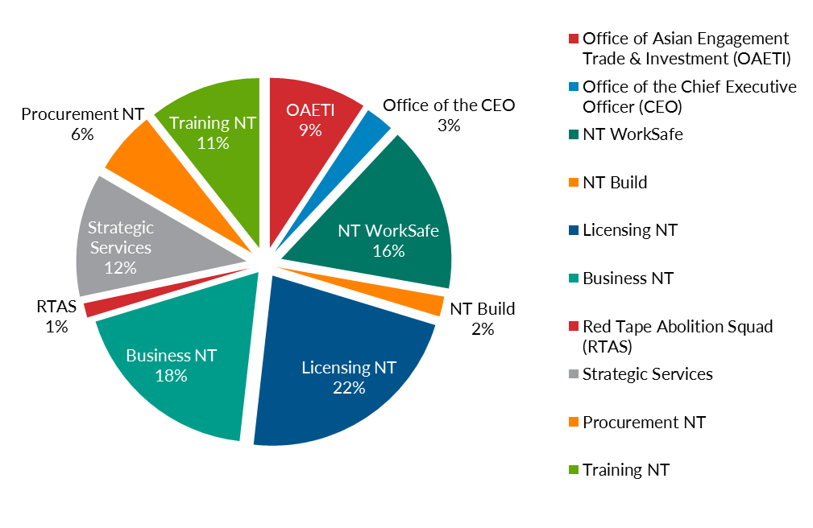

Years of service by employees (headcount)
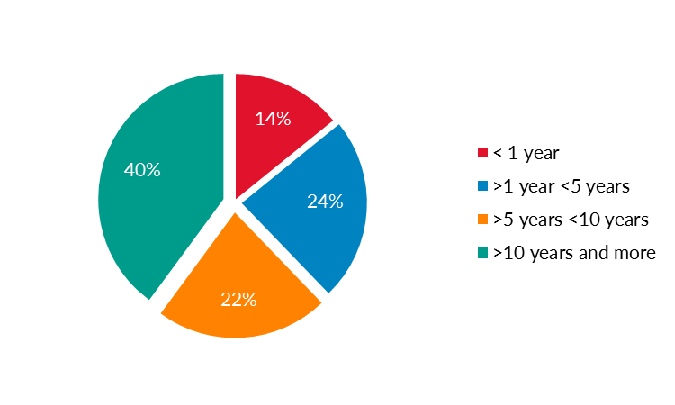
Department teams are experienced professionals with 62% having worked in the Northern Territory Public Sector for more than five years. 40% of employees had more than 10 years’ service.
Of employees entering the department’s workforce, 14% have less than a year service, which likely indicates they have commenced their public sector careers with the department.

Employees by age and gender (adjusted paid employees)
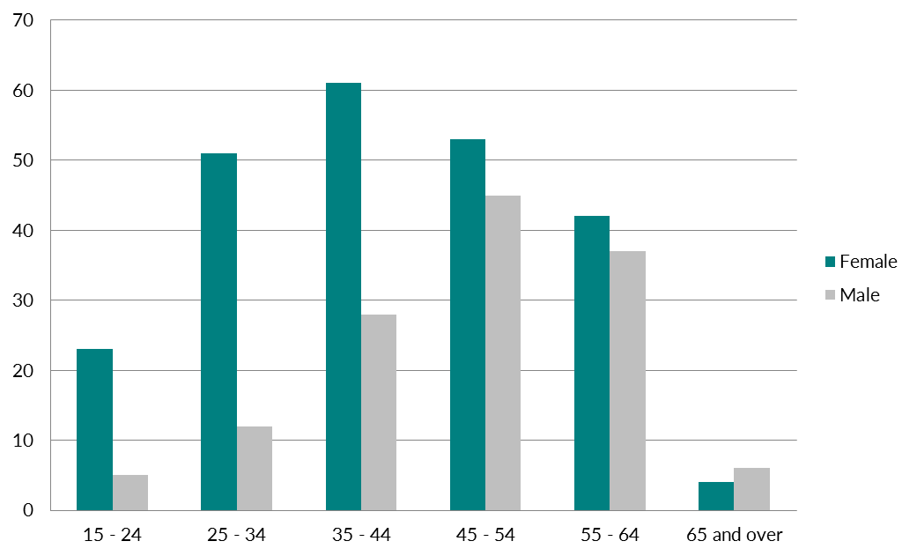

Employees by classification and gender (adjusted paid employees)
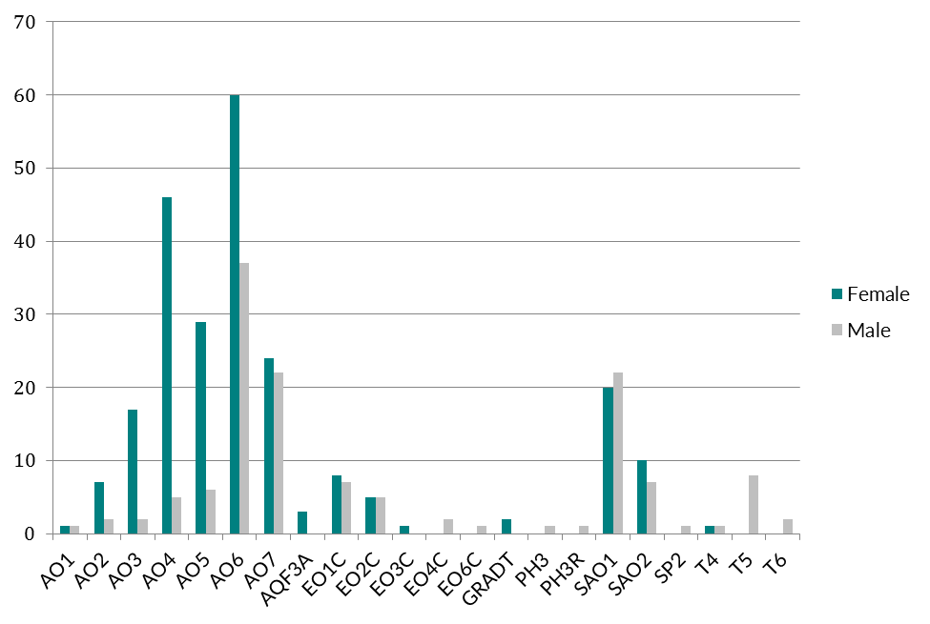

Employee type (adjusted paid employees)
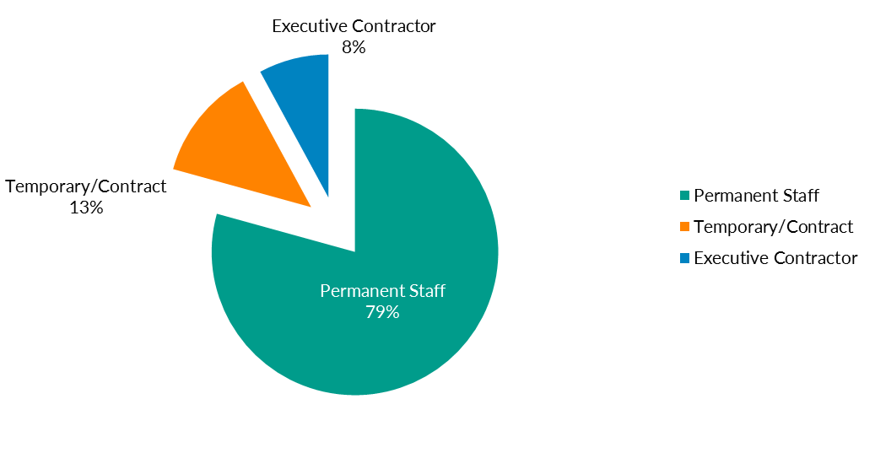

Employee turnover
Employee turnover for the year was 17%, excluding transfers to elsewhere in the Northern Territory Public Sector.

Redundancies
Two ongoing employees received voluntary redundancies in 2015-16.

Expenditure on learning and professional development
The department supports employees to pursue learning activities which enable them to more effectively carry out their work responsibilities and achieve business objectives. Targeted skill development is facilitated through a range of activities including mobility, mentoring, cross-divisional projects, study, courses, leadership programs and on-the job learning.

Early careers programs
At 30 June 2016, the department had four trainees completing their studies, three graduate trainees under our Graduate Development Program and one Indigenous Employment Program participant. Engagement of additional recruits is planned for the 2016-17 financial year.
In 2015-16:
- one trainee with a disability graduated
- one Indigenous Employment Program participant graduated.

Diversity
People from all backgrounds are encouraged to apply for positions and advertised short-term opportunities to promote equity.
The department’s Aboriginal and Torres Strait Islander (ATSI) Special Measures Plan commenced in 2015-16, providing ATSI applicants with priority consideration in recruitment processes. ATSI employee numbers have increased from 20 to 27 (7.4%) during 2015-16, and will remain a priority for the department through 2016-17.
The number of employees identifying as being from a non-English speaking background decreased over the reporting period, from eight to seven employees in this category.
The number of employees identifying as having a disability increased from six in 2014-15 to seven in 2015-16.

Industrial relations
No industrial relations claims were lodged against the department by employees during 2015-16.

Flu vaccinations
126 employees chose to participate in the department’s flu vaccination program. Vaccinations were provided free-of-charge.

Workers Compensation
Four workers compensation claims were lodged during 2015-16. A range of policies, procedures and reporting mechanisms have been embedded to promote a proactive approach to early intervention, risk and injury management in the workplace.
Information on the workers compensation process is available on the intranet and included in the employee induction program. As an early intervention approach, employees are supported with services to assist with resolution of workplace issues without lodging a workers compensation claim.

Flexible working arrangements
The department values work-life balance and currently supports a number of family friendly and flexible working arrangements that meet the needs of the office and employees. These arrangements include working part-time, flexible work hours, use of recreation and long service leave at half pay, purchasing additional leave and home-based work. As at 30 June 2016 there were 13 part time employees which is an increase of two from the prior year.

Employee assistance
The employee assistance program (EAP) allows employees and their family to access free, confidential counselling. These services are available for any issue for which an employee may need assistance and advice.
Employees can choose counselling sessions from the NT Government panel of providers. Employees are able to access up to three visits for any particular matter. Should additional visits be recommended, this is addressed on a case-by-case basis. If employees are comfortable advising their supervisor that they have an appointment with an EAP provider, they are not required to make up the appointment time or use leave to cover their absence from the workplace.
In 2015-16, over 91 employees or family members accessed this program, with over 104 sessions attended. This is an increase on 2014-15 where 50 employees or family members accessed 91 sessions.

Reporting against Employment Instructions
As required under the NT Public Sector Employment and Management Act, the department’s performance against each Employment Instruction is reported below.
Employment instruction | Agency actions
Filling vacancies  Agency must develop a procedure for filling vacancies consistent with the Act, its subordinate legislation and any relevant award or enterprise agreement. | The agency implemented streamlined recruitment processes and a special measures plan, providing for priority consideration of Aboriginal and Torres Strait Islander applicants.  Merit selection training numbers: 143  Agency recruitment actions:  - 133 vacancies advertised (68 Ongoing and 65 Fixed Period)  - 77 new commencements to the NT Government  - 49 transfers in from other public employers  - 51 Separations (resignations)  - 40 Transfers out (to other public employers).
Probation  Agency must develop a probation procedure consistent with the Act, its subordinate legislation and any relevant award or enterprise agreement. | Probation guidelines and procedures were reviewed to improve performance planning, feedback, monitoring and development.  Agency probation statistics:  - 27 Probation Confirmations (at 6 months)  - 4 Probation Extensions with Development Plans  - 0 Probation Terminations.
Natural justice  The principles of natural justice are observed in all dealings with employees and are reflected in relevant policies and procedures. | Information on the application of natural justice is provided through induction, information sessions and through specific case management. Natural justice is applied to all appropriate processes.
Employee performance and development systems  Agency must develop and implement a performance development system consistent with the Act, its subordinate legislation and any relevant award or enterprise agreement. Agency to report annually to OCPE on management, training and employee development programs. | Department employees MyPlans are completed and submitted to HR annually. The MyPlan is based on individual performance and development and establishes a link between individual performance, position responsibilities, department values and strategic objectives. The process allows for future planning activities and training to meet the needs of the individual and the work unit.  In 2015-16 Human Resources completed an in-depth review of the current performance development system to identify and develop a number of improvements for implementation in 2016-17.
Medical examinations  Agency may engage a health practitioner in accordance with the Act and Employment Instruction Number 3. | Medical examinations may be arranged for a number of reasons under the Act or relevant enterprise agreement. These referrals are managed by Human Resources in relation to case management matters and are highly confidential.  The agency has internal operating procedures for medical referrals and all referrals are provided in writing to the employee.  One employee was referred for an independent medical examination in 2015-16.
Performance and inability  Agency to provide OCPE with information relating to performance and inability. | The agency supports employees through our performance framework, which includes regular performance feedback and development. Information on our performance framework is available on the intranet.  Formal performance and inability processes under the Act are managed by Human Resources in relation to case management matters and are highly confidential.  There were no formal performance and inability processes during 2015-16. All performance concerns were successfully managed and resolved through performance development processes.
Discipline  Agency may develop discipline policy consistent with the Act, its subordinate legislation and any relevant award or enterprise agreement, and to provide OCPE with information relating to disciplinary processes. | Agency information on managing employee performance is available on the staff intranet. Supporting information in relation to staff conduct, delivery of services and use of government resources is delivered through the induction program.  Disciplinary matters are resolved through appropriate management actions with the support of the Human Resources Unit and in accordance with department procedures and OCPE instructions.  There were two formal discipline processes during 2015-16.
Internal agency complaints and section 59 grievance reviews  Agency will develop an internal employee grievance handling policy and procedure consistent with the Act, its subordinate legislation and any relevant award or enterprise agreement. | The agency has an Internal Complaints Resolution Procedure available to staff and Managers.  Formal complaint processes under the Act are managed by Human Resources in relation to case management matters and are highly confidential.  There were three formal complaints processes during 2015-16.
Employment records  Agency must comply with the requirements of the Information Act (NT) regarding correction, collection and handling of personal information contained in an employee’s employment record. | In conjunction with the Information Management Unit, Human Resources has an approved file plan and ensure that any information detailed under Employment Instruction number 9 is placed on an employee’s personnel file.
Equality of employment opportunity programs  Agency must develop an Equality of Employment Opportunity Program consistent with the Act, its subordinate legislation, the Anti-Discrimination Act and any relevant award or enterprise agreement. Agency to report annually to OCPE on programs and initiatives. | The agency is currently finalising a People Strategy that includes an Indigenous Employment and Career Development Plan. There is currently a Special Measures plan in place to provide priority consideration to Aboriginal and Torres Strait Islander applicants and several individual disability support plans for current employees.  In 2015-16 the agency developed a cultural competency communication information session and toolkit that is aligned to our client-base and the diversity of our employees.
Occupational health and safety standard programs  Agency must ensure the application of appropriate occupational health and safety (OHS) standards and programs. | The agency has Work Health and Safety (WHS) Policy and Framework that is monitored through a WHS Management Committee with representatives from a range of workplace locations. Workplace Committees are established to assist the department meet its safety obligations to staff and promote WHS awareness in the workplace. Information is available on the intranet.  In 2015-16 there were 27 incidents registered, compared with 18 in 2014-15.
Code of conduct  The Code of Conduct stipulates the basic level of conduct expected of public sector officers as defined in the Act. | The agency provides information on code of conduct through induction/orientation processes, the intranet and a range of HR information sessions and case management matters. Code of conduct is also promoted through sound management practices.  Breaches of the code of conduct are addressed immediately and appropriately.
Appropriate workplace behaviour  Agency must develop and implement a policy and procedure to foster appropriate workplace behaviour and a culture of respect, and to deal effectively with inappropriate workplace behaviour and bullying. | Information concerning appropriate workplace behaviours is delivered through the staff induction process. Behaviours are reinforced through modelling sensible leadership behaviours and respect.  Inappropriate workplace behaviours are addressed immediately in collaboration with Human Resources, management and the employee/s.
Redeployment and redundancy procedures  Agency must ensure redeployment processes are consistent with the Act, its subordinate legislation and any relevant award or enterprise agreement, and that redeployees are provided with an appropriate level of assistance and case management. | The agency actively manages redeployee and unattached employees to find new ongoing positions. Where required, additional support is provided through development activities to enhance an employee’s appeal and resume. Similarly, where the agency employs a former redeployee, performance development is provided in the new role.  In 2015-16 the agency had seven redeployees, successfully placed two and is providing meaningful temporary placements to the remaining five. There are currently four unattached officers on long-term.
Special measures  Agency must ensure the application of appropriate Special Measures Plans consistent with the Act, its subordinate legislation, the Anti-Discrimination Act and any relevant award or enterprise agreement. | The agency has two special measures plans in place.  Disability Employment  Of the seven employees that identify as having a disability, two are employed under the NTPS EmployAbility program and are supported in the workplace through individual disability support plans.  Aboriginal and Torres Strait Islander people (“Aboriginal people”) Special Measures Plan  The agency has consistently exceeded targets, as set out in the document, ‘Enhancing Indigenous Participation’ (September 2014). The agency annual Aboriginal employment targets for 2015 and 2016 were 4.4% and 5% respectively, and by 2020 the target is 8%. The agency is well on the way to exceeding all future targets.  The agency currently have 27 employees (7.4%) identifying as Aboriginal employees.  The agency fully implemented its Aboriginal Special Measures Plan in December 2015.  Special Measures Statistics:  - 63 vacancies advertised under special measures  - 85 special measures applications received  - 13 found successful  - 32 found unsuitable  - 40 still pending recruitment.  - 1 vacancy advertised with an approved exemption for special measures from the Commissioner for Public Employment  Of the 1 098 applications received in 2015-16, only 7.7% were from special measures applicants.

Performance reporting against output groups – Key Deliverables

Business NT ¹ | 2014-15  Actual | 2015-16  Budget | 2015-16  Actual
Contacts with the TBC for licence and business services | 136 499 | 120 000 | 161 334
October Business Month participation ² | 9 005 | 7 000 | 9 332
October Business Month participation satisfaction | 97% | 94% | 95%
Upskill Workshop participation ^{2,3} | 759 | 700 | 511
Upskill Workshop participation satisfaction | 96% | 95% | 99%
Number of businesses assisted through the Business Growth Program | 186 | 200 | 219
Value of grants and sponsorships to support business and industry development | 7.08M | 6.6M | 9.9M
Indigenous Workforce Participation: ^{2,4}
- Additional people in jobs | N/A | 260 | 332
- Supported businesses and organisations | N/A | 40 | 106
- Due to a restructure in 2015-16 three measures moved to Asian Engagement, Trade and Investment.
- New measure.
- Due to an increase in costs, fewer workshops were run which limited participation numbers.
- Variation from budget due to increased employment outcomes and employers being supported through labour coordination and mobility projects.
Strategic Policy | 2014-15  Actual | 2015-16  Budget | 2015-16  Actual
Labour market and economic fact sheets issued ¹ | 61 | 40 | 46
- Previously under Business Engagement.
Red Tape Abolition Squad | 2014-15  Actual | 2015-16  Budget | 2015-16  Actual
Reduction in annual licence and permit renewal ^{1, 2} | N/A | 10% | 40%
Reduction in reporting requirements ^{1, 3} | N/A | 10% | 4.8%
Increase in transactions online ^{1, 4} | N/A | 10% | 1%
- New measure. Results for 2015-2016 represent the change between March 2015 and June 2016. For future years, the change will be measured from 1 July to 30 June.
- Target was exceeded as a result of a focused effort on this element of the Red Tape Reduction Strategy.
- The defined baseline of reporting requirements was lower than expected which resulted in fewer opportunities to reduce red tape in this area.
- Transaction is defined as a permit, licence, registration, or approval. Progress toward the target was affected by delays in the implementation of online systems.
Procurement NT | 2014-15  Actual | 2015-16  Budget | 2015-16  Actual
Level of business and industry satisfaction with procurement reform program¹ | 80% | 80% | 80%
Quality of service and advice provided to client agencies¹ | 80% | 80% | 80%
- New measure.

Asian Engagement, Trade and Investment | 2014-15  Actual | 2015-16  Budget | 2015-16  Actual
Stakeholder satisfaction with advice on strategy, policy and operational initiatives¹ | -- | >85% | 75%
Stakeholder satisfaction with facilitation of trade and investment opportunities for Territory companies¹ | -- | >85% | 80%
Stakeholder satisfaction with Trade Support Scheme¹ | -- | >85% | 85%
Number of sub-contract commitments benefiting local business from the Ichthys LNG project ² | 899 | 500 | 750
Territory Worker database registrations: ^{2, 3}
- International | 397 | 600 | 322
- Interstate | 357 | 500 | 245
Business and skilled migration visas for nominations  and sponsorships assessed ^{2, 4} | -- | 1600 | 1 356
- New measure.
- Due to a restructure in 2015-16 this measure moved from Business NT.
- Promotion of the database was reduced due to an internal review of database functionality, which led to fewer registrations.
- Revised methodology, deliverable previously measured nominations and sponsorships certified, not assessed, the 2015-16 budget figure has been modified to reflect estimate figures in 2016-17 Budget Paper No. 3.

Training NT | 2014-15  Actual | 2015-16  Budget | 2015-16  Actual
Apprenticeship and traineeship commencements¹ | 2 936 | 2 800 | 2 135
Apprenticeship and traineeship completions ^{1, 2} | -- | 1 200 | 1 084
Training participation rate ^{2, 3, 4} | -- | 10% | 12%
Successful training completions ⁵ | 75.6% | 80% | 83%
Proportion of graduates in employment or further  study ^{2, 3} | -- | 90% | 90%
Proportion of graduates satisfied with overall quality of their training ^{2, 3} | -- | 85% | 87%
- Numbers have been declining since a peak in 2010, which is in line with broader national trends.
- New measure.
- Figures are for the 2014 calendar year activity, national reports are published during the 2015-16 Year.
- Based on 15 – 64 Year olds.
- Figures are for the 2015 calendar year activity.

Licensing NT | 2014-15  Actual | 2015-16  Budget | 2015-16  Actual
Alcohol management plans community sign off ^{1, 2} | 24 | 29 | 24
Alcohol management plans developed/implemented ^{1, 3} | 35 | 35 | 35
Value of community benefit fund grants ⁴ | 1.9M | 11.9M | 8.0M
Licences and authorities administered ⁵ | 25 154 | 24 000 | 30 202
Operational visits undertaken | 1 251 | 1 000 | 1 164
Race meetings conducted in the Territory ⁶ | 125 | 126 | 125
Grant funding to Thoroughbred Racing NT ⁷ | 14.747M | 14.7M | 14.475M
Grant funding to Darwin Greyhounds Association ⁷ | 0.685M | 0.6M | 0.570M
Building practitioners registered ⁸ | 2 423 | 3 500 | 2 599
- This number is cumulative.
- Due to the new NPA signed in May 2016 the focus shifted to Alcohol Action Initiatives.
- The Alcohol Management Plans (AMPs) for Tennant Creek and Alice Springs were already included in the 35. They are reviewed AMPs and therefore do not increase the 2015-16 actual figure.
- Budget increased following additional funding for the Community Benefit Fund. 2015-16 actual figures are lower than expected due to a timing issue between the awarding of grants and the actual payment made. It is anticipated this issue will only affect 2015-16.
- Increase from budget is due to the addition of electrical, plumbing and architectural licences, which were moved to the department in late 2014-15 and were not included in the 2015-16 budget.
- Previously reported under the Department of Sports and Recreation.
- New Measure for 2015-16 however data is available for 2014-15.
- Previously reported under the Department of Lands, Planning and the Environment. The decrease reflects a modernisation in construction activity.
NT WorkSafe | 2014-15  Actual | 2015-16  Budget | 2015-16  Actual
Completed workplace visits | 5 947 | 6 000 | 6 016
Workers compensation mediations ¹ | 302 | 300 | 400
Information session/education campaigns ² | 157 | 50 | 271
Licences issued ³ | 11 184 | 9 000 | 13 185
NT WorkSafe enquiries | 28 205 | 30 000 | 29 433
- Workers compensation mediation numbers have increased due to claimants having an increased awareness of their appeal rights and a preparedness to challenge decisions made by insurers
- NT WorkSafe has broadened their definition of Information / Education Sessions to include presentations by Inspectors at Toolbox meetings.
- Licences issued has increased due to:
  - business licences issued being captured in reporting
  - a year of capturing NT White cards issued
  - extension granted to High Risk Work Licence holders to allow an upgrade after 1 July 2015.
- The implementation of work, health and safety legislation has settled resulting in fewer enquiries.

Corporate and Governance | 2014-15  Actual | 2015-16  Budget | 2015-16  Actual
Client satisfaction with services | 71% | 80% | 71%
Staff satisfaction with leadership and direction | 73% | 80% | 81%

Appendix A

Statutory responsibilities / legislation administered
The department is responsible for the following principal areas of government and for administering the legislation detailed below.

Areas of government Please read in outline view for best navigational experience.
- Alcohol management plans
- Alcohol policy
- Apprenticeships and traineeships
- Asian engagement
- Assistance to Desert Peoples Centre
- Business and industry development
- Business and skilled migration
- Casinos, gaming, wagering and lotteries
- Co-operatives
- Dangerous goods
- Desert Knowledge Australia
- Developing industry and attracting investment
- Electricity Safety Regulator
- Explosives
- Financial assistance to industry associations and business
- Horseracing, trotting and greyhound racing
- Incorporated associations
- Indigenous business enterprise support
- Indigenous workforce participation
- Industry, economic and labour market analysis
- Industry participation
- International investment promotion
- Licensing and regulation of liquor, kava, tobacco, agents and sex workers
- Major Project facilitation
- Northern Territory Employment and Training Authority
- NT Build
- Occupational licences relating to the land use, including building work
- Occupational licences relating to the other areas of government allotted to the agency
- Procurement policy
- Procurement Review Board
- Private security industry
- Quality of training
- NT Racing Commission
- Red tape reduction
- Research and innovation
- Safety regulation
- Smoking in liquor licensed premises
- Totalisators
- Territory Business Centres
- Trade development, strategy and policy
- Training and employment programs and assistance schemes
- Vocational education and training administration
- Work health and safety
- Work Health Authority
- Workers rehabilitation and compensation
- Workforce attraction (international and interstate)

Legislation
- Agents Licensing Act
- Architects Act
- Associations Act
- Auctioneers Act
- Auctioneers Act Repeal Act
- Building Act (provisions relating to the regulation and licensing of occupations)
- Business Names (National Uniform Legislation) Implementation Act
- Business Names (National Uniform Legislation) Request Act
- Commercial and Private Agents Licensing Act
- Construction Industry Long Service Leave and Benefits Act
- Consumer Affairs and Fair Trading Act (Parts 3, 10 and 14)
- Co-operatives (National Uniform Legislation) Act
- Dangerous Goods Act
- Desert Knowledge Australia Act
- Electricity Reform Act (provisions about safety regulation)
- Electrical Workers and Contractors Act
- Gaming Control Act (except provisions about taxes and levies)
- Gaming Machine Act (except Part 8)
- Ichthys LNG Project Act
- Kava Management Act
- Licensing (Director-General) Act
- Licensed Surveyors Act (provisions relating to the regulation and licensing of occupations)
- Liquor Act
- Mutual Recognition (Northern Territory) Act
- Northern Territory Employment and Training Act
- Northern Territory Products Symbol Act
- Plumbers and Drainers Licensing Act (provisions relating to the regulation and licensing of occupations)
- Plumbers and Drainers Licensing (Validation) Act
- Private Security Act
- Procurement Act
- Prostitution Regulation Act
- Racing and Betting Act (except Part IV, Division 5)
- Radioactive Ores and Concentrates (Packaging and Transport) Act
- Return to Work Act
- Sale of NT TAB Act
- Soccer Football Pools Act (except provisions about duties)
- Tobacco Control Act (provisions about smoking in liquor licensed premises, licensing and enforcement)
- Totalisator Licensing and Regulation Act (except provisions about wagering tax)
- Transport of Dangerous Goods by Road and Rail (National Uniform Legislation) Act
- Trans-Tasman Mutual Recognition Act
- Unlawful Betting Act
- Work Health Administration Act
- Work Health and Safety (National Uniform Legislation) Act
- Year 2000 Information Disclosure Act

Appendix B

Department of Business statutory authorities and boards

Agents Licensing Board of the Northern Territory
Agents Licensing Act
This Board is established pursuant to section 6 of the Agents Licensing Act. The purpose of the Board is to administer legislation and consider applications from, and complaints relating to, conveyancing, real estate and business agents and their representatives.

Agents Licensing Fidelity Guarantee Fund of the Northern Territory
This Fund is a body corporate and is established pursuant to section 94 of the Agents Licensing Act. The primary responsibility of the Fund is to maintain and operate the moneys of the Fund. Moneys of the Fund comprise interest on licensed agents’ trust accounts, licence and registration fees, interest on investments and fines imposed by the Agents Licensing Board. The Fund may compensate a person who suffers a pecuniary loss arising from a defalcation of trust monies or misappropriation of any other property.

Appeals and Review Tribunal*
Northern Territory Employment and Training Act
The Tribunal is established pursuant to Part 8 of the Northern Territory Employment and Training Act. The purpose of the Tribunal is to carry out inquiries in relation to decisions made pursuant to the Act, including with regard to apprenticeships and traineeships in the Northern Territory.
* The Tribunal ceased in July 2016 when the Act was repealed.

Architects Board
Architects Act
This Board is established pursuant to section 5 of the Architects Act. The Board registers and maintains a listing of all registered architects, conducts architects practice exams as part of the national system and hears complaints in relation to registered architects.

Building Practitioners Board
Building Act
This Board is established pursuant to section 12 of the Building Act. The Board registers and maintains a register of building practitioners (builders, building certifiers, certifying plumbers and drainers, and certifying engineers). The Board also maintains a system of performance reporting on practitioners, monitors the competence and professional conduct of practitioners, and conducts inquiries into the work and conduct of practitioners, and if necessary, takes disciplinary action.

Business Advisory Council
Non-statutory, established by the Minister for Business in July 2013
The purpose of the Council is to provide strategic advice to the Minister on significant business issues and emerging trends. The Council assists in ensuring the department is responsive to and an effective point of contact for business, and delivers services that better reflect the expectations of business.

Community Benefit Committee
Gaming Control Act
This Committee is established pursuant to section 68B of the Gaming Control Act. The Committee makes recommendations to the Minister in relation to the disbursement from the Community Benefit Fund, and monitors contributions that clubs with gaming machines make to the community.

Construction and Development Advisory Council*
Non-statutory, established by the Minister for Business in 2014
The purpose of the Council was to investigate areas of regulatory burden, and identify opportunities to create a competitive business environment for the construction and development sector.
* The Council ceased in April 2016 following provision of its report to Government concluding its review findings.

Desert Knowledge Australia Board
Desert Knowledge Australia Act 2003
This Board is established pursuant to section 5 of the Desert Knowledge Australia Act 2003 to provide direction and oversee the activities of Desert Knowledge Australia.

Electrical Workers and Contractors Licensing Board
Electrical Workers and Contractors Act
This Board is established pursuant to section 6 of the Electrical Workers and Contractors Act. The Board registers and maintains a register of electrical workers, and conducts inquiries into the work and conduct of electrical workers, and if necessary takes disciplinary action.

Local Benefit Advisory Panel
Non-statutory, established by the Minister for Business in November 2015
This Panel was established to provide independent advice to NT Government agencies of Buy Local aspects of tender responses valued at over $5 million, providing objective advice on claims made and benefits proposed in the local content component of tender responses.

Nominal Insurer
Return to Work Act (formerly the Workers Rehabilitation and Compensation Act)
The Nominal Insurer is a body corporate established pursuant to section 150 of the Return to Work Act to protect injured workers whose employers do not have workers compensation insurance coverage, and to protect employers and injured workers where insurers default in the payment of compensation under workers compensation insurance.

Northern Territory Employment and Training Authority Advisory Board
Non-statutory, established by the Minister for Employment and Training in 2014
The purpose of the Advisory Board is to inform and oversee the review of the Northern Territory Employment Training Act, and ensure that the NT Government’s policy and strategic priority settings for vocational education and training meet the expectations of government and industry.

NT Build
Construction Industry Long Service Leave and Benefits Act
NT Build is a body corporate established pursuant to section 53 of the Construction Industry Long Service Leave and Benefits Act to administer the NT Build Portable Long Service Leave Scheme, and to advise and make recommendations to the Minister about the operation of the Construction Industry Long Service Leave and Benefits Act.

Non-Government Organisations Advisory Council
Non-statutory, established by the Minister for Business in June 2015
The purpose of the Advisory Council is to oversee a review of red tape in the Non-Government Organisation sector.

Northern Territory Racing Commission
Racing and Betting Act
The Commission is established pursuant to section 6 of the Racing and Betting Act. The Commission controls, supervises regulates and develops trotting and greyhound racing. The department is responsible for and provides secretariat services to the Commission. The department regulates the wagering industry and supports the NT Racing Commission by investigating applications, acquisitions, disputes and complaints associated with the industry on the Commission’s behalf.

Plumbers and Drainers Licensing Board
Plumbers and Drainers Licensing Act
The Plumbers and Drainers Licensing Board is established pursuant to section 5 of the Plumbers and Drainers Licensing Act. The Board issues Advance Tradesman Licence and Journeyman Licence cards, investigates complaints, and if necessary, takes disciplinary action.

Procurement Review Board
Procurement Act 1995
The Board is established pursuant to section 6 of the Procurement Act 1995. The Board determines appeals in relation to the eligibility or admissibility of a quote to tender in accordance with the Procurement Directions; reviews or audits agencies’ procurement procedures or procurement activity; and advises the Minister, agencies or any other person in relation to procurement procedures or procurement activity in agencies.

Racing Appeals Tribunal
Racing and Betting Act
The Tribunal is established pursuant to section 145F of the Racing and Betting Act. The Tribunal hears and determines appeals against penalties imposed in disciplinary proceedings arising from, or in relation to, the conduct of greyhound racing and horse racing.

Scheme Monitoring Committee
Return to Work Act (formerly the Workers Rehabilitation and Compensation Act)
The Committee is established pursuant to section 141 of the Return to Work Act. The Committee monitors the viability and performance of the Northern Territory Workers Compensation Scheme and monitors the premium rates offered for workers compensation insurance in the Northern Territory.
The primary role of the Committee is to consider the scheme review which is carried out annually by the scheme actuary.

Surveyors Board
Licensed Surveyors Act
The Board is a body corporate established pursuant to section 8 of the Licensed Surveyors Act. The Board maintains the Register of Licensed Surveyors and manages the processional training of graduates, which leads to the licensing process. The Board provides reciprocal agreements between states and letters of competency for NT licensed surveyors; applies disciplinary action to licensed surveyors as appropriate; sets Survey Practice Directions, and monitors and maintains them to current best practice, as well as the presentation of Survey Plan Drawing Standards.

Tourism Advisory Council*
Non-statutory, established by the Minister for Business in August 2015
The purpose of the Council is to work with the tourism and hospitality sector and NT Government agencies to identify and offer solutions to reduce red tape burden on the sector.
* The Council ceased in April 2016 following provision of its report to NT Government on its review findings.

Work Health and Safety Advisory Council
Work Health and Safety (National Uniform Legislation) Act
- The Advisory Council is established pursuant to Schedule 2 of the Work Health and Safety (National Uniform Legislation) Act. The Advisory Council is designed as a tripartite body with representatives from industry sectors and worker and employer organisations.
Its functions include:
- keeping the operation of the Act under review
- making recommendations to the Minister on possible improvements to the administration of the Act or the standards of work health and safety in the NT
- carrying out investigations at the request of the Minister on matters relating to work health and safety, and to report to the Minister on the results of the investigations
- performing any other advisory functions relating to work health and safety as the Minister directs.

Workers Rehabilitation and Compensation Advisory Council
Return to Work Act (formerly the Workers Rehabilitation and Compensation Act)
The Advisory Council is established pursuant to section 8 of the Return to Work Act. The Advisory Council comprises representatives from industry sectors, the insurance industry, worker and employer groups and individuals with expertise in the rehabilitation of injured workers.
Its functions include:
- keeping the operation of the Act under review
- making recommendations to the Minister on possible improvements to the administration of the Act, or to the statutory scheme for the rehabilitation and compensation of injured workers in the NT
- carrying out investigations at the request of the Minister into questions about the rehabilitation and compensation of injured workers and to report to the Minister on the results of the investigations
- performing any other advisory functions relating to workers rehabilitation and compensation as the Minister directs.

Appendix C

Business grants and funding

Business Growth Program
A suite of innovative grants and consultant services to help existing businesses, Indigenous enterprises and not-for-profit organisations grow and become more viable.
Description | Number of grants/ transactions | Value ($) | Number of businesses
Alice Springs | 44 | 215 604 | 37
Arnhem | 1 | 3 058 | 1
Barkly | 2 | 11 273 | 2
Darwin | 158 | 726 346 | 136
East Arnhem | 22 | 202 311 | 19
Kakadu | 3 | 31 909 | 3
Katherine | 16 | 83 564 | 14
Tiwi | 5 | 64 094 | 5
Yulara | 2 | 5000 | 2
Total | 253 | 1 343 159 | 219

Community Based Childcare Centre Program
Delivers grants and consultant services to ensure good governance and effective business systems exist in parent managed community based child care services to strengthen their viability.
Description | Number of grants/ transactions | Value ($) | Number of businesses
Alice Springs | 11 | 38 442 | 5
Darwin | 21 | 78 709 | 11
Katherine | 1 | 2 400 | 1
Nhulunbuy | 1 | 3 109 | 1
Tennant Creek | 2 | 7 851 | 1
Total | 36 | 130 511 | 19

Smarter Business Solutions NT Program
Delivers technical advice, assistance and guidance to business people looking to adopt resource-efficient practices that are good for the financial bottom line, as well as being good for the environment.
Description | Number of grants/ transactions | Value ($) | Number of businesses
Alice Springs | 36 | 413 580 | 29
Barkly | 3 | 22 803 | 3
Daly | 2 | 23 526 | 2
Darwin | 10 | 90 904 | 9
East Arnhem | 1 | 5 294 | 1
Kakadu | 1 | 8 000 | 1
Katherine | 6 | 48 297 | 5
Total | 59 | 612 404 | 50

Indigenous Business Development Program
Assists Indigenous people and joint ventures (where Indigenous people hold significant equity) to enter or expand commercial business arrangements, that will support/facilitate employment and/or wealth creation opportunities.
Description | Number of grants/ transactions | Value ($) | Number of businesses
Alice Springs | 9 | 201 066 | 9
Arnhem | 5 | 24 755 | 5
Barkly | 1 | 14 155 | 1
Darwin | 21 | 431 375 | 20
East Arnhem | 9 | 221 767 | 7
Kakadu | 2 | 10 091 | 2
Katherine | 3 | 59 689 | 3
Tiwi | 1 | 22 727 | 1
Yulara | 3 | 59 249 | 3
Total | 54 | 1 044 874 | 51
Note: Community Benefit Fund grants are reported separately in the Community Benefit Fund annual report which is available on the department’s website business.nt.gov.au

Breakdown of business grants and funding allocation above $10 000
Business Growth Program | Value ($)
A & B Welding Pty Ltd | 23 290
Adjumarllarl Aboriginal Corporation | 10 000
Alice Springs Brake and Clutch | 10 580
Baptist Care Northern Territory | 10 910
Beagle Motor Inn | 16 380
Combined Communication Solutions Pty Limited | 13 640
Crowhurst Engineering | 10 000
Darwin Trailer Boat Club Incorporated | 16 510
Deltareef Pty Ltd | 27 190
Dr Tina Lambert Organisational Development Consultant | 10 870
Dundee Rock Pty Ltd | 13 550
Exact Carpentry and Construction Pty Ltd | 12 050
Gove Pharmacy | 10 440
Gunkeihmi Aboriginal Corporation | 19 000
Marthakal Homeland Resource Centre Aboriginal Corporation | 13 820
Morningside Electrical Contractors & Consultants Pty Ltd | 22 110
Motor Trades Association Incorporated | 20 360
Munupi Pty Ltd | 20 000
Northern Territory Council of Social Service Incorporated | 11 250
Paspalis Enterprises Pty Ltd | 23 730
Primary Industries Training Advisory Council (NT) Incorporated | 20 000
Roofmaster and Metalmaster | 13 640
Scott Hammet Building & Carpentry Pty Ltd | 12 000
Triple P Contracting Pty Ltd | 18 000
YBE (2) Pty Ltd | 20 650
Zenco Constructions Pty Ltd | 30 630

Smarter Business Solutions | Value ($)
Alice Springs Airport Pty Limited | 10 000
Amburla Nominees Pty Ltd | 40 000
Aviation Historical Society of the NT Incorporated | 14 150
Desert Palms Resort | 20 000
Ecoenergy Australia Pty Ltd | 11 600
Elkedra Pastoral Co Pty Ltd | 27 260
Finke River Mission of Lutheran Church of Australia | 20 000
Fogarty Holdings NT Pty Ltd | 20 000
Gillen Club Incorporated | 10 000
Huckitta Enterprises Pty Ltd | 20 000
Marrakai Springs Pty Ltd | 17 200
Merit Partners | 10 980
Mount Ebenezer Roadhouse | 20 000
Mount Riddock Pastoral Co | 22 470
Our Lady of the Sacred Heart Catholic College | 20 000
Outback Caravan Park | 14 050
P.A Severin & Co. | 23 480
Palngun Wurnangat Association | 11 930
Parap Fine Foods | 29 780
Ross River Resort Pty Ltd | 16 440
Terrace Emporium | 27 260
The Cabinet Shop | 20 000
Tilmouth Roadhouse Pty Ltd | 20 000
Yambah Proprietors | 22 870
YMCA of Central Australia Incorporated | 19 480

Community Based Childcare | Value ($)
Braitling Neighborhood Centre Incorporated | 10 270
Gap Community Child Care Centre Incorporated | 13 110
Karama Community & Children’s Centre Incorporated | 17 090
Malak Family Centre Incorporated | 20 680
Mitchell Street Child Care Centre Incorporated | 12 120

Indigenous Business Development Program | Value ($)
Alice Springs Tap Doctor | 27 270
Alluring Beauty | 10 290
Amos Fencing Contracting | 22 120
Andy's Data Cabling | 12 410
Arafura Swamp Rangers Aboriginal Corporation | 10 600
Aragon Drafting & Design | 22 450
Arlpwe Artists Aboriginal Corporation | 14 150
Baniritjpi Aboriginal Corporation | 16 660
Baniyala Garrangali Aboriginal Corporation | 16 660
Bawaka Aboriginal Corporation | 22 300
Bukudal School Camps | 22 300
Capital Group NT Pty Ltd | 27 440
Danila Dilba Biluru Butji Binnilutlum Health Service Aboriginal Corporation | 30 000
ECB Training Services Pty Ltd | 20 000
Fit Az Fitness and Sports Training | 27 270
Flash Tyres N.T. Pty Ltd | 24 640
Frear Anderson | 10 000
Gainz Civil Pty Ltd | 27 270
Go Wide Cattle Company Pty Ltd | 27 080
Iridescent Beauty | 13 640
Kakadu Secrets | 15 350
Karrke Pty Ltd | 23 720
Kathy Jane's Nursery | 15 040
Kings Creek Station Pty Limited | 27 270
Larrakia Development Corporation Pty Ltd | 27 270
Lirrwi Yolngu Tourism Aboriginal Corporation | 26 340
Marthakal Homelands and Resource Centre Aboriginal Corporation | 19 770
Mururrgu (Birany Birany) Aboriginal Corporation | 16 660
Next Generation Workforce Pty Ltd | 28 690
Ngurratjuta/Pmara NT Jarra Aboriginal Corporation | 27 080
Nitmiluk Tours Pty Ltd | 29 690
NT Maintenance & Repairs | 19 160
Nyinyikay Dha Wuba Aboriginal Corporation | 22 300
River Gums Store | 25 710
R Jeffrey and D.M Motlop | 27 270
Savanna Alliance (Australia) Corporation Limited | 27 270
Small Freight NT | 27 270
Tinkerbee Cultural and Interpretation Services | 17 960
Tiwi Islands Training and Employment Board | 22 730
Tri North Haulage | 30 000
Two-ilpa Aboriginal Corporation | 21 600
Wandawuy Ralkan Yolngu Corporation | 16 660
Welkin Life | 14 370
Yagbani Aboriginal Corporation | 12 570
Yangapi Productions Pty Ltd | 27 270
Yingwati Pty Ltd | 20 080

Indigenous Workforce Participation Initiatives Program  (includes Business in the Bush) | Value ($)
Angkerle Aboriginal Corporation | 32 000
Arnhem Land Progress Aboriginal Corporation | 319 860
Crest NT Pty Ltd | 116 000
Deltareef Pty Ltd | 35 000
ECB Training Services Pty Ltd | 449 690
IE Project (NT) Pty Ltd | 191 000
Karen Sheldon Catering Pty Ltd | 54 760
Larrakia Nation Aboriginal Corporation | 12 260
Ngarda Civil and Mining Pty Ltd | 131 040
NT Department of Correctional Services | 22 050
NT Project Group Pty Ltd | 15 000
Tennant Creek Transport Inc | 30 000
Tiwi Enterprises Pty Ltd | 71 500
Waltja Tjutangku Palyapayi Aboriginal Corporation | 24 780

Stronger Futures Local Jobs Program | Value ($)
Group Training Northern Territory | 1 124 000

Industry Development Support Program | Value ($)
Australian Hotels Association - NT Branch Incorporated | 87 000
Australian Industry & Defence Network - Northern Territory | 113 000
Business Enterprise Centre (Darwin Region) Incorporated | 340 000
Chamber of Commerce Northern Territory | 254 000
Civil Contractors Federation Northern Territory Branch | 100 000
East Arnhem Land Tourist Association Incorporated | 25 000
Industry Capability Network NT | 1 160 000
Motor Trades Association (N.T) Incorporated | 65 000
Northern Territory Indigenous Business Network | 60 000
Palmerston Regional Business Association Incorporated | 40 000
Petroleum Club NT Incorporated | 40 000

Industry Development Grants | Value ($)
Ambrose Indigenous Business Pty Limited | 560 000
Automobile Association of Northern Territory Incorporated | 60 000
Darren James Burton | 20 000
Dhimurru Aboriginal Corporation | 15 000
Gong-Dal Aboriginal Corporation | 25 000
Gwalwa Daraniki Association Incorporated | 169 850
Larrakia Nation Aboriginal Corporation | 30 000
Rusca Bros. Services Pty Ltd | 40 000
The Arnhem Land Progress Aboriginal Corporation | 10 000
The Karama Community and Children's Centre Incorporated | 25 000
Tracy Village Social & Sports Club Incorporated | 18 550
Yupanalla Aboriginal Corporation | 40 760

Sponsorship | Value ($)
Australian Hotels Association - NT Branch Incorporated | 10 000
Australian Industry & Defence Network - Northern Territory | 10 000
Australian Institute of Company Directors | 10 000
Matilda Alegria | 10 000
Territory Proud Incorporated | 10 000

Open Territory | Value ($)
Chamber of Commerce Northern Territory | 230 000
Sprout Creative (NT) Pty Ltd | 51 000

Office of Asian Engagement Trade and Investment | Value ($)
Chamber of Commerce Northern Territory | 110 000

Trade Support Scheme | Value ($)
Artists of Ampilatwatja Aboriginal Corporation | 12 380
Asia Pacific Aircraft Solutions Limited | 14 440
Big Fish Graphics NT | 16 690
Desart Incorporated | 13 880
Goodhand Outback Experience Pty Ltd | 11 540
NT Beverages Group Pty Ltd | 19 820
NT Chamber of Commerce & Industry Incorporated | 17 230
SEIT Outback Australia Pty Ltd | 14 640
Tellus Holdings Limited | 21 710
Tropical Hunting Safaris Pty Ltd | 16 550
Universal Site Monitoring Pty Ltd | 29 830

Business Innovation Support Initiatives (2015-16 approved funding allocation) | Value ($)
Centre For Appropriate Technology Limited | 59 840
Gessit Pty. Ltd. | 25 000
i-Vet (Australia) Pty. Ltd. | 24 000
SRA Information Technology Pty. Ltd. | 30 000
Stefan Walter Maier | 11 000
Xlocktech Pty. Ltd. ¹ | 48 000
- Total consists of two applications for $24 000 each.
Higher education scholarships are awarded each year to Year 12 school leavers to assist them in undertaking their first degree. The top 10 recipients receive special recognition. Scholarships are worth $5 000 per year and were awarded to 40 students in 2016.
Top 10 Please read in outline view for best navigational experience.
- Isaac Bell
- Rachel Carroll
- Tayler Cosentino
- Matthew Holohan
- Thomas Huntingford
- Jessica Lim
- Anna Miers
- Sarah Moore
- Tarun Ponneri
- Mary-Rose Thomas

Higher Education
- Liyadari Alahakoon
- Christine Badenhop
- Darcy Baggley
- Jemma Britton
- Dylan Campbell
- Omja Das
- Duyen Doan
- Eugene Duffy
- Poppy Dutton-Waterford
- Ewan Gerken
- Stella Griffiths
- Rebekah Hallett
- Dana Harper
- Kate Heydon
- Matthew Humphreys
- Lydia Laouis
- Meika Liveris
- Matilda Lyons
- Jumana Mazid
- Sarah McRae
- Monty Nixon
- Jorjilou Reyes
- Kristen Scott
- Anika Sorensen
- Kurt Stanwix
- Natalie Strawhorn
- Gede Sumada
- Nam Tang
- Zachariah Thorbjornsen
- Georgia Zaleski

Vocational education and training (VET) scholarships are awarded annually to people undertaking study in a Certificate IV to Advanced Diploma level course. Scholarships are valued at $3 000 for a one semester course and $5 000 for 12-24 month course. The following students were awarded a VET scholarship in 2016.

- Janet Brown
- Tiani Cook
- Rowan Dally
- Ma. Fides Dela Torre
- Ryan Gaskon
- Stacey Hopkins
- Hellen Kenyi
- Shane McDowell
- Stephanie Ottley
- Michelle Padget
- Fatima Tsvanhu

Appendix D

Insurance Arrangements

Self-Insurance arrangements 2015-16
Insurable risk category | Mitigation strategies | No. of incidents | Value of claims ($)
Public Liability | - employees are instructed on occupational health and safety guidelines and incorporate this at all public events  - assessment undertaken with all procurement processes to ensure public liability is in accordance with the conditions of contract. | Nil | Nil
Assets and Inventories – All | - portable and attractable item policy and asset policy to provide guidance to employees regarding their responsibilities and accountability  - regular inspections and stocktakes. | Nil | Nil
Assets and Inventories - Buildings | - building audits e.g. security, maintenance, compliance  - appropriate security and testing e.g. fire systems, alarms, patrols  - repairs and maintenance and minor new works programs. | Nil | Nil
Assets and Inventories - Vehicles | - regular service and maintenance checks in accordance with manufacturer's recommendations. | 19 | 34 510
Indemnities | - agency governance officer checks all contracts and agreements that contain indemnities and where possible indemnity clauses are removed from the contracts  - any new high risk indemnity is checked by the Department of Attorney-General and Justice  - a risk assessment is conducted on each indemnity and the project officer is required to confirm it is commercially acceptable  - approval process is in accordance with section 34 of the Financial Management Act and Treasurer's Direction G2.5 | Nil | Nil
Workers Compensation | - Work health and safety (WHS) policy  - WHS governance framework implemented to ensure agency compliancy with relevant legislation  - WHS Audit conducted every two years  - WHS Building Committees meet regularly  - Employee Assistance Program offered to employees  - Trained First Aid Officers in each building  - Early Intervention Program  - Work-life balance strategies  - Job specific training, support and inductions  - Work-site assessments  - Injury Management and Rehabilitation Services  - Medical referrals and management plans  - Purchase of commercial travel insurance to cover employees travelling overseas | Total: 9  Ongoing: 1  New: 4  Closed: 4 | 236 964

Insurable risk category | Cost ($) | No. of claims | Value of claims ($)
Business Travel | 948 | 1 | 310
Public Liability | 245 | Nil | Nil

Appendix E

Financial Statements Overview

Main Results
- The department reported a deficit of $0.403 million for the year, compared to an original budgeted deficit of $4.384 million and a revised budgeted deficit of $7.989 million. This favourable outcome is mainly due to Commonwealth revenue for National Partnership Agreements relating to Vocational Education and Training Reforms and NT Remote Aboriginal Investment - Alcohol Action Initiatives totalling $3.8 million, were received late in June 2016 and therefore the associated expenditure will occur in future years. Also Community Benefit Fund grants of $2.9 million were committed in 2015-16 but shall be paid out to recipients in 2016-17. After adjusting for non-cash items the operating result is a surplus of $1.629 million.
- Income was $191.9 million or $5.5 million above original budget mainly due to above budget revenue collected under the Return to Work Act, additional output appropriation relating to new initiatives and additional funding of $3.9 million received from the Commonwealth upon signing the new National Partnership Agreement NT Remote Aboriginal Investment.
- Expenses were $192.3 million or $1.5 million above original budget mainly due to the unbudgeted increase in Goods and Services Received Free of Charge resulting from additional services and leased properties provided by the Department of Corporate and Information Services under the Service Level Agreements.
- The department’s net assets were $45.225 million at year end and $0.395 million less than the prior financial year resulting from an impairment loss and gifting of two training centre assets to community organisations.
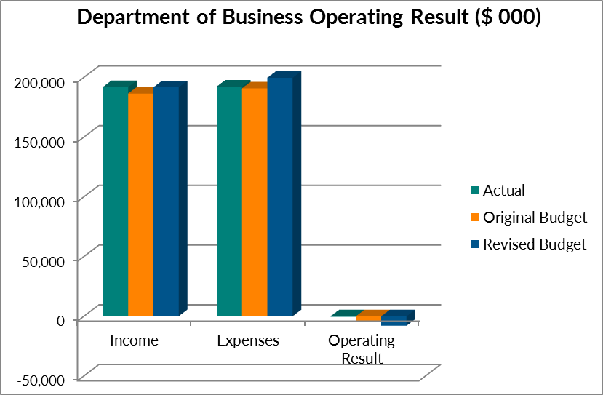

Income
The department received income of $191.916 million in 2015-16 exceeding original budget by $5.519 million. The department’s revenue was made up of the following:
- Output Appropriation: 76% ($145.912 million) of total revenue. This revenue received from the NT Government was used to fund Business and Industry Development and Support (21.6%), Training (52%), Policy and Regulatory Support (22.2%) and Corporate and Governance (4.2%).
- Commonwealth Appropriation: $25.432 million (13.3%) funding received from the Australian Government comprising of:
  - $14.715 million under the National Agreement for Skills and Workforce Development;
  - $2.852 million was for the National Partnership Agreement for Skills Reform; and
  - $7.865 million for the National Partnership Agreement for NT Remote Aboriginal Investment.
- Goods and Services Received Free of Charge: $5.403 million (2.8%) is notional revenue for office accommodation, information technology, procurement and payroll services provided by the Department of Corporate and Information Services and is offset by notional expense to the same value. This was $1.35 million above original budget as a result of additional services and leased properties.
- Taxes: $10.36 million (5.4%) received from the gaming machine community benefit levy. This was $0.891 million below original budget and is related to gambling taxes collected.
- Goods and Services Income: $3.446 million (1.8%) received from the sale of goods and services. This revenue was mainly sourced from insurers’ contributions under the Return to Work Act implemented by NT WorkSafe. It also includes hiring out facilities, recovery of costs, sponsorships and fees.
- Other Revenue (including Interest Revenue and Grants and Subsidies Revenue): $1.363 million (0.7%) consists of co-contributions from other agencies to fund grants to support business, and refunds of funding provided in prior year to grant recipients due to non-delivery of programs.
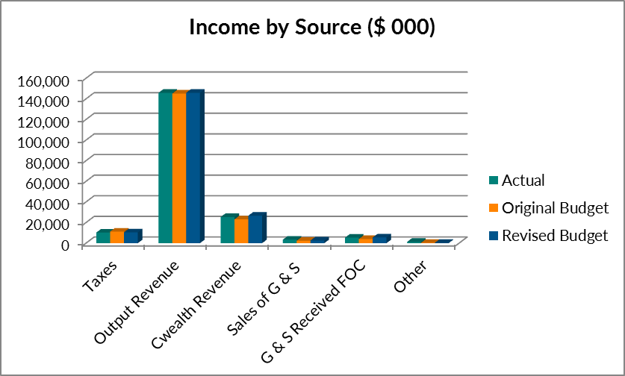

Expenses
The department incurred expenses of $192.319 million in 2015-16 or $1.538 million more than original budget. This was mainly due to an increase in the Goods and Services Received Free of Charge resulting from additional services and leased properties. The department’s expenditure was made up of the following:
- Employee Expenses: $40.33 million (21%) costs associated with staffing including salary, payroll tax and fringe benefits tax. This was $1.766 million above original budget due to additional positions required for new initiatives including Open Territory, the Home Improvement Scheme, and to engage more with business and industry.
- Purchase of Goods and Services: $13.618 million (7.1%). This was $0.347 million below original budget and was a managed savings measure to cover the overspend in the employee budget.
- Repairs and Maintenance: $0.441 million (0.2%). This was $0.333 million less than original budget due to delays in work being delivered in remote areas.
- Property Management: $1.177 million (0.6%) compared to original budget of $0.966 million as a result of additional costs incurred in relation to office relocations in the Darwin CBD.
- Depreciation and Other: $7.438 million (3.9%). This amount represents the department’s non-cash transactions and includes charges levied by the Department of Corporate and Information Services and asset adjustments. This is $1.598 million above original budget due the increase in Goods and Services Received Free of Charge.
- Grants and Subsidies: $129.283 million (67.2%). This is the largest expense item for the department and was $1.389 million below original budget, reflecting the timing of Commonwealth funding received late in the financial year.
- Interest Expense: $32 000. This is an expense relating to interest on land leased in remote communities where training facilities are held.
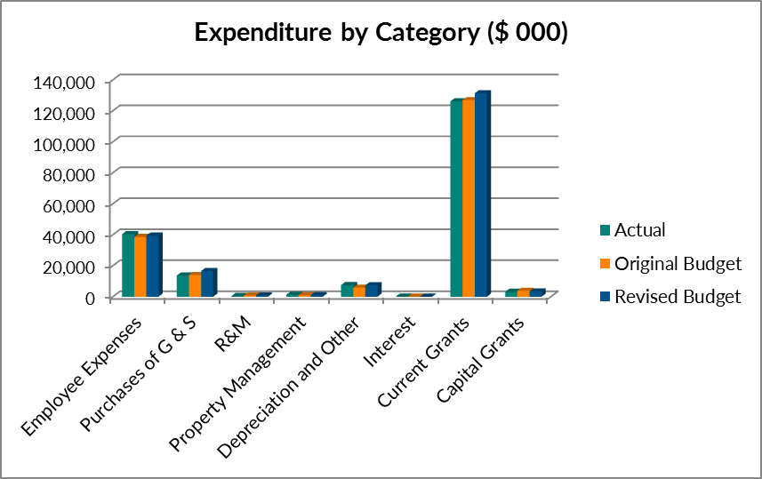

Balance Sheet
The balance sheet provides a summary of the department’s balances at the end of the financial year for assets, liabilities and equity.

Assets
The department held $56.26 million worth of assets as at 30 June 2016 and $1.251 million more than the prior year. The main components were non-current assets of property, plant and equipment and heritage and cultural assets which comprise 61.8% of the total assets. The main component of this is training centres in remote regions. The department also held cash and deposits worth $19.219 million (34.2%). The majority of this is money committed to externally funded projects in future years and Community Benefit Fund grants. Money is also held in trust for the Electronic Gaming Machine application levies pending a decision.

Liabilities
The department’s liabilities as at 30 June 2016 were $11.035 million. The main components were deposits held (money held in trust for third parties) 34.1%, payables (amounts owing to suppliers) 11.8% and current and non-current provisions (mainly employee) 48.8%.

Equity
Equity reflects the department’s net assets or net worth which totalled $45.225 million as at 30 June 2016. This represents a decrease of $0.395 million compared to 30 June 2015. This is a result of the training centre asset impairment and gifting of assets to community organisations.

Cash Flow Statement
The cash flow statement provides information on how cash was received and spent during the year. It differs from the operating statement as the operating statement includes non-cash items.
The cash flows are summarised as follows:
 |  | 2015-16 $'000
Net Cash from/(used in) Operating Activities |  | 2,861
Net Cash from /(used in) Investing Activities |  | (1,322)
Net Cash from/(used in) Financing Activities |  | 2,285
Net Increase/(Decrease) in Cash Held |  | 3,824
Cash at Beginning of Financial Year |  | 15,395
Cash at End of Financial Year |  | 19,219
The department’s cash balance is very high due to receiving funding from the Commonwealth in the last few days of the financial year. $10.881 million of this money is committed to externally funded projects in future years, $2.942 million is for Community Benefit Fund grants approved for 2016-17 and $3.764 million is money held in trust for third parties.

Appendix F

Financial Statements
Department of Business

Certification of the Financial Statements

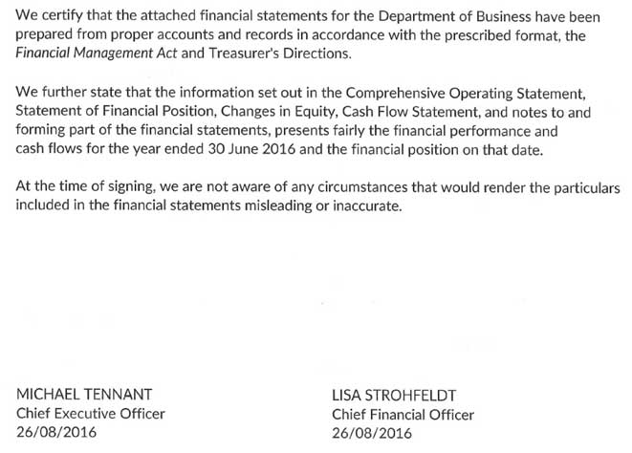

Comprehensive Operating Statement
For the year ended 30 June 2016
 | Note | 2016  $'000 | 2015  $'000
Income
Taxation Revenue |  | 10 360 | 2 939
Grants and Subsidies Revenue
Current |  | 421 | 1 039
Appropriation
Output |  | 145 912 | 138 512
Commonwealth |  | 25 432 | 23 676
Sales of Goods and Services |  | 3 446 | 1 615
Goods and Services Received Free of Charge | 4 | 5 403 | 4 318
Interest Income |  | 2 | 2
Gain/Loss on disposal of assets | 5 | 0 | 0
Other Income |  | 940 | 657
Total Income | 3 | 191 916 | 172 758
Expenses
Employee Expenses |  | 40 330 | 36 897
Administrative Expenses
Purchases of Goods and Services | 6 | 13 618 | 12 521
Repairs and Maintenance |  | 441 | 481
Property Management |  | 1 177 | 1 159
Depreciation and Amortisation | 10,11 | 1 671 | 1 662
Other Administrative Expenses ⁽¹⁾ |  | 5 767 | 7 689
Grants and Subsidies Expenses
Current |  | 126 139 | 110 876
Capital |  | 3 144 | 3 921
Community service obligations |  | 0 | 0
Interest Expenses |  | 32 | 28
Total Expenses | 3 | 192 319 | 175 234
Net Surplus / (Deficit) |  | (403) | (2 476)
Other Comprehensive Income
Changes in Accounting Policies |  | 0 | 0
Correction of Prior Period Errors |  | 0 | 0
Changes in Asset Revaluation |  | 0 | 0
Total Other Comprehensive Income |  | 0 | 0
Comprehensive Result |  | (403) | (2 476)

(1) Includes the Department of Corporate and Information Services SLA charges, and gifting of training centre assets and asset impairment loss.

The Comprehensive Operating Statement is to be read in conjunction with the notes to the financial statements.

Statement of Financial Position
For the year ended 30 June 2016
 | Note | 2016  $'000 | 2015  $'000
Assets
Current Assets
Cash and Deposits | 7 | 19 219 | 15 395
Receivables | 8 | 1 500 | 3 500
Advances and Investments | 9 | 45 | 43
Prepayments |  | 752 | 613
Other Assets |  | 0 | 0
Total Current Assets |  | 21 516 | 19 551
Non-Current Assets
Property, Plant and Equipment | 10,12 | 34 736 | 35 450
Heritage and Cultural Assets | 11,12 | 8 | 8
Total Non-Current Assets |  | 34 744 | 35 458
Total Assets |  | 56 260 | 55 009
Liabilities
Current Liabilities
Deposits Held |  | 3 764 | 1 473
Payables | 13 | 1 301 | 2 126
Borrowings and Advances | 14 | 9 | 9
Provisions | 15 | 4 060 | 3 981
Total Current Liabilities |  | 9 134 | 7 589
Non-Current Liabilities
Borrowings and Advances | 14 | 574 | 584
Provisions | 15 | 1 327 | 1 216
Total Non-Current Liabilities |  | 1 901 | 1 800
Total Liabilities |  | 11 035 | 9 389
Net Assets |  | 45 225 | 45 620
Equity
Capital |  | 53 994 | 53 986
Accumulated Funds |  | (8 769) | (8 366)
Total Equity |  | 45 225 | 45 620

The Statement of Financial Position is to be read in conjunction with the notes to the financial statements.

Statement of Changes in Equity
For the year ended 30 June 2016
 | Note | Equity at  01 July  $'000 | Comprehensive  result  $'000 | Transactions with owners in  their capacity as owner  $'000 | Equity at  30 June  $'000
2015-16
Accumulated Funds |  | (8 366) | (403) | 0 | (8 769)
Changes in Accounting Policy |  | 0 | 0 | 0 | 0
 |  | (8 366) | (403) | 0 | (8 769)
Capital - Transactions with Owners
Equity Injections
Capital Appropriation |  | 1 000 | 0 | 0 | 1 000
Equity Transfers In |  | 44 214 | 0 | 8 | 44 222
Other Equity Injections |  | 13 553 | 0 | 0 | 13 553
Equity Withdrawals
Capital Withdrawals |  | (4 699) | 0 | 0 | (4 699)
Transfer Out |  | ( 82) | 0 | 0 | ( 82)
 |  | 53 986 | 0 | 8 | 53 994
Total Equity at End of Financial Year |  | 45 620 | (403) | 8 | 45 225
2014-15
Accumulated Funds |  | (5 890) | (2 476) | 0 | (8 366)
Changes in Accounting Policy |  | 0 | 0 | 0 | 0
 |  | (5 890) | (2 476) | 0 | (8 366)
Capital - Transactions with Owners
Equity Injections
Capital Appropriation |  | 1 000 | 0 | 0 | 1 000
Equity Transfers In |  | 43 920 | 0 | 294 | 44 214
Other Equity Injections |  | 13 553 | 0 | 0 | 13 553
Equity Withdrawals
Capital Withdrawals |  | (3 668) | 0 | (1 031) | (4 699)
Transfer Out |  | (29) | 0 | (53) | (82)
 |  | 54 776 | 0 | (790) | 53 986
Total Equity at End of Financial Year |  | 48 886 | (2 476) | (790) | 45 620

This Statement of Changes in Equity is to be read in conjunction with the notes to the financial statements.

Cash Flow Statement
For the year ended 30 June 2016
 | Note | 2016  $'000 | 2015  $'000
Cash Flows from Operating Activities
Operating Receipts
Taxation Revenue |  | 10 360 | 2 939
Grants and Subsidies Revenue
Current |  | 421 | 1 039
Appropriation
Output |  | 145 912 | 138 512
Commonwealth |  | 25 432 | 23 676
Receipts from Sales of Goods and Services |  | 15 300 | 11 877
Interest Revenue |  | 2 | 2
Total Operating Receipts |  | 197 427 | 178 045
Operating Payments
Payments to Employees |  | (41 071) | (36 512)
Payments for Goods and Services |  | (24 180) | (24 858)
Grants and Subsidies Paid
Current |  | (126 139) | (110 876)
Capital |  | (3 144) | (3 921)
Interest Paid |  | (32) | (28)
Total Operating Payments |  | (194 566) | (176 195)
Net cash from/(used in) Operating Activities | 16 | 2 861 | 1 850
Cash Flows From Investing Activities
Investing Receipts
Repayment of Advances |  | 2 | 2
Total Investing Receipts |  | 2 | 2
Investing Payments
Purchase of Assets |  | (1 320) | (54)
Advances and Investing Payments |  | (4) | (2)
Total Investing Payments |  | (1 324) | (56)
Net cash from/(used in) Investing Activities |  | (1 322) | (54)
Cash Flows From Financing Activities
Financing Receipts
Deposits Received |  | 2 291 | 1 150
Capital Appropriation |  | 0 | 0
Equity Injections |  | 0 | 0
Total Financing Receipts |  | 2 291 | 1 150
Financing Payments
Payments |  | (6) | (11)
Equity Withdrawals |  | 0 | (1 031)
Total Financing Payments |  | (6) | (1 042)
Net cash from/(used in) Financing Activities |  | 2 285 | 108
Net increase/(decrease) in Cash Held |  | 3 824 | 1 904
Cash at Beginning of Financial Year |  | 15 395 | 13 491
Cash at end of Financial Year | 7 | 19 219 | 15 395

The Cash Flow Statement is to be read in conjunction with the notes to the financial statements.

Index of Notes to the Financial Statements
Note
- Objectives and Funding
- Statement of Significant Accounting Policies
- Comprehensive Operating Statement by Output Group
Income
- Goods and Services Received Free of Charge
Expenses
- Gain/Loss on Disposal of Assets
- Purchases of Goods and Services
Assets
- Cash and Deposits
- Receivables
- Advances and Investments
- Property, Plant and Equipment
- Heritage and Cultural Assets
- Fair Value Measurement of Non-Financial Assets
Liabilities
- Payables
- Borrowings and Advances
- Provisions
Other Disclosures
- Notes to the Cash Flow Statement
- Financial Instruments
- Commitments
- Contingent Liabilities and Contingent Assets
- Events Subsequent to Balance Date
- Accountable Officer’s Trust Account
- Write-offs, Postponements and Waivers, Gifts and Ex Gratia Payments
- Schedule of Administered Territory Items
- Budgetary Information
- Administered Territory Items

Objectives and Funding
The Department of Business is responsible for ensuring government priorities relating to a range of services to business and the wider Northern Territory community are effectively implemented, including:
- developing and broadening the Territory’s economy, industry capability and business competitiveness, facilitating new investment and major economic projects and connecting local businesses with national and international opportunities;
- strengthening the Northern Territory’s national and international engagement;
- funding and administering the provision of an Australian standard adult Vocational Education and Training (VET) system in the Territory, coordinating training, employment and workforce growth initiatives, responding to occupational skill priorities and facilitating skilled worker programs;
- providing regulatory operations to support gambling, liquor, racing and other industries;
- delivering Territory-wide regulation of workforce health and safety, dangerous goods, electrical safety and managing the Territory’s workers compensation and rehabilitation framework;
- developing and managing the government procurement policy framework, and providing procurement advice and assistance to business, industry and government agencies; and
- analysing and providing advice on strategic industry and economic development initiatives, business operating environment improvements, and national and Territory business policy developments.
The Department of Business is predominantly funded by, and is dependent on, the receipt of Parliamentary appropriations. The financial statements encompass all funds through which the agency controls resources to carry on its functions and deliver outputs. For reporting purposes, outputs delivered by the agency are summarised into several Output Groups. Note 3 provides summary financial information in the form of a Comprehensive Operating Statement by Output.

Statement of Significant Accounting Policies
- Statement of Compliance
The financial statements have been prepared in accordance with the requirements of the Financial Management Act and related Treasurer's Directions. The Financial Management Act requires the Department of Business to prepare financial statements for the year ended 30 June 2016 based on the form determined by the Treasurer. The form of the Department of Business's financial statements includes:
- a Certification of the Financial Statements;
- a Comprehensive Operating Statement;
- a Statement of Financial Position;
- a Statement of Changes in Equity;
- a Cash Flow Statement; and
- applicable explanatory notes to the financial statements.

- Basis of Accounting
The financial statements have been prepared using the accrual basis of accounting, which recognises the effect of financial transactions and events when they occur, rather than when cash is paid out or received. As part of the preparation of the financial statements, all intra- agency transactions and balances have been eliminated.
Except where stated, the financial statements have also been prepared in accordance with the historical cost convention.
The form of the agency financial statements is consistent with the accrual budget format and the requirements of Australian Accounting Standards. The effects of all relevant new and revised Standards and Interpretations issued by the Australian Accounting Standards Board (AASB) that are effective for the current annual reporting period have been evaluated.
The following new and revised accounting standards and interpretations were effective for the first time in 2015-16:
AASB 1048 Interpretation of Standards This reflects amended versions of Interpretations arising in relation to amendments to AASB 9 Financial Instruments and consequential amendments arising from the issuance of AASB 15 Revenue from Contracts with Customers. The standard does not impact the financial statements.
AASB 2014-8 Amendments to Australian Accounting Standards arising from AASB 9 This Standard makes amendments to AASB 9 Financial Instruments (December 2009) and AASB 9 Financial Instruments (December 2010). These amendments arise from the issuance of AASB 9 Financial Instruments in December 2014. The standard does not impact the financial statements.
AASB 2015-3 Amendments to Australian Accounting Standards arising from the withdrawal of AASB 1031 Materiality The standard completes the withdrawal of references to AASB 1031 in all Australian Accounting Standards and Interpretations, allowing the standard to effectively be withdrawn. The standard does not impact the financial statements.
AASB 2014-1 Amendments to Australian Accounting Standards (Part E - Financial Instruments) Part E of this Standard defers the application date of AASB 9 Financial Instruments to annual reporting periods beginning on or after 1 January 2018. The standard does not impact the financial statements.
The following standards and interpretations are likely to have an insignificant impact on the financial statements for future reporting periods, but the exact impact is yet to be determined:
Standard/Interpretation | Effective for annual reporting periods beginning on or after
AASB 9 Financial Instruments (December 2014), AASB 2014-7 Amendments to Australian Accounting Standards arising from AASB 9 (December 2014) | 1 January 2018
AASB 15 Revenue from Contracts with Customers, AASB 2014-5 Amendments to Australian Accounting Standards arising from AASB 15 | 1 January 2018
AASB 1057 Application of Accounting Standards | 1 January 2016
AASB 2015-9 Amendments to Australian Accounting Standards - Scope and Application Paragraphs [AASB 8, 133 and 1057] | 1 January 2016
The following standards and interpretations are expected to have a potential impact on the financial statements for future reporting periods:
Standard/Interpretation | Effective for annual reporting periods beginning on or after | Impact
AASB 2015-6 Amendments to Australian Accounting Standards – Extending Related Party Disclosures to Not-for-Profit Public Sector Entities [AASB 10, 124 and 1049] | 1 July 2016 | New note disclosure to include remuneration of Key Management Personnel (KMP) and related party transactions.
AASB 2016-2 Amendments to Australian Accounting Standards – Disclosure Initiative: Amendments to AASB 107 | 1 January 2017 | New disclosure on the reconciliation of the changes in liabilities arising from financing activities
AASB 16 Leases | 1 January 2019 | Reclassification of operating leases greater than 12 months to finance lease reporting requirements
AASB 9 Financial Instruments | 1 January 2018 | Simplified requirements for classification and measurement of financial assets
AASB 15 Revenue from Contracts with Customers | 1 January 2018 | Requires an entity to recognise revenue when the entity satisfies a performance obligation by transferring a promised good or service to a customer.
AASB 2014-1 Amendments to Australian Accounting Standards [Part E Financial Instruments] | 1 January 2018 | Amends various AAS's to reflect the deferral of the mandatory application date of AASB 9
AASB 2014-4 Amendments to Australian Accounting Standards - Clarification of Acceptable Methods of Depreciation and Amortisation [AASB 116 and AASB 138] | 1 January 2016 | Provides additional guidance on how the depreciation or amortisation of property, plant and equipment and intangible assets should be calculated and clarifies that the use of revenue-based methods to calculate the depreciation of an asset is not appropriate.
AASB 2014-5 Amendments to Australian Accounting Standards arising from AASB 15 | 1 January 2017 | Amends the measurement of trade receivables.
AASB 2014-7 Amendments to Australian Accounting Standards arising from AASB 9 | 1 January 2018 | Amends various AAS's to reflect the changes as a result of AASB 9

- Reporting Entity
The financial statements cover the Department as an individual reporting entity.
The Department is a Northern Territory department established under the Interpretation Act Administrative Arrangements Order.
The principal place of business of the Department is: 19 Smith Street, Darwin, Northern Territory 0800.
- Agency and Territory Items
The financial statements of the Department of Business include income, expenses, assets, liabilities and equity over which the Department of Business has control. Certain items, while managed by the agency, are controlled and recorded by the Territory rather than the agency (Territory items). Territory items are recognised and recorded in the Central Holding Authority as discussed below.
Central Holding Authority
The Central Holding Authority is the 'parent body' that represents the Government's ownership interest in Government controlled entities.
The Central Holding Authority also records all Territory items, such as income, expenses, assets and liabilities controlled by the Government and managed by Agencies on behalf of the Government. The main Territory item is Territory income, which includes taxation and royalty revenue, Commonwealth general purpose funding (such as GST revenue), fines, and statutory fees and charges.
The Central Holding Authority also holds certain Territory assets not assigned to Agencies as well as certain Territory liabilities that are not practical or effective to assign to individual Agencies, such as unfunded superannuation and long service leave.

The Central Holding Authority recognises and records all Territory items, and as such, these items are not included in the agency's financial statements. However, as the agency is accountable for certain Territory items managed on behalf of Government, these items have been separately disclosed in Note 23: Schedule of Administered Territory Items.
- Comparatives
Where necessary, comparative information for the 2014-15 financial year has been reclassified to provide consistency with current year disclosures.
- Presentation and Rounding of Amounts
Amounts in the financial statements and notes to the financial statements are presented in Australian dollars and have been rounded to the nearest thousand dollars, with amounts of $500 or less being rounded down to zero. Figures in the financial statements and notes may not equate due to rounding.
- Changes in Accounting Policies
There have been no changes to accounting policies adopted in 2015-16 as a result of management decisions.
- Accounting Judgements and Estimates
The preparation of the financial report requires the making of judgements and estimates that affect the recognised amounts of assets, liabilities, revenues and expenses and the disclosure of contingent liabilities. The estimates and associated assumptions are based on historical experience and various other factors that are believed to be reasonable under the circumstances, the results of which form the basis of making the judgements about the carrying values of assets and liabilities that are not readily apparent from other sources. Actual results may differ from these estimates.
The estimates and underlying assumptions are reviewed on an ongoing basis. Revisions to accounting estimates are recognised in the period in which the estimate is revised if the revision affects only that period, or in the period of revision and future periods if the revision affects both current and future periods.
Judgements and estimates that have significant effects on the financial statements are disclosed in the relevant notes to the financial statements. Notes that include significant judgements and estimates are:
- Employee Benefits - Note 2 (v) and Note 15 Non-current liabilities in respect of employee benefits measured as the present value of estimated future cash outflows based on the appropriate Government bond rate, estimates of future salary and wage levels and employee periods of service.
- Property, Plant and Equipment – Note 2 (r): The fair value of land, building, infrastructure and property, plant and equipment are determined on significant assumptions of the exit price and risks in the perspective market participant, using the best information available.
- Allowance for Impairment Losses - Note 2 (o), 8: Receivables and 17: Financial Instruments.
- Depreciation and Amortisation - Note 2 (l), Note 10: Property, Plant and Equipment.

- Goods and Services Tax
Income, expenses and assets are recognised net of the amount of Goods and Services Tax (GST), except where the amount of GST incurred on a purchase of goods and services is not recoverable from the Australian Taxation Office (ATO). In these circumstances the GST is recognised as part of the cost of acquisition of the asset or as part of the expense.
Receivables and payables are stated with the amount of GST included. The net amount of GST recoverable from, or payable to, the ATO is included as part of receivables or payables in the Statement of Financial Position.
Cash flows are included in the Cash Flow Statement on a gross basis. The GST components of cash flows arising from investing and financing activities which are recoverable from, or payable to, the ATO are classified as operating cash flows. Commitments and contingencies are disclosed net of the amount of GST recoverable or payable unless otherwise specified.
- Income Recognition
Income encompasses both revenue and gains.
Income is recognised at the fair value of the consideration received, exclusive of the amount of GST. Exchange of goods or services of the same nature and value without any cash consideration being exchanged are not recognised as income.
Grants and Other Contributions
Grants, donations, gifts and other non-reciprocal contributions are recognised as revenue when the entity obtains control over the assets comprising the contributions.
Contributions are recognised at their fair value. Contributions of services are only recognised when a fair value can be reliably determined and the services would be purchased if not donated.
Appropriation
Output Appropriation is the operating payment to each agency for the outputs they provide and is calculated as the net cost of agency outputs after taking into account funding from agency income. It does not include any allowance for major non-cash costs such as depreciation.
Output Appropriation is apportioned between the four Output Groups based on the cost of delivering the Department of Business's strategic priorities.
Commonwealth appropriation follows from the Intergovernmental Agreement on Federal Financial Relations. It has resulted in Special Purpose Payments and National Partnership payments being made by the Commonwealth Treasury to state treasuries, in a manner similar to arrangements for GST payments. These payments are received by the Department of Treasury and Finance on behalf of the Central Holding Authority and then on-passed to the relevant agencies as Commonwealth Appropriation.
Revenue in respect of Appropriations is recognised in the period in which the agency gains control of the funds.
Sale of Goods
Revenue from the sale of goods is recognised (net of returns, discounts and allowances) when:
- the significant risks and rewards of ownership of the goods have transferred to the buyer;
- the agency retains neither continuing managerial involvement to the degree usually associated with ownership nor effective control over the goods sold;
- the amount of revenue can be reliably measured;
- it is probable that the economic benefits associated with the transaction will flow to the agency; and
- the costs incurred or to be incurred in respect of the transaction can be measured reliably.
Rendering of Services
Revenue from rendering services is recognised by reference to the stage of completion of the contract. The revenue is recognised when:
- the amount of revenue, stage of completion and transaction costs incurred can be reliably measured; and
- it is probable that the economic benefits associated with the transaction will flow to the entity.
Interest Revenue
Interest revenue is recognised as it accrues, taking into account the effective yield on the financial asset.
Goods and Services Received Free of Charge
Goods and services received free of charge are recognised as revenue when a fair value can be reliably determined and the resource would have been purchased if it had not been donated. Use of the resource is recognised as an expense.
The Department of Corporate and Information Services provide free of charge services to the Department of Business.
Disposal of Assets
A gain or loss on disposal of assets is included as a gain or loss on the date control of the asset passes to the buyer, usually when an unconditional contract of sale is signed. The gain or loss on disposal is calculated as the difference between the carrying amount of the asset at the time of disposal and the net proceeds on disposal.
Contributions of Assets
Contributions of assets and contributions to assist in the acquisition of assets, being non-reciprocal transfers, are recognised, unless otherwise determined by Government, as gains when the agency obtains control of the asset or contribution. Contributions are recognised at the fair value received or receivable.
Administered Income
The Department collects regulatory fees on behalf of the Territory. The Department does not gain control over assets arising from these collections, consequently no income is recognised in the Departments financial statements. Accordingly, these amounts are disclosed as income in Note 25 Administered Territory Items.
- Repairs and Maintenance Expenses
Funding is received for repairs and maintenance works associated with agency assets as part of Output Revenue. Costs associated with repairs and maintenance works on agency assets are expensed as incurred.
- Depreciation and Amortisation Expense
Items of property, plant and equipment, including buildings but excluding land, have limited useful lives and are depreciated or amortised using the straight-line method over their estimated useful lives.
Amortisation applies in relation to intangible non-current assets with limited useful lives and is calculated and accounted for in a similar manner to depreciation.
The estimated useful lives for each class of asset are in accordance with the Treasurer's Directions and are determined as follows:
 | 2016 | 2015
Buildings | 5 - 50 Years | 5 - 50 Years
Plant and Equipment | 5 - 10 Years | 5 - 10 Years
Infrastructure | 10 Years | 10 Years
Computer Hardware | 3 - 10 Years | 3 - 10 Years
Cultural Asset | 100 Years | 100 Years
Assets are depreciated or amortised from the date of acquisition or from the time an asset is completed and held ready for use.
- Interest Expense
Interest expenses include interest and finance lease charges. Interest expenses are expensed in the period in which they are incurred.
- Cash and Deposits
For the purposes of the Statement of Financial Position and the Cash Flow Statement, cash includes cash on hand, cash at bank and cash equivalents. Cash equivalents are highly liquid short-term investments that are readily convertible to cash. Cash at bank includes monies held in the Accountable Officer’s Trust Account (AOTA) that are ultimately payable to the beneficial owner – refer to Note 21.
- Receivables
Receivables include accounts receivable and other receivables and are recognised at fair value less any allowance for impairment losses.
The allowance for impairment losses represents the amount of receivables the agency estimates are likely to be uncollectible and are considered doubtful. Analyses of the age of the receivables that are past due as at the reporting date are disclosed in an aging schedule in Note 17. Reconciliation of changes in the allowance accounts is also presented.
Accounts receivable are generally settled within 30 days and other receivables within 30 days.
- Prepayments
Prepayments represent payments in advance of receipt of goods and services or that part of expenditure made in one accounting period covering a term extending beyond that period.
- Investments
Investments are held at fair value less any allowance for impaired losses. Any impairment losses are reported in the Comprehensive Operating Statement.
- Property, Plant and Equipment
Acquisitions
All items of property, plant and equipment with a cost, or other value, equal to or greater than $10,000 are recognised in the year of acquisition and depreciated as outlined below. Items of property, plant and equipment below the $10,000 threshold are expensed in the year of acquisition.
The construction cost of property, plant and equipment includes the cost of materials and direct labour, and an appropriate proportion of fixed and variable overheads.
Complex Assets
Major items of plant and equipment comprising a number of components that have different useful lives, are accounted for as separate assets. The components may be replaced during the useful life of the complex asset.
Subsequent Additional Costs
Costs incurred on property, plant and equipment subsequent to initial acquisition are capitalised when it is probable that future economic benefits in excess of the originally assessed performance of the asset will flow to the entity in future years. Where these costs represent separate components of a complex asset, they are accounted for as separate assets and are separately depreciated over their expected useful lives.
Construction (Work in Progress)
As part of the Financial Management Framework, the Department of Infrastructure is responsible for managing general government capital works projects on a whole of Government basis. Therefore appropriation for the Department of Business capital works is provided directly to the Department of Infrastructure and the cost of construction work in progress is recognised as an asset of that Department. Once completed, capital works assets are transferred to the agency.
- Revaluations and Impairment
Revaluation of Assets
Subsequent to initial recognition, assets belonging to the following classes of non-current assets are revalued with sufficient regularity to ensure that the carrying amount of these assets does not differ materially from their fair value at reporting date:
  - Heritage and Cultural;
  - Land; and
  - Buildings.
Fair value is the amount for which an asset could be exchanged, or liability settled, between knowledgeable, willing parties in an arm’s length transaction.
Plant and equipment are stated at historical cost less depreciation, which is deemed to equate to fair value.
Impairment of Assets
An asset is said to be impaired when the asset's carrying amount exceeds its recoverable amount.
Non-current physical and intangible agency assets are assessed for indicators of impairment on an annual basis. If an indicator of impairment exists, the agency determines the asset's recoverable amount. The asset's recoverable amount is determined as the higher of the asset's depreciated replacement cost and fair value less costs to sell. Any amount by which the asset's carrying amount exceeds the recoverable amount is recorded as an impairment loss.
Impairment losses are recognised in the Comprehensive Operating Statement. They are disclosed as an expense unless the asset is carried at a revalued amount. Where the asset is measured at a revalued amount, the impairment loss is offset against the Asset Revaluation Surplus for that class of asset to the extent that an available balance exists in the Asset Revaluation Surplus.
In certain situations, an impairment loss may subsequently be reversed. Where an impairment loss is subsequently reversed, the carrying amount of the asset is increased to the revised estimate of its recoverable amount. A reversal of an impairment loss is recognised in the Comprehensive Operating Statement as income, unless the asset is carried at a revalued amount, in which case the impairment reversal results in an increase in the Asset Revaluation Reserve.
- Leased Assets
Leases under which the agency assumes substantially all the risks and rewards of ownership of an asset are classified as finance leases. Other leases are classified as operating leases.
Finance Leases
Finance leases are capitalised. A leased asset and a lease liability equal to the present value of the minimum lease payments are recorded at the inception of the lease.
Lease payments are allocated between the principal component of the lease liability and the interest expense.
Operating leases
Operating lease payments made at regular intervals throughout the term are expensed when the payments are due, except where an alternative basis is more representative of the pattern of benefits to be derived from the leased property. Lease incentives under an operating lease of a building or office space is recognised as an integral part of the consideration for the use of the leased asset. Lease incentives are to be recognised as a deduction of the lease expenses over the term of the lease.
- Payables
Liabilities for accounts payable and other amounts payable are carried at cost which is the fair value of the consideration to be paid in the future for goods and services received, whether or not billed to the agency. Accounts payable are normally settled within 30 days.
- Employee Benefits
Provision is made for employee benefits accumulated as a result of employees rendering services up to the reporting date. These benefits include wages and salaries and recreation leave. Liabilities arising in respect of wages and salaries and recreation leave and other employee benefit liabilities that fall due within twelve months of reporting date are classified as current liabilities and are measured at amounts expected to be paid. Non-current employee benefit liabilities that fall due after twelve months of the reporting date are measured at present value, calculated using the Government long term bond rate.
No provision is made for sick leave, which is non-vesting, as the anticipated pattern of future sick leave to be taken is less than the entitlement accruing in each reporting period.
Employee benefit expenses are recognised on a net basis in respect of the following categories:
- wages and salaries, non-monetary benefits, recreation leave, sick leave and other leave entitlements; and
- other types of employee benefits.
As part of the Financial Management Framework, the Central Holding Authority assumes the long service leave liabilities of Government Agencies, including the Department of Business and as such no long service leave liability is recognised in agency financial statements.
- Superannuation
Employees' superannuation entitlements are provided through the:
- NT Government and Public Authorities Superannuation Scheme (NTGPASS);
- Commonwealth Superannuation Scheme (CSS); or
- non-government employee nominated schemes for those employees commencing on or after 10 August 1999.

The agency makes superannuation contributions on behalf of its employees to the Central Holding Authority or non-government employee nominated schemes. Superannuation liabilities related to government superannuation schemes are held by the Central Holding Authority and as such are not recognised in the agency's financial statements.
- Contributions By and Distributions To Government
The agency may receive contributions from Government where the Government is acting as owner of the Agency. Conversely, the agency may make distributions to Government. In accordance with the Financial Management Act and Treasurer's Directions, certain types of contributions and distributions, including those relating to administrative restructures, have been designated as contributions by, and distributions to, Government. These designated contributions and distributions are treated by the agency as adjustments to equity.
The Statement of Changes in Equity provides additional information in relation to contributions by, and distributions to, Government.
- Commitments
Disclosures in relation to capital and other commitments, including lease commitments are shown at Note 18.
Commitments are those contracted as at 30 June where the amount of the future commitment can be reliably measured.
- Financial Instruments
A financial instrument is a contract that gives rise to a financial asset of one entity and a financial liability or equity instrument of another entity. Financial assets and liabilities are recognised on the Statement of Financial Position when the agency becomes a party to the contractual provisions of the financial instrument. The agency’s financial instruments include cash and deposits; receivables; advances; payables, borrowing and advances received.
Due to the nature of operating activities, certain financial assets and financial liabilities arise under statutory obligations rather than a contract. Such financial assets and liabilities do not meet the definition of financial instruments as per AASB 132 Financial Instruments Presentation. These include statutory receivables arising from taxes including GST and penalties.
Classification of Financial Instruments
AASB 7 Financial Instruments: Disclosures requires financial instruments to be classified and disclosed within specific categories depending on their nature and purpose.
Financial assets are classified into the following categories:
- financial assets at fair value through profit or loss;
- held-to-maturity investments;
- loans and receivables; and
- available-for-sale financial assets.
Financial liabilities are classified into the following categories:
- financial liabilities at fair value through profit or loss (FVTPL); and
- financial liabilities at amortised cost.

Financial Liabilities at Amortised Cost
Financial instrument liabilities measured at amortised cost include all advances received, finance lease liabilities and borrowings. Amortised cost is calculated using the effective interest method.
Note 17 provide additional information on financial instruments.
- Fair Value Measurement
Fair value is the price that would be received to sell an asset or paid to transfer a liability in an orderly transaction between market participants at the measurement date.
Fair value measurement of a non-financial asset takes into account a market participant’s ability to generate economic benefits by using the asset in its highest and best use or by selling it to another market participant that would use the asset in its highest and best use. The highest and best use takes into account the use of the asset that is physically possible, legally permissible and financially feasible.
When measuring fair value, the valuation techniques used maximise the use of relevant observable inputs and minimise the use of unobservable inputs. Unobservable inputs are used to the extent that sufficient relevant and reliable observable inputs are not available for similar assets/liabilities.
Observable inputs are publicly available data that are relevant to the characteristics of the assets/liabilities being valued. Observable inputs used by the agency include, but are not limited to, published sales data for land and general office buildings.
Unobservable inputs are data, assumptions and judgments that are not available publicly, but are relevant to the characteristics of the assets/liabilities being valued. Such inputs include internal agency adjustments to observable data to take account of particular and potentially unique characteristics/functionality of assets/liabilities and assessments of physical condition and remaining useful life.
All assets and liabilities for which fair value is measured or disclosed in the financial statements are categorised within the following fair value hierarchy based on the inputs used:
Level 1 – inputs are quoted prices in active markets for identical assets or liabilities;
Level 2 – inputs are inputs other than quoted prices included within Level 1 that are observable for the asset or liability, either directly or indirectly; and
Level 3 – inputs are unobservable.

Comprehensive Operating Statement by Output Group
 |  | Business and Industry Development and Support |  | Training |  | Policy and Regulatory Support |  | Corporate and Governance |  | Total
 | Note | 2016  $'000 | 2015  $'000 | 2016  $'000 | 2015  $'000 | 2016  $'000 | 2015  $'000 | 2016  $'000 | 2015  $'000 | 2016  $'000 | 2015  $'000
Income
Taxation Revenue |  | 0 | 0 | 0 | 0 | 10 360 | 2 939 | 0 | 0 | 10 360 | 2 939
Current Grants and Subsides Revenue |  | 320 | 978 | 5 | 45 | 67 | 0 | 29 | 16 | 421 | 1 039
Appropriation
Output |  | 31 501 | 28 956 | 75 806 | 73 605 | 32 446 | 31 602 | 6 159 | 4 349 | 145 912 | 138 512
Commonwealth |  | 0 | 0 | 17 567 | 19 706 | 7 865 | 3 970 | 0 | 0 | 25 432 | 23 676
Sales of Goods and Services |  | 406 | 372 | 612 | 508 | 2 428 | 735 | 0 | 0 | 3 446 | 1 615
Interest Revenue |  | 2 | 2 | 0 | 0 | 0 | 0 | 0 | 0 | 2 | 2
Goods and Services Received Free of Charge | 4 | 2 052 | 1 563 | 620 | 487 | 2 186 | 1 796 | 545 | 472 | 5 403 | 4 318
Gain on disposal of assets | 5 | 0 | 0 | 0 | 0 | 0 | 0 | 0 | 0 | 0 | 0
Other Income |  | 129 | 164 | 428 | 95 | 382 | 398 | 1 | 0 | 940 | 657
Total Income |  | 34 410 | 32 035 | 95 038 | 94 446 | 55 734 | 41 440 | 6 734 | 4 837 | 191 916 | 172 758
Expenses
Employee Expenses |  | 15 440 | 13 765 | 4 094 | 3 983 | 15 477 | 15 043 | 5 319 | 4 106 | 40 330 | 36 897
Administrative Expenses
Purchase of Goods and Services | 6 | 6 888 | 5 813 | 1 812 | 1 841 | 3 925 | 4 139 | 993 | 728 | 13 618 | 12 521
Repairs and Maintenance |  | 77 | 65 | 322 | 358 | 34 | 2 | 8 | 56 | 441 | 481
Property Management |  | 136 | 201 | 716 | 534 | 302 | 390 | 23 | 34 | 1 177 | 1 159
Depreciation and Amortisation | 10,11 | 157 | 146 | 1 286 | 1 276 | 186 | 196 | 42 | 44 | 1 671 | 1 662
Other Administrative Expenses ⁽¹⁾ |  | 2 053 | 1 563 | 980 | 3 859 | 2 189 | 1 796 | 545 | 471 | 5 767 | 7 689
Grants and Subsidies Expenses
Current |  | 13 007 | 11 479 | 87 350 | 79 967 | 25 772 | 19 430 | 10 | 0 | 126 139 | 110 876
Capital |  | 0 | 0 | 3 144 | 3 671 | 0 | 250 | 0 | 0 | 3 144 | 3 921
Interest expenses |  | 0 | 0 | 32 | 28 | 0 | 0 | 0 | 0 | 32 | 28
Total Expenses |  | 37 758 | 33 032 | 99 736 | 95 517 | 47 885 | 41 246 | 6 940 | 5 439 | 192 319 | 175 234
Net Surplus / (Deficit) |  | (3 348) | (997) | (4 698) | (1 071) | 7 849 | 194 | (206) | (602) | (403) | (2 476)
Total Other Comprehensive Income |  | 0 | 0 | 0 | 0 | 0 | 0 | 0 | 0 | 0 | 0
Comprehensive Result |  | (3 348) | (997) | (4 698) | (1 071) | 7 849 | 194 | (206) | (602) | (403) | (2 476)
(1) Includes the Department of Corporate and Information Services SLA charges, and gifting of training centre assets and asset impairment loss.
The Comprehensive Operating Statement is to be read in conjunction with the notes to the financial statements.

Goods and Services Received Free of Charge
 | 2016  $'000 | 2015  $'000
Department of Corporate and Information Services | 5 403 | 4 318
Total Goods And Services Received Free of Charge | 5 403 | 4 318

Gain/Loss on Disposal of Assets
The Department of Business did not make any gain/loss on disposal of assets in 2015-16.

Purchases of Goods and Services
The net surplus/(deficit) has been arrived at after charging the following expenses:
 | 2016  $'000 | 2015  $'000
Goods and Services Expenses:
Consultants ⁽¹⁾ | 2 670 | 3 015
Advertising ⁽²⁾ | 85 | 82
Accommodation | 361 | 385
Marketing and Promotion ⁽³⁾ | 2 408 | 1 462
Document Production | 85 | 75
Communications | 570 | 613
Information Technology Charges ⁽⁴⁾ | 2 737 | 2 740
Legal Expenses ⁽⁵⁾ | 240 | 37
Motor Vehicle Expenses | 876 | 815
Membership and Subscription | 123 | 124
Training and Study | 368 | 387
Official Duty Fares | 608 | 665
Travelling Allowance | 219 | 239
Audit Fees | 89 | 105
Client Travel | 286 | 159
Equipment Expenses ⁽⁶⁾ | 297 | 299
Office Requisites & Stationery | 87 | 93
Recruitment ⁽⁷⁾ | 85 | 60
Other Expenses | 1 424 | 1 166
Total Purchases of Goods and Services | 13 618 | 12 521
(1) Includes marketing, promotion and IT consultants.
(2) Does not include recruitment advertising or marketing and promotion advertising.
(3) Includes advertising for marketing and promotion but excludes marketing and promotion consultants’ expenses, which are incorporated in the consultants’ category.
(4) Includes general IT technology charges and IT hardware & software expenses, but does not include IT consultants, which are incorporated in the consultants' category.
(5) Includes legal fees, claim and settlement costs.
(6) Includes multi-function device lease charges and other equipment costs.
(7) Includes recruitment-related advertising costs.

Cash and Deposits
 | 2016  $'000 | 2015  $'000
Cash on Hand | 13 | 1 013
Cash at Bank | 19 206 | 14 382
Total Cash And Deposits | 19 219 | 15 395

Receivables
 | 2016  $'000 | 2015  $'000
Current
Accounts Receivable | 259 | 694
Less: Allowance for Impairment Losses | (13) | (31)
 | 246 | 663
GST Receivables | 1 135 | 1 288
Other Receivables | 119 | 1 549
Total Receivables | 1 500 | 3 500

Advances and Investments
 | 2016  $'000 | 2015  $'000
Advances | 45 | 43
Less: Allowance for Impairment Losses | 0 | 0
Total Advances | 45 | 43

Property, Plant and Equipment
 | 2016  $'000 | 2015  $'000
Land
At Fair Value | 980 | 980
Less: Accumulated Depreciation | 0 | 0
 | 980 | 980
Leased Land
At Capitalised Cost | 641 | 641
Less: Accumulated Depreciation | (65) | (49)
 | 576 | 592
Buildings
At Fair Value | 61 071 | 61 769
Less: Accumulated Depreciation | (31 138) | (30 443)
Less: Accumulated Impairment Loss | (529) | (389)
 | 29 404 | 30 937
Plant and Equipment
At Fair Value | 5 236 | 5 184
Less: Accumulated Depreciation | (2 723) | (2 243)
 | 2 513 | 2 941
Computer Hardware
At Capitalised Cost | 0 | 44
Less: Accumulated Depreciation | 0 | (44)
 | 0 | 0
Computer Software Work in Progress
At Capitalised Cost | 1 263 | 0
 | 1 263 | 0
Total Property, Plant and Equipment | 34 736 | 35 450

Impairment of Property, Plant and Equipment
Agency property, plant and equipment assets were assessed for impairment as at 30 June 2016. As a result of this review, one impairment adjustment was made during the year which relates to the training centre building in Maningrida. The building has nil value in use. $140,000 of impairment losses were recognised against Buildings. Impairment losses were charged to expenses.

- Property, Plant and Equipment (continued)
2016 Property, Plant and Equipment Reconciliations
A reconciliation of the carrying amounts of property, plant and equipment at the beginning and end of 2015-16 is set out below:
 | Land  $'000 | Leased  Land  $'000 | Buildings  $'000 | Plant and  Equipment  $'000 | Computer  Hardware  $'000 | Computer  Software  Work in  Progress  $'000 | Total  $'000
Carrying Amount as at 1 July 2015 | 980 | 592 | 30 937 | 2 941 | 0 | 0 | 35 450
Additions | 0 | 0 | 0 | 55 | 0 | 1 263 | 1 318
Depreciation and Amortisation | 0 | (16) | (1 172) | (483) | 0 | 0 | (1 671)
Additions/(Disposals) from Asset Transfers | 0 | 0 | (221) | 0 | 0 | 0 | (221)
Impairment losses | 0 | 0 | (140) | 0 | 0 | 0 | (140)
Carrying Amount as at 30 June 2016 | 980 | 576 | 29 404 | 2 513 | 0 | 1 263 | 34 736

2015 Property, Plant and Equipment Reconciliations
A reconciliation of the carrying amounts of property, plant and equipment at the beginning and end of 2014-15 is set out below:
 | Land  $'000 | Leased  Land  $'000 | Buildings  $'000 | Plant and  Equipment  $'000 | Computer  Hardware  $'000 | Computer  Software  Work in  Progress  $'000 | Total  $'000
Carrying Amount as at 1 July 2014 | 980 | 601 | 35 361 | 3 218 | 13 | 0 | 40 173
Additions | 0 | 0 | 0 | 53 | 0 | 0 | 53
Depreciation and Amortisation | 0 | (9) | (1 180) | (459) | (13) | 0 | (1 662)
Additions/(Disposals) from Asset Transfers | 0 | 0 | (2 855) | 129 | 0 | 0 | (2 726)
Impairment losses | 0 | 0 | (389) | 0 | 0 | 0 | (389)
Carrying Amount as at 30 June 2015 | 980 | 592 | 30 937 | 2 941 | 0 | 0 | 35 450

Heritage and Cultural Assets
 | 2016  $'000 | 2015  $'000
Carrying Amount
At Valuation | 10 | 10
Less: Accumulated Depreciation | (2) | (2)
Written down value as at 30 June | 8 | 8
Reconciliation of Movements
Carrying Amount as at 1 July | 8 | 8
Additions/(Disposals) from Asset Transfers | 0 | 0
Carrying Amount as at 30 June | 8 | 8
Impairment of Heritage and Cultural Assets
Agency heritage and cultural assets were assessed for impairment as at 30 June 2016. No impairment adjustments were required as a result of this review.

Fair Value Measurement of Non-Financial Assets
- Fair Value Hierarchy
Fair values of non-financial assets categorised by levels of inputs used to compute fair value are:
2015-16 | Level 1  $’000 | Level 2  $’000 | Level 3  $’000 | Total Fair  Value  $’000
Asset Classes
Land (Note 10) |  |  | 980 | 980
Buildings (Note 10) |  |  | 29 404 | 29 404
Plant and Equipment (Note 10) |  |  | 2 513 | 2 513
Heritage and Cultural Assets (Note 11) |  |  | 8 | 8
Total | 0 | 0 | 32 905 | 32 905

2014-15 | Level 1  $’000 | Level 2  $’000 | Level 3  $’000 | Total Fair  Value  $’000
Asset Classes
Land (Note 10) |  |  | 980 | 980
Buildings (Note 10) |  |  | 30 937 | 30 937
Plant and Equipment (Note 10) |  |  | 2 941 | 2 941
Heritage and Cultural Assets (Note 11) |  |  | 8 | 8
Total | 0 | 0 | 34 866 | 34 866
There were no transfers between Level 1 and Level 2 or 3 during 2015-16.

- Fair Value Measurement of Non-Financial Assets (continued)
- Valuation Techniques and Inputs
Valuation techniques used to measure fair value in 2015-16 are:
 | Level 2  Techniques | Level 3  Techniques
Asset Classes
Land |  | Cost approach
Buildings |  | Cost approach
Plant and Equipment |  | Cost approach
Heritage and Cultural Assets |  | Cost approach
There were no changes in valuation techniques from 2014-15 to 2015-16.
Level 3 fair values of buildings, and cultural assets were determined by calculating their depreciated replacement costs because an active market does not exist for such facilities. The depreciated replacement cost was based on a combination of internal records of the historical cost of the facilities, adjusted for contemporary technology and construction approaches. Significant judgement was also used in assessing the remaining service potential of the facilities, given local environmental conditions, projected usage, and records of the current condition of the facilities. Plant and Equipment are stated at historical cost less depreciation which is deemed to equate to fair value.

- Fair Value Measurement of Non-Financial Assets (continued)
- Additional Information for Level 3 Fair Value Measurements
- Reconciliation of Recurring Level 3 Fair Value Measurements
 | Land  $’000 | Building  $’000 | Plant and  Equipment  $’000 | Heritage  And  Cultural  Assets  $’000 | Total  $’000
Fair value as at 1 July 2015 | 980 | 30 937 | 2 941 | 8 | 34 866
Additions | 0 | 0 | 55 | 0 | 55
Disposals | 0 | 0 | 0 | 0 | 0
Transfers from level 2 | 0 | 0 | 0 | 0 | 0
Transfers to level 2 | 0 | 0 | 0 | 0 | 0
Depreciation | 0 | (1 172) | (483) | 0 | (1 655)
Gains/losses recognised in net surplus/deficit | 0 | (361) | 0 | 0 | (361)
Gains/losses recognised in other comprehensive income | 0 | 0 | 0 | 0 | 0
Fair value as at 30 June 2016 | 980 | 29 404 | 2 513 | 8 | 32 905

 | Land  $’000 |  | Building  $’000 |  | Plant and  Equipment  $’000 |  | Heritage  And  Cultural  Assets  $’000 |  | Total  $’000
Fair value as at 1 July 2014 |  | 0 |  | 35 361 |  | 3 218 |  | 8 |  | 38 587
Additions |  | 0 |  | 110 |  | 287 |  | 0 |  | 397
Disposals |  | 0 |  | 0 |  | (105) |  | 0 |  | (105)
Transfers from level 2 |  | 980 |  | 0 |  | 0 |  | 0 |  | 980
Transfers to level 2 |  | 0 |  | 0 |  | 0 |  | 0 |  | 0
Depreciation |  | 0 |  | (1 180) |  | (459) |  | 0 |  | (1 640)
Gains/losses recognised in net surplus/deficit |  | 0 |  | (3 354) |  | 0 |  | 0 |  | (3 354)
Gains/losses recognised in other comprehensive income |  | 0 |  | 0 |  | 0 |  | 0 |  | 0
Fair value as at 30 June 2015 |  | 980 |  | 30 937 |  | 2 941 |  | 8 |  | 34 866
- Sensitivity Analysis
Unobservable inputs used in computing the fair value of buildings, plant and equipment, and heritage and cultural assets include the historical cost and the consumed economic benefit of each asset.
In respect of sensitivity of fair value to changes in input value, a higher historical cost results in a higher fair value and greater consumption of economic benefit lowers fair value.

Payables
 | 2016  $'000 | 2015  $'000
Accounts Payable | 383 | 594
Accrued Expenses | 918 | 1 532
Total Payables | 1 301 | 2 126

Borrowings and Advances
 | 2016  $'000 | 2015  $'000
Current
Finance Lease Liabilities | 9 | 9
Non-Current
Finance Lease Liabilities | 574 | 584
Total Borrowings and Advances | 583 | 593

Finance Lease Liabilities | Minimum Lease Payments |  | Present Value of the Minimum Lease Payments
 | 2016  $'000 | 2015  $'000 | 2016  $'000 | 2015  $'000
Not later than one year | 37 | 37 | 9 | 9
1 to 5 years | 147 | 147 | 42 | 40
Later than 5 Years | 970 | 1 008 | 532 | 544
 | 1 154 | 1 192 | 583 | 593
Less future finance charges | (571) | (599) | 0 | 0
Total Finance Leases Liabilities | 583 | 593 | 583 | 593
Finance Lease Arrangements
The Department of Business leases land for its training centres on Indigenous land in five remote communities in the Northern Territory.
The lease terms vary between 20 and 40 years with most of them offering lease extension options. The present value discount factor used for the minimum lease payments is 4.72% since the inception of the leases in 2012.

Provisions
 | 2016  $'000 | 2015  $'000
Current
Employee Benefits:
Recreation Leave | 2 861 | 2 754
Leave Loading | 537 | 484
Other Employee Benefits | 54 | 61
Provision for Employer Superannuation Contributions ⁽¹⁾ | 259 | 329
Other Current Provisions:
Other Provisions ⁽¹⁾ | 349 | 353
Non-Current
Employee Benefits:
Recreation Leave | 1 327 | 1 216
Total Provisions | 5 387 | 5 197
(1) Provision for Employer Superannuation Contributions was reclassified from Other Current Provisions to Current Employee Benefits.
Reconciliations of Other Provisions⁽²⁾
 | 2016  $'000 | 2015  $'000
Balance as at 1 July | 353 | 327
Additional provisions recognised | 518 | 450
Reductions arising from payments | (522) | (424)
Balance as at 30 June | 349 | 353
(2) Other provisions relate to fringe benefits tax and payroll tax.
The Department of Business employed 357.77 full time equivalent (FTE) employees including 6.8 FTEs for NT Build as at 30 June 2016.

Notes to the Cash Flow Statement
Reconciliation of Cash
The total of Agency cash and deposits of $19,218,563 recorded in the Statement of Financial Position is consistent with that recorded as cash in the Cash Flow Statement.
Reconciliation of Net Surplus/(Deficit) to Net Cash From Operating Activities
 | 2016  $'000 | 2015  $'000
Net Operating Surplus/(Deficit):
Net Operating Surplus/(Deficit) | (403) | (2 476)
(Profit)/Impairment on revaluation of non-current assets | 0 | 0
Non-Cash Items:
Depreciation | 1 671 | 1 662
Asset Write-Offs/Write-Downs | 140 | 3 354
Asset Donations/Gifts | 221 | 0
R&M - Minor New Work Non Cash | 6 | 5
Doubtful Debts Expense | 0 | 0
Changes in Assets and Liabilities:
Decrease/(Increase) in Receivables | 2 000 | (860)
Decrease/(Increase) in Prepayments | (139) | (510)
(Decrease)/Increase in Payables | (825) | 525
(Decrease)/Increase in Provision for Employee Benefits | 194 | 91
(Decrease)/Increase in Other Provisions | (4) | 59
Net Cash From Operating Activities | 2 861 | 1 850

Financial Instruments
A financial instrument is a contract that gives rise to a financial asset of one entity and a financial liability or equity instrument of another entity. Financial instruments held by the Department of Business include cash and deposits, receivables, payables and finance leases. The Department of Business has limited exposure to financial risks as discussed below.
- Categorisation of Financial Instruments
The carrying amounts of the Department of Business's financial assets and liabilities by category are disclosed in the table below.
2015-16 Categorisation of Financial Instruments
 | Fair value through profit or loss
 | Held for trading  $’000 | Designated  At fair value  $’000 | Financial  Assets – loans  And  Receivables  $’000 | Financial  Liabilities – amortised cost  $’000 | Total  $’000
Cash and deposits | 0 | 19 219 | 0 | 0 | 19 219
Receivables⁽¹⁾ | 0 | 0 | 365 | 0 | 365
Advances | 0 | 0 | 45 | 0 | 45
Total Financial Assets | 0 | 19 219 | 410 | 0 | 19 629
Deposits held | 0 | 3 764 | 0 | 0 | 3 764
Payables | 0 | 1 301 | 0 | 0 | 1 301
Finance Lease Liabilities | 0 | 0 | 0 | 583 | 583
Total Financial Liabilities | 0 | 5 065 | 0 | 583 | 5 648
(1) Total amounts disclosed here exclude statutory amounts.
2014-15 Categorisation of Financial Instruments
 | Fair value through profit or loss
 | Held for trading  $’000 |  | Designated  At fair value  $’000 |  | Financial  Assets – loans  And  Receivables  $’000 |  | Financial  Liabilities – amortised cost  $’000 |  | Total  $’000
Cash and deposits |  | 0 |  | 15 395 |  | 0 |  | 0 |  | 15 395
Receivables⁽¹⁾ |  | 0 |  | 0 |  | 2 212 |  | 0 |  | 2 212
Advances |  | 0 |  | 0 |  | 43 |  | 0 |  | 43
Total Financial Assets |  | 0 |  | 15 395 |  | 2 255 |  | 0 |  | 17 650
Deposits held |  | 0 |  | 1 473 |  | 0 |  | 0 |  | 1 473
Payables |  | 0 |  | 2 126 |  | 0 |  | 0 |  | 2 126
Finance Lease Liabilities |  | 0 |  | 0 |  | 0 |  | 593 |  | 593
Total Financial Liabilities |  | 0 |  | 3 599 |  | 0 |  | 593 |  | 4 192
(1) Total amounts disclosed here exclude statutory amounts.

- Financial Instruments (continued)
- Credit Risk
The agency has limited credit risk exposure (risk of default). In respect of any dealings with organisations external to Government, the agency has adopted a policy of only dealing with credit worthy organisations and obtaining sufficient collateral or other security where appropriate, as a means of mitigating the risk of financial loss from defaults.
The carrying amount of financial assets recorded in the financial statements, net of any allowances for losses, represents the agency's maximum exposure to credit risk without taking account of the value of any collateral or other security obtained.
Receivables
Receivable balances are monitored on an ongoing basis to ensure that exposure to bad debts is not significant.
A reconciliation and aging analysis of receivables is presented below.
Internal Receivables | Aging of  Receivables  $'000 | Aging of  Impaired  Receivables  $'000 | Net Receivables  $'000
2015-16
Not Overdue | 129 | 0 | 129
Overdue for less than 30 Days | 1 | 0 | 1
Overdue for 30 to 60 Days | 3 | 0 | 3
Overdue for more than 60 Days | 0 | 0 | 0
Total | 133 | 0 | 133

Internal Receivables | Aging of  Receivables  $'000 | Aging of  Impaired  Receivables  $'000 | Net Receivables  $'000
2014-15
Not Overdue | 1 596 | 0 | 1 596
Overdue for less than 30 Days | 42 | 0 | 42
Overdue for 30 to 60 Days | 0 | 0 | 0
Overdue for more than 60 Days | 0 | 0 | 0
Total | 1 638 | 0 | 1 638

- Financial Instruments (continued)
- Credit Risk (continued)
External Receivables | Aging of  Receivables  $'000 | Aging of  Impaired  Receivables  $'000 | Net Receivables  $'000
2015-16
Not Overdue | 185 | 0 | 185
Overdue for less than 30 Days | 35 | 0 | 35
Overdue for 30 to 60 Days | 0 | 0 | 0
Overdue for more than 60 Days | 25 | 13 | 12
Total | 245 | 13 | 232

Reconciliation of the Allowance for Impairment Losses
2015-16 | $'000
Opening | 31
Written off during the year | (20)
Recovered during the year | 0
Increase/(decrease) in allowance recognised in profit or loss | 2
Total | 13

External Receivables | Aging of  Receivables  $'000 | Aging of  Impaired  Receivables  $'000 | Net Receivables  $'000
2014-15
Not Overdue | 371 | 0 | 371
Overdue for less than 30 Days | 144 | 0 | 144
Overdue for 30 to 60 Days | 22 | 0 | 22
Overdue for more than 60 Days | 68 | 31 | 37
Total | 605 | 31 | 574

Reconciliation of the Allowance for Impairment Losses
2014-15 | $'000
Opening | 118
Written off during the year | (103)
Recovered during the year | 0
Increase/(decrease) in allowance recognised in profit or loss | 16
Total | 31

- Liquidity Risk
Liquidity risk is the risk that the agency will not be able to meet its financial obligations as they fall due. The agency's approach to managing liquidity is to ensure that it will always have sufficient liquidity to meet its liabilities when they fall due.
The table overleaf details the agency's remaining contractual maturity for its financial assets and liabilities.
2016 Maturity analysis for financial assets and liabilities
 |  | Fixed Interest Rate
 | Variable  Interest  $'000 | Less than  a Year  $'000 | 1 to 5  Years  $'000 | More than  5 Years  $'000 | Non  Interest  Bearing  $'000 | Total  $'000 | Weighted  Average  %
Financial Assets
Cash and deposits | 0 | 0 | 0 | 0 | 19 219 | 19 219
Receivables | 0 | 0 | 0 | 0 | 365 | 365
Advances | 0 | 1 | 3 | 39 | 2 | 45 | 4.00%
Total Financial Assets | 0 | 1 | 3 | 39 | 19 586 | 19 629
Financial Liabilities
Deposits Held | 0 | 0 | 0 | 0 | 3 764 | 3 764
Payables | 0 | 0 | 0 | 0 | 1 301 | 1 301
Borrowings and Advances | 0 | 9 | 42 | 532 | 0 | 583 | 4.72%
Total Financial Liabilities | 0 | 9 | 42 | 532 | 5 065 | 5 648

2015 Maturity analysis for financial assets and liabilities
 |  | Fixed Interest Rate
 | Variable  Interest  $'000 | Less than  a Year  $'000 | 1 to 5  Years  $'000 | More than  5 Years  $'000 | Non  Interest  Bearing  $'000 | Total  $'000 | Weighted  Average  %
Financial Assets
Cash and deposits | 0 | 0 | 0 | 0 | 15 395 | 15 395
Receivables | 0 | 0 | 0 | 0 | 2 212 | 2 212
Advances | 0 | 2 | 7 | 34 | 0 | 43 | 4.00%
Total Financial Assets | 0 | 2 | 7 | 34 | 17 607 | 17 650
Financial Liabilities
Deposits Held | 0 | 0 | 0 | 0 | 1 473 | 1 473
Payables | 0 | 0 | 0 | 0 | 2 126 | 2 126
Borrowings and Advances | 0 | 9 | 40 | 544 | 0 | 593 | 4.72%
Total Financial Liabilities | 0 | 9 | 40 | 544 | 3 599 | 4 192

- Financial Instruments (continued)
- Market Risk
Market risk is the risk that the fair value of future cash flows of a financial instrument will fluctuate because of changes in market prices. It comprises interest rate risk, price risk and currency risk.
- Interest Rate Risk
The Department of Business has limited exposure to interest rate risk as agency financial assets and financial liabilities, with the exception of finance leases are non-interest bearing. Finance lease arrangements are established on a fixed interest rate and as such do not expose the Department of Business to interest rate risk.
- Price Risk
The Department of Business is not exposed to price risk as the Department of Business does not hold units in unit trusts.
- Currency Risk
The Department of Business is not exposed to currency risk as the Department of Business does not hold borrowings denominated in foreign currencies or transactional currency exposures arising from purchases in a foreign currency.
- Net Fair Value
The fair value of the Department of Business's financial instruments is determined on the basis of fair value for cash, deposits, advances, receivables and payables approximating their carrying amount, which is also their amortised cost.
The Department of Business does not hold any derivative financial instruments or any financial assets and liabilities whose fair value is measured other than at amortised cost.

Commitments
- Capital Expenditure Commitments
Capital expenditure commitments contracted for at balance date but not recognised as liabilities are payable as follows:
 | 2016 |  | 2015
 | Internal  $'000 | External  $'000 | Internal  $'000 | External  $'000
Within one year | 77 | 1 234 | 77 | 1 234
Later than one year and not later than five years | 0 | 0 | 0 | 0
Later than five years | 0 | 0 | 0 | 0
 | 77 | 1 234 | 77 | 1 234
- Operating Lease Commitments
The agency leases property under non-cancellable operating leases expiring from 1 to 5 years. Leases generally provide the entity with a right of renewal at which time all lease terms are renegotiated.
Future operating lease commitments not recognised as liabilities are payable as follows:
 | 2016 |  | 2015
 | Internal  $'000 | External  $'000 | Internal  $'000 | External  $'000
Within one year | 494 | 14 | 430 | 35
Later than one year and not later than five years | 576 | 1 | 328 | 33
Later than five years | 0 | 0 | 0 | 0
 | 1 070 | 15 | 758 | 68
- Other Expenditure Commitments
Other non-cancellable expenditure commitments not recognised as liabilities are payable as follows:
 | 2016 |  | 2015
 | Internal  $'000 | External  $'000 | Internal  $'000 | External  $'000
Within one year ⁽¹⁾ | 0 | 8 503 | 0 | 8 980
Later than one year and not later than five years | 0 | 4 752 | 0 | 2 570
Later than five years | 0 | 0 | 0 | 0
 | 0 | 13 255 | 0 | 11 550
(1) Comparative figure for 2014-15 reporting year has been restated to include only the non-cancellable expenditure commitments.

Contingent Liabilities and Contingent Assets
- Contingent liabilities
The Department of Business has entered into agreements, which contain indemnity clauses. The contingent liabilities arising from the indemnities are unquantifiable, but expected to be immaterial. However, for all the events that would give rise to the liabilities, the department has comprehensive risk management procedures in place.
- Contingent assets
The Department of Business had no contingent assets at 30 June 2016 or 30 June 2015.

Events Subsequent to Balance Date
No events have arisen between the end of the financial year and the date of this report that require adjustment to, or disclosure in these financial statements.

Accountable Officer's Trust Account
In accordance with section 7 of the Financial Management Act, an Accountable Officer's Trust Account has been established for the receipt of money to be held in trust. A summary of activity is shown below:
Nature of Trust Money | Opening  Balance  1 July 2015  $'000 | Receipts  $'000 | Payments  $'000 | Closing Balance  30 June 2016  $'000
Key Deposits Katherine Training Centre | 5 | 1 | 1 | 5
Unclaimed Monies | 298 | 3 | 235 | 66
Surveyor's Board | 70 | 13 | 16 | 67
Electronic Gaming Machine Application Levy | 1 100 | 4 289 | 1 763 | 3 626
 | 1 473 | 4 306 | 2 015 | 3 764

Write-offs, Postponements and Waivers, Gifts and Ex Gratia Payments
 | Agency |  | Agency |  | Territory |  | Territory
 | 2016  $'000 | No. of  Trans. | 2015  $'000 | No. of  Trans. | 2016  $'000 | No. of  Trans. | 2015  $'000 | No. of  Trans.
Write-offs, Postponements and Waivers Under the Financial Management Act
Represented by:
Amounts written off, waived and postponed by Delegates
Irrecoverable amounts payable to the Territory or an Agency written off ^{(a)} | 0 | 1 | 4 | 3 | 0 | 0 | 0 | 0
Losses or deficiencies of money written off | 0 | 0 | 0 | 0 | 0 | 0 | 0 | 0
Public property written off | 0 | 0 | 0 | 0 | 0 | 0 | 0 | 0
Waiver or postponement of right to receive or recover money or property | 0 | 0 | 0 | 0 | 0 | 0 | 0 | 0
Total written off, waived and postponed by Delegates | 0 | 1 | 4 | 3 | 0 | 0 | 0 | 0
Amounts written off, waived and postponed by the Treasurer
Irrecoverable amounts payable to the Territory or an Agency written off | 20 | 1 | 99 | 5 | 0 | 0 | 0 | 0
Losses or deficiencies of money written off | 0 | 0 | 0 | 0 | 0 | 0 | 0 | 0
Public property written off | 0 | 0 | 0 | 0 | 0 | 0 | 0 | 0
Waiver or postponement of right to receive or recover money or property | 0 | 0 | 0 | 0 | 0 | 0 | 0 | 0
Total written off, waived and postponed by the Treasurer | 20 | 1 | 99 | 5 | 0 | 0 | 0 | 0
Write-offs, Postponements and Waivers Authorised Under Other Legislation^{(b)} | 0 | 0 | 2 965 | 1 | 0 | 0 | 0 | 0
Gifts Under the Financial Management Act^{(c)} | 221 | 2 | 0 | 0 | 0 | 0 | 0 | 0
  - There was one Agency write-off by Delegates during 2015-16, however the amount is under $500 and has been rounded down to zero.
  - The write-off is authorised under the Crown Land Act. The Centre for Appropriate Technology was granted freehold title over 36 Priest St, Alice Springs and the buildings at this address were no longer assets of the department.
  - Two training centre assets were gifted to community organisations during 2015-16.

The Department of Business had no ex gratia payments in 2015-16 and 2014-15.

Schedule of Administered Territory Items
The following Territory items are managed by the Department of Business on behalf of the Government and are recorded in the Central Holding Authority (refer Note 2(d)).
 | 2016  $'000 | 2015  $'000
Territory Income and Expenses
Income
Fees from regulatory services | 13 533 | 2 600
Other income | 427 | 15 231
Total Income | 13 960 | 17 831
Expenses
Central Holding Authority income transferred | 13 960 | 17 831
Other administrative expenses | 0 | 0
Total Expenses | 13 960 | 17 831
Territory Income less Expenses | 0 | 0
Territory Assets and Liabilities
Assets
Other receivables | 0 | 0
Total Assets | 0 | 0
Liabilities
Central Holding Authority income payable | 0 | 0
Unearned Central Holding Authority income | 0 | 0
Total Liabilities | 0 | 0
Net Assets | 0 | 0

Budgetary Information
- Comprehensive Operating Statement
Comprehensive Operating Statement | 2015-16  Actual  $'000 | 2015-16  Original  Budget  $'000 | Variance  $'000 | Note
Income
Taxation Revenue | 10 360 | 11 251 | (891) | 1
Grants and Subsidies Revenue
Current | 421 | 0 | 421
Appropriation
Output | 145 912 | 145 208 | 704 | 2
Commonwealth | 25 432 | 23 095 | 2 337 | 3
Sales of Goods and Services | 3 446 | 2 422 | 1 024 | 4
Goods and Services Received Free of Charge | 5 403 | 4 056 | 1 347 | 5
Interest Income | 2 | 2 | 0
Gain/Loss on disposal of assets | 0 | 0 | 0
Other Income | 940 | 363 | 577 | 6
Total Income | 191 916 | 186 397 | 5 519
Expenses
Employee Expenses | 40 330 | 38 564 | 1 766 | 7
Administrative Expenses
Purchases of Goods and Services | 13 618 | 13 965 | (347)
Repairs and Maintenance | 441 | 774 | (333)
Property Management | 1 177 | 966 | 211
Depreciation and Amortisation | 1 671 | 1 784 | (113)
Other Administrative Expenses | 5 767 | 4 056 | 1 711 | 5
Grants and Subsidies Expenses
Current | 126 139 | 126 875 | (736) | 8
Capital | 3 144 | 3 797 | (653) | 9
Community service obligations | 0 | 0 | 0
Interest Expenses | 32 | 0 | 32
Total Expenses | 192 319 | 190 781 | 1 538
Net Surplus/(Deficit) | (403) | (4 384) | 3 981
Other Comprehensive Income
Changes in Accounting Policies | 0 | 0 | 0
Correction of Prior Period Errors | 0 | 0 | 0
Changes in Asset Revaluation | 0 | 0 | 0
Total Other Comprehensive Income | 0 | 0 | 0
Comprehensive Result | (403) | (4 384) | 3 981

- Budgetary Information (continued)
24(a) Notes:
The following note descriptions relate to variances greater than 10 percent or $0.5 million, or where multiple significant variances have occurred.
- The $0.89 million decrease in taxation revenue compared to the May 2015 Budget reflects the actual Community Benefit Levy generated was less than anticipated.
- The increase of $0.7 million in output appropriation relates to additional funding for Open Territory events and establishment of Indigenous crocodile hatchery enterprises.
- Commonwealth appropriation increased by $2.3 million since the May 2015 Budget as a result of new funding received for the National Partnership Agreement - Alcohol Schedule.
- Increase in sales of goods and services revenue of $1 million mainly relates to insurers' contribution implemented by WorkSafe NT under the Return to Work Act during 2015-16.
- Goods and Services Received Free of Charge revenue and expenses increased by $1.35 million as a result of additional services and leased properties provided by the Department of Corporate and Information Services under the Service Level Agreement.
- The $0.58 million increase in other income includes unbudgeted one off recovery of prior year training grants as a result of under delivery as well as the additional revenue generated from October Business Month events.
- The employee expenses are $1.77 million greater than originally budgeted due to the additional positions required for new initiatives including Open Territory, the Home Improvement Scheme, and to engage more with business and industry.
- The $0.74 million decrease in current grants expenses reflects some Commonwealth funding received in late June 2016 was not expended by 30 June.
- The decrease of $0.65 million in capital grants expenses relates to a reduction in capital funding to the public providers of Vocational Education and Training (VET) as a savings measure.

- Budgetary Information (continued)
- Statement of Financial Position
Statement of Financial Position | 2015-16  Actual  $'000 | 2015-16  Original  Budget  $'000 | Variance  $'000 | Note
Assets
Current Assets
Cash and Deposits | 19 219 | 1 871 | 17 348 | 1
Receivables | 1 500 | 2 787 | (1 287) | 2
Advances and Investments | 45 | 43 | 2
Prepayments | 752 | 103 | 649 | 3
Other Assets | 0 | 0 | 0
Total Current Assets | 21 516 | 4 804 | 16 712
Non-Current Assets
Property, Plant and Equipment | 34 736 | 34 364 | 372
Heritage and Cultural Assets | 8 | 8 | 0
Total Non-Current Assets | 34 744 | 34 372 | 372
Total Assets | 56 260 | 39 176 | 17 084
Liabilities
Current Liabilities
Deposits Held | 3 764 | 384 | 3 380 | 4
Payables | 1 301 | 1 624 | (323)
Borrowings and Advances | 9 | 8 | 1
Provisions | 4 060 | 3 928 | 132
Total Current Liabilities | 9 134 | 5 944 | 3 190
Non-Current Liabilities
Borrowings and Advances | 574 | 592 | (18)
Provisions | 1 327 | 1 346 | (19)
Total Non-Current Liabilities | 1 901 | 1 938 | (37)
Total Liabilities | 11 035 | 7 882 | 3 153
Net Assets | 45 225 | 31 294 | 13 931
Equity
Capital | 53 994 | 54 243 | (249)
Accumulated Funds | (8 769) | (22 949) | 14 180 | 5
Total Equity | 45 225 | 31 294 | 13 931

- Budgetary Information (continued)
24(b) Notes:
The following note descriptions relate to variances greater than 10 percent or $0.5 million, or where multiple significant variances have occurred.
- The increase of $17.35 million in cash and deposits reflects the Commonwealth funding received in June 2016, which has been committed to future years, committed Community Benefit Fund grants not yet paid to the recipients, funds held in trust accounts, as well as, improved operating results.
- Receivables are lower than original budget by $1.29 million mainly due to the receivable relating to the Electronic Gaming Machine (EGM) Application Levy recognised in prior year was a one off.
- The prepayments have increased by $0.65 million as a result of the increased requirement for prepaid goods and services which were not included in the original budget.
- Additional $3.38 million in deposits held is largely represented by EGM Application Levy collected awaiting a decision by the Director General of Licensing NT.
- The movement in accumulated funds reflects improved operating results.

- Budgetary Information (continued)
- Cash Flow Statement
Cash Flow Statement | 2015-16  Actual  $'000 | 2015-16  Original  Budget  $'000 | Variance  $'000 | Note
Cash Flows from Operating Activities
Operating Receipts
Taxation Revenue | 10 360 | 11 251 | (891) | 1
Grants and Subsidies Revenue
Current | 421 | 0 | 421
Appropriation
Output | 145 912 | 145 208 | 704 | 2
Commonwealth | 25 432 | 23 095 | 2 337 | 3
Receipts from Sales of Goods and Services | 15 300 | 2 785 | 12 515 | 4
Interest Revenue | 2 | 2 | 0
Total Operating Receipts | 197 427 | 182 341 | 15 086
Operating Payments
Payments to Employees | (41 071) | (38 564) | (2 507) | 5
Payments for Goods and Services | (24 180) | (15 705) | (8 475) | 6
Grants and Subsidies Paid
Current | (126 139) | (126 875) | 736 | 7
Capital | (3 144) | (3 797) | 653 | 8
Interest Paid | (32) | 0 | (32)
Total Operating Payments | (194 566) | (184 941) | (9 625)
Net cash from/(used in) Operating Activities | 2 861 | (2 600) | 5 461
Cash Flows from Investing Activities
Investing Receipts
Repayment of Advances | 2 | 0 | 2
Total Investing Receipts | 2 | 0 | 2
Investing Payments
Purchase of Assets | (1 320) | 0 | (1 320) | 9
Advances and Investing Payments | (4) | 0 | (4)
Total Investing Payments | (1 324) | 0 | (1 324)
Net cash from/(used in) Investing Activities | (1 322) | 0 | (1 322)
Cash Flows from Financing Activities
Financing Receipts
Deposits Received | 2 291 | 0 | 2 291 | 10
Capital Appropriation | 0 | 0 | 0
Equity Injections | 0 | 0 | 0
Total Financing Receipts | 2 291 | 0 | 2 291
Financing Payments
Payments | (6) | 0 | (6)
Equity Withdrawals | 0 | 0 | 0
Total Financing Payments | (6) | 0 | (6)
Net cash from/(used in) Financing Activities | 2 285 | 0 | 2 285
Net increase/(decrease) in Cash Held | 3 824 | (2 600) | 6 424
Cash at Beginning of Financial Year | 15 395 | 4 471 | 10 924
Cash at end of Financial Year | 19 219 | 1 871 | 17 348
- Budgetary Information (continued)
24(c) Notes:
The following note descriptions relate to variances greater than 10 percent or $0.5 million, or where multiple significant variances have occurred.
- The $0.89 million decrease in taxation revenue compared to the May 2015 Budget reflects the actual Community Benefit Levy generated was less than anticipated.
- The increase of $0.7 million in output appropriation relates to additional funding for Open Territory events and establishment of Indigenous crocodile hatchery enterprises.
- Commonwealth appropriation increased by $2.3 million since the May 2015 Budget as a result of new funding received for the National Partnership Agreement - Alcohol Schedule.
- The increase of $12.5 million in receipts from sales of goods and services includes unbudgeted GST refunds and higher than budgeted insurers' contribution implemented under the Return to Work Act.
- The payments to employees are $2.5 million greater than originally budgeted due to the additional positions required for new initiatives including Open Territory, the Home Improvement Scheme, and to engage more with business and industry.
- The increase of $8.5 million in payments for goods and services relates to GST on purchases of goods and services and grants paid which are not reflected in the budget.
- The below budget current grants payment of $0.74 million resulted from late receipt of Commonwealth funding.
- The decrease of $0.65 million in capital grants payments relates to a reduction in capital funding to the public providers of Vocational Education and Training (VET) as a savings measure.
- The increase of $1.3 million in purchase of assets relates to the development of a new licensing system (LORIS) and a Customer Relationship Management (CRM) system.
- Deposits received are largely represented by EGM Application Levy collected as a result of changes to legislation.

Administered Territory Items
In addition to the specific departmental operations which are included in the financial statements, the department administers or manages other activities and resources on behalf of the Territory such as ‘Fees from Regulatory Services'. The transactions relating to these activities are reported as administered items in this note.
Territory Income and Expenses | 2015-16  Actual  $'000 | 2015-16  Original  Budget  $'000 | Variance  $'000 | Note
Income
Fees from regulatory services | 13 533 | 1 731 | 11 802 | 1
Other income | 427 | 608 | (181)
Total Income | 13 960 | 2 339 | 11 621
Expenses
Central Holding Authority income transferred | 13 960 | 2 339 | 11 621 | 1
Other administrative expenses | 0 | 0 | 0
Total Expenses | 13 960 | 2 339 | 11 621
Territory Income less Expenses | 0 | 0 | 0

Territory Assets and Liabilities | 2015-16  Actual  $'000 | 2015-16  Original  Budget  $'000 | Variance  $'000 | Note
Assets
Other receivables | 0 | 0 | 0
Total Assets | 0 | 0 | 0
Liabilities
Central Holding Authority income payable | 0 | 0 | 0
Unearned Central Holding Authority income | 0 | 0 | 0
Total Liabilities | 0 | 0 | 0
Net Assets | 0 | 0 | 0
25 Notes:
The following note descriptions relate to variances greater than 10 percent or $0.5 million, or where multiple significant variances have occurred.
- The increase in fees from regulatory services and Central Holding Authority income transferred relates to Electronic Gaming Machine Application Levies received for the approved applications and additional licence fees as per the UBET agreement.

Appendix G

Department contact details

Darwin
GPO BOX 3200
Darwin NT 0801
Telephone: (08) 8982 1700
General Contact: businessinfo@nt.gov.au
Chief Executive Officer: ceo.dob@nt.gov.au
Business Advisory Council: bac.dob@nt.gov.au

Territory Business Centres
Email: territory.businesscentre@nt.gov.au
Phone: 1800 193 111 Please read in outline view for best navigational experience.
Darwin
Ground Floor, Development House
76 The Esplanade
Darwin
Alice Springs
Ground Floor, The Green Well Building
50 Bath Street
Alice Springs
Katherine
Shop 1, Randazzo Building
18 Katherine Terrace
Katherine
Tennant Creek
Shop 2, Barkly House
Corner Davidson and Patterson Streets
Tennant Creek

Other Contacts

Division | Phone | Email
Business NT | (08) 8999 5479 | businessinfo@nt.gov.au
Executive | (08) 8999 5204 | dob@nt.gov.au
Strategic Services | (08) 8999 1829 | dob@nt.gov.au
Licensing NT | (08) 8999 1800 | licensingnt.dob@nt.gov.au
Office of Asian Engagement, Trade and Investment | (08) 8999 5329 | investment@nt.gov.au
Procurement NT | (08) 8999 5212 | procurement.liaison@nt.gov.au
Red Tape Abolition | 1800 754 466 | cutting.redtape@nt.gov.au
Training NT | (08) 8935 7708 | training.nt@nt.gov.au
NT WorkSafe | 1800 019 115 | ntworksafe@nt.gov.au

Appendix H

Feedback
We value your feedback and input. You can contact us with anything from red tape reduction initiatives to new ways to support and grow Territory businesses and the Territory economy. We would also appreciate your input on how we can better report activities to you.
You can provide feedback online at: https://business.nt.gov.au/contact/website-feedback-form

