Mineral Titles Act 2010
NOTICE OF LAND CEASING TO BE A MINERAL TITLE AREA
Title Type and Number: | Extractive Mineral Permit 25678
Area ceased on: | 14 November 2022
Area: | 33.00 Hectare
Locality: | REYNOLDS RIVER
Name of Applicants(s)Holder(s): | 100% MCKINNON TRANSPORT PTY LTD [ACN. 054 373 376]
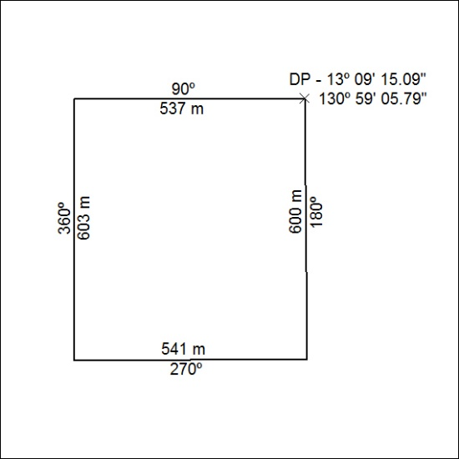

401/22

Mineral Titles Act 2010
NOTICE OF LAND CEASING TO BE A MINERAL TITLE AREA
Title Type and Number: | Mineral Lease (Central) 17
Area ceased on: | 17 November 2022
Area: | 6.00 Hectare
Locality: | TENNANT CREEK
Name of Applicants(s)Holder(s): | 50% ESTATE OF NICHOLSON Erbon Percy, 8.34% CARTER John Kirwin, 8.34% COOK Jennifer Erica, 8.33% CARTER Gowan Russell, 8.33% CARTER Suzanne Lee, 8.33% CARTER Pamela Ann, 8.33% COOK Alexander Kym
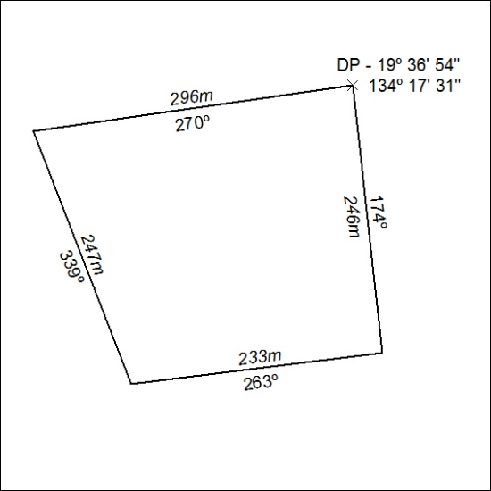

402/22

