Mineral Titles Act
NOTICE OF GRANT OF A MINERAL TITLE
Title Type and Number: | Extractive Mineral Exploration Licence 32874
Granted: | 21 February 2022, for a period of 2 Years
Area: | 4 Blocks, 13.23 km²
Locality: | WESTERN CREEK
Name of Holder/s: | 100% TERRITORY SANDS PTY LTD [ACN. 632 797 972]
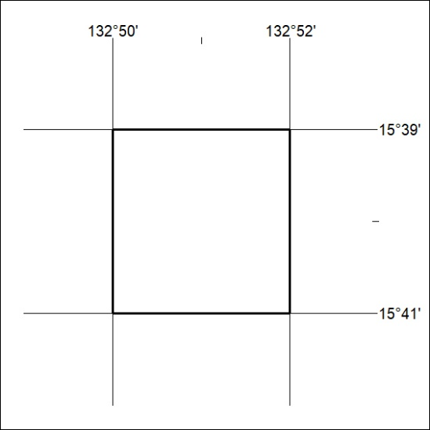
Area granted is indicated above. The titleholder is not permitted to exercise occupational rights on any land that is subject to a development title, or an application for a development title. Any land the subject of a Reserved Land gazettal under the Mineral Titles Act and all land vested in the Commonwealth of Australia is also excluded by description but not excised from the grant area.
41/22

Mineral Titles Act
NOTICE OF GRANT OF A MINERAL TITLE
Title Type and Number: | Extractive Mineral Exploration Licence 32875
Granted: | 21 February 2022, for a period of 2 Years
Area: | 4 Blocks, 13.23 km²
Locality: | WESTERN CREEK
Name of Holder/s: | 100% TERRITORY SANDS PTY LTD [ACN. 632 797 972]
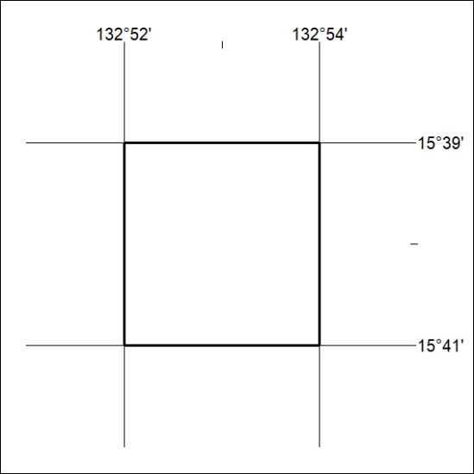
Area granted is indicated above. The titleholder is not permitted to exercise occupational rights on any land that is subject to a development title, or an application for a development title. Any land the subject of a Reserved Land gazettal under the Mineral Titles Act and all land vested in the Commonwealth of Australia is also excluded by description but not excised from the grant area.
42/22

