Mineral Titles Act 2010
NOTICE OF LAND CEASING TO BE A MINERAL TITLE AREA
Title Type and Number: | Exploration Licence 27126
Area Ceased on: | 02 January 2022
Area: | 21 Blocks, 67.85 km²
Locality: | TANAMI
Name of Applicant(s)/Holder(s): | 100% PRODIGY GOLD NL* [ACN. 009 127 020]
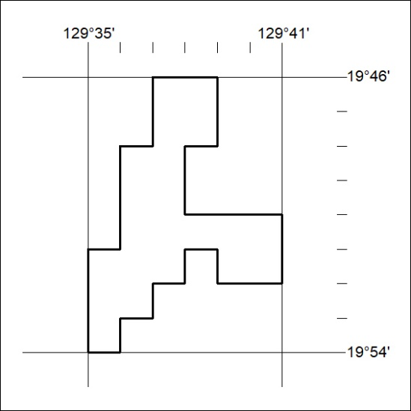

007/22

Mineral Titles Act 2010
NOTICE OF LAND CEASING TO BE A MINERAL TITLE AREA
Title Type and Number: | Exploration Licence 28326
Area Ceased on: | 02 January 2022
Area: | 48 Blocks, 155.90 km²
Locality: | WARE
Name of Applicant(s)/Holder(s): | 100% PRODIGY GOLD NL* [ACN. 009 127 020]
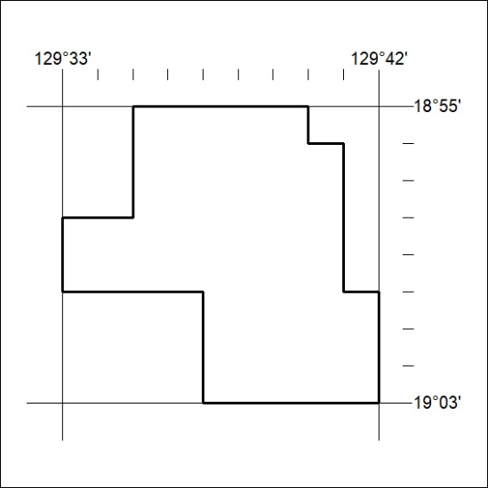

008/22

