Mineral Titles Act 2010
NOTICE OF LAND CEASING TO BE A MINERAL TITLE AREA
Title Type and Number: | Exploration Licence 30219
Area Ceased on: | 22 November 2021
Area: | 13 Blocks, 42.48 km²
Locality: | NAPIER
Name of Applicant(s)/Holder(s): | 100% MARTIN Anthony Ernest
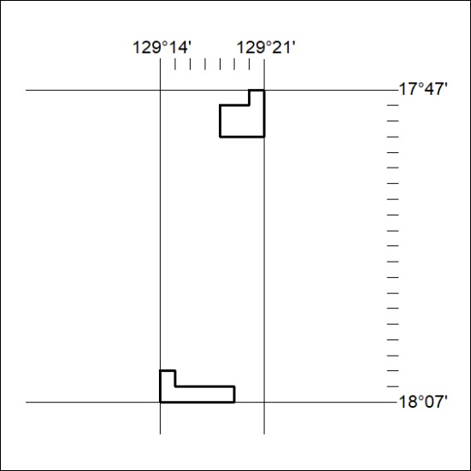

431/21

