Mineral Titles Act 2010
NOTICE OF LAND CEASING TO BE A MINERAL TITLE AREA
Title Type and Number: | Exploration Licence 31686
Area Ceased on: | 14 October 2021
Area: | 28 Blocks, 92.21 km²
Locality: | BATTEN
Name of Applicant(s)/Holder(s): | 100% BMEX LIMITED* [ACN. 615 217 680]
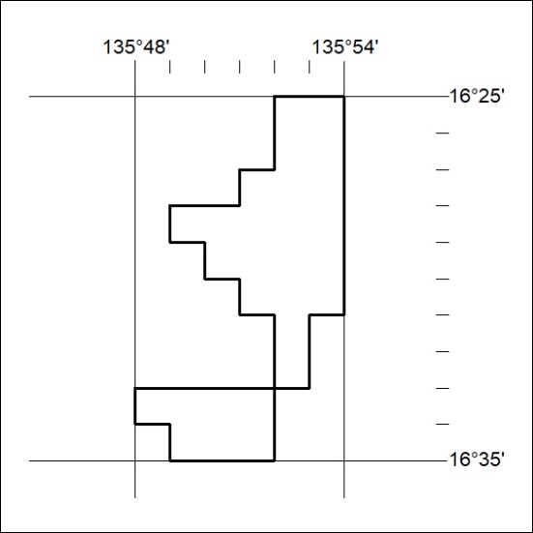

385/21

