Mineral Titles Act
NOTICE OF GRANT OF A MINERAL TITLE
Title Type and Number: | Exploration Licence 32682
Granted: | 12 October 2021, for a period of 6 Years
Area: | 53 Blocks, 157.75 km²
Locality: | RIDDOCH
Name of Holder/s: | 100% ARC MARLBOROUGH PTY LIMITED [ACN. 127 139 780]
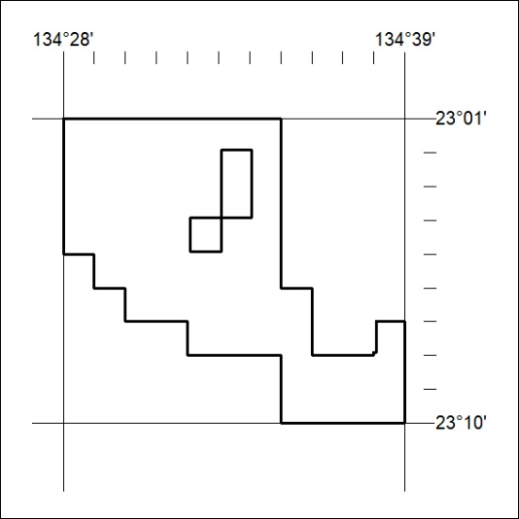
Area granted is indicated above. The titleholder is not permitted to exercise occupational rights on any land that is subject to a development title, or an application for a development title. Any land the subject of a Reserved Land gazettal under the Mineral Titles Act and all land vested in the Commonwealth of Australia is also excluded by description but not excised from the grant area.

384/21

