Mineral Titles Act 2010
NOTICE OF LAND CEASING TO BE A MINERAL TITLE APPLICATION AREA
Title Type and Number: | Exploration Licence 32679
Area Ceased on: | 14 September 2021
Area: | 250 Blocks, 785.03 km²
Locality: | LIMBLA
Name of Applicant(s)/Holder(s): | 100% GEMPART (NT) PTY LTD* [ACN. 081 859 896]
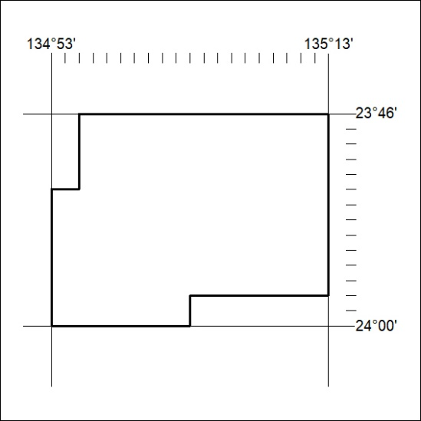

349/21

