Mineral Titles Act 2010
NOTICE OF LAND CEASING TO BE A MINERAL TITLE AREA
Title Type and Number: | Exploration Licence 29578
Area Ceased on: | 10 August 2021
Area: | 33 Blocks, 105.42 km²
Locality: | ANNINGIE
Name of Applicant(s)/Holder(s): | 100% ENIGMA MINING LIMITED [ACN. 009 225 558]
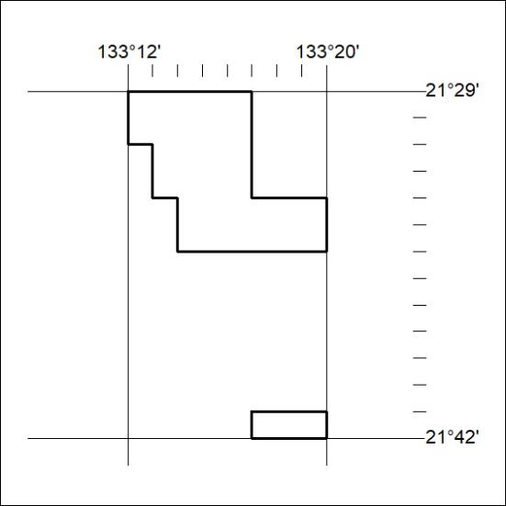

294/21

Mineral Titles Act 2010
NOTICE OF LAND CEASING TO BE A MINERAL TITLE AREA
Title Type and Number: | Exploration Licence 32349
Area Ceased on: | 10 August 2021
Area: | 60 Blocks, 182.41 km²
Locality: | ILLOGWA
Name of Applicant(s)/Holder(s): | 100% GEMPART (NT) PTY LTD* [ACN. 081 859 896]
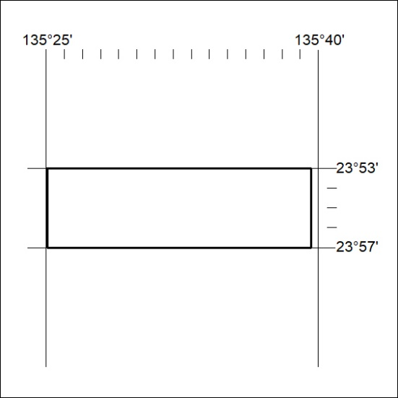

295/21

