Mineral Titles Act 2010
NOTICE OF LAND CEASING TO BE A MINERAL TITLE APPLICATION AREA
Title Type and Number: | Exploration Licence 32186
Area Ceased on: | 20 July 2021
Area: | 238 Blocks, 778.37 km²
Locality: | COANJULA
Name of Applicant(s)/Holder(s): | 100% HARKISS MINERAL DISCOVERY PTY LTD [ACN. 603 435 856]
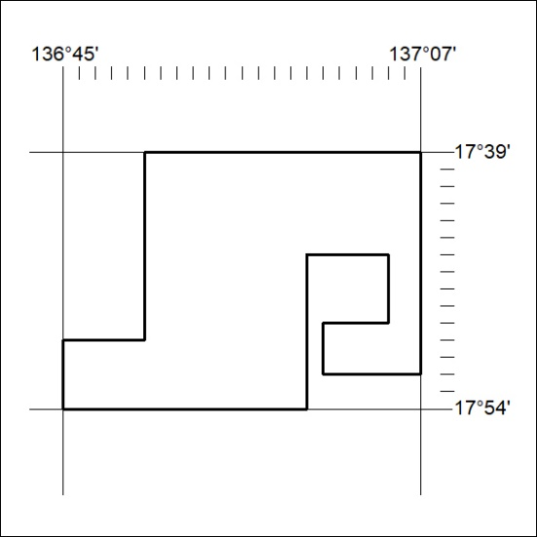

274/21

Mineral Titles Act 2010
NOTICE OF LAND CEASING TO BE A MINERAL TITLE APPLICATION AREA
Title Type and Number: | Exploration Licence 32187
Area Ceased on: | 20 July 2021
Area: | 213 Blocks, 694.82 km²
Locality: | BENMARA
Name of Applicant(s)/Holder(s): | 100% HARKISS MINERAL DISCOVERY PTY LTD [ACN. 603 435 856]
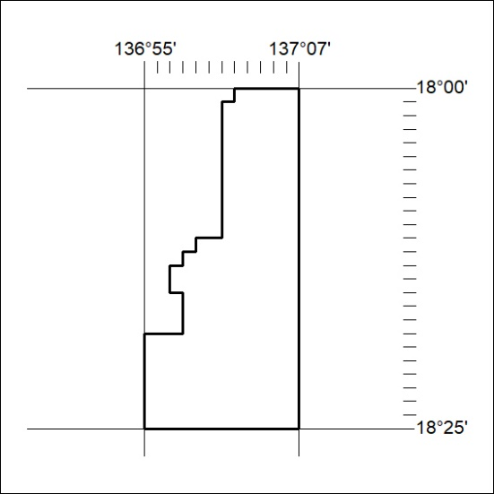

275/21

