Mineral Titles Act 2010
NOTICE OF LAND CEASING TO BE A MINERAL TITLE AREA
Title Type and Number: | Exploration Licence 30832
Area Ceased on: | 12 July 2021
Area: | 7 Blocks, 23.40 km²
Locality: | McKINLAY RIVER
Name of Applicant(s)/Holder(s): | 100% TRENDSHEER HOLDINGS PTY LTD [ACN. 621 426 515]
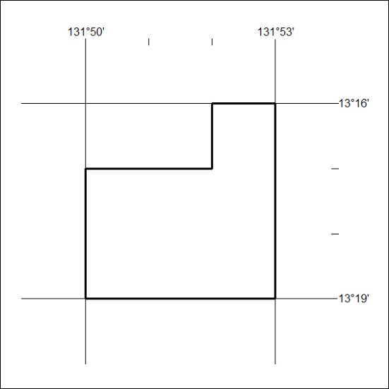

269/21

Mineral Titles Act
NOTICE OF GRANT OF A MINERAL TITLE
Title Type and Number: | Exploration Licence 32577
Granted: | 13 July 2021, for a period of 6 Years
Area: | 114 Blocks, 352.98 km²
Locality: | CARRARA
Name of Holder/s: | 100% CIENTIFICA PTY LTD [ACN. 645 504 178]
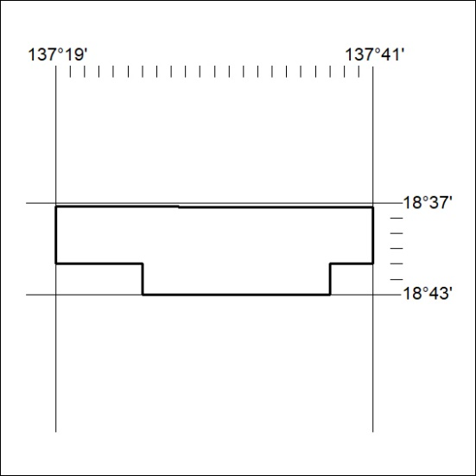
Area granted is indicated above. The titleholder is not permitted to exercise occupational rights on any land that is subject to a development title, or an application for a development title. Any land the subject of a Reserved Land gazettal under the Mineral Titles Act and all land vested in the Commonwealth of Australia is also excluded by description but not excised from the grant area.

270/21

Mineral Titles Act
NOTICE OF GRANT OF A MINERAL TITLE
Title Type and Number: | Exploration Licence 32635
Granted: | 13 July 2021, for a period of 6 Years
Area: | 2 Blocks, 6.47 km²
Locality: | DALMORE
Name of Holder/s: | 90% INCA MINERALS LIMITED [ACN. 128 512 907], 5% MRG RESOURCES PTY LTD [ACN. 614 946 164], 5% WEST Jonathan
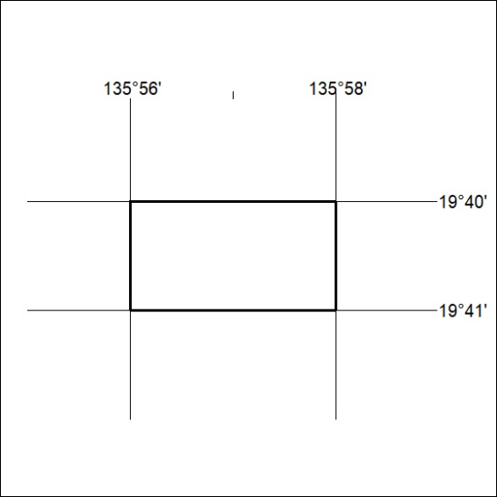
Area granted is indicated above. The titleholder is not permitted to exercise occupational rights on any land that is subject to a development title, or an application for a development title. Any land the subject of a Reserved Land gazettal under the Mineral Titles Act and all land vested in the Commonwealth of Australia is also excluded by description but not excised from the grant area.

271/21

