# Northern Territory business count 2020

The Northern Territory (NT) had 15 072 actively trading businesses at June 2020, comprising 0.62% of total actively trading businesses in Australia.

The highest number of operating businesses was in New South Wales. This was followed by Victoria, Queensland, Western Australia, South Australia, Tasmania, the Australian Capital Territory and the Northern Territory.

# Business counts

There were 15 072 actively operating businesses in the NT at June 2020, an increase of 303 businesses (2.1%) compared with June 2019.

In June 2020, the NT had 15 072 trading businesses, compared with 14 769 businesses in June 2019 and 14 470 businesses in June 2018.

There were 2 422 404 actively operating businesses in Australia at June 2020, an increase of 46 651 businesses (2.0%) from June 2019.

# Business entry, exit and survival

In 2019-20, the entry rate for businesses in the NT was 14.7%, slightly higher than the national average of 14.5%.

The highest entry rate was in the Australian Capital Territory (16.2%) followed by Victoria (15.6%) and New South Wales (14.8%). South Australia had the lowest entry rate (12.3%).

## Business count (actively trading), June 2020

National count: 2 422 404

Currently not distributed: 1 462

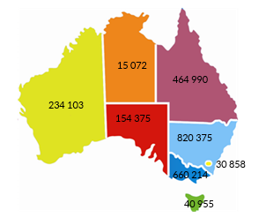

*Source: ABS Cat No 8165.0*

## Number and growth of NT businesses

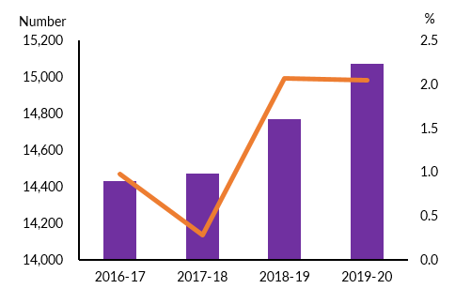

*Source: ABS Cat No 8165.0*

In 2019-20, the exit rate for NT was 12.4%, lower than the entry rate and resulting in an increase in the number of overall businesses. The NT had the fourth lowest exit rate while Australia Capital Territory (ACT) had the highest (13.7%). Nationally, the exit rate was 12.5%.

Of the 14 289 businesses operating in June 2016 in the NT, 87.3% were still operating in June 2017, 77.3% survived to June 2018, 70.3% were still operating in June 2019 and 64.6% survived to June 2020.

Nationally, 65.1% of the businesses operating in June 2016 survived to June 2020.

Of the businesses operating in June 2016, the highest survival rate in June 2020 was recorded in Tasmania (68.7%), followed by South Australia (67.7%). The lowest survival rate was in the ACT (62.5%).

In June 2017, the Territory had 1988 business entries and of these 77.2% survived to June 2018, 60.0% survived to June 2019 and 51.0% survived to June 2020. Nationally, the survival rate in June 2020 of business entries in 2016-17 was 53.3%.

# Business size

Australian Bureau of Statistics (ABS) defines business size by level of employment as follows:

* Small business : 0-19 employees
* Medium business: 20-199 employees
* Large business: 200+ employees

The majority of actively trading businesses in the NT are small. In June 2020, 96.2% were small businesses, 3.6% were medium businesses and 0.2% were large businesses. Nationally, 97.5% of the businesses were small.

## Business entry and exit rates, June 2020

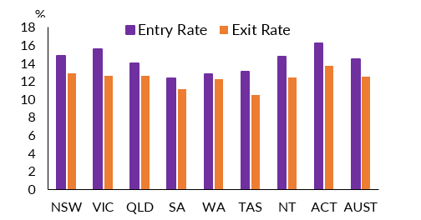

*Source: ABS Cat No 8165.0*

## NT business size, June 2020

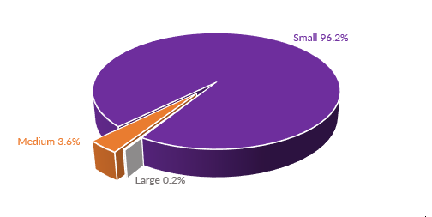

*Source: ABS Cat No 8165.0*

Of the small businesses in the NT, 63.2% were non-employing businesses, 23.3% had 1‑4 employees and 13.5% had between 5 and 19 employees.

The non-employing businesses as a percentage of total number of businesses in the NT accounted for 61.4%.

# Business numbers - industry sector distribution

In June 2020, the ‘Construction” industry had the highest number of businesses operating in the NT with 18.8% of total businesses. This was followed by ‘Rental, Hiring and Real Estate Services’ (12.6%); ‘Professional, Scientific and Technical Services’ (9.6%); ‘Transport, Postal and Warehousing’ (8.8%); ‘Retail Trade’ (6.2%) and ‘Finance and Insurance Services’ (6.1%).

At the national level, ‘Construction’ industry had the highest number of businesses (16.4%) followed by ‘Professional, Scientific and Technical Services’ (12.5%), ‘Rental, Hiring and Real Estate Services’ (10.9%), and ‘Financial & Insurance Services (9.0%).

The majority of businesses in the NT are in the ‘services sector’ (all industries except ‘Agriculture, Forestry and Fishing’; ‘Mining’; ‘Manufacturing’; ‘Electricity, water, gas and waste services’; and ‘Construction’). In June 2020, the ‘services sector’ had 71.5% of all NT businesses.

# Regional distribution of business

The majority of the businesses in the Territory are located in the Greater Darwin region (Darwin City, Darwin Suburbs, Litchfield and Palmerston).

## NT small business sub-categories

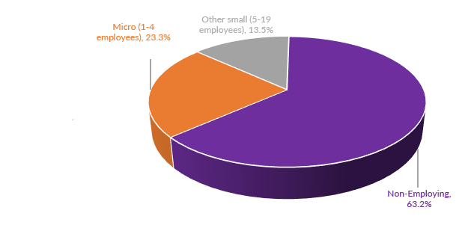

*Source: ABS Cat No 8165.0*

## NT business by industry, June 2020

In June 2020, the ‘Construction” industry had the highest number of businesses operating in the NT with 18.8% of total businesses. This was followed by ‘Rental, Hiring and Real Estate Services’ (12.6%); ‘Professional, Scientific and Technical Services’ (9.6%); ‘Transport, Postal and Warehousing’ (8.8%); ‘Retail Trade’ (6.2%) and ‘Finance and Insurance Services’ (6.1%).





*Source: ABS Cat No 8165.0*

In June 2020, 74.1% of all businesses in the NT were located in the Greater Darwin region. The Alice Springs region had the second highest number of businesses (14.1%), the Katherine region had 6.4%, Daly-Tiwi-West Arnhem had 2.4%, East Arnhem had 1.7%, and the Barkly region had 1.3%. Business locations of about 1.2% of the businesses were ‘currently unknown’.

# Annual business turnover

At June 2020, the NT had 25.2% of businesses operating in the ‘zero to <$50k’ turnover range. About 12.8% of the businesses were operating in the ‘$50k to <$100k’ range, 17.6% in the ‘$100k to <$200k’ range, 18.5% were in the ‘$200k to <$500k’ range, 17.0% in the ‘$500k to <$2m’ range, 5.4% in the ‘$2m to <$5m range, 1.8% in the $5m to <$10m range, and 1.7% in the $10m+ range.

•More than half (55.8%) of the NT businesses have an annual turnover of less than $200k.

Nationally, around 25.0% of businesses were operating in the turnover range of ‘zero to <$50k’, 34.1% in the ‘$50k to <$200k’ turnover range, 33.9% in the ‘$200k to <$2m’ turnover range, 4.0% in the ‘$2m to <$5m’ turnover range; 1.4% in the ‘$5m to <$10m’ turnover range and 1.6% in the $10m or more’ turnover range.

## NT businesses by region, June 2020

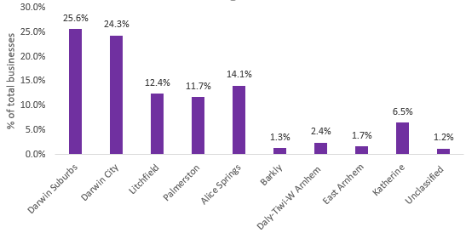

*Source: ABS Cat No 8165.0*

## Business location, June 2020

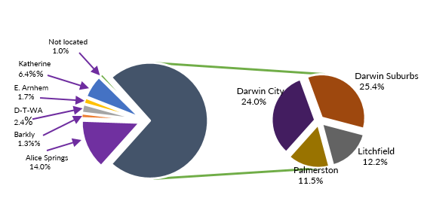*Source: ABS Cat No 8165.0*

## NT business count by turnover, June 2020

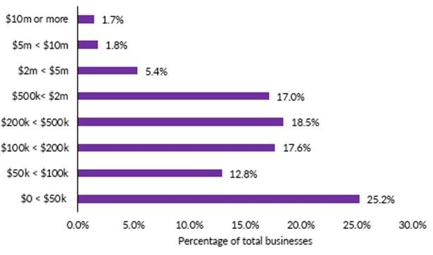

*Source: ABS Cat. No. 8165.0 and ABS unpublished data*

# The conceptual and practical basis for counts of Australian businesses, including entries and exits

## Reference period, June 2020(a)

Flow chart: The conceptual and practical basis for counts of Australian businesses, including entries and exits.
Reference Period June 2020(a)


(a) The ABS Business Register is updated monthly and data is extracted as close to 30 June 2019 as possible. Therefore, in addition to out of scope ABNs, minor differences in the timing of the CABEE frame contribute to the difference between end of year business counts presented in this release and those published by the ABR.

(b)

No. of active ABNs with no active in-scope roles  
No. of active ABNs with active in-scope roles other than active ITW and GST roles  
No. of active ABNs with invalid ANZSIC / SISCA / State - active ITW or GST roles only  
No. of mutually exclusive active ABNs excluded due to being ITW or GST LTNRs  
Active ABNs with active ITW role only  
Out of scope TOLO / ANZSIC / SISCA

*Source: ABS Cat. No. 8165.0*

## Notes:

ABS business count is derived from Australian Bureau of Statistics Business Register (ABSBR) and is populated with information from the Australian Business Register (ABR). Most businesses in Australia are required to have an Australian Business Number (ABN) and register with ABR. Actively trading businesses with a turnover of at least of $75,000 per annum and $150 000 for non-profit organisations are required to have an ABN and remit GST. Businesses with <$75,000 turnover can voluntary register for ABN and these voluntarily registered businesses are included in the business counts. See appendix 1 for details on the basis for counts of businesses. For further information, please refer to ABS Catalogue number 8165.0.

The ABS definition of business exit is ‘a business for which the ABN or GST role has been cancelled and/or which has ceased to remit GST for at least five consecutive quarters in respect of that ABN (or 3 consecutive years for annual remitters)’. It should be noted that a business exit event does not necessarily equate to a business ‘failure’. There may be other reasons such as sale of business (owner retiring, etc) or change in the business structure e.g. mergers and takeovers.

## Data source:

Australian Bureau of Statistics, Catalogue Number 8165.0  
For further information:  
Contact: Economic Analysis  
 Department of Trade, Business and Innovation  
Phone: 89995139

Information current as at: 30 June 2020

Disclaimer: The Northern Territory of Australia gives no warranty of assurance, and makes no representation as to the accuracy of any information or advice contained in this publication, or that it is suitable for your intended use. You should not rely upon information in this publication for the purpose of making any serious business or investment decisions without obtaining independent and/or professional advice in relation to your particular situation.