Mineral Titles Act 2010
NOTICE OF LAND CEASING TO BE A MINERAL TITLE AREA
Title Type and Number: | Exploration Licence 26825
Area Ceased on: | 27 January 2021
Area: | 29 Blocks, 92.42 km²
Locality: | CRAWFORD
Name of Applicant(s)/Holder(s): | 100% PRODIGY GOLD NL* [ACN. 009 127 020]
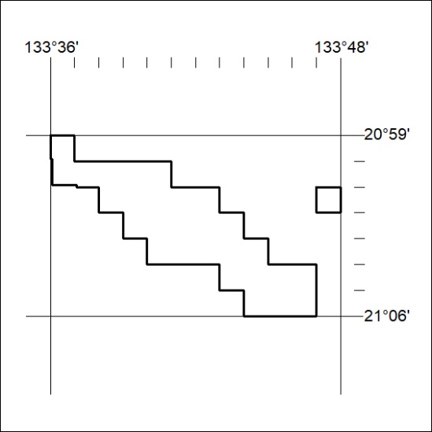

16/21

Mineral Titles Act 2010
NOTICE OF LAND CEASING TO BE A MINERAL TITLE AREA
Title Type and Number: | Exploration Licence 32016
Area Ceased on: | 28 January 2021
Area: | 36 Blocks, 110.44 km²
Locality: | DALY RIVER
Name of Applicant(s)/Holder(s): | 100% HAMERSLEY METALS PTY LTD [ACN. 622 868 213]
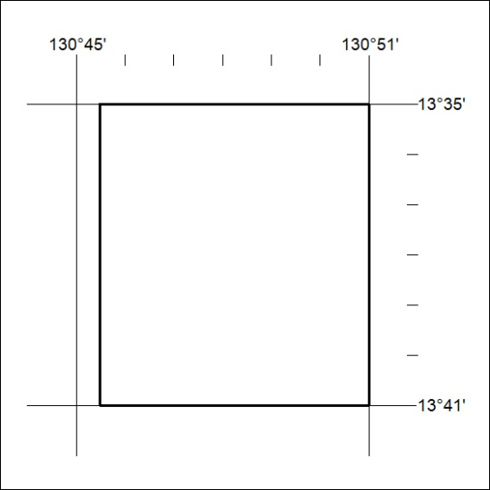

17/21

Mineral Titles Act 2010
NOTICE OF LAND CEASING TO BE A MINERAL TITLE AREA
Title Type and Number: | Extractive Mineral Permit 31334
Area ceased on: | 28 January 2021
Area: | 10.20 Hectare
Locality: | KOOLPINYAH
Name of Applicants(s)Holder(s): | 100% MOUSELLIS & SONS PTY. LTD. [ACN. 009 654 791]
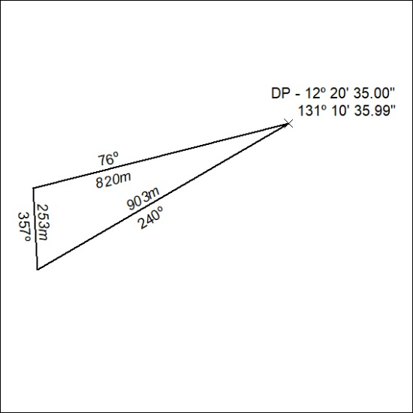

17/21

