Mineral Titles Act 2010
NOTICE OF LAND CEASING TO BE A MINERAL TITLE APPLICATION AREA
Title Type and Number: | Exploration Licence 25582
Area Ceased on: | 17 December 2020
Area: | 401 Blocks, 1206.69 km²
Locality: | BONNEY
Name of Applicant(s)/Holder(s): | 100% TODD RIVER METALS PTY LTD [ACN. 600 314 038]
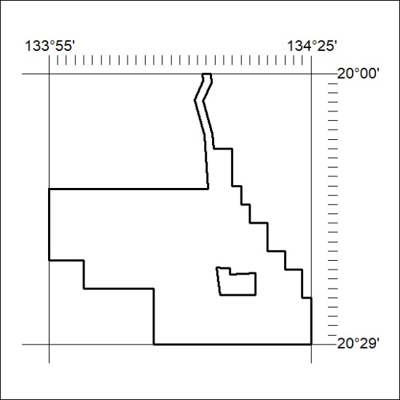

416/20

Mineral Titles Act 2010
NOTICE OF LAND CEASING TO BE A MINERAL TITLE APPLICATION AREA
Title Type and Number: | Exploration Licence 25587
Area Ceased on: | 17 December 2020
Area: | 82 Blocks, 248.21 km²
Locality: | OORADIDGEE
Name of Applicant(s)/Holder(s): | 100% TODD RIVER METALS PTY LTD [ACN. 600 314 038]
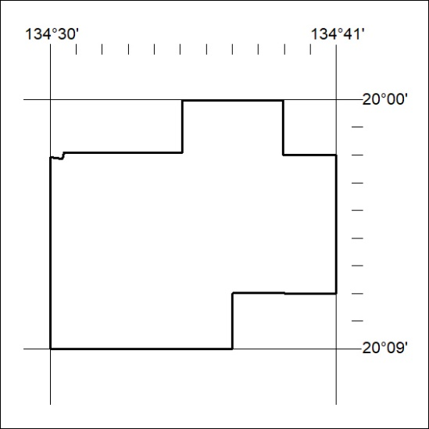

417/20

Mineral Titles Act
NOTICE OF GRANT OF A MINERAL TITLE
Title Type and Number: | Extractive Mineral Exploration Licence 32375
Granted: | 16 December 2020, for a period of 2 Years
Area: | 4 Blocks, 13.35 km²
Locality: | PINE CREEK
Name of Holder/s: | 100% MOUSELLIS Pothitos
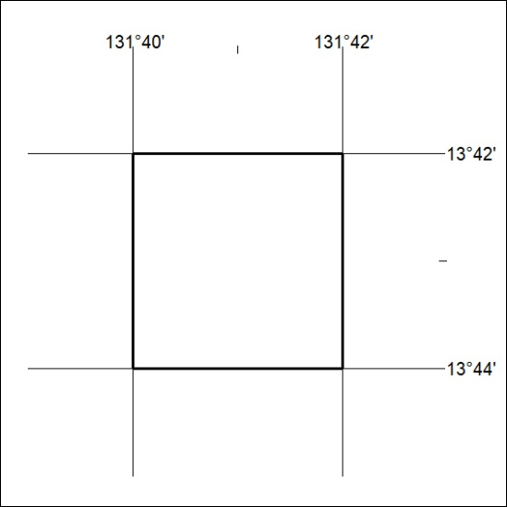
Area granted is indicated above. The titleholder is not permitted to exercise occupational rights on any land that is subject to a development title, or an application for a development title. Any land the subject of a Reserved Land gazettal under the Mineral Titles Act and all land vested in the Commonwealth of Australia is also excluded by description but not excised from the grant area.
418/20

Mineral Titles Act
NOTICE OF GRANT OF A MINERAL TITLE
Title Type and Number: | Extractive Mineral Exploration Licence 32376
Granted: | 16 December 2020, for a period of 2 Years
Area: | 3 Blocks, 10.01 km²
Locality: | PINE CREEK
Name of Holder/s: | 100% MOUSELLIS Pothitos
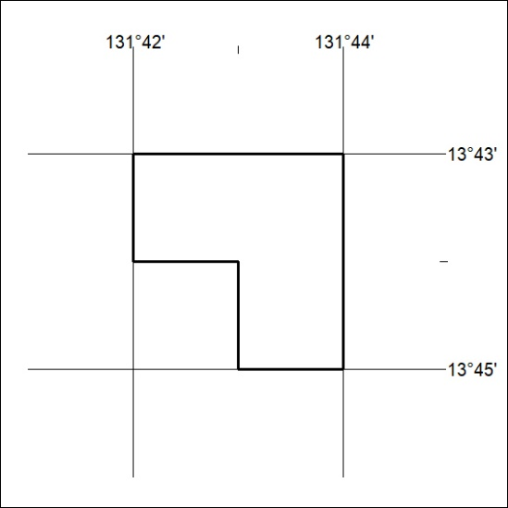
Area granted is indicated above. The titleholder is not permitted to exercise occupational rights on any land that is subject to a development title, or an application for a development title. Any land the subject of a Reserved Land gazettal under the Mineral Titles Act and all land vested in the Commonwealth of Australia is also excluded by description but not excised from the grant area.
419/20

