Mineral Titles Act 2010
NOTICE OF LAND CEASING TO BE A MINERAL TITLE AREA
Title Type and Number: | Mineral Lease 29938
Area ceased on: | 23 April 2020
Area: | 18.00 Hectare
Locality: | McKINLAY RIVER
Name of Applicants(s)Holder(s): | 80% OZ URANIUM PTY LTD [ACN. 164 615 749], 20% TROW David
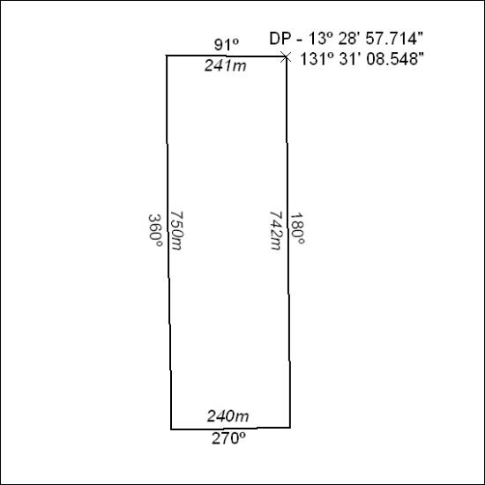
170/20

