Mineral Titles Act
NOTICE OF GRANT OF A MINERAL TITLE
Title Type and Number: | Exploration Licence 32148
Granted: | 19 March 2020, for a period of 6 Years
Area: | 13 Blocks, 43.16 km²
Locality: | PINE CREEK
Name of Holder/s: | 100% BACCHUS RESOURCES PTY LTD [ACN. 606 340 872]
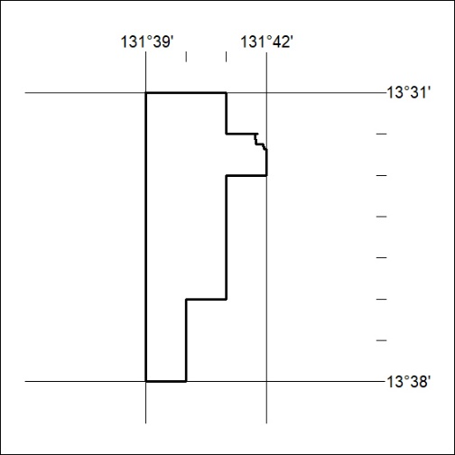
Area granted is indicated above. The titleholder is not permitted to exercise occupational rights on any land that is subject to a development title, or an application for a development title. Any land the subject of a Reserved Land gazettal under the Mineral Titles Act and all land vested in the Commonwealth of Australia is also excluded by description but not excised from the grant area.

143/20

Mineral Titles Act
NOTICE OF GRANT OF A MINERAL TITLE
Title Type and Number: | Exploration Licence 32248
Granted: | 19 March 2020, for a period of 6 Years
Area: | 249 Blocks, 818.86 km²
Locality: | FLAT TOP HILL
Name of Holder/s: | 100% SANTONIAN RESOURCES PTY LTD [ACN. 627 611 563]
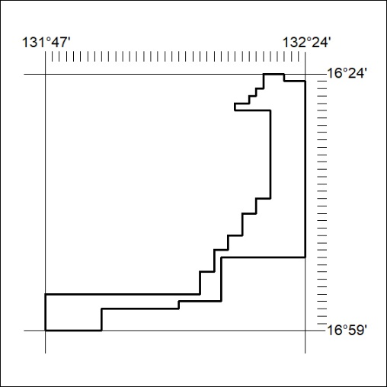
Area granted is indicated above. The titleholder is not permitted to exercise occupational rights on any land that is subject to a development title, or an application for a development title. Any land the subject of a Reserved Land gazettal under the Mineral Titles Act and all land vested in the Commonwealth of Australia is also excluded by description but not excised from the grant area.

144/20

