Mineral Titles Act 2010
NOTICE OF LAND CEASING TO BE A MINERAL TITLE AREA
Title Type and Number: | Exploration Licence 31787
Area Ceased on: | 07 October 2019
Area: | 250 Blocks, 811.41 km²
Locality: | WOLLOGORANG
Name of Applicant(s)/Holder(s): | 100% TSC EXPLORATION PTY LTD* [ACN. 622 780 027]
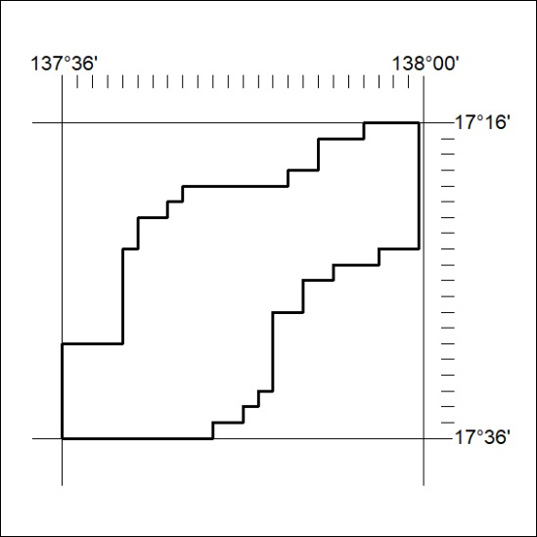

418/19

Mineral Titles Act 2010
NOTICE OF LAND CEASING TO BE A MINERAL TITLE AREA
Title Type and Number: | Exploration Licence 31788
Area Ceased on: | 07 October 2019
Area: | 250 Blocks, 820.53 km²
Locality: | WOLLOGORANG
Name of Applicant(s)/Holder(s): | 100% TSC EXPLORATION PTY LTD* [ACN. 622 780 027]
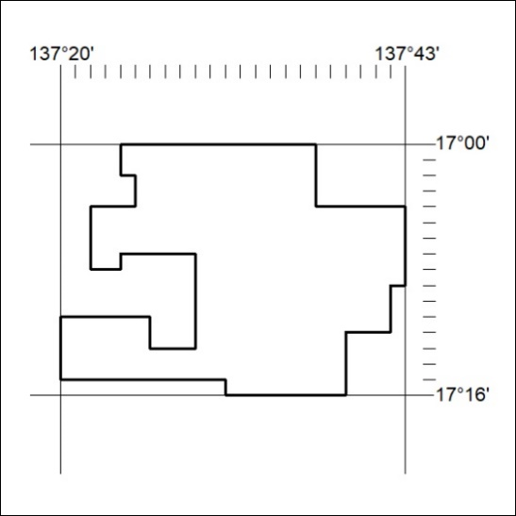

419/19

Mineral Titles Act
NOTICE OF GRANT OF A MINERAL TITLE
Title Type and Number: | Exploration Licence 32041
Granted: | 04 October 2019, for a period of 6 Years
Area: | 15 Blocks, 24.99 km²
Locality: | NOONAMAH
Name of Holder/s: | 100% ALDEBARAN CONTRACTING PTY LTD [ACN. 128 020 299]
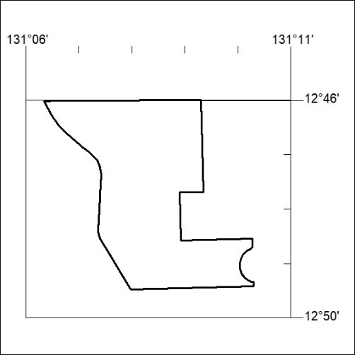
Area granted is indicated above. The titleholder is not permitted to exercise occupational rights on any land that is subject to a development title, or an application for a development title. Any land the subject of a Reserved Land gazettal under the Mineral Titles Act and all land vested in the Commonwealth of Australia is also excluded by description but not excised from the grant area.

420/19

