Mineral Titles Act 2010
NOTICE OF LAND CEASING TO BE A MINERAL TITLE AREA
Title Type and Number: | Exploration Licence 25553
Area Ceased on: | 28 August 2019
Area: | 2 Blocks, 6.68 km²
Locality: | TIPPERARY
Name of Applicant(s)/Holder(s): | 100% OZ URANIUM PTY LTD [ACN. 164 615 749]
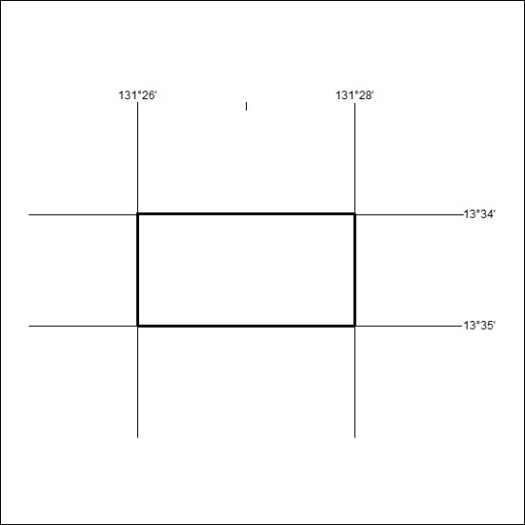
362/19

Mineral Titles Act 2010
NOTICE OF LAND CEASING TO BE A MINERAL TITLE AREA
Title Type and Number: | Exploration Licence 31013
Area Ceased on: | 29 August 2019
Area: | 21 Blocks, 68.87 km²
Locality: | LANCEWOOD
Name of Applicant(s)/Holder(s): | 100% SCRIVEN EXPLORATION PTY LTD [ACN. 006 264 615]
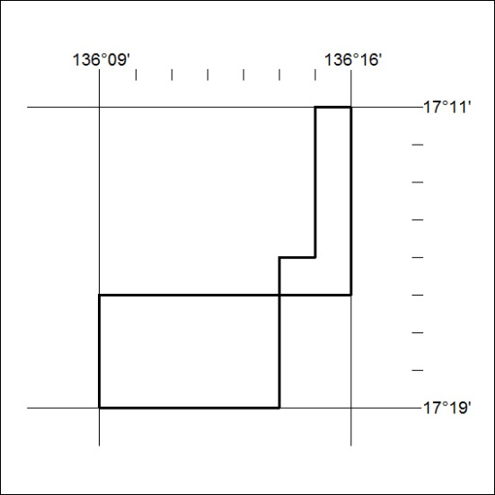
363/19

Mineral Titles Act 2010
NOTICE OF LAND CEASING TO BE A MINERAL TITLE AREA
Title Type and Number: | Exploration Licence 31685
Area Ceased on: | 29 August 2019
Area: | 13 Blocks, 42.66 km²
Locality: | LANCEWOOD
Name of Applicant(s)/Holder(s): | 100% SCRIVEN EXPLORATION PTY LTD [ACN. 006 264 615]
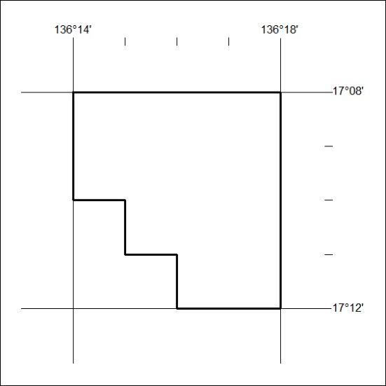
364/19

Mineral Titles Act 2010
NOTICE OF LAND CEASING TO BE A MINERAL TITLE AREA
Title Type and Number: | Extractive Mineral Exploration Licence 31472
Area Ceased on: | 30 August 2019
Area: | 4 Blocks, 9.87 km²
Locality: | KOOLPINYAH
Name of Applicant(s)/Holder(s): | 100% YEBNA SANDS PTY LTD [ACN. 606 114 603]
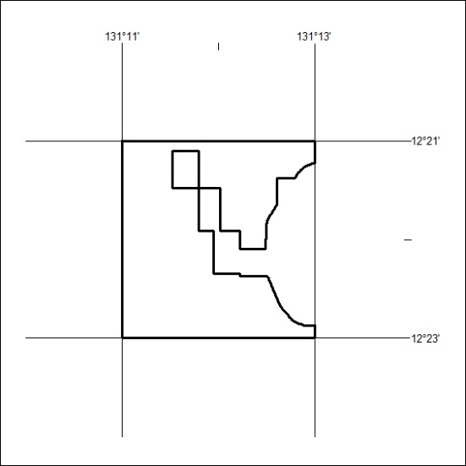
365/19

Mineral Titles Act 2010
NOTICE OF LAND CEASING TO BE A MINERAL TITLE AREA
Title Type and Number: | Extractive Mineral Exploration Licence 31473
Area Ceased on: | 30 August 2019
Area: | 4 Blocks, 8.23 km²
Locality: | KOOLPINYAH
Name of Applicant(s)/Holder(s): | 100% YEBNA SANDS PTY LTD [ACN. 606 114 603]
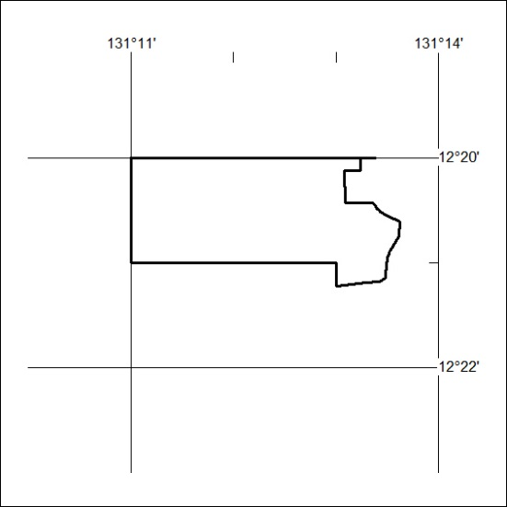
366/19

