Mineral Titles Act 2010
NOTICE OF LAND CEASING TO BE A MINERAL TITLE AREA
Title Type and Number: | Exploration Licence 31098
Area Ceased on: | 12 July 2019
Area: | 104 Blocks, 327.37 km²
Locality: | NAPPERBY
Name of Applicant(s)/Holder(s): | 100% ENERGY METALS LTD [ACN. 111 306 533]
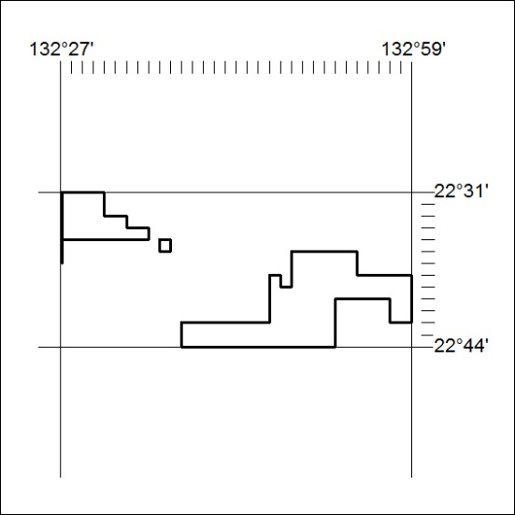

287/19

Mineral Titles Act 2010
NOTICE OF LAND CEASING TO BE A MINERAL TITLE AREA
Title Type and Number: | Extractive Mineral Exploration Licence 31268
Area Ceased on: | 11 July 2019
Area: | 2 Blocks, 2.38 km²
Locality: | NOONAMAH
Name of Applicant(s)/Holder(s): | 100% ALDEBARAN CONTRACTING PTY LTD [ACN. 128 020 299]
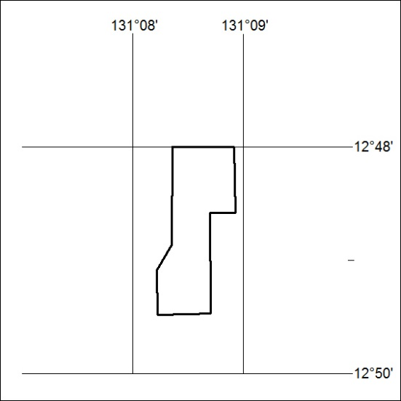

288/19

