Mineral Titles Act 2010
NOTICE OF LAND CEASING TO BE A MINERAL TITLE AREA
Title Type and Number: | Exploration Licence 30844
Area Ceased on: | 30 May 2019
Area: | 14 Blocks, 45.98 km²
Locality: | LANCEWOOD
Name of Applicant(s)/Holder(s): | 100% MMG EXPLORATION PTY LTD* [ACN. 119 136 659]
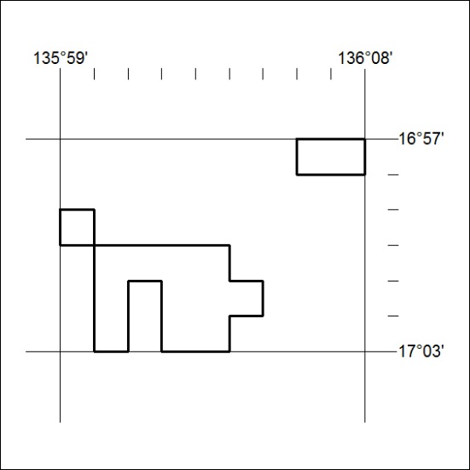

208/19

Mineral Titles Act 2010
NOTICE OF LAND CEASING TO BE A MINERAL TITLE AREA
Title Type and Number: | Exploration Licence 30845
Area Ceased on: | 30 May 2019
Area: | 8 Blocks, 26.29 km²
Locality: | GLYDE
Name of Applicant(s)/Holder(s): | 100% MMG EXPLORATION PTY LTD* [ACN. 119 136 659]
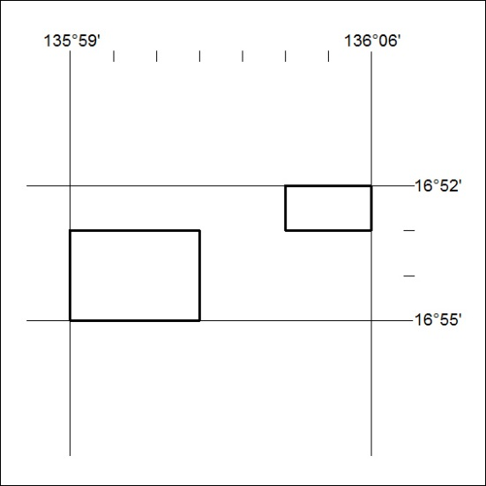

209/19
Mineral Titles Act 2010
NOTICE OF LAND CEASING TO BE A MINERAL TITLE AREA
Title Type and Number: | Exploration Licence 30868
Area Ceased on: | 30 May 2019
Area: | 4 Blocks, 13.20 km²
Locality: | BATTEN
Name of Applicant(s)/Holder(s): | 100% MMG EXPLORATION PTY LTD* [ACN. 119 136 659]
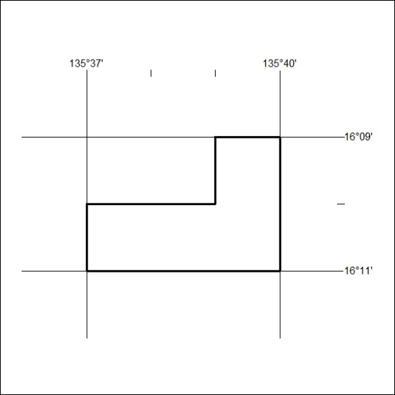

210/19

Mineral Titles Act 2010
NOTICE OF LAND CEASING TO BE A MINERAL TITLE AREA
Title Type and Number: | Exploration Licence 30869
Area Ceased on: | 30 May 2019
Area: | 32 Blocks, 105.26 km²
Locality: | GLYDE
Name of Applicant(s)/Holder(s): | 100% MMG EXPLORATION PTY LTD* [ACN. 119 136 659]
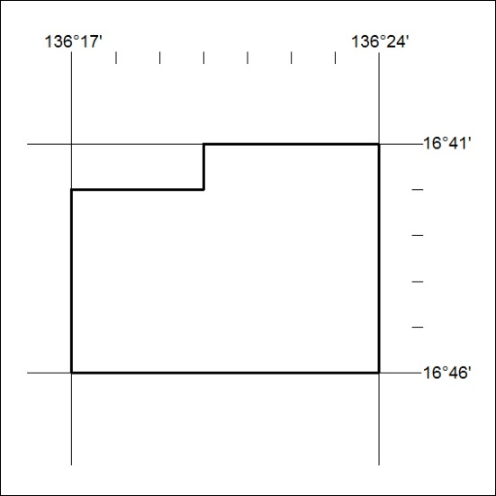

211/19
Mineral Titles Act 2010
NOTICE OF LAND CEASING TO BE A MINERAL TITLE AREA
Title Type and Number: | Exploration Licence 30923
Area Ceased on: | 30 May 2019
Area: | 9 Blocks, 29.56 km²
Locality: | GLYDE
Name of Applicant(s)/Holder(s): | 100% MMG EXPLORATION PTY LTD* [ACN. 119 136 659]
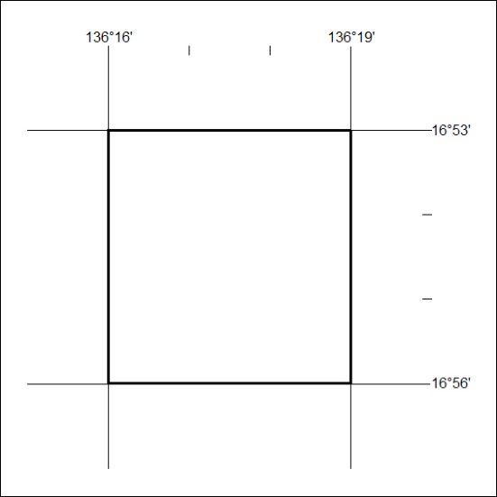

212/19

Mineral Titles Act 2010
NOTICE OF LAND CEASING TO BE A MINERAL TITLE AREA
Title Type and Number: | Exploration Licence 30948
Area Ceased on: | 30 May 2019
Area: | 211 Blocks, 684.21 km²
Locality: | BAUHINIA DOWNS
Name of Applicant(s)/Holder(s): | 100% MMG EXPLORATION PTY LTD* [ACN. 119 136 659]
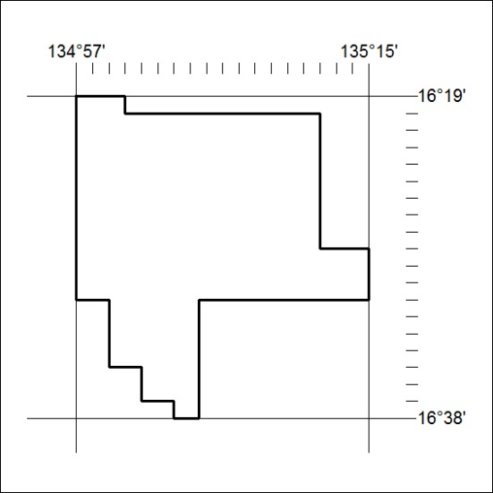

213/19
Mineral Titles Act 2010
NOTICE OF LAND CEASING TO BE A MINERAL TITLE AREA
Title Type and Number: | Exploration Licence 30950
Area Ceased on: | 30 May 2019
Area: | 250 Blocks, 824.61 km²
Locality: | BAUHINIA DOWNS
Name of Applicant(s)/Holder(s): | 100% MMG EXPLORATION PTY LTD* [ACN. 119 136 659]
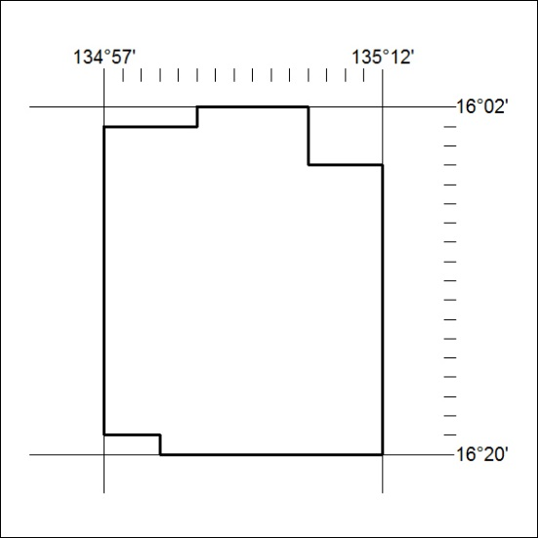

214/19

Mineral Titles Act 2010
NOTICE OF LAND CEASING TO BE A MINERAL TITLE AREA
Title Type and Number: | Exploration Licence 30980
Area Ceased on: | 30 May 2019
Area: | 13 Blocks, 42.71 km²
Locality: | GLYDE
Name of Applicant(s)/Holder(s): | 100% MMG EXPLORATION PTY LTD* [ACN. 119 136 659]
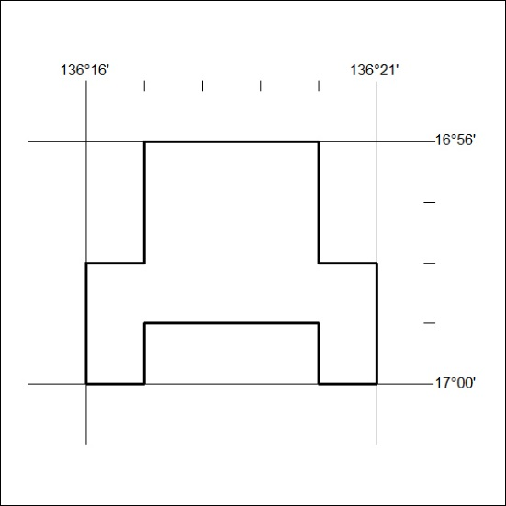

215/19
Mineral Titles Act 2010
NOTICE OF LAND CEASING TO BE A MINERAL TITLE AREA
Title Type and Number: | Exploration Licence 30981
Area Ceased on: | 30 May 2019
Area: | 4 Blocks, 13.14 km²
Locality: | GLYDE
Name of Applicant(s)/Holder(s): | 100% MMG EXPLORATION PTY LTD* [ACN. 119 136 659]
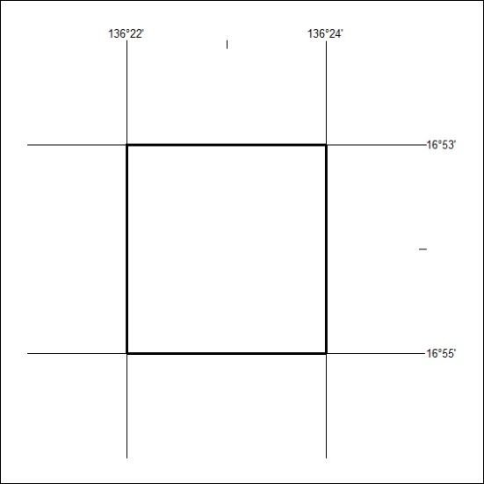

216/19

Mineral Titles Act 2010
NOTICE OF LAND CEASING TO BE A MINERAL TITLE AREA
Title Type and Number: | Exploration Licence 31044
Area Ceased on: | 30 May 2019
Area: | 47 Blocks, 154.49 km²
Locality: | GLYDE
Name of Applicant(s)/Holder(s): | 100% MMG EXPLORATION PTY LTD* [ACN. 119 136 659]
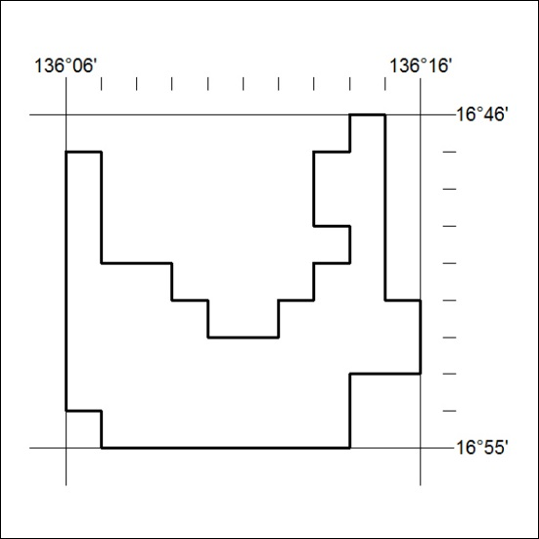

217/19
Mineral Titles Act 2010
NOTICE OF LAND CEASING TO BE A MINERAL TITLE AREA
Title Type and Number: | Exploration Licence 31254
Area Ceased on: | 30 May 2019
Area: | 84 Blocks, 275.87 km²
Locality: | LANCEWOOD
Name of Applicant(s)/Holder(s): | 100% MMG EXPLORATION PTY LTD* [ACN. 119 136 659]
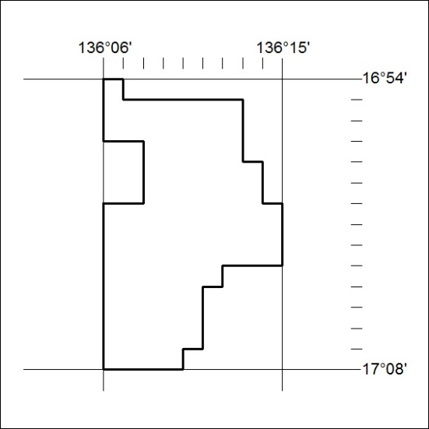

218/19

Mineral Titles Act 2010
NOTICE OF LAND CEASING TO BE A MINERAL TITLE AREA
Title Type and Number: | Exploration Licence 31294
Area Ceased on: | 30 May 2019
Area: | 67 Blocks, 219.93 km²
Locality: | LANCEWOOD
Name of Applicant(s)/Holder(s): | 100% MMG EXPLORATION PTY LTD* [ACN. 119 136 659]
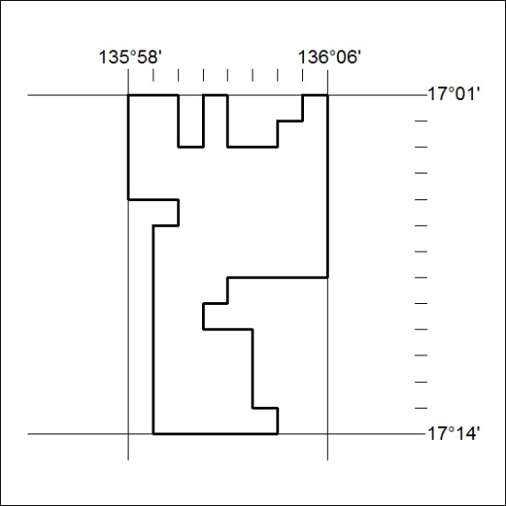

219/19
Mineral Titles Act 2010
NOTICE OF LAND CEASING TO BE A MINERAL TITLE AREA
Title Type and Number: | Exploration Licence 31426
Area Ceased on: | 30 May 2019
Area: | 18 Blocks, 59.27 km²
Locality: | MALLAPUNYAH
Name of Applicant(s)/Holder(s): | 100% MMG EXPLORATION PTY LTD* [ACN. 119 136 659]
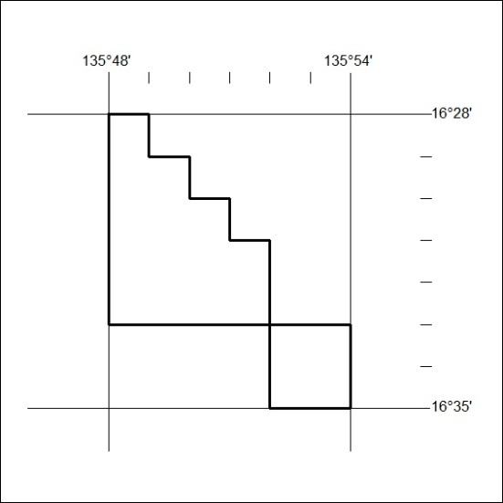

220/19

Mineral Titles Act 2010
NOTICE OF LAND CEASING TO BE A MINERAL TITLE AREA
Title Type and Number: | Exploration Licence 31596
Area Ceased on: | 30 May 2019
Area: | 44 Blocks, 145.33 km²
Locality: | BING BONG
Name of Applicant(s)/Holder(s): | 100% MMG EXPLORATION PTY LTD* [ACN. 119 136 659]
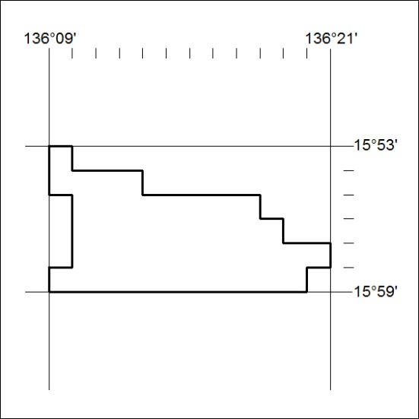

221/19
Mineral Titles Act 2010
NOTICE OF LAND CEASING TO BE A MINERAL TITLE AREA
Title Type and Number: | Exploration Licence 31597
Area Ceased on: | 30 May 2019
Area: | 52 Blocks, 171.85 km²
Locality: | BING BONG
Name of Applicant(s)/Holder(s): | 100% MMG EXPLORATION PTY LTD* [ACN. 119 136 659]
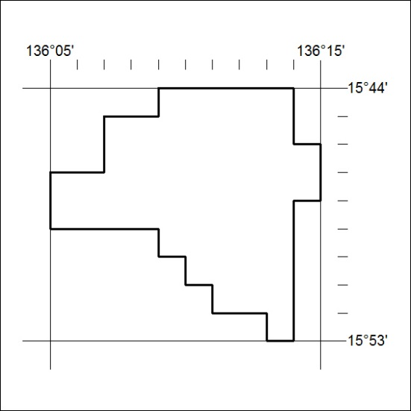

222/19

Mineral Titles Act 2010
NOTICE OF LAND CEASING TO BE A MINERAL TITLE AREA
Title Type and Number: | Exploration Licence 31614
Area Ceased on: | 30 May 2019
Area: | 3 Blocks, 9.87 km²
Locality: | GLYDE
Name of Applicant(s)/Holder(s): | 100% MMG EXPLORATION PTY LTD* [ACN. 119 136 659]
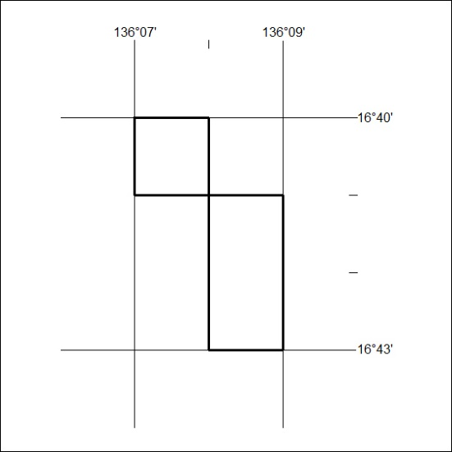

223/19
Mineral Titles Act 2010
NOTICE OF LAND CEASING TO BE A MINERAL TITLE AREA
Title Type and Number: | Exploration Licence 31615
Area Ceased on: | 30 May 2019
Area: | 36 Blocks, 118.19 km²
Locality: | LANCEWOOD
Name of Applicant(s)/Holder(s): | 100% MMG EXPLORATION PTY LTD* [ACN. 119 136 659]
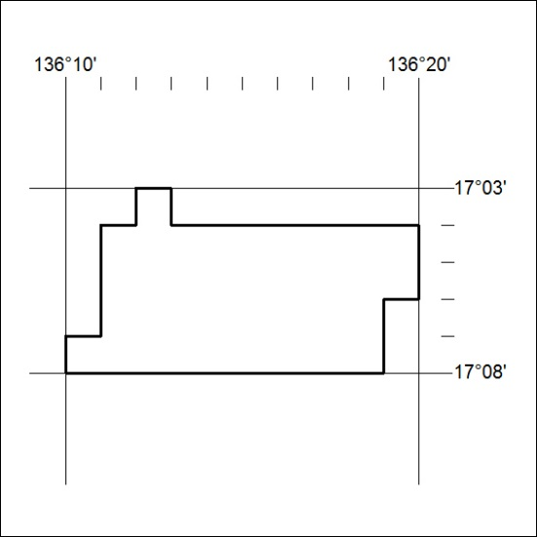

224/19

Mineral Titles Act 2010
NOTICE OF LAND CEASING TO BE A MINERAL TITLE AREA
Title Type and Number: | Exploration Licence 31616
Area Ceased on: | 30 May 2019
Area: | 72 Blocks, 236.70 km²
Locality: | GLYDE
Name of Applicant(s)/Holder(s): | 100% MMG EXPLORATION PTY LTD* [ACN. 119 136 659]
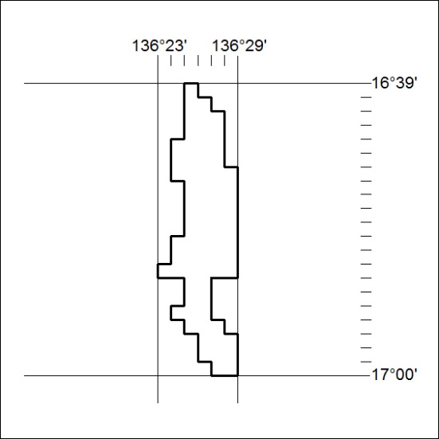

225/19
Mineral Titles Act 2010
NOTICE OF LAND CEASING TO BE A MINERAL TITLE AREA
Title Type and Number: | Exploration Licence 31622
Area Ceased on: | 30 May 2019
Area: | 7 Blocks, 23.00 km²
Locality: | GLYDE
Name of Applicant(s)/Holder(s): | 100% MMG EXPLORATION PTY LTD* [ACN. 119 136 659]
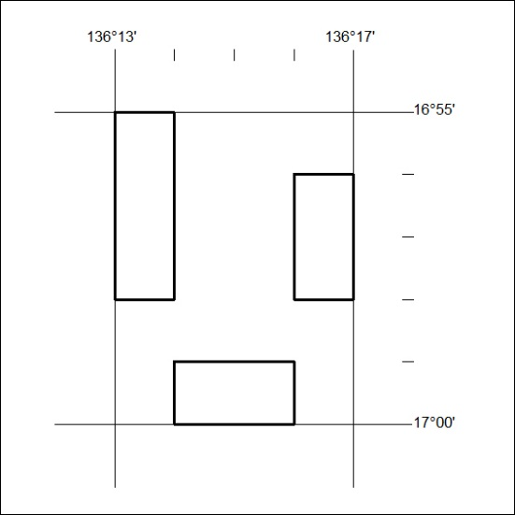

226/19

Mineral Titles Act 2010
NOTICE OF LAND CEASING TO BE A MINERAL TITLE AREA
Title Type and Number: | Exploration Licence 31687
Area Ceased on: | 30 May 2019
Area: | 46 Blocks, 148.88 km²
Locality: | BATTEN
Name of Applicant(s)/Holder(s): | 100% MMG EXPLORATION PTY LTD* [ACN. 119 136 659]
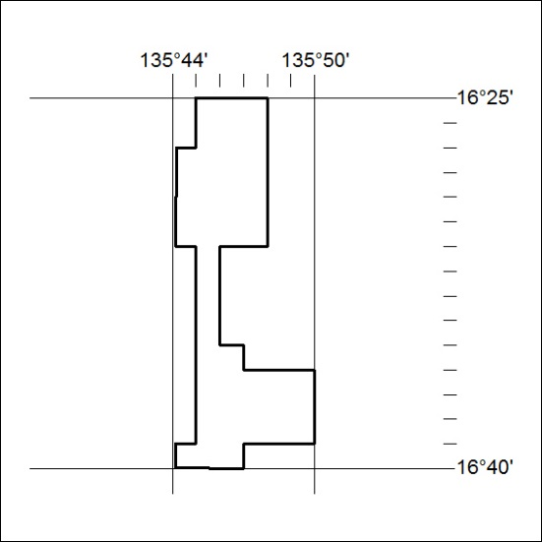

227/19
Mineral Titles Act 2010
NOTICE OF LAND CEASING TO BE A MINERAL TITLE AREA
Title Type and Number: | Exploration Licence 31688
Area Ceased on: | 30 May 2019
Area: | 134 Blocks, 440.69 km²
Locality: | GLYDE
Name of Applicant(s)/Holder(s): | 100% MMG EXPLORATION PTY LTD* [ACN. 119 136 659]
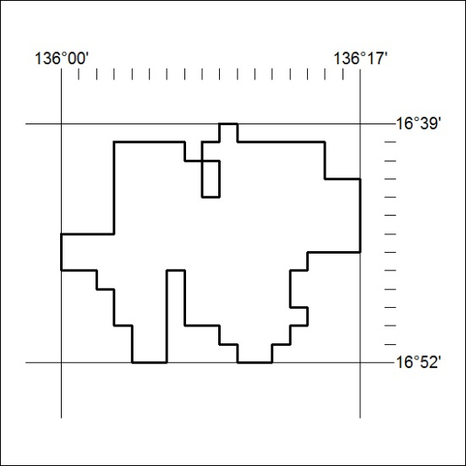

228/19

Mineral Titles Act 2010
NOTICE OF LAND CEASING TO BE A MINERAL TITLE AREA
Title Type and Number: | Exploration Licence 31689
Area Ceased on: | 30 May 2019
Area: | 170 Blocks, 559.66 km²
Locality: | GLYDE
Name of Applicant(s)/Holder(s): | 100% MMG EXPLORATION PTY LTD* [ACN. 119 136 659]
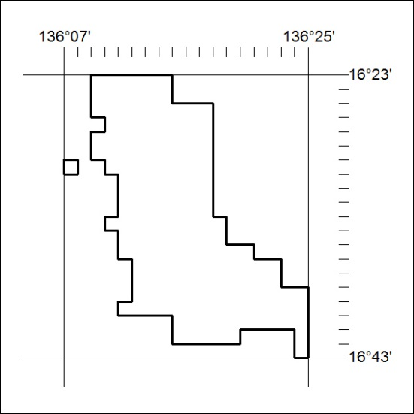

229/19
Mineral Titles Act 2010
NOTICE OF LAND CEASING TO BE A MINERAL TITLE AREA
Title Type and Number: | Exploration Licence 31690
Area Ceased on: | 30 May 2019
Area: | 55 Blocks, 180.69 km²
Locality: | GLYDE
Name of Applicant(s)/Holder(s): | 100% MMG EXPLORATION PTY LTD* [ACN. 119 136 659]
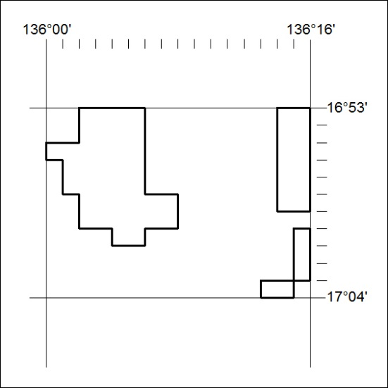

230/19

Mineral Titles Act 2010
NOTICE OF LAND CEASING TO BE A MINERAL TITLE AREA
Title Type and Number: | Exploration Licence 31691
Area Ceased on: | 30 May 2019
Area: | 185 Blocks, 607.23 km²
Locality: | LANCEWOOD
Name of Applicant(s)/Holder(s): | 100% MMG EXPLORATION PTY LTD* [ACN. 119 136 659]
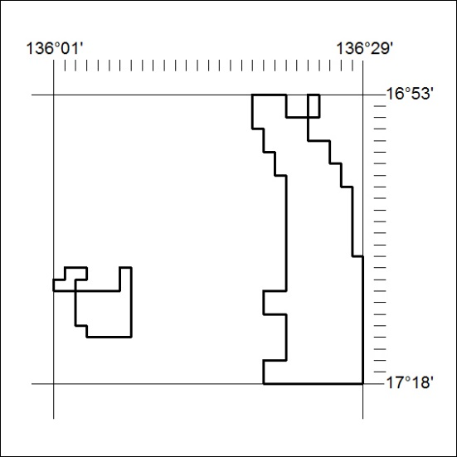

231/19
Mineral Titles Act 2010
NOTICE OF LAND CEASING TO BE A MINERAL TITLE AREA
Title Type and Number: | Exploration Licence 31801
Area Ceased on: | 30 May 2019
Area: | 242 Blocks, 752.56 km²
Locality: | MITCHIEBO
Name of Applicant(s)/Holder(s): | 100% MMG EXPLORATION PTY LTD* [ACN. 119 136 659]
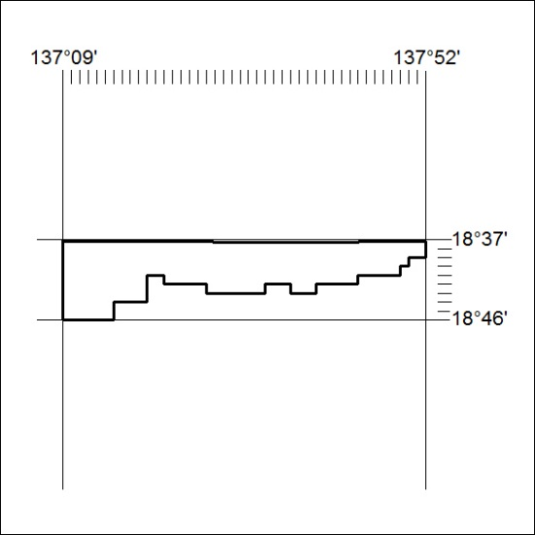

232/19

Mineral Titles Act 2010
NOTICE OF LAND CEASING TO BE A MINERAL TITLE AREA
Title Type and Number: | Exploration Licence 31802
Area Ceased on: | 30 May 2019
Area: | 232 Blocks, 753.37 km²
Locality: | MITTIEBAH
Name of Applicant(s)/Holder(s): | 100% MMG EXPLORATION PTY LTD* [ACN. 119 136 659]
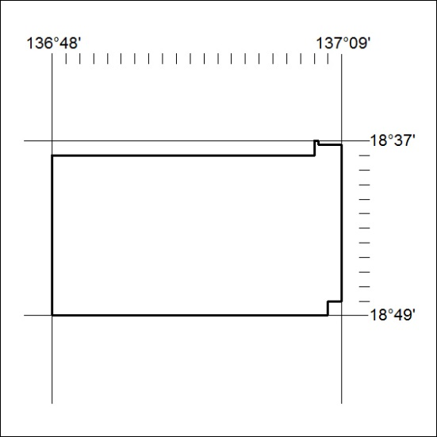

233/19
Mineral Titles Act 2010
NOTICE OF LAND CEASING TO BE A MINERAL TITLE AREA
Title Type and Number: | Exploration Licence 31803
Area Ceased on: | 30 May 2019
Area: | 84 Blocks, 277.45 km²
Locality: | NUTWOOD
Name of Applicant(s)/Holder(s): | 100% MMG EXPLORATION PTY LTD* [ACN. 119 136 659]
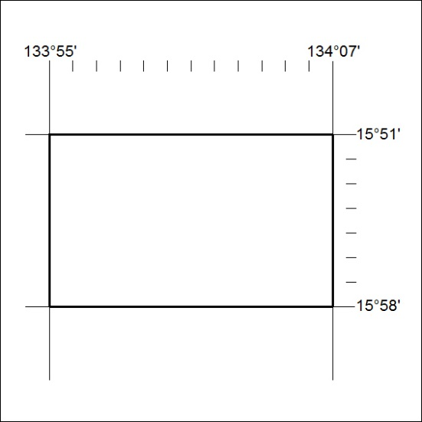

234/19

Mineral Titles Act 2010
NOTICE OF LAND CEASING TO BE A MINERAL TITLE AREA
Title Type and Number: | Exploration Licence 31804
Area Ceased on: | 30 May 2019
Area: | 240 Blocks, 793.08 km²
Locality: | NUTWOOD
Name of Applicant(s)/Holder(s): | 100% MMG EXPLORATION PTY LTD* [ACN. 119 136 659]
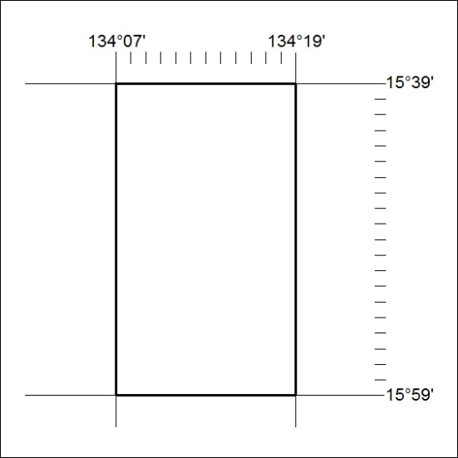

235/19
Mineral Titles Act 2010
NOTICE OF LAND CEASING TO BE A MINERAL TITLE AREA
Title Type and Number: | Exploration Licence 31805
Area Ceased on: | 31 May 2019
Area: | 238 Blocks, 787.56 km²
Locality: | NUTWOOD
Name of Applicant(s)/Holder(s): | 100% MMG EXPLORATION PTY LTD* [ACN. 119 136 659]
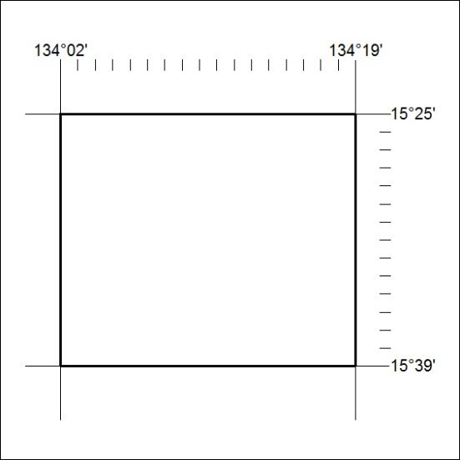

236/19

Mineral Titles Act 2010
NOTICE OF LAND CEASING TO BE A MINERAL TITLE AREA
Title Type and Number: | Exploration Licence 31806
Area Ceased on: | 30 May 2019
Area: | 240 Blocks, 793.34 km²
Locality: | MARYFIELD
Name of Applicant(s)/Holder(s): | 100% MMG EXPLORATION PTY LTD* [ACN. 119 136 659]
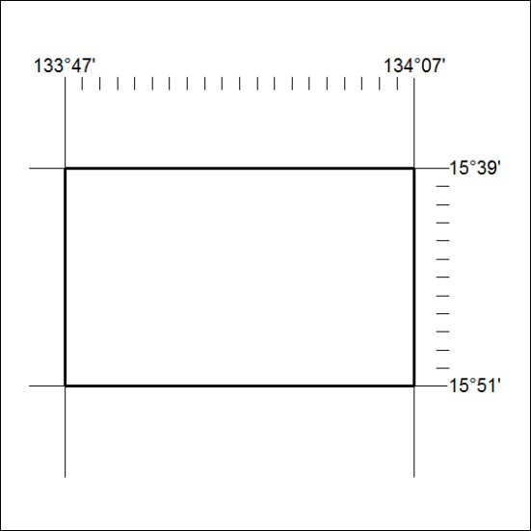

237/19
Mineral Titles Act 2010
NOTICE OF LAND CEASING TO BE A MINERAL TITLE AREA
Title Type and Number: | Exploration Licence 31807
Area Ceased on: | 30 May 2019
Area: | 226 Blocks, 747.93 km²
Locality: | MARYFIELD
Name of Applicant(s)/Holder(s): | 100% MMG EXPLORATION PTY LTD* [ACN. 119 136 659]
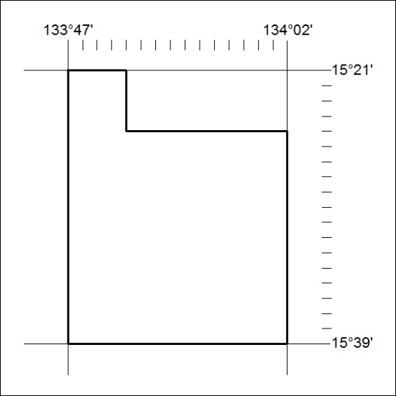

238/19

Mineral Titles Act 2010
NOTICE OF LAND CEASING TO BE A MINERAL TITLE AREA
Title Type and Number: | Exploration Licence 31808
Area Ceased on: | 30 May 2019
Area: | 234 Blocks, 774.20 km²
Locality: | MARYFIELD
Name of Applicant(s)/Holder(s): | 100% MMG EXPLORATION PTY LTD* [ACN. 119 136 659]
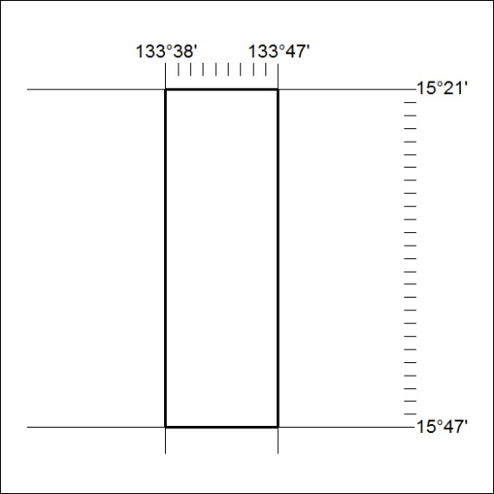

239/19
Mineral Titles Act 2010
NOTICE OF LAND CEASING TO BE A MINERAL TITLE AREA
Title Type and Number: | Exploration Licence 31809
Area Ceased on: | 30 May 2019
Area: | 234 Blocks, 774.20 km²
Locality: | MARYFIELD
Name of Applicant(s)/Holder(s): | 100% MMG EXPLORATION PTY LTD* [ACN. 119 136 659]
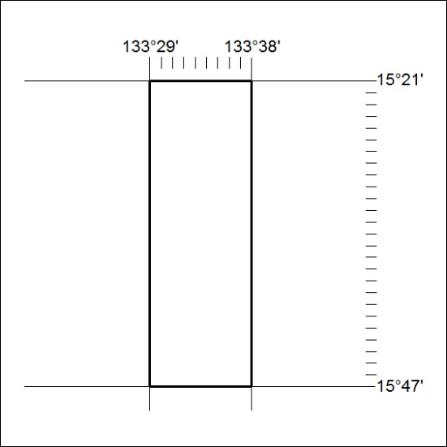

240/19

Mineral Titles Act 2010
NOTICE OF LAND CEASING TO BE A MINERAL TITLE AREA
Title Type and Number: | Exploration Licence 31810
Area Ceased on: | 30 May 2019
Area: | 228 Blocks, 754.34 km²
Locality: | LARRIMAH
Name of Applicant(s)/Holder(s): | 100% MMG EXPLORATION PTY LTD* [ACN. 119 136 659]
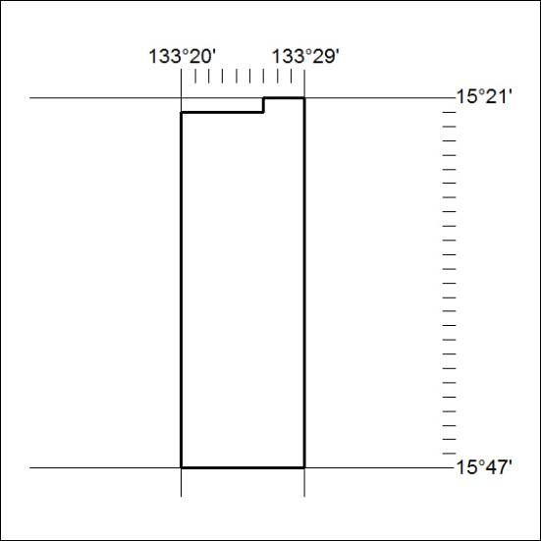

241/19
Mineral Titles Act 2010
NOTICE OF LAND CEASING TO BE A MINERAL TITLE AREA
Title Type and Number: | Exploration Licence 31875
Area Ceased on: | 30 May 2019
Area: | 5 Blocks, 16.45 km²
Locality: | MALLAPUNYAH
Name of Applicant(s)/Holder(s): | 100% MMG EXPLORATION PTY LTD* [ACN. 119 136 659]
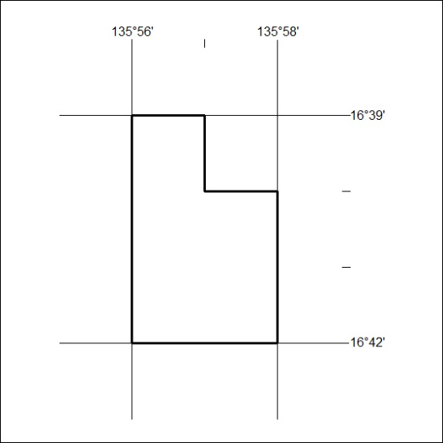

242/19

