Mineral Titles Act
NOTICE OF GRANT OF A MINERAL TITLE
Title Type and Number: | Extractive Mineral Permit 30299
Granted: | 17 May 2019, for a period of 5 Years
Area: | 16.50 Hectares
Locality: | MARY RIVER
Name of Holder/s: | 100% DARWIN CHRISTIAN MINISTRIES INC
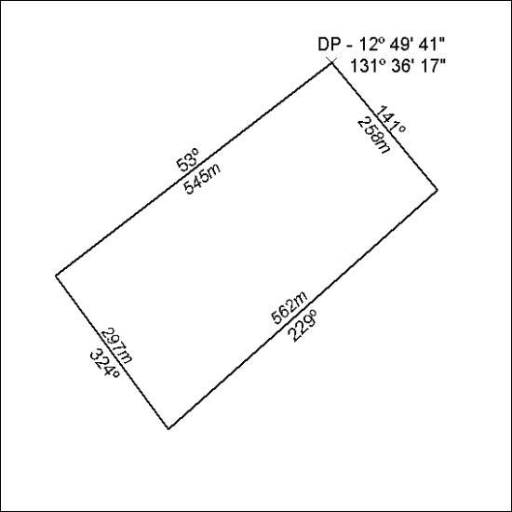

185/19

